Unit 2: ICS Fundamentals Review

This page intentionally left blank.

Visuals

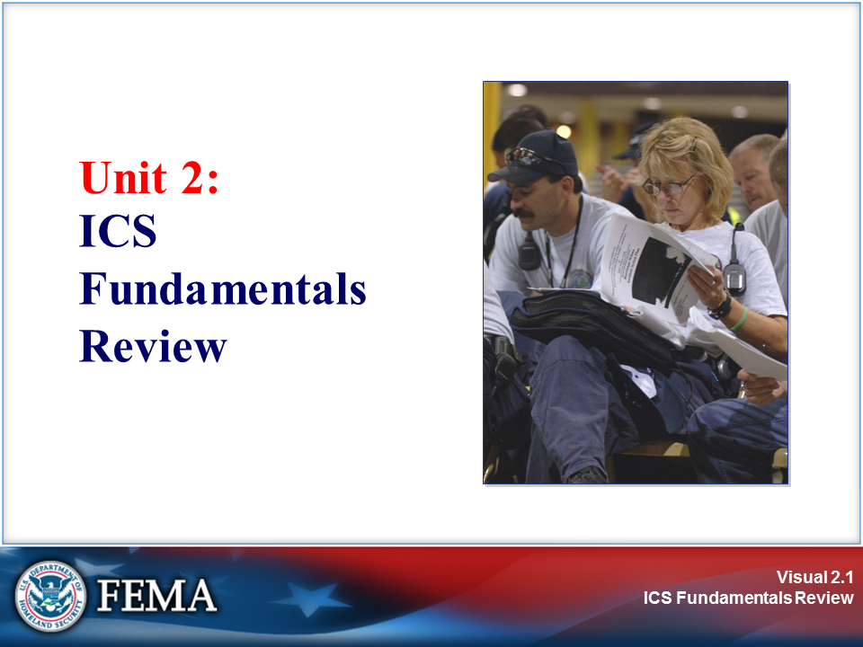 | 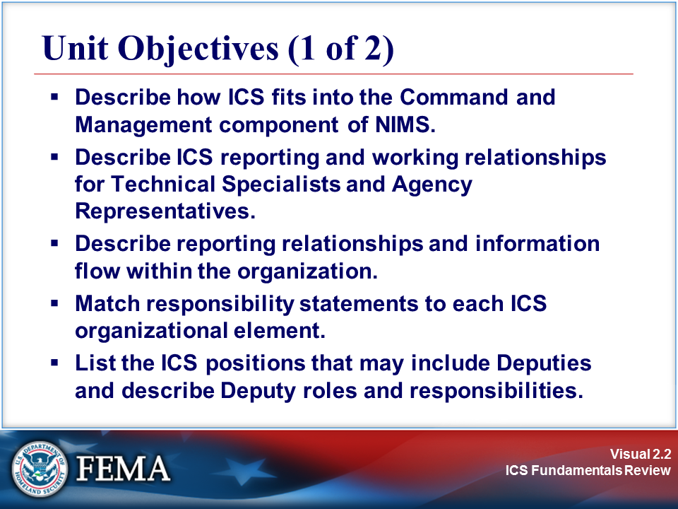
Your Notes

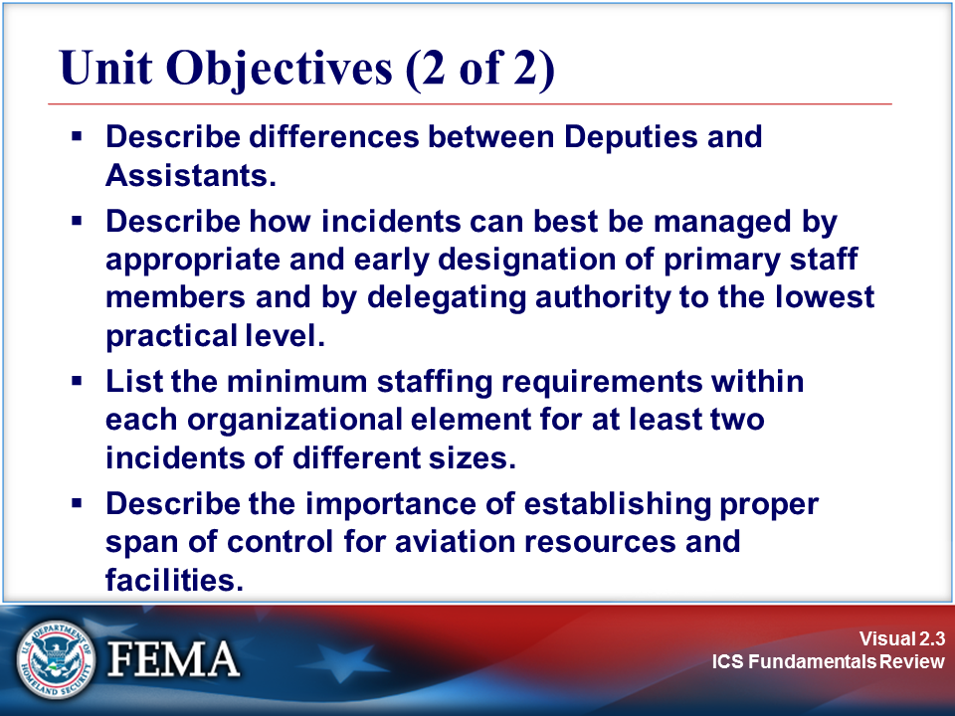 | 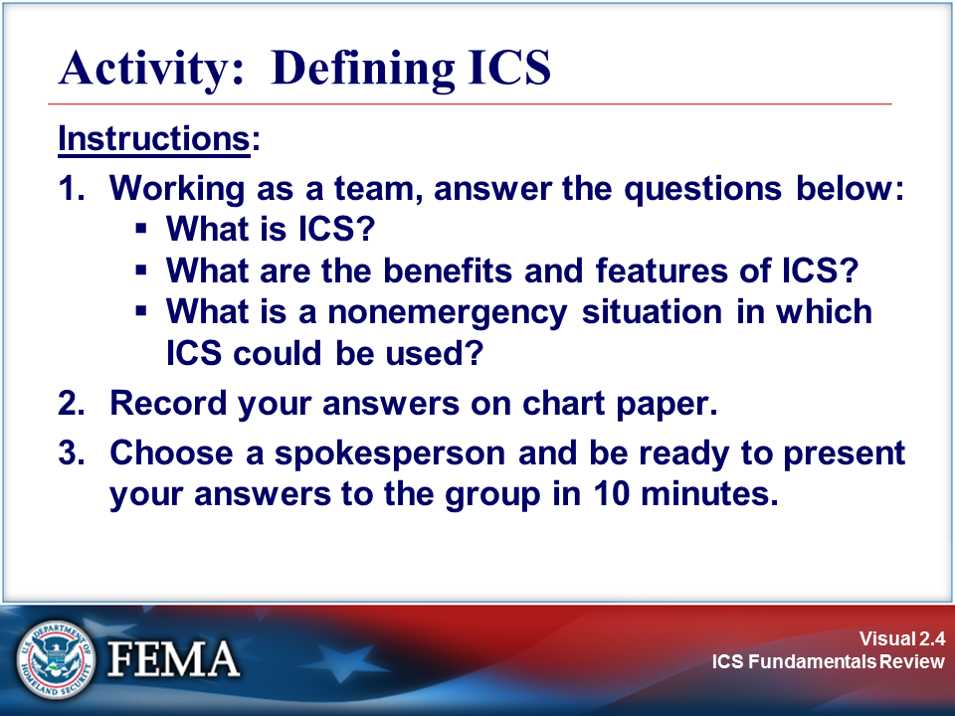
Your Notes

Activity: Defining ICS

ICS Review Materials: ICS History and Features

Incident Command System (ICS)

ICS was developed in the 1970s following a series of catastrophic fires in California's urban interface. Property damage ran into the millions, and many people died or were injured. The personnel assigned to determine the causes of these outcomes studied the case histories and discovered that response problems could rarely be attributed to lack of resources or failure of tactics. Surprisingly, studies found that response problems were far more likely to result from inadequate management than from any other single reason.

The Incident Command System:

- Is a standardized management tool for meeting the demands of small or large emergency or nonemergency situations.

- Represents "best practices" and has become the standard for emergency management across the country.

- May be used for planned events, natural disasters, and acts of terrorism.

- Is a key feature of the National Incident Management System (NIMS).

As stated in NIMS, “The ICS is a management system designed to enable effective and efficient domestic incident management by integrating a combination of facilities, equipment, personnel, procedures, and communications operating within a common organizational structure, designed to enable effective and efficient domestic incident management. A basic premise of ICS is that it is widely applicable. It is used to organize both near-term and long-term field-level operations for a broad spectrum of emergencies, from small to complex incidents, both natural and manmade. ICS is used by all levels of government—Federal, State, local, and tribal—as well as by many private-sector and nongovernmental organizations. ICS is also applicable across disciplines. It is normally structured to facilitate activities in five major functional areas: command, operations, planning, logistics, and finance and administration.”

Activity: Defining ICS (Continued)

ICS Review Materials: ICS History and Features

ICS Features

The 14 essential ICS features are listed below:

- Common Terminology: Using common terminology helps to define organizational functions, incident facilities, resource descriptions, and position titles.

- Modular Organization: The Incident Command organizational structure develops in a modular fashion that is based on the size and complexity of the incident, as well as the specifics of the hazard environment created by the incident.

- Management by Objectives: Includes establishing overarching objectives; developing strategies based on incident objectives; developing and issuing assignments, plans, procedures, and protocols; establishing specific, measurable objectives for various incident management functional activities and directing efforts to attain them, in support of defined strategies; and documenting results to measure performance and facilitate corrective action.

- Incident Action Planning: Incident Action Plans (IAPs) provide a coherent means of communicating the overall incident objectives in the context of both operational and support activities.

- Manageable Span of Control: Span of control is key to effective and efficient incident management. Within ICS, the span of control of any individual with incident management supervisory responsibility should range from three to seven subordinates.

- Incident Locations and Facilities: Various types of operational support facilities are established in the vicinity of an incident to accomplish a variety of purposes. Typical designated facilities include Incident Command Posts, Bases, Camps, Staging Areas, Mass Casualty Triage Areas, and others as required.

- Comprehensive Resource Management: Maintaining an accurate and up-to-date picture of resource utilization is a critical component of incident management. Resources are defined as personnel, teams, equipment, supplies, and facilities available or potentially available for assignment or allocation in support of incident management and emergency response activities.

- Integrated Communications: Incident communications are facilitated through the development and use of a common communications plan and interoperable communications processes and architectures.

- Establishment and Transfer of Command: The command function must be clearly established from the beginning of an incident. When command is transferred, the process must include a briefing that captures all essential information for continuing safe and effective operations.

(Continued on the next page.)

Activity: Defining ICS (Continued)

ICS Review Materials: ICS History and Features

ICS Features (Continued)

- Chain of Command and Unity of Command: Chain of command refers to the orderly line of authority within the ranks of the incident management organization. Unity of command means that every individual has a designated supervisor to whom he or she reports at the scene of the incident. These principles clarify reporting relationships and eliminate the confusion caused by multiple, conflicting directives. Incident managers at all levels must be able to control the actions of all personnel under their supervision.

- Unified Command: In incidents involving multiple jurisdictions, a single jurisdiction with multiagency involvement, or multiple jurisdictions with multiagency involvement, Unified Command allows agencies with different legal, geographic, and functional authorities and responsibilities to work together effectively without affecting individual agency authority, responsibility, or accountability.

- Accountability: Effective accountability at all jurisdictional levels and within individual functional areas during incident operations is essential. To that end, the following principles must be adhered to:

- Check-In: All responders, regardless of agency affiliation, must report in to receive an assignment in accordance with the procedures established by the Incident Commander.
- Incident Action Plan: Response operations must be directed and coordinated as outlined in the IAP.
- Unity of Command: Each individual involved in incident operations will be assigned to only one supervisor.
- Personal Responsibility: All responders are expected to use good judgment and be accountable for their actions.
- Span of Control: Supervisors must be able to adequately supervise and control their subordinates, as well as communicate with and manage all resources under their supervision.
- Resource Tracking: Supervisors must record and report resource status changes as they occur.

- Dispatch/Deployment: Personnel and equipment should respond only when requested or when dispatched by an appropriate authority.

- Information and Intelligence Management: The incident management organization must establish a process for gathering, analyzing, sharing, and managing incident-related information and intelligence.

Visuals

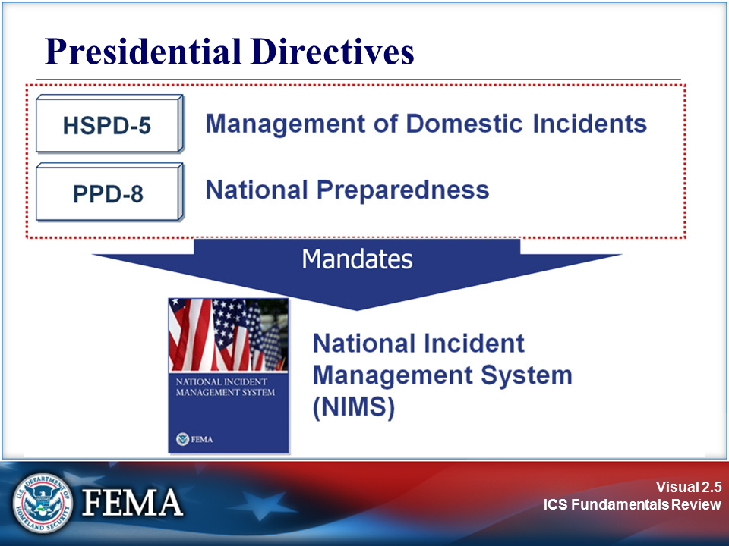 | 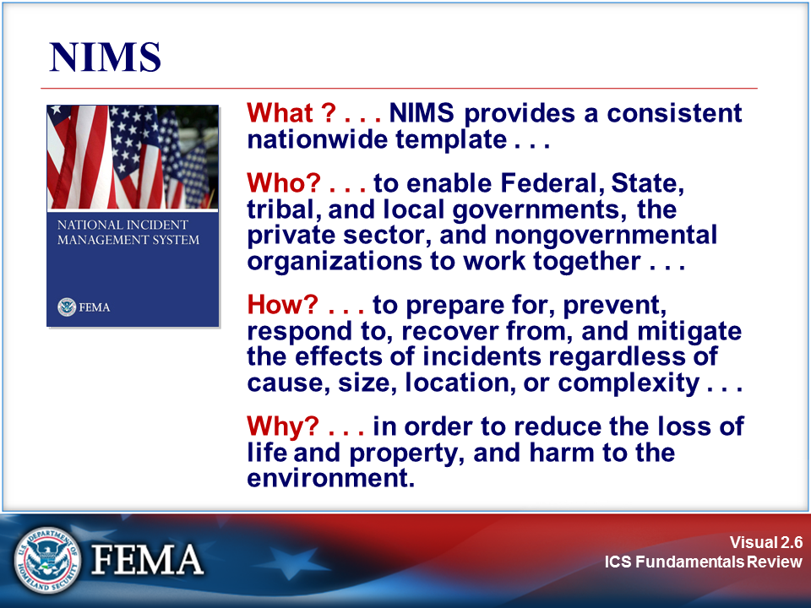
Your Notes

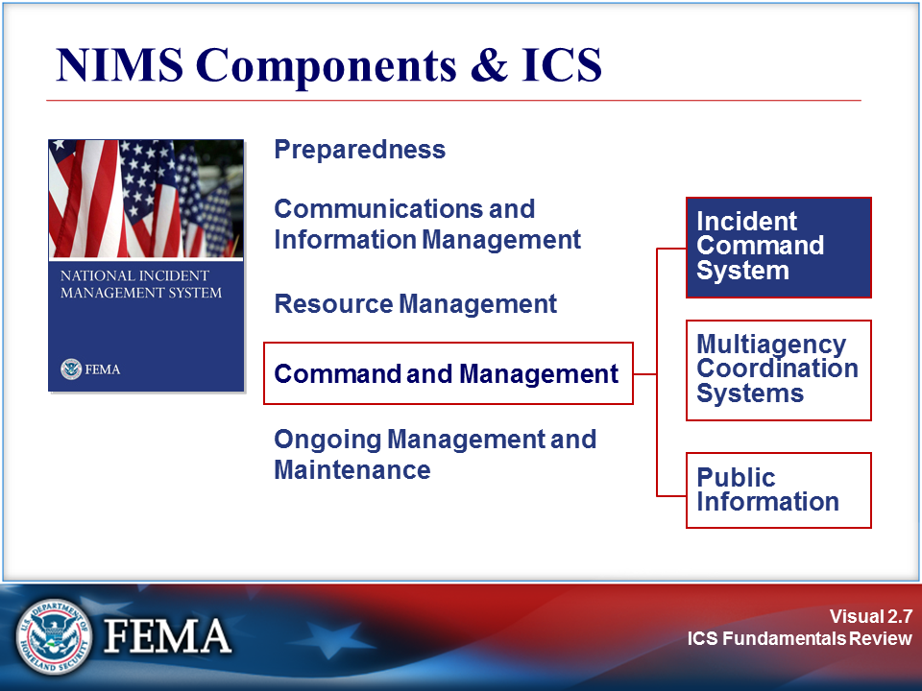 | View the job aid on the next page.
Your Notes

Job Aid: NIMS Components and ICS

NIMS Components and ICS

Following is a synopsis of each major component of NIMS.

- Preparedness. Effective incident management and incident response activities begin with a host of preparedness activities conducted on an ongoing basis, in advance of any potential incident. Preparedness involves an integrated combination of assessment, planning, procedures and protocols, training and exercises, personnel qualification and certification, equipment certification, and evaluation and revision.

- Communications and Information Management. Emergency management and incident response activities rely on communications and information systems that provide a common operating picture to all command and coordination sites. NIMS describes the requirements necessary for a standardized framework for communications and emphasizes the need for a common operating picture. NIMS is based on the concepts of interoperability, reliability, scalability, portability, and the resiliency and redundancy of communication and information systems.

- Resource Management. Resources (such as personnel, equipment, and/or supplies) are needed to support critical incident objectives. The flow of resources must be fluid and adaptable to the requirements of the incident. NIMS defines standardized mechanisms and establishes the resource management process to: identify requirements, order and acquire, mobilize, track and report, recover and demobilize, reimburse, and inventory resources.

- Command and Management. The Command and Management component within NIMS is designed to enable effective and efficient incident management and coordination by providing flexible, standardized incident management structures. The structure is based on three key organizational constructs: the Incident Command System, Multiagency Coordination Systems, and Public Information.

- Ongoing Management and Maintenance. DHS/FEMA manages the development and maintenance of NIMS. This includes developing NIMS programs and processes as well as keeping the NIMS document current.

Additional information: www.fema.gov/emergency/nims

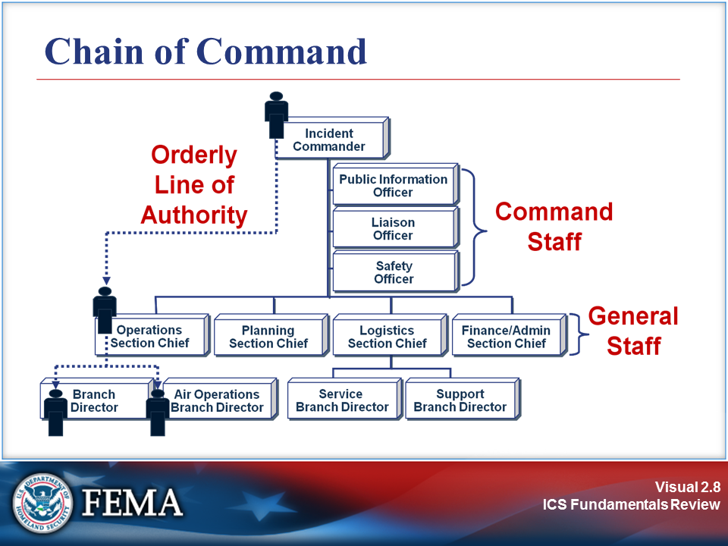 | 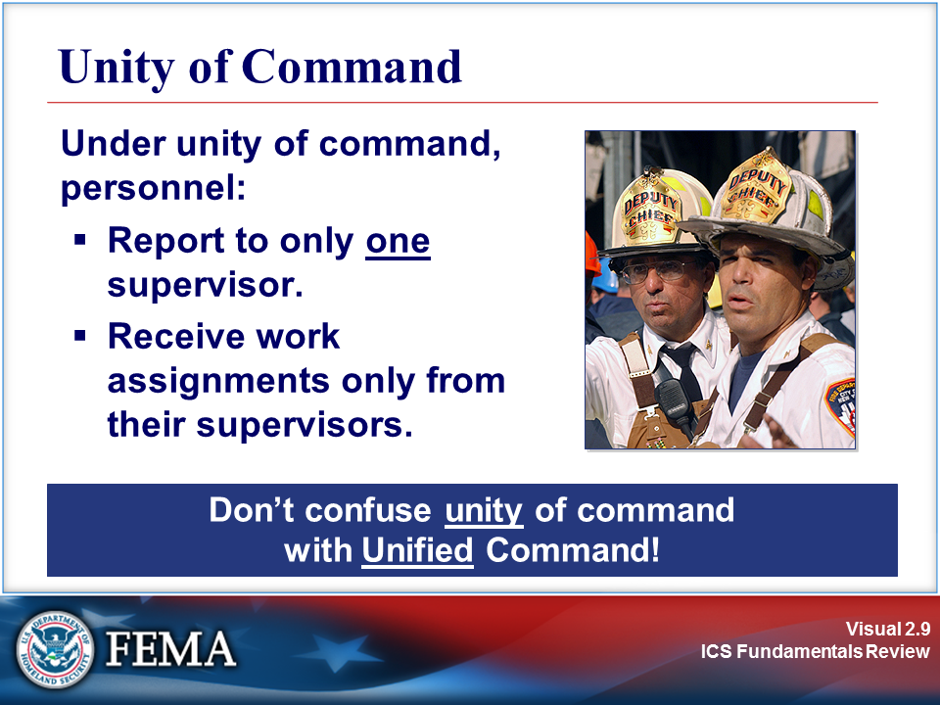
Your Notes

Your Notes

Visuals

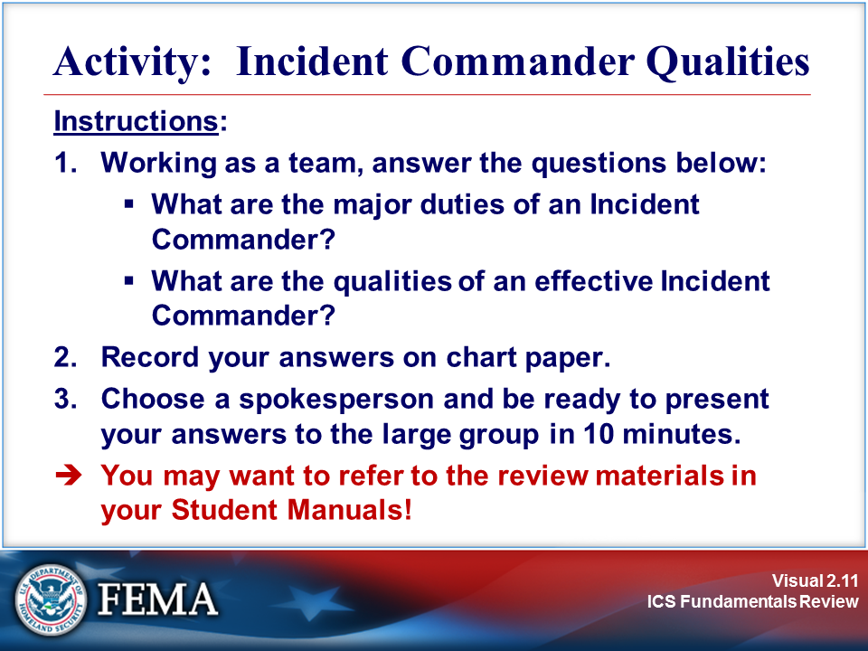 | Complete the activity before proceeding.
Your Notes

Activity: Incident Commander Qualities

Overall Organizational Functions

ICS was designed by identifying the primary activities or functions necessary to effectively respond to incidents. Analyses of incident reports and review of military organizations were all used in ICS development. These analyses identified the primary needs of incidents.

As incidents became more complex, difficult, and expensive, the need for an organizational manager became more evident. Thus in ICS, and especially in larger incidents, the Incident Commander manages the organization and not the incident.

In addition to the Command function, other desired functions and activities were to:

- Delegate authority and provide a separate organizational level within the ICS structure with sole responsibility for the tactical direction and control of resources.
- Provide logistical support to the incident organization.
- Provide planning services for both current and future activities.
- Provide cost assessment, time recording, and procurement control necessary to support the incident and the managing of claims.
- Promptly and effectively interact with the media, and provide informational services for the incident, involved agencies, and the public.
- Provide a safe operating environment within all parts of the incident organization.
- Ensure that assisting and cooperating agencies’ needs are met, and to see that they are used in an effective manner.

Incident Commander

The Incident Commander is technically not a part of either the General or Command Staff. The Incident Commander is responsible for:

- Having clear authority and knowing agency policy.
- Ensuring incident safety.
- Establishing an Incident Command Post.
- Setting priorities, and determining incident objectives and strategies to be followed.
- Establishing the ICS organization needed to manage the incident.
- Approving the Incident Action Plan.
- Coordinating Command and General Staff activities.
- Approving resource requests and use of volunteers and auxiliary personnel.
- Ordering demobilization as needed.
- Ensuring after-action reports are completed.
- Authorizing information release to the media.

Visuals

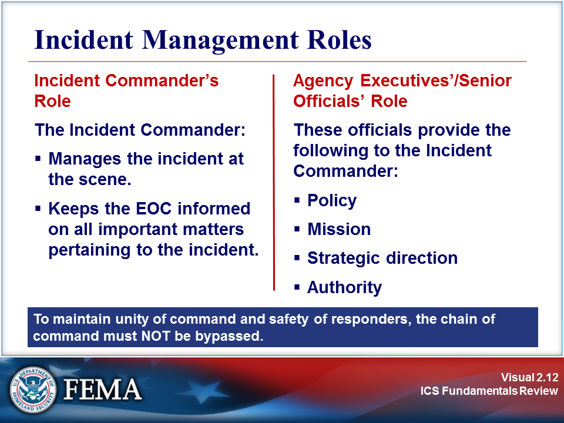 | 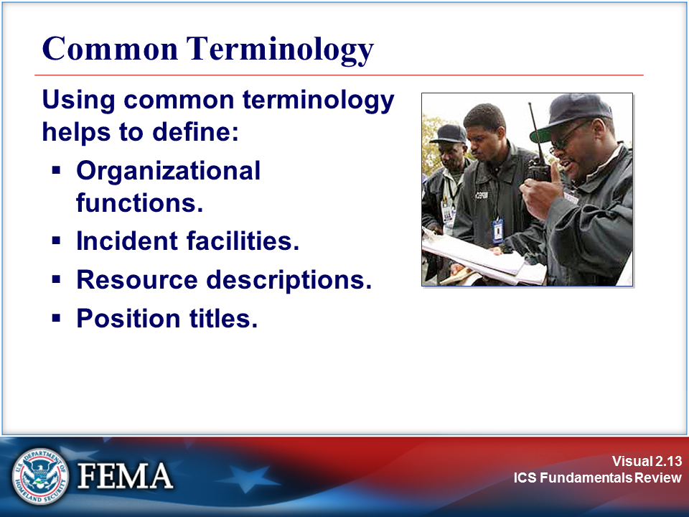
Your Notes

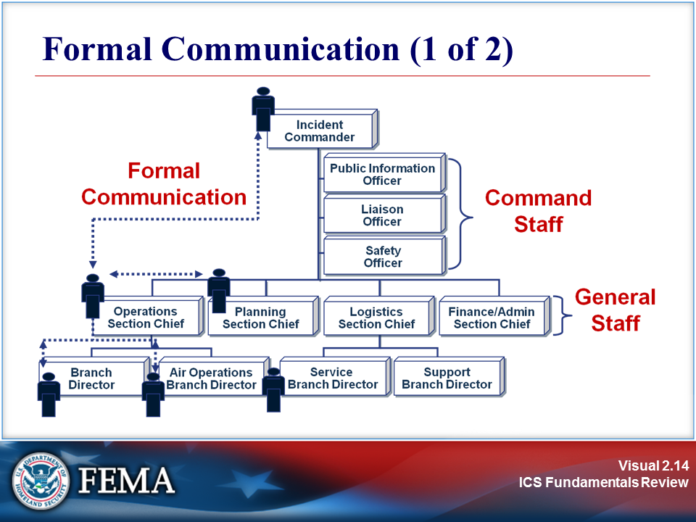 | 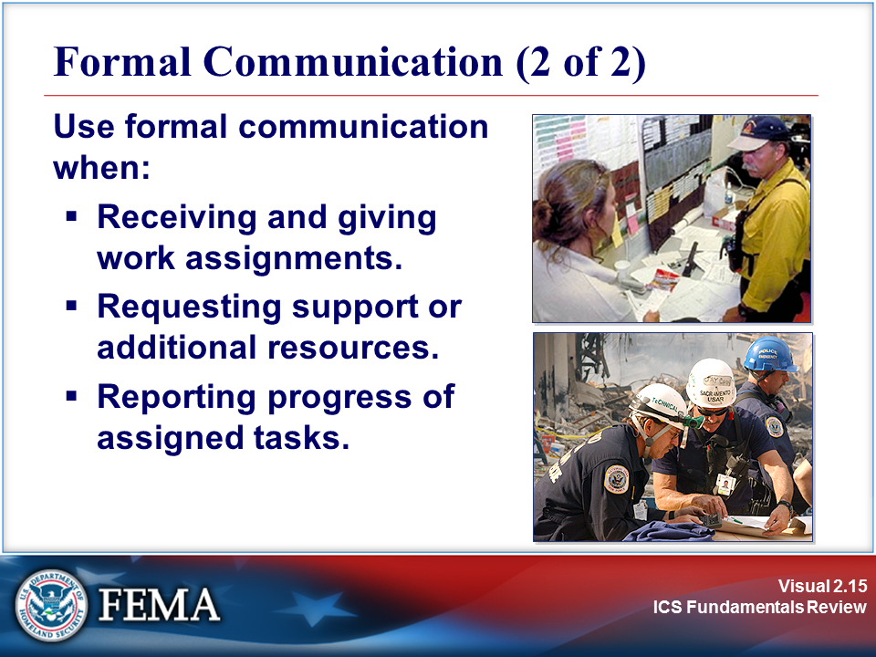
Your Notes

Visuals

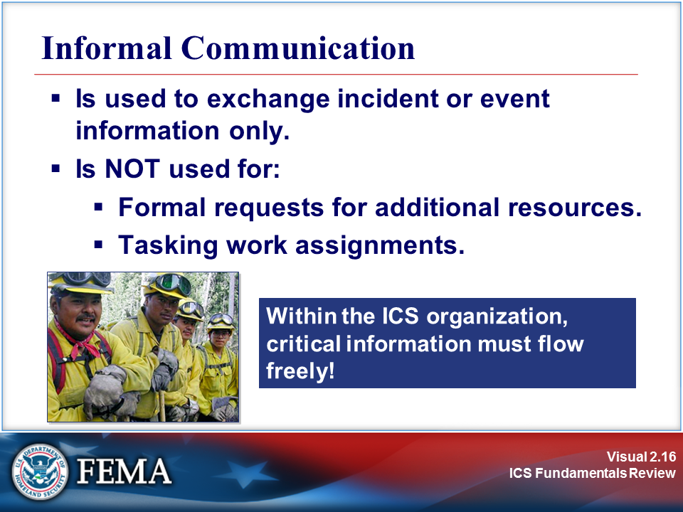 | 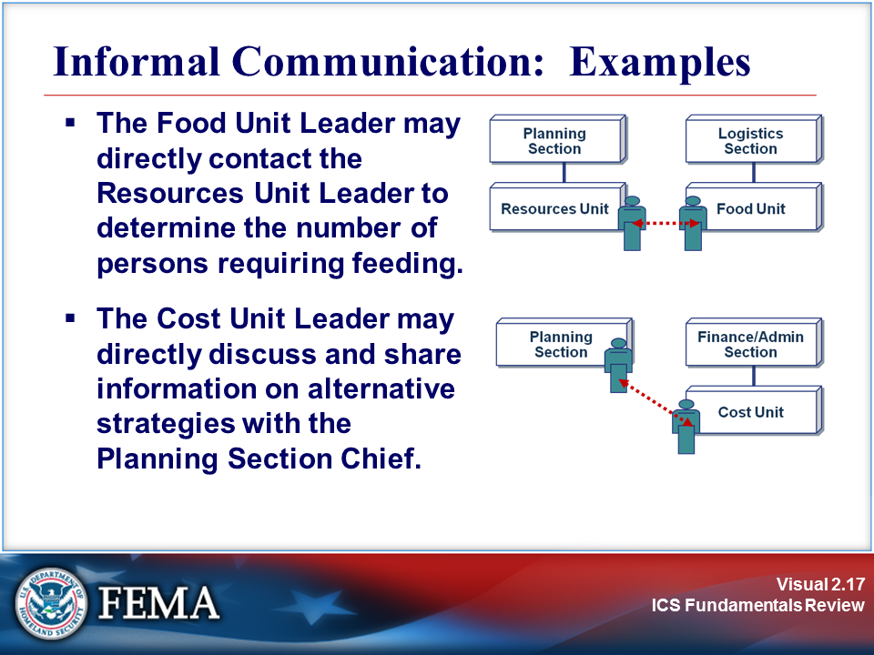
Your Notes

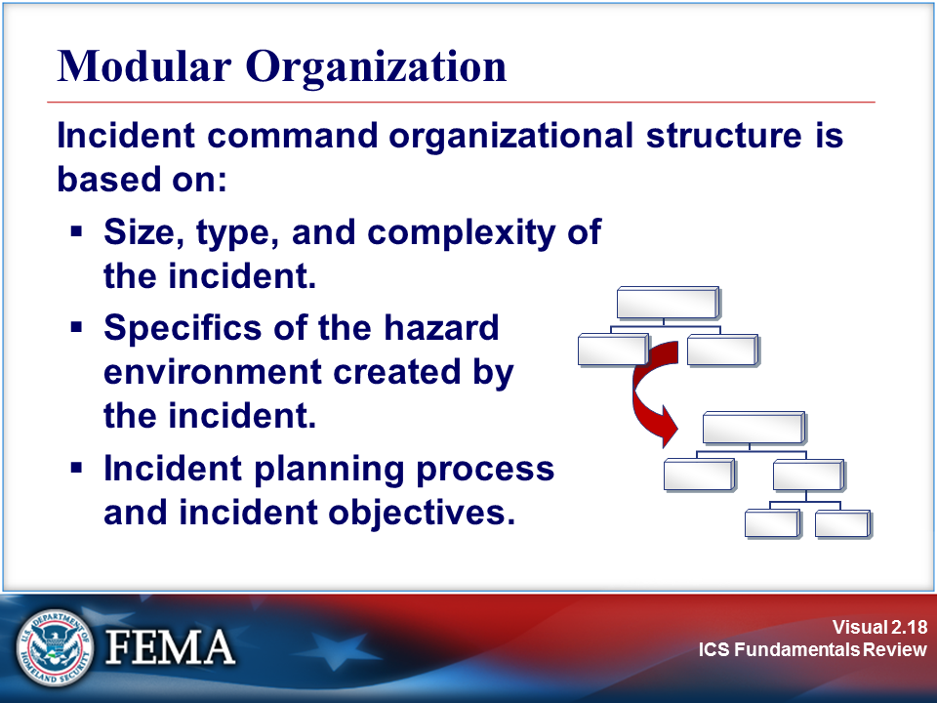 | View the job aid on the next page.
Your Notes

Job Aid: Modular Organization

ICS Review Materials: Incident Complexity

Incident Complexity

“Incident complexity” is the combination of involved factors that affect the probability of control of an incident. Many factors determine the complexity of an incident, including, but not limited to, area involved, threat to life and property, political sensitivity, organizational complexity, jurisdictional boundaries, values at risk, weather, strategy and tactics, and agency policy.

Incident complexity is considered when making incident management level, staffing, and safety decisions.

Various analysis tools have been developed to assist consideration of important factors involved in incident complexity. Listed below are the factors that may be considered in analyzing incident complexity:

- Community and responder safety
- Impacts to life, property, and the economy
- Potential hazardous materials
- Weather and other environmental influences
- Likelihood of cascading events
- Potential crime scene (including terrorism)
- Political sensitivity, external influences, and media relations
- Area involved, jurisdictional boundaries
- Availability of resources
- Potential to extend into multiple operational periods

Visuals

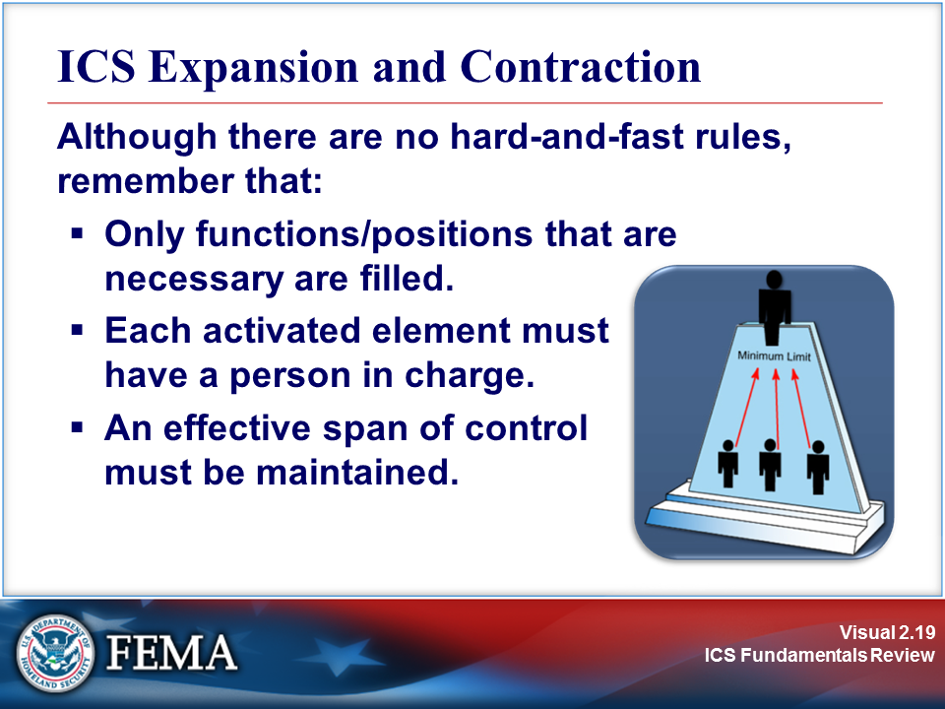 | 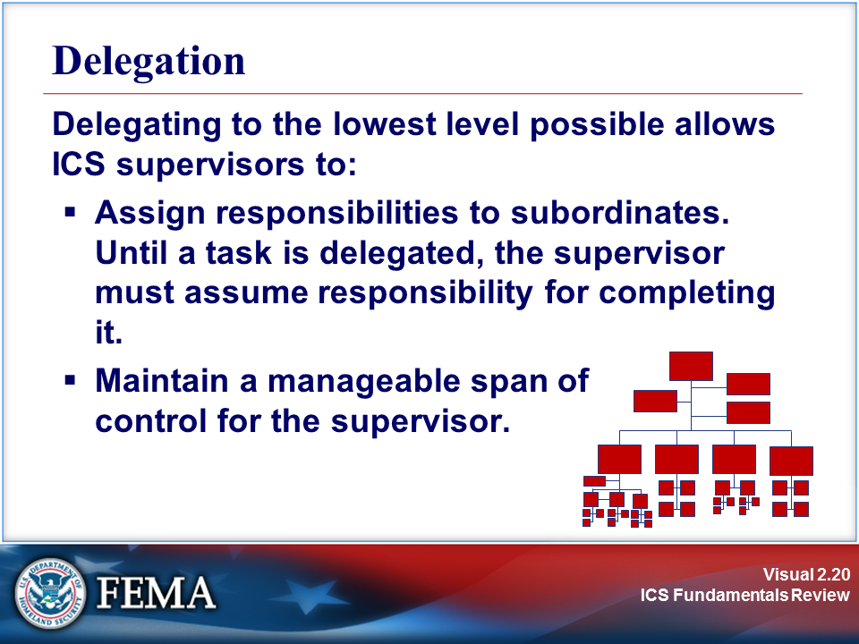
Your Notes

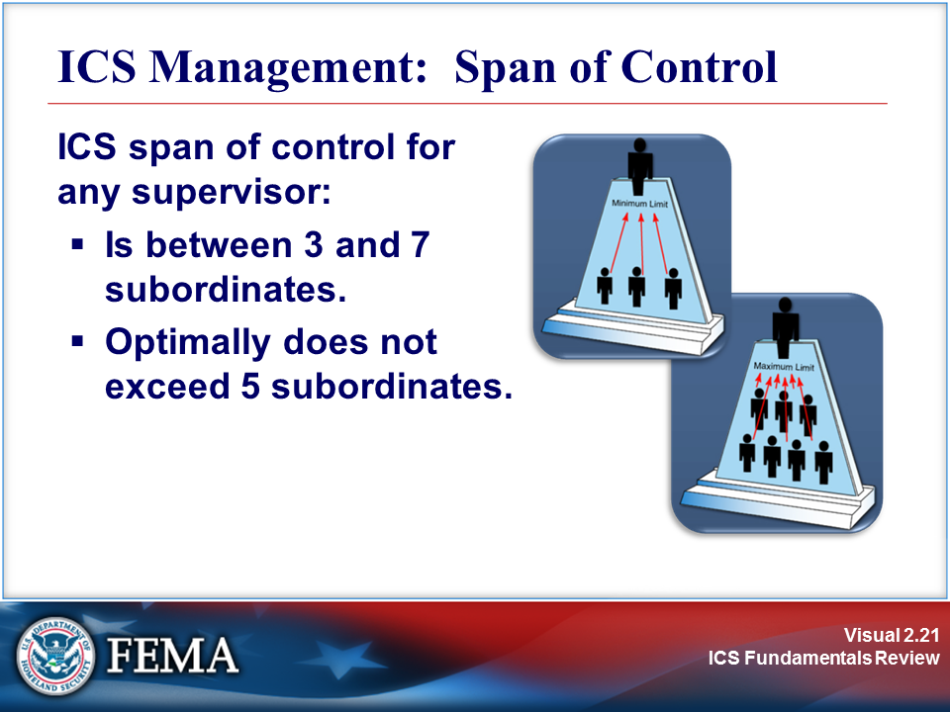 | 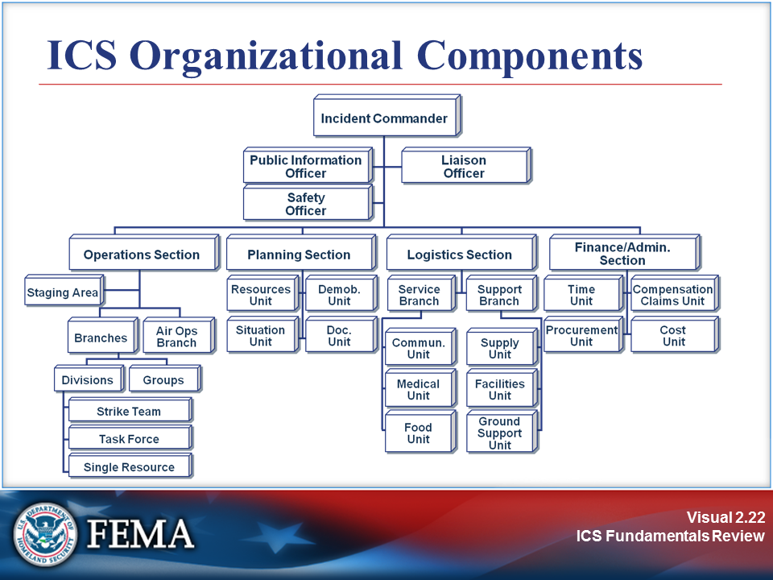
Your Notes

Job Aid: ICS Organizational Components

ICS Review Materials: Organizational Elements

Organizational Structure

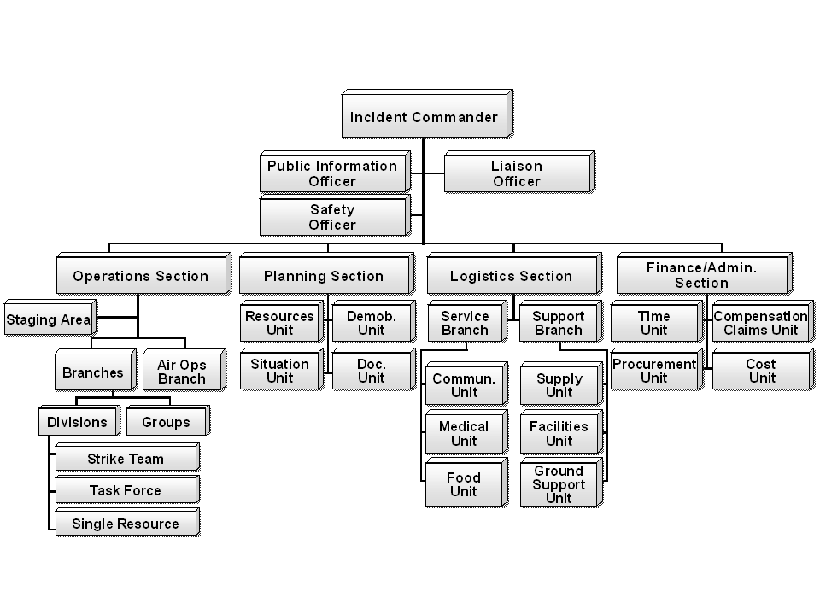

- Command Staff: The staff who report directly to the Incident Commander, including the Public Information Officer, Safety Officer, Liaison Officer, and other positions as required.
- Section: The organizational level having responsibility for a major functional area of incident management (e.g., Operations, Planning, Logistics, Finance/Administration, and Intelligence/Investigations (if established)). The Section is organizationally situated between the Branch and the Incident Command.
- Branch: The organizational level having functional or geographical responsibility for major aspects of incident operations. A Branch is organizationally situated between the Section Chief and the Division or Group in the Operations Section, and between the Section and Units in the Logistics Section. Branches are identified by the use of Roman numerals or by functional area.
- Division: The organizational level having responsibility for operations within a defined geographic area. The Division level is organizationally between the Strike Team and the Branch.
- Group: An organizational subdivision established to divide the incident management structure into functional areas of operation. Groups are located between Branches (when activated) and Resources in the Operations Section.
- Unit: The organizational element with functional responsibility for a specific incident planning, logistics, or finance/administration activity.
- Task Force: Any combination of resources assembled to support a specific mission or operational need. All resource elements within a Task Force must have common communications and a designated leader.
- Strike Team: A set number of resources of the same kind and type that have an established minimum number of personnel, common communications, and a leader.
- Single Resource: An individual, a piece of equipment and its personnel complement, or a crew/team of individuals with an identified work supervisor that can be used on an incident.

Incident Management Team

An Incident Management Team (IMT) is comprised of the Incident Commander and the appropriate Command and General Staff personnel assigned to an incident. The level of training and experience of the IMT members, coupled with the identified formal response requirements and responsibilities of the IMT, are factors in determining “type,” or level, of IMT.

Command Staff

The Command Staff is assigned to carry out staff functions needed to support the Incident Commander. These functions include interagency liaison, incident safety, and public information.

Command Staff positions are established to assign responsibility for key activities not specifically identified in the General Staff functional elements. These positions may include the Public Information Officer (PIO), Safety Officer (SO), and Liaison Officer (LNO), in addition to various others, as required and assigned by the Incident Commander.

The table on the following page summarizes the responsibilities of the Command Staff.

General Staff

The General Staff represents and is responsible for the functional aspects of the Incident Command structure. The General Staff typically consists of the Operations, Planning, Logistics, and Finance/Administration Sections.

General guidelines related to General Staff positions include the following:

- Only one person will be designated to lead each General Staff position.
- General Staff positions may be filled by qualified persons from any agency or jurisdiction.
- Members of the General Staff report directly to the Incident Commander. If a General Staff position is not activated, the Incident Commander will have responsibility for that functional activity.
- Deputy positions may be established for each of the General Staff positions. Deputies are individuals fully qualified to fill the primary position. Deputies can be designated from other jurisdictions or agencies, as appropriate. This is a good way to bring about greater interagency coordination.
- General Staff members may exchange information with any person within the organization. Direction takes place through the chain of command. This is an important concept in ICS.
- General Staff positions should not be combined. For example, to establish a "Planning and Logistics Section," it is better to initially create the two separate functions, and if necessary for a short time place one person in charge of both. That way, the transfer of responsibility can be made easier.

Following the first table is a table that summarizes the responsibilities of the General Staff.

Command Staff | Responsibilities
Public Information Officer | - Determine, according to direction from the IC, any limits on information release.  - Develop accurate, accessible, and timely information for use in press/media briefings.  - Obtain IC’s approval of news releases.  - Conduct periodic media briefings.  - Arrange for tours and other interviews or briefings that may be required.  - Monitor and forward media information that may be useful to incident planning.  - Maintain current information, summaries, and/or displays on the incident.  - Make information about the incident available to incident personnel.  - Participate in planning meetings.
Safety Officer | - Identify and mitigate hazardous situations.  - Ensure safety messages and briefings are made.  - Exercise emergency authority to stop and prevent unsafe acts.  - Review the Incident Action Plan for safety implications.  - Assign assistants qualified to evaluate special hazards.  - Initiate preliminary investigation of accidents within the incident area.  - Review and approve the Medical Plan.  - Participate in planning meetings.
Liaison Officer | - Act as a point of contact for agency representatives.  - Maintain a list of assisting and cooperating agencies and agency representatives.  - Assist in setting up and coordinating interagency contacts.  - Monitor incident operations to identify current or potential interorganizational problems.  - Participate in planning meetings, providing current resource status, including limitations and capabilities of agency resources.  - Provide agency-specific demobilization information and requirements.
Assistants | In the context of large or complex incidents, Command Staff members may need one or more assistants to help manage their workloads. Each Command Staff member is responsible for organizing his or her assistants for maximum efficiency.
Additional Command Staff | Additional Command Staff positions may also be necessary depending on the nature and location(s) of the incident, and/or specific requirements established by the Incident Commander. For example, a Legal Counsel may be assigned directly to the Command Staff to advise the Incident Commander on legal matters, such as emergency proclamations, legality of evacuation orders, and legal rights and restrictions pertaining to media access. Similarly, a Medical Advisor may be designated and assigned directly to the Command Staff to provide advice and recommendations to the Incident Commander in the context of incidents involving medical and mental health services, mass casualty, acute care, vector control, epidemiology, and/or mass prophylaxis considerations, particularly in the response to a bioterrorism event.
General Staff | Responsibilities
Operations Section Chief | The Operations Section Chief is responsible for managing all tactical operations at an incident. The Incident Action Plan (IAP) provides the necessary guidance. The need to expand the Operations Section is generally dictated by the number of tactical resources involved and is influenced by span of control considerations.  Major responsibilities of the Operations Section Chief are to:  - Assure safety of tactical operations.  - Manage tactical operations.  - Develop the operations portion of the IAP.  - Supervise execution of operations portions of the IAP.  - Request additional resources to support tactical operations.  - Approve release of resources from active operational assignments.  - Make or approve expedient changes to the IAP.  - Maintain close contact with IC, subordinate Operations personnel, and other agencies involved in the incident.
Planning Section Chief | The Planning Section Chief is responsible for providing planning services for the incident. Under the direction of the Planning Section Chief, the Planning Section collects situation and resources status information, evaluates it, and processes the information for use in developing action plans. Dissemination of information can be in the form of the IAP, in formal briefings, or through map and status board displays.  Major responsibilities of the Planning Section Chief are to:  - Collect and manage all incident-relevant operational data.  - Supervise preparation of the IAP.  - Provide input to the IC and Operations in preparing the IAP.  - Incorporate Traffic, Medical, and Communications Plans and other supporting materials into the IAP.  - Conduct and facilitate planning meetings.  - Reassign personnel within the ICS organization.  - Compile and display incident status information.  - Establish information requirements and reporting schedules for units (e.g., Resources and Situation Units).  - Determine need for specialized resources.  - Assemble and disassemble Task Forces and Strike Teams not assigned to Operations.  - Establish specialized data collection systems as necessary (e.g., weather).  - Assemble information on alternative strategies.  - Provide periodic predictions on incident potential.  - Report significant changes in incident status.  - Oversee preparation of the Demobilization Plan.

General Staff | Responsibilities
Logistics Section Chief | The Logistics Section Chief provides all incident support needs with the exception of logistics support to air operations. The Logistics Section is responsible for providing:  - Facilities.  - Transportation.  - Communications.  - Supplies.  - Equipment maintenance and fueling.  - Food services (for responders).  - Medical services (for responders).  - All off-incident resources.  Major responsibilities of the Logistics Section Chief are to:  - Provide all facilities, transportation, communications, supplies, equipment maintenance and fueling, food and medical services for incident personnel, and all off-incident resources.  - Manage all incident logistics.  - Provide logistical input to the IAP.  - Brief Logistics Staff as needed.  - Identify anticipated and known incident service and support requirements.  - Request additional resources as needed.  - Ensure and oversee the development of the Communications, Medical, and Traffic Plans as required.  - Oversee demobilization of the Logistics Section and associated resources.
Finance/  Administration Section Chief | The Finance/Administration Section Chief is responsible for managing all financial aspects of an incident. Not all incidents will require a Finance/Administration Section. Only when the involved agencies have a specific need for finance services will the Section be activated.  Major responsibilities of the Finance/Administration Section Chief are to:  - Manage all financial aspects of an incident.  - Provide financial and cost analysis information as requested.  - Ensure compensation and claims functions are being addressed relative to the incident.  - Gather pertinent information from briefings with responsible agencies.  - Develop an operating plan for the Finance/Administration Section and fill Section supply and support needs.  - Determine the need to set up and operate an incident commissary.  - Meet with assisting and cooperating agency representatives as needed.  - Maintain daily contact with agency(s) headquarters on finance matters.  - Ensure that personnel time records are completed accurately and transmitted to home agencies.  - Ensure that all obligation documents initiated at the incident are properly prepared and completed.  - Brief agency administrative personnel on all incident-related financial issues needing attention or followup.  - Provide input to the IAP.
Source: NIMS

Visuals

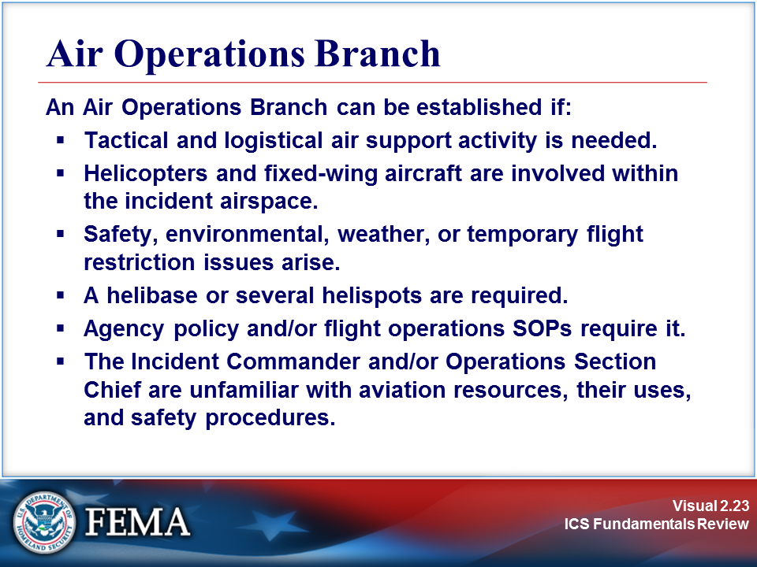 | View the job aid on the next page.
Your Notes

Job Aid: Air Operations Branch

Aviation Operations
Fire Control | Fixed-wing aircraft and helicopters for water and retardant drops, use of helicopters for transporting personnel to and from tactical assignments, for reconnaissance, and for logistical support.
Forest and Other Land Management Programs | Pest control programs.
Maritime Incidents | Hazardous materials spills, accidents, and searches.
Other Applications | Communications relay airborne command and control, photo mapping, etc.
Search and Rescue | Fixed-wing and helicopters for flying ground and water search patterns, medical evacuations, and logistical support.
Medical Evacuation | Transportation of injured victims and personnel.
Earthquakes, Floods, etc. | Reconnaissance, situation and damage assessment, rescue, logistical support, etc.
Law Enforcement | Reconnaissance, surveillance, direction, control, and transportation security.

Visuals

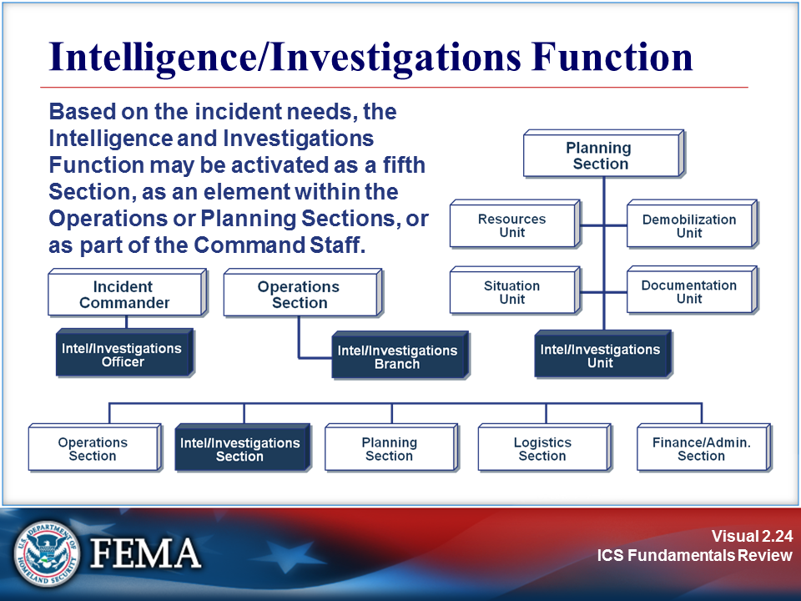 | 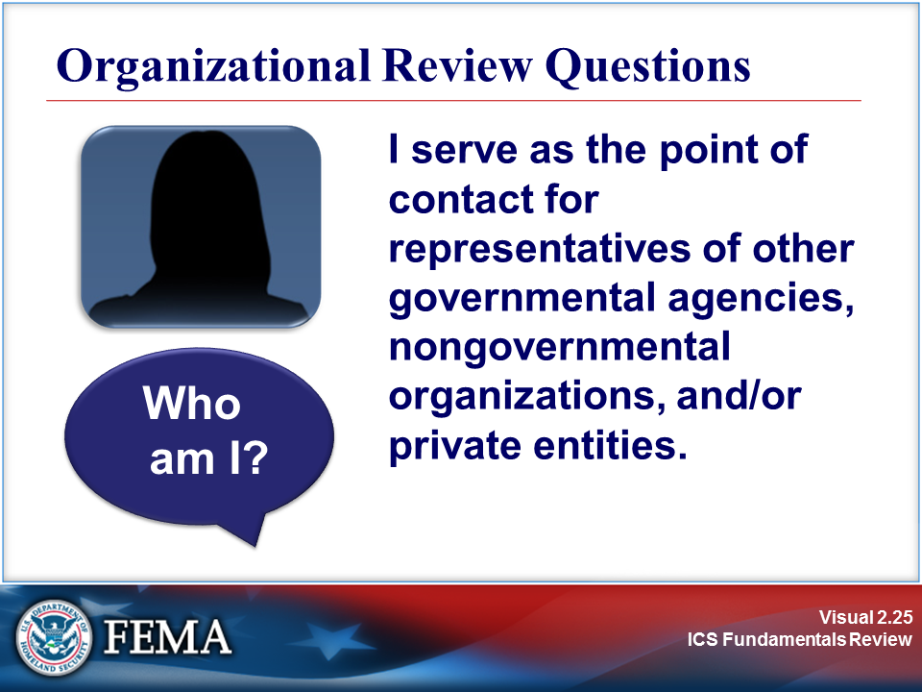
Your Notes

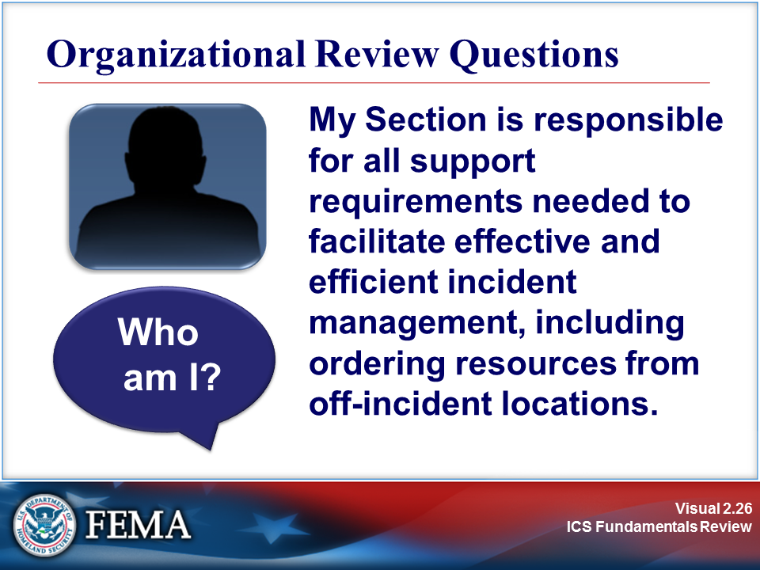 | 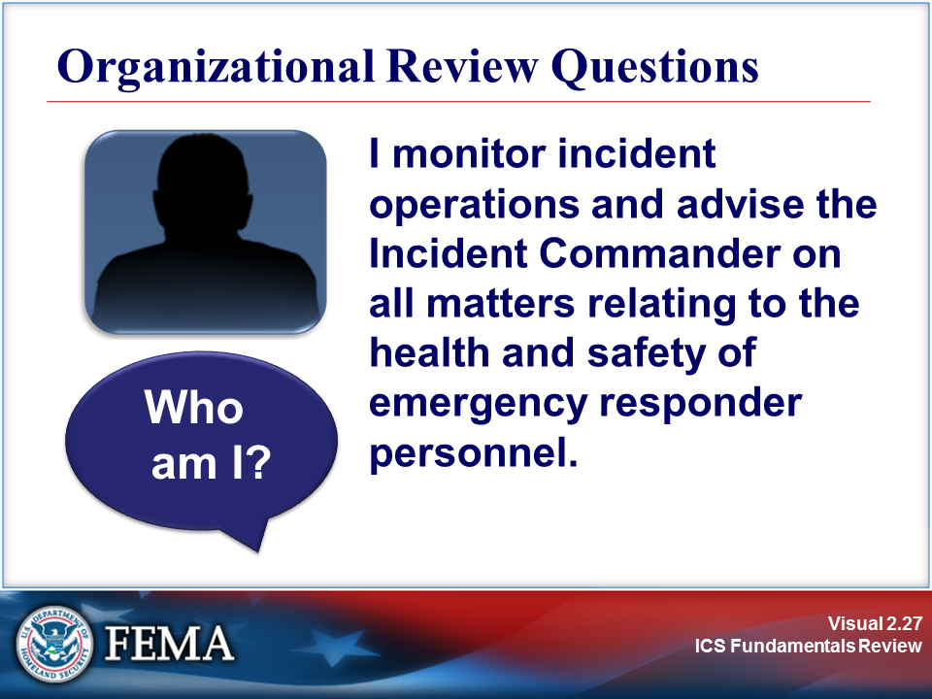
Your Notes

Visuals

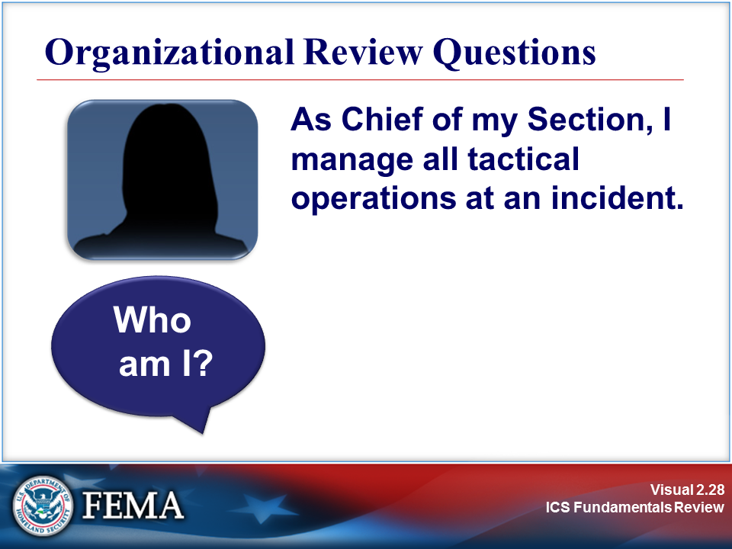 | 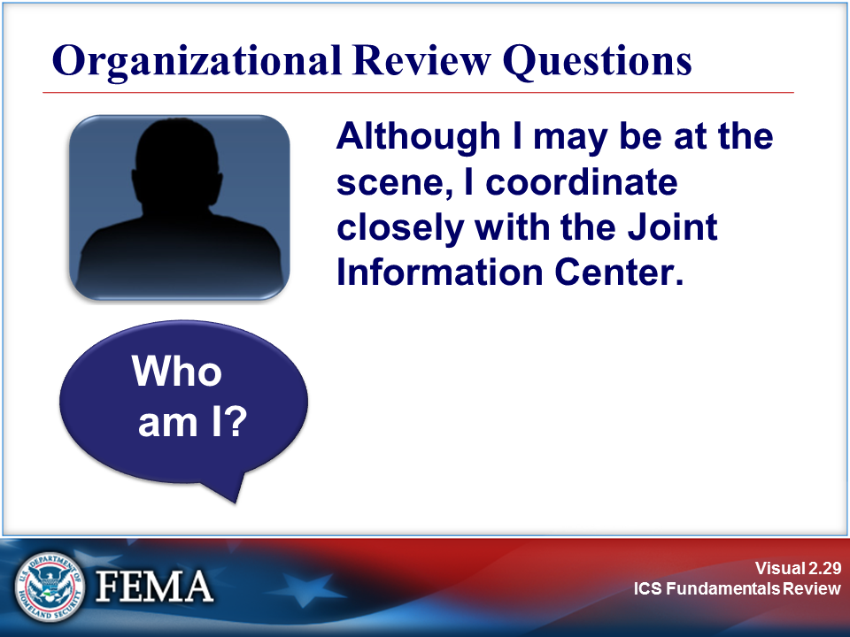
Your Notes

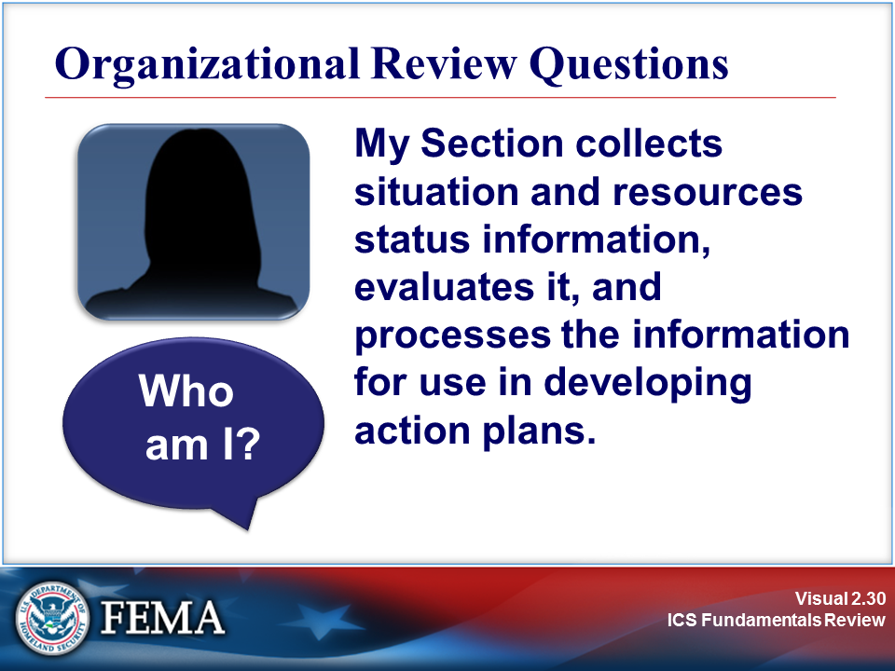 | 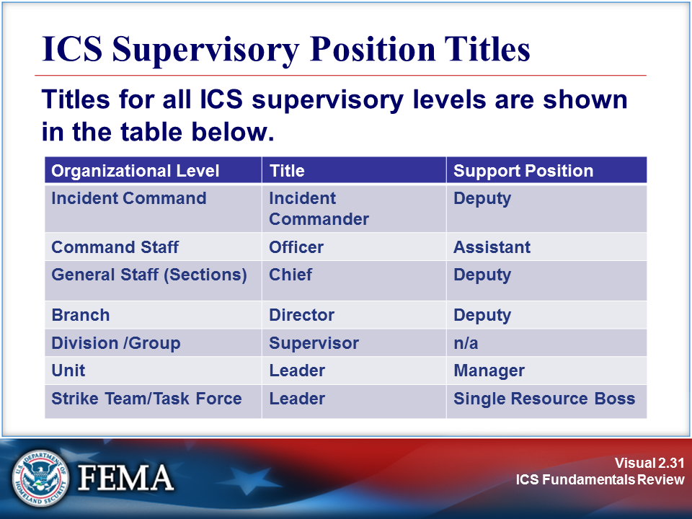
Your Notes

Visuals

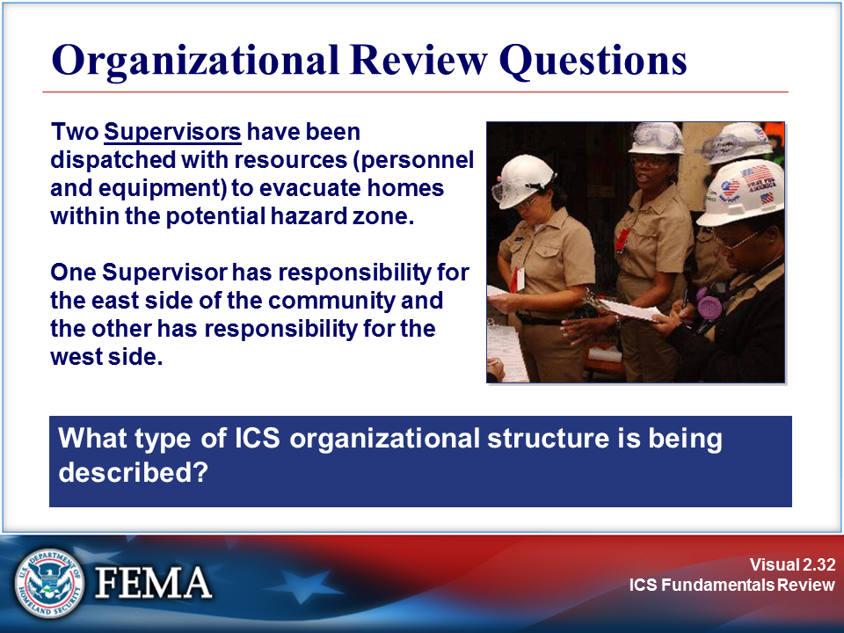 | 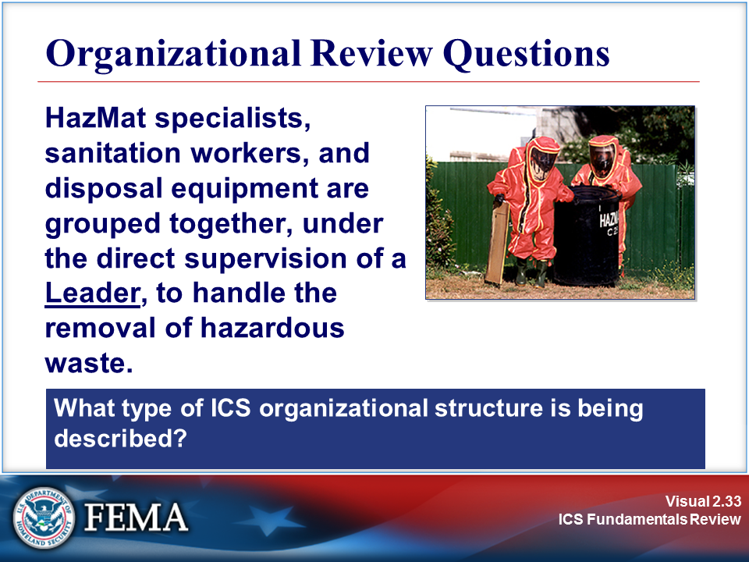
Your Notes

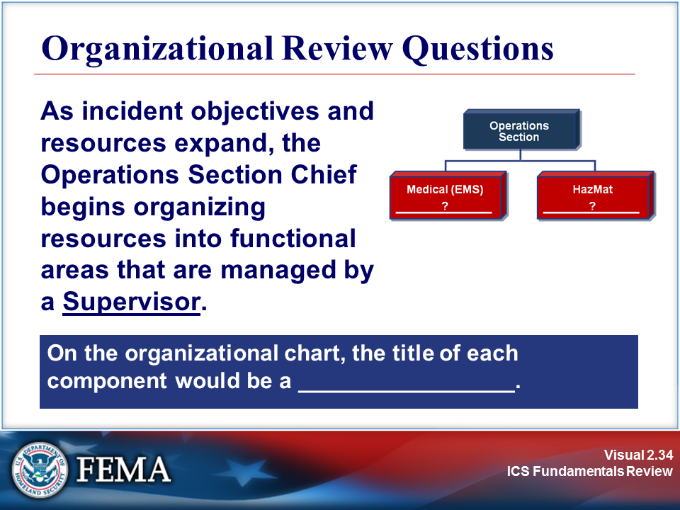 | 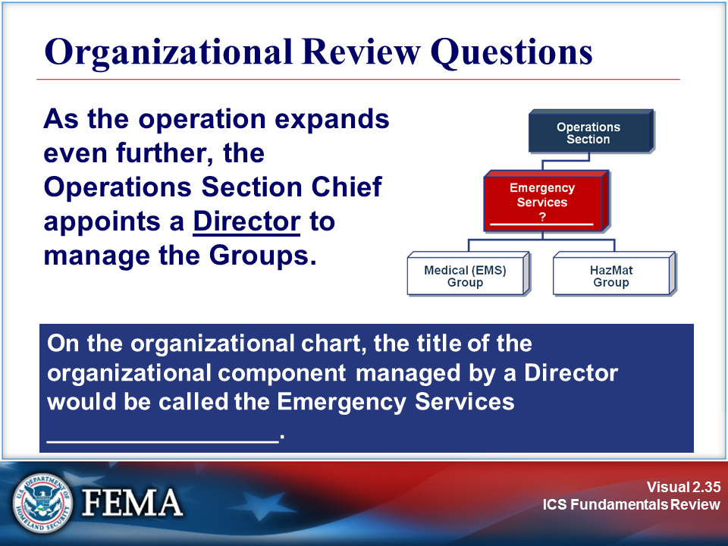
Your Notes

Visuals

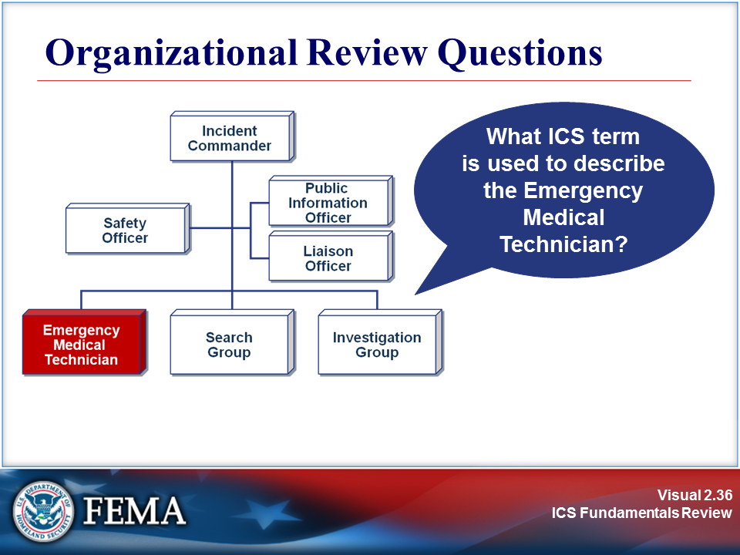 | 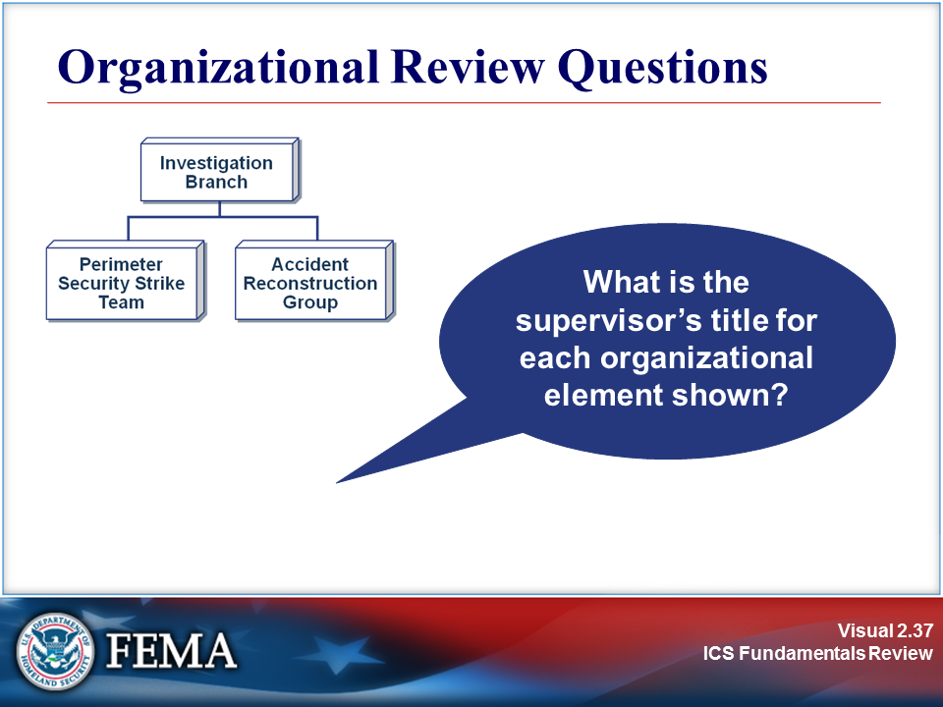
Your Notes

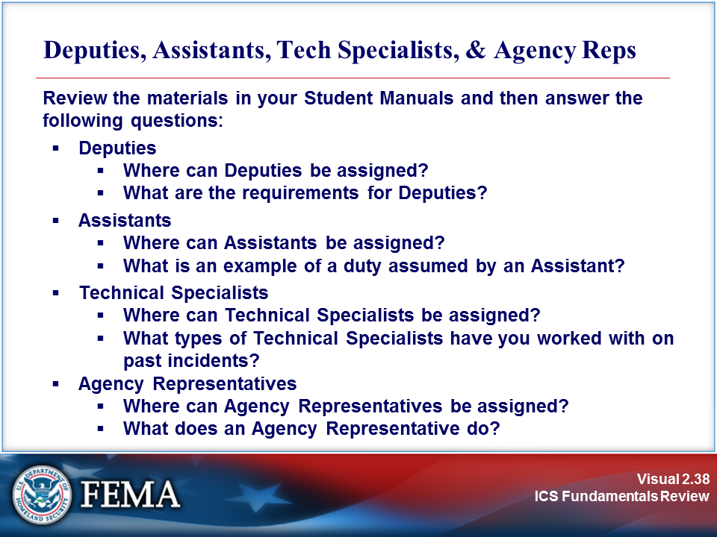 | View the job aid on the next page.
Your Notes

Job Aid: Deputies, Assistants, Tech Specialists, and Agency Reps

ICS Review Materials: Deputies, Assistants, Technical Specialists, and
Agency Representatives

Deputies

The Incident Commander may have one or more Deputies. An individual assuming a Deputy role must be equally capable of assuming the primary role. Therefore, a Deputy Incident Commander must be able to assume the Incident Commander's role.

Following are three reasons to designate Deputies:

- To perform specific tasks as requested by the Incident Commander.
- To perform the Incident Command function in a relief capacity (e.g., to take over the next operational period).
- To represent an assisting agency that may share jurisdiction or have jurisdiction in the future.

The Operations Section Chief, Planning Section Chief, Logistics Section Chief, Finance/Administration Section Chief, and Branch Directors may also have one or more Deputies.

Assistants

The Public Information Officer, Safety Officer, and Liaison Officer may have Assistants, as necessary. The Assistants may represent assisting agencies or jurisdictions, or simply assist in managing the workload associated with the position.

- Assistant Public Information Officers may be assigned to the field or Joint Information Center or assigned to handle internal information.
- Assistant Safety Officers may have specific responsibilities, such as aviation, hazardous materials, etc.
- Assistant Liaison Officers may coordinate with specific agency representatives or groups of representatives.

The Assistant title indicates a level of technical capability, qualification, and responsibility subordinate to the primary positions.

Job Aid: Deputies, Assistants, Tech Specialists, and Agency Reps (Continued)

Technical Specialists

Certain incidents or events may require the use of Technical Specialists who have specialized knowledge and expertise. Technical Specialists may function within the Planning Section, or be assigned wherever their services are required.

While each incident dictates the need for Technical Specialists, some examples of the more commonly used specialists are:
- Meteorologists.
- Environmental Impact Specialists.
- Flood Control Specialists.
- Water Use Specialists.
- Fuels and Flammable Materials Specialists.
- Hazardous Substance Specialists.
- Fire Behavior Specialists.
- Structural Engineers.
- Training Specialists.

Agency Representatives

An Agency Representative is an individual assigned to an incident from an assisting or cooperating agency. The Agency Representative must be given authority to make decisions on matters affecting that agency's participation at the incident.

Agency Representatives report to the Liaison Officer, or to the Incident Commander in the absence of a Liaison Officer.

Major responsibilities of the Agency Representative are to:
- Ensure that all of their agency resources have completed check-in at the incident.
- Obtain briefing from the Liaison Officer or Incident Commander.
- Inform their agency personnel on the incident that the Agency Representative position has been filled.
- Attend planning meetings as required.
- Provide input to the planning process on the use of agency resources, unless resource Technical Specialists are assigned from the agency.
- Cooperate fully with the Incident Commander and the Command and General Staffs on the agency's involvement at the incident.
- Oversee the well-being and safety of agency personnel assigned to the incident.
- Advise the Liaison Officer of any special agency needs, requirements, or agency restrictions.
- Report to agency dispatch or headquarters on a prearranged schedule.
- Ensure that all agency personnel and equipment are properly accounted for and released prior to departure.
- Ensure that all required agency forms, reports, and documents are complete prior to departure.
- Have a debriefing session with the Liaison Officer or Incident Commander prior to departure.

Job Aid: Deputies, Assistants, Tech Specialists, and Agency Reps (Continued)

Deputies
Where can Deputies be assigned?
What are the requirements for Deputies?

Assistants
Where can Assistants be assigned?
What is an example of a duty assumed by an Assistant?
Note: The Assistant title indicates a level of technical capability, qualification, and responsibility subordinate to the primary positions.

Technical Specialists
Where can Technical Specialists be assigned?

What types of Technical Specialists have you worked with on past incidents?

Agency Representatives
Where can Agency Representatives be assigned?

What does an Agency Representative do?

Visuals

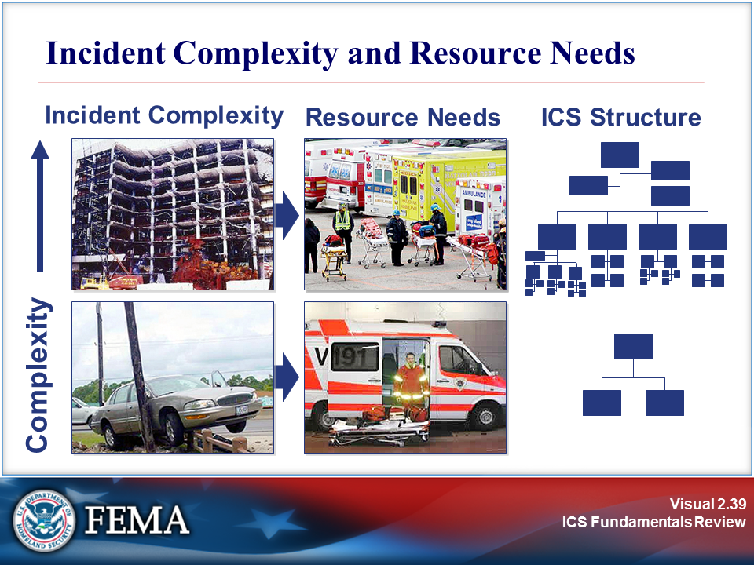 | 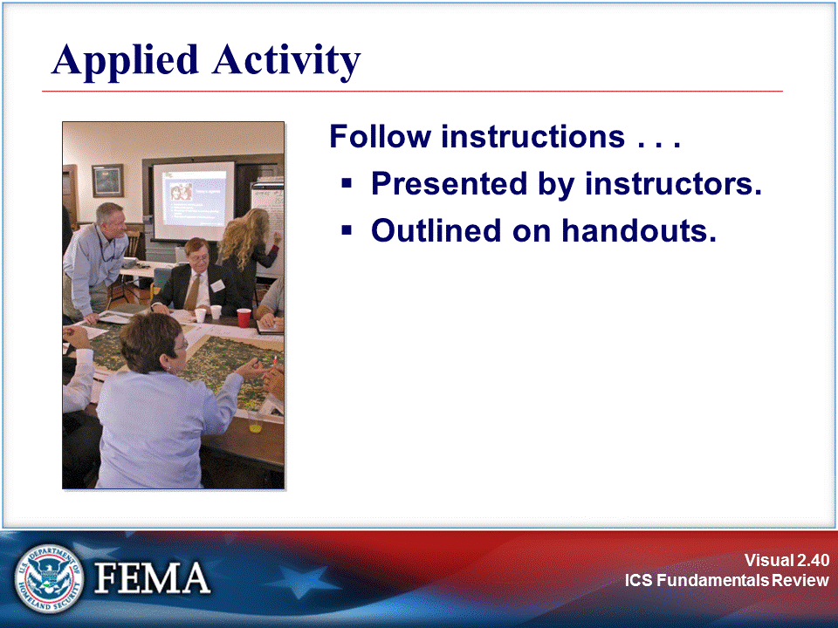
Your Notes

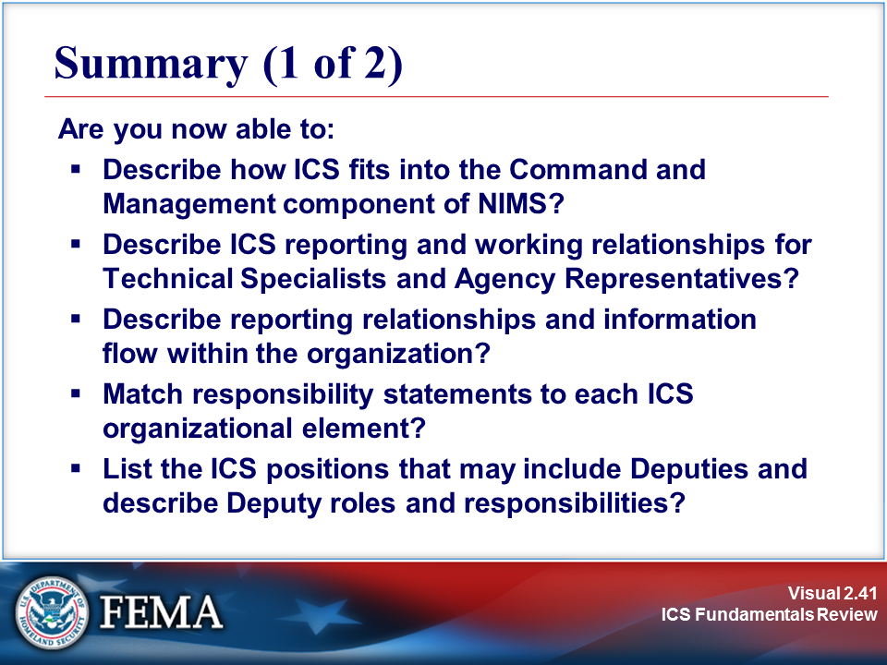 | 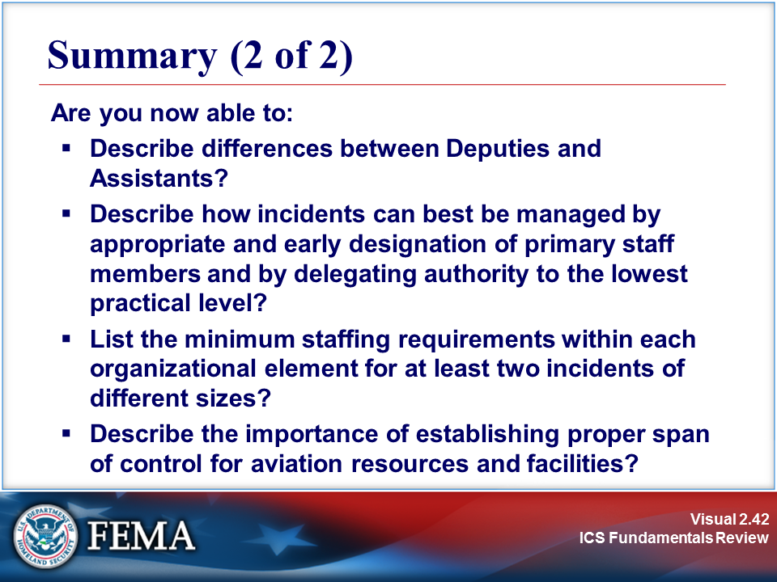
Your Notes

