Unit 3: Unified Command

This page intentionally left blank.

Visuals

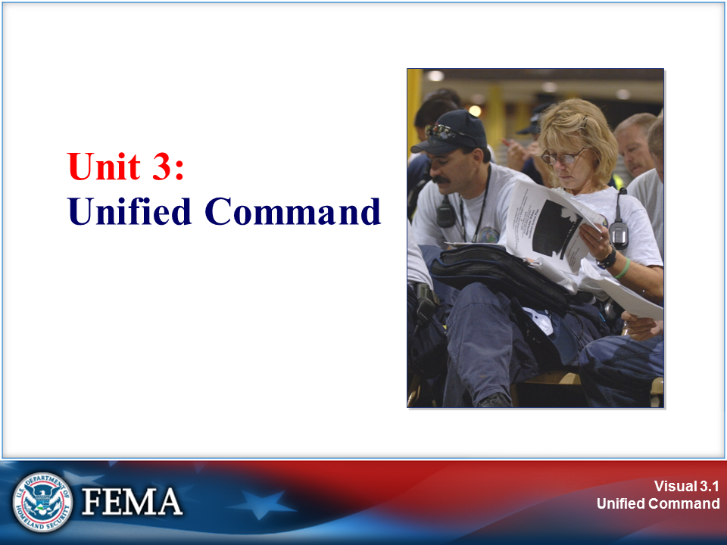 | 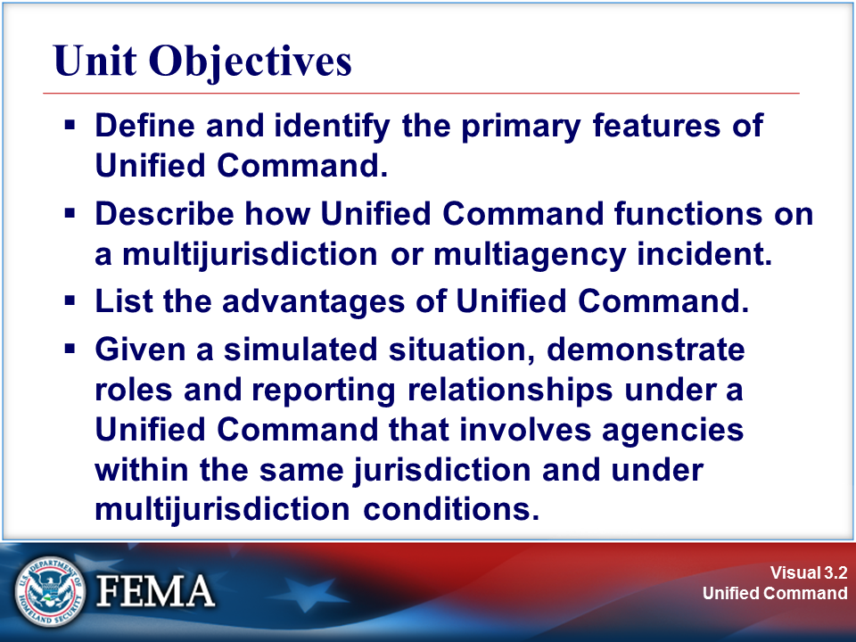
Your Notes

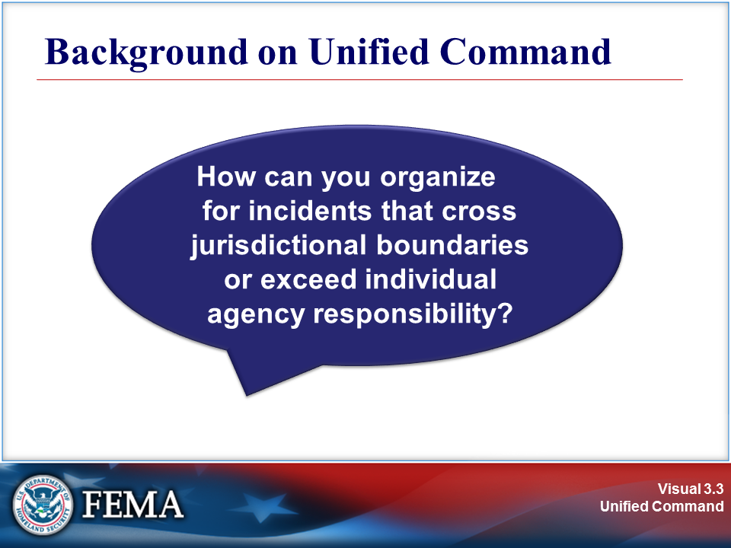 | 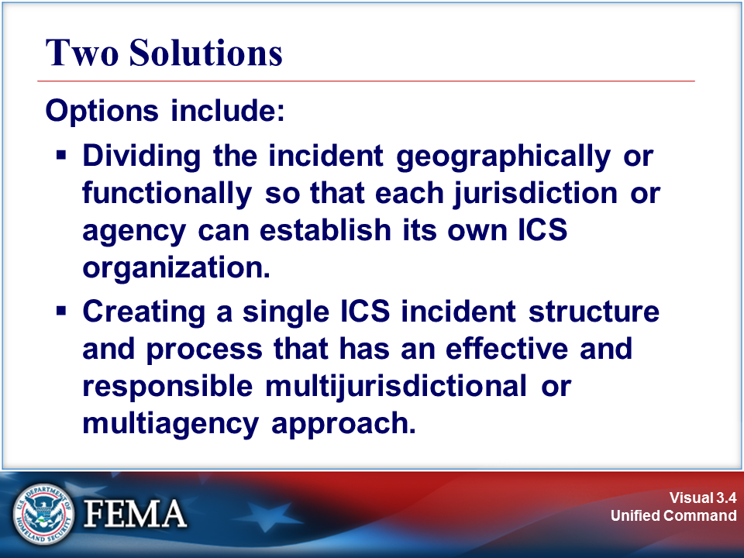
Your Notes

Visuals

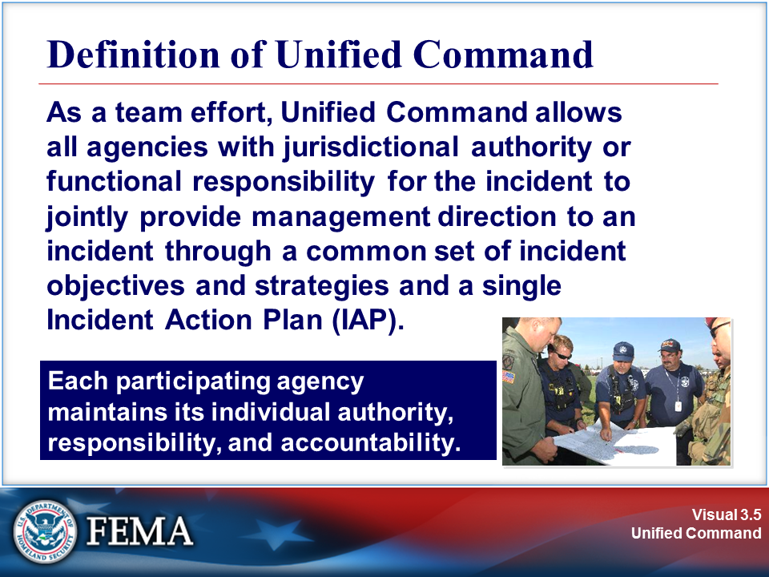 | 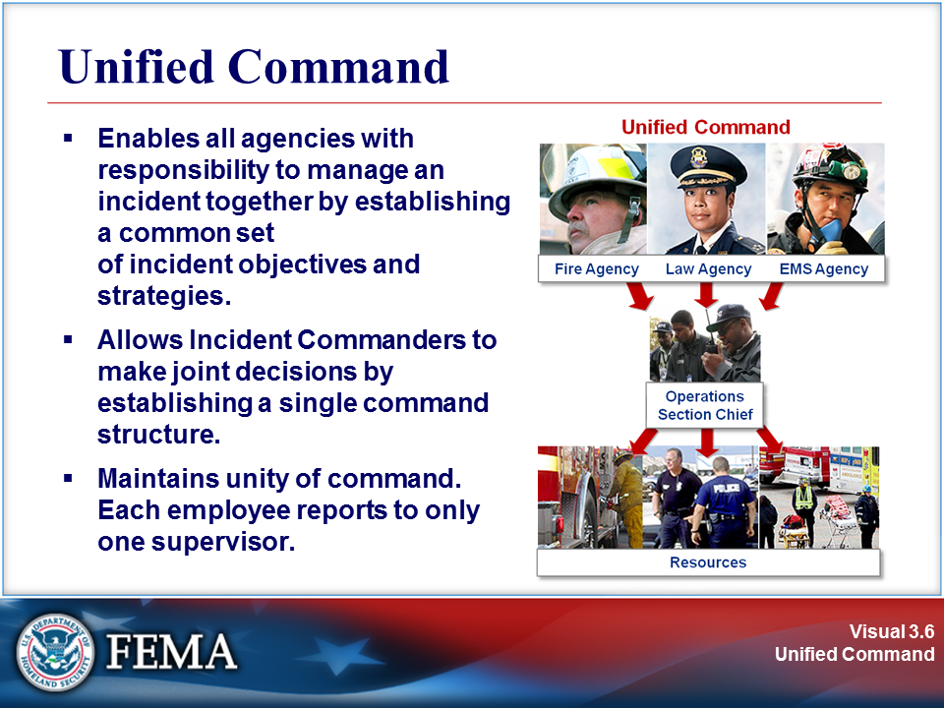
Your Notes

Review the job aid on the next page.

Job Aid: Unified Command

Comparison of a Single Incident Commander and Unified Command

Single Incident Commander | Unified Command
The Incident Commander is solely responsible (within the confines of his or her authority) for establishing incident objectives and strategies.  The Incident Commander is directly responsible for ensuring that all functional area activities are directed toward accomplishment of the strategy. | The individuals designated by their jurisdictional or organizational authorities (or by departments within a single jurisdiction) must jointly determine objectives, strategies, plans, resource allocations, and priorities and work together to execute integrated incident operations and maximize the use of assigned resources.

Source: NIMS

Visuals

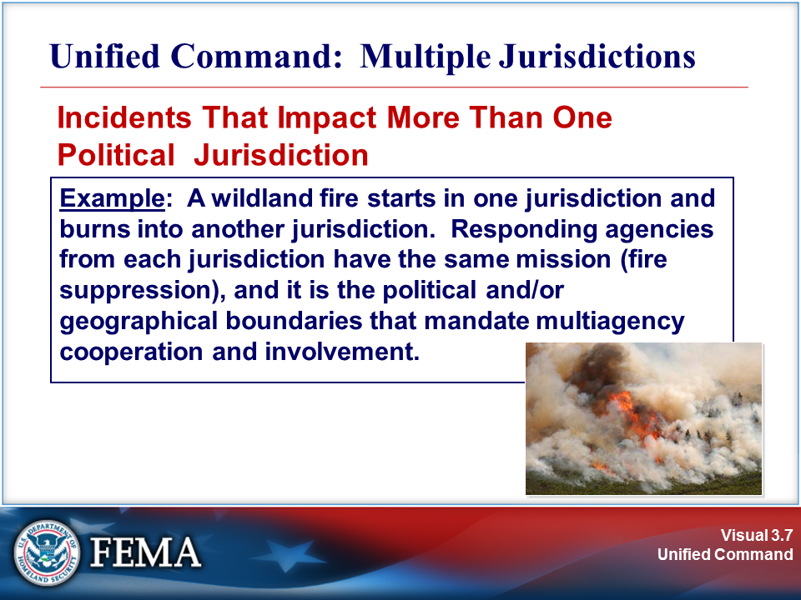 | 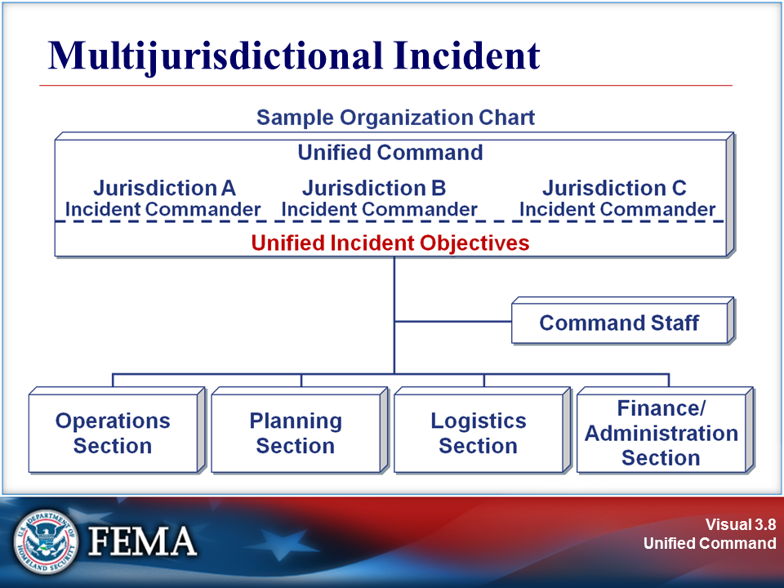
Your Notes

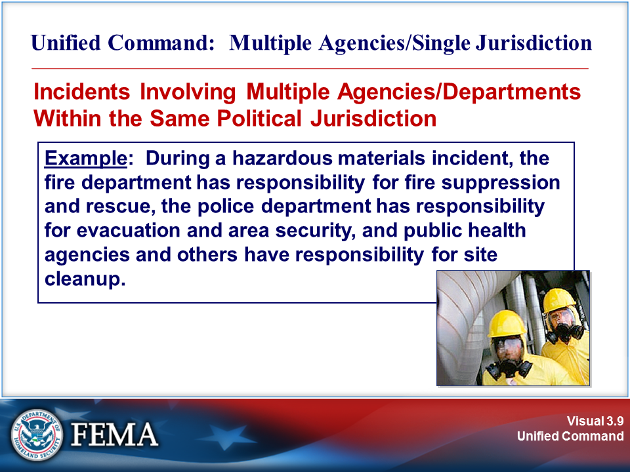 | 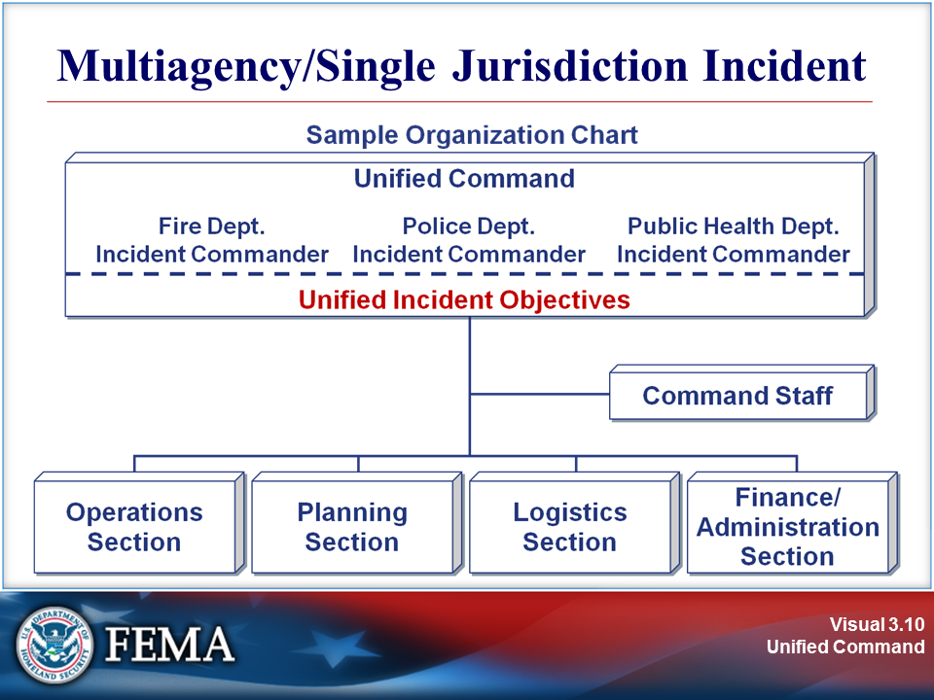
Your Notes

Visuals

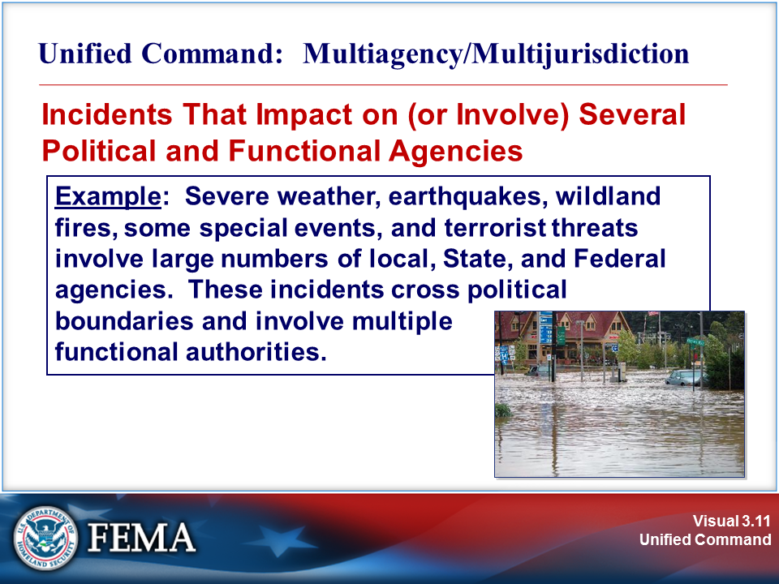 | 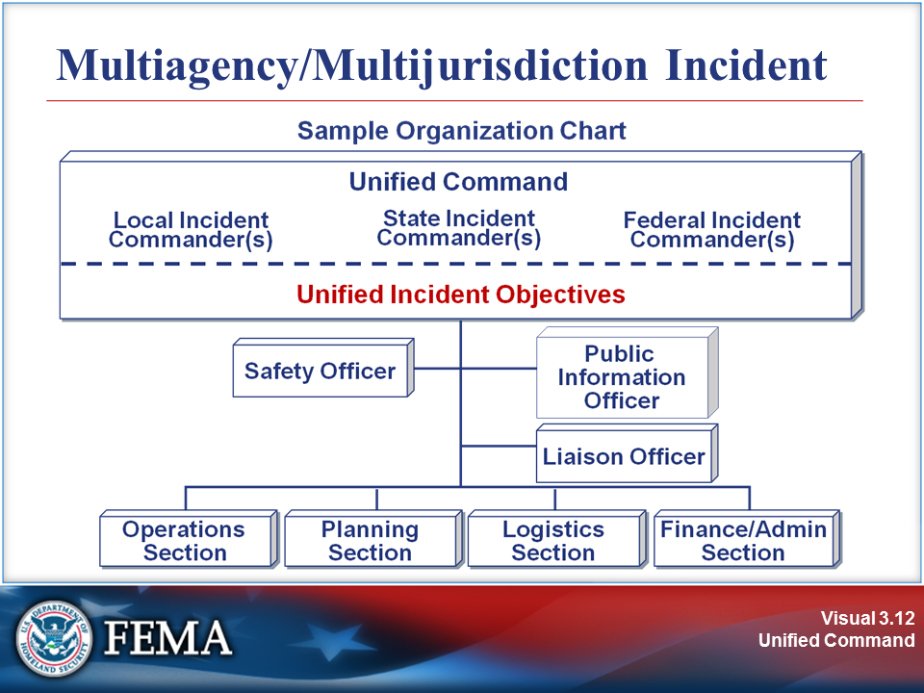
Your Notes

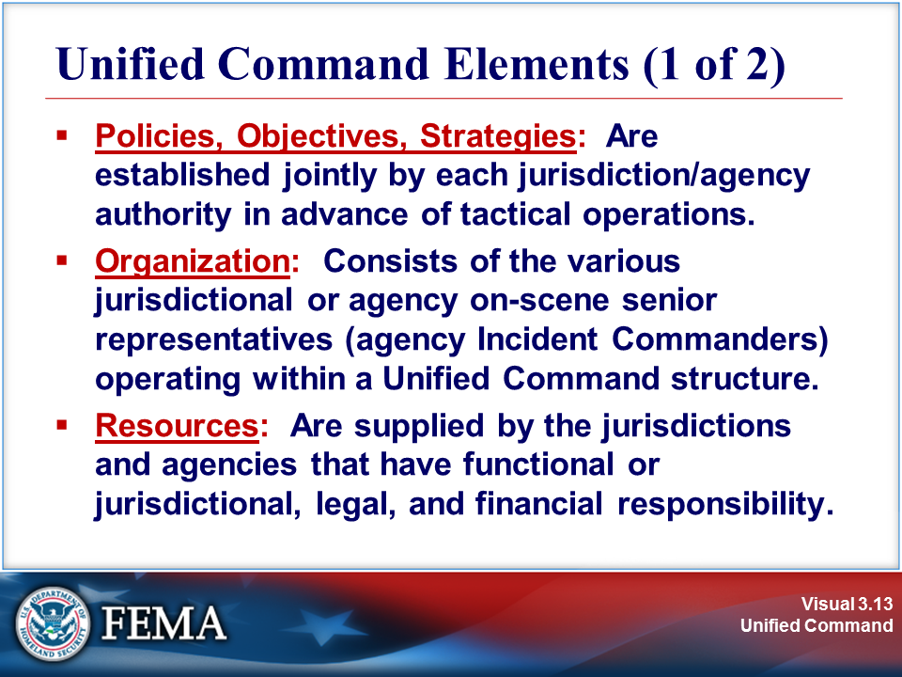 | 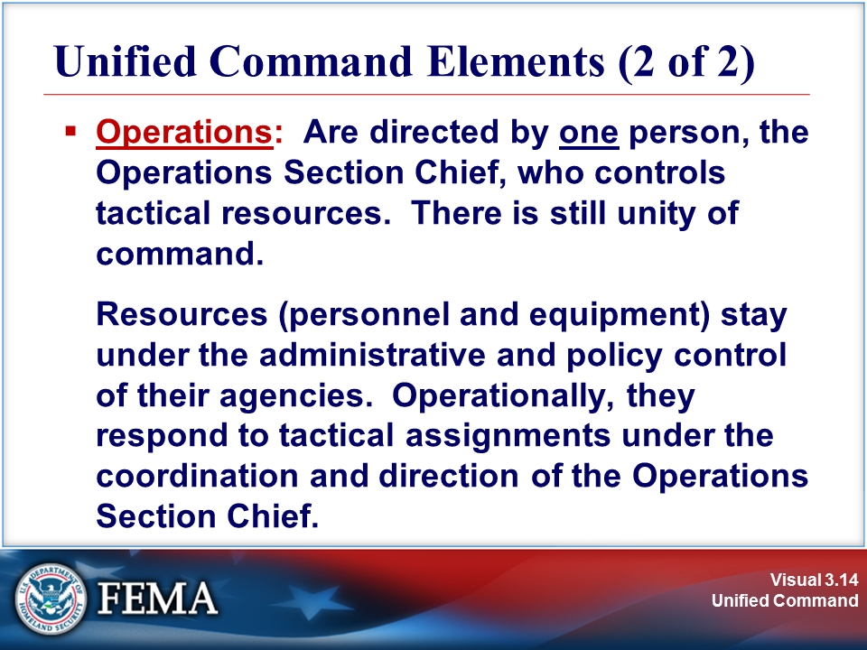
Your Notes

Visuals

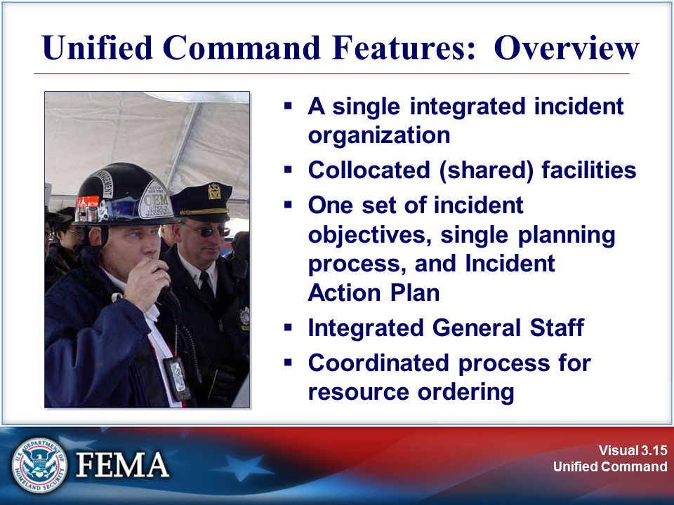 | 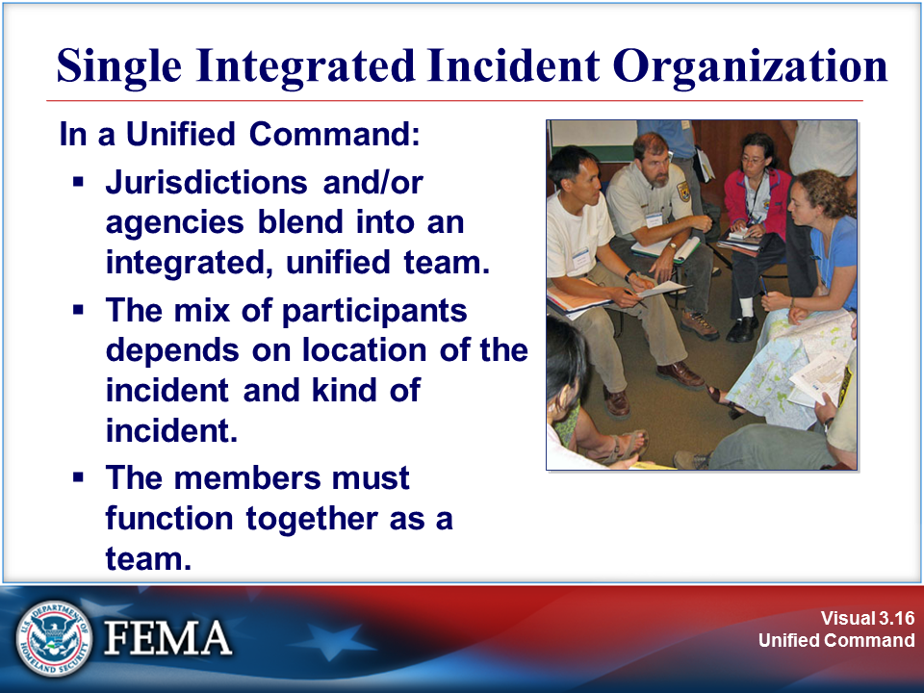
Your Notes

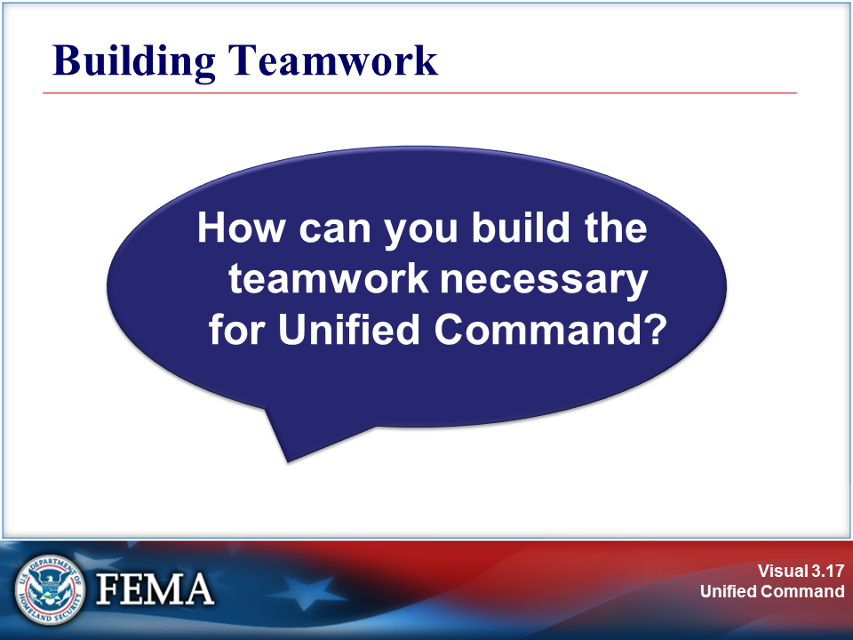 | 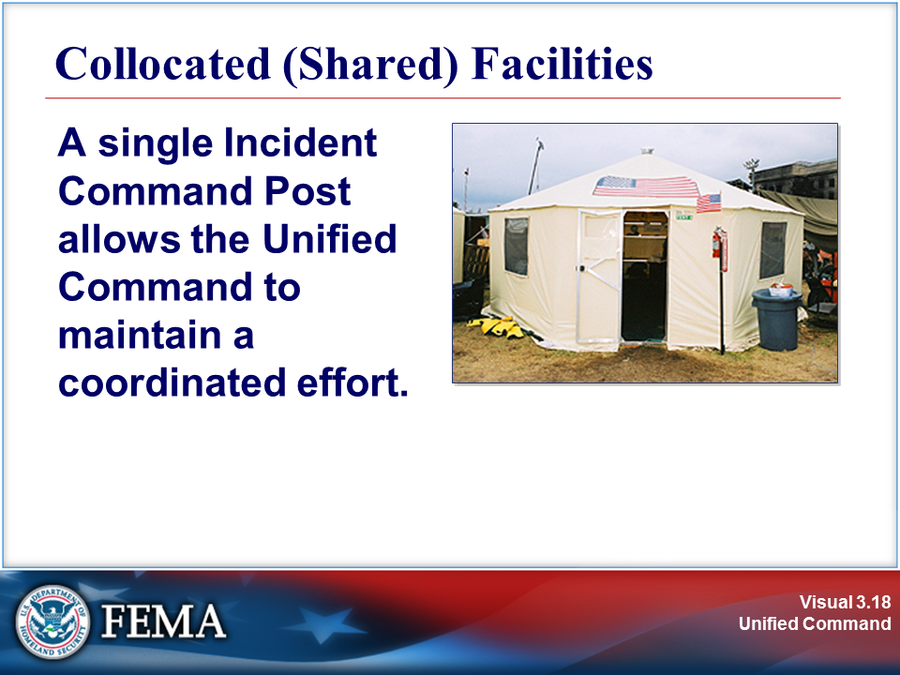
Your Notes

Visuals

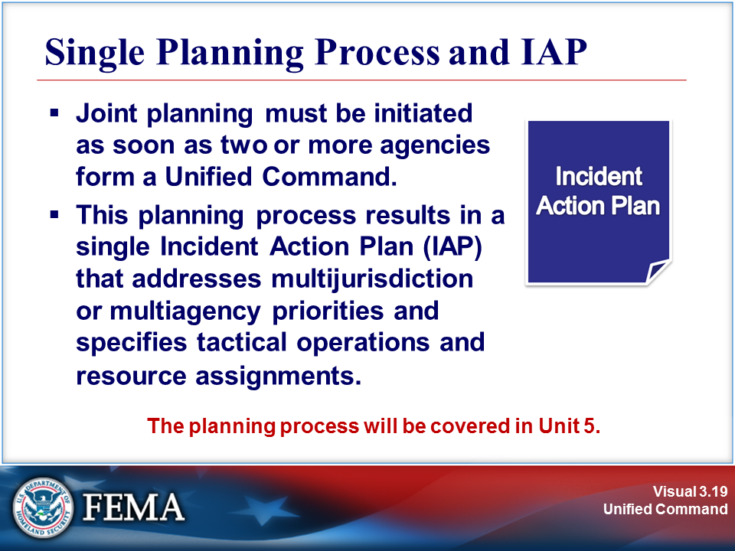 | 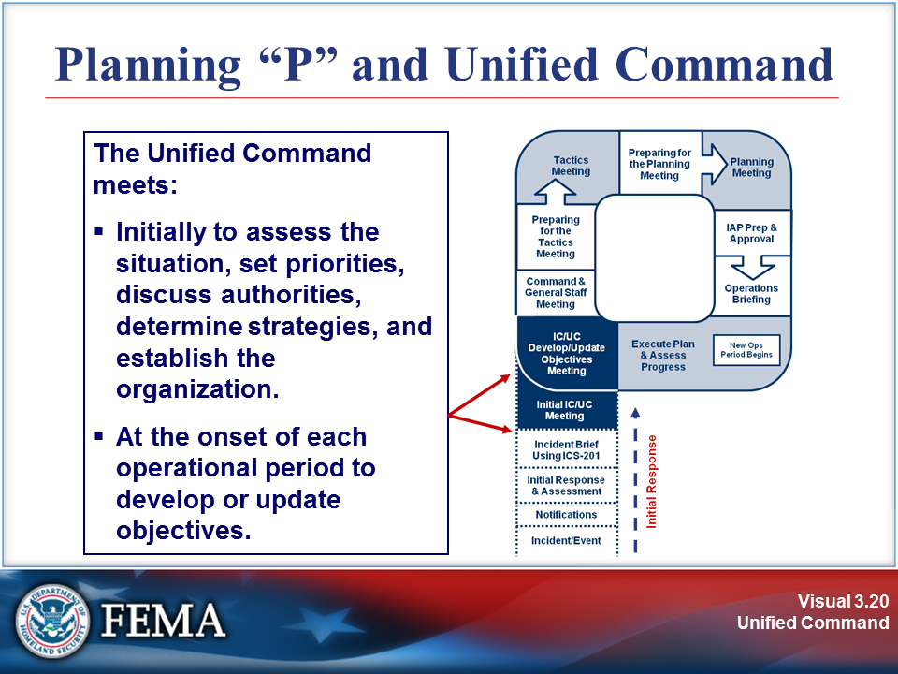
Your Notes

Review the job aid on the next page.

Job Aid: Planning “P” and Unified Command

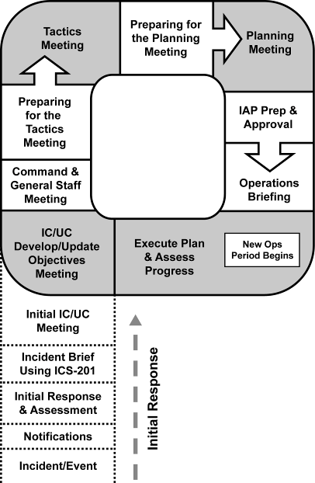

- The leg of the “P” describes the initial response period: Once the incident/event begins, the steps are Notifications, Initial Response & Assessment, Incident Briefing using ICS-201, and Initial Incident Command (IC)/Unified Command (UC) Meeting.
- At the top of the leg of the “P” is the beginning of the first operational planning period cycle. In this circular sequence, the steps are IC/UC Develop/Update Objectives Meeting, Command and General Staff Meeting, Preparing for the Tactics Meeting, Tactics Meeting, Preparing for the Planning Meeting, Planning Meeting, IAP Prep & Approval, and Operations Briefing.
- At this point a new operational period begins. The next step is Execute Plan & Assess Progress, after which the cycle begins again.

Visuals

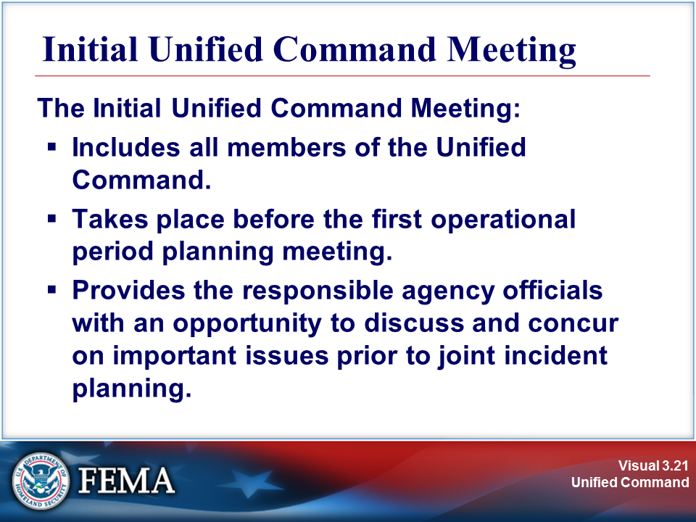 | View the sample agenda on the next page.
Your Notes

Sample: Initial Unified Command Meeting Agenda

- Statement of specific jurisdictional/agency goals, based on the following overarching priorities:
  - #1: Life Safety
  - #2: Incident Stabilization
  - #3: Property Preservation
- Presentation of jurisdictional limitations, concerns, and restrictions
- Development of a collective set of incident objectives
- Establishment of and agreement on acceptable priorities
- Adoption of an overall strategy or strategies to accomplish objectives
- Agreement on the basic organization structure
- Designation of the best qualified and acceptable Operations Section Chief
- Agreement on General Staff personnel designations
- Agreement on planning, logistical, and finance agreements and procedures
- Agreement on the resource ordering process to be followed
- Agreement on cost-sharing procedures
- Agreement on informational matters
- Designation of one agency official to act as the Unified Command spokesperson

Visuals

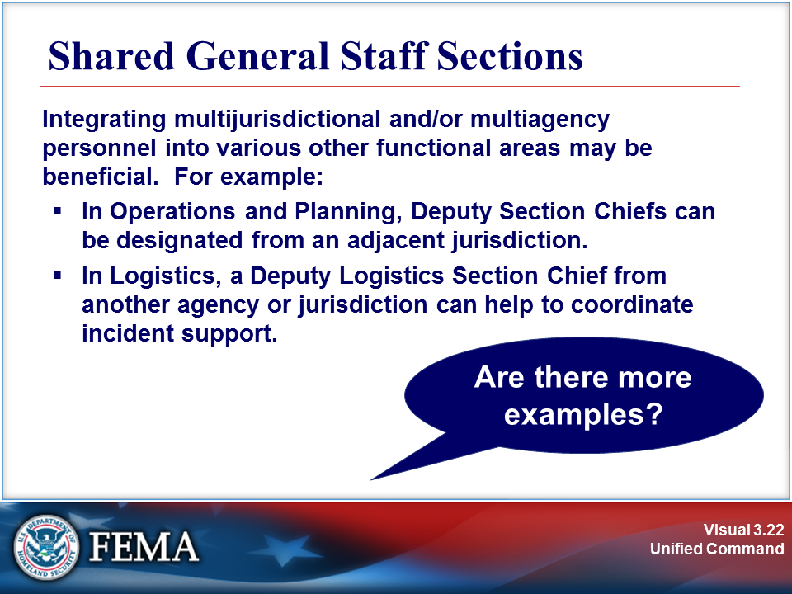 | 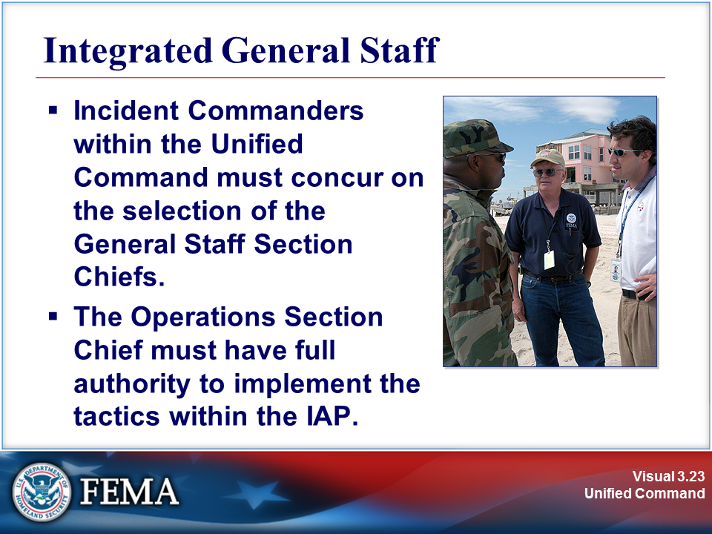
Your Notes

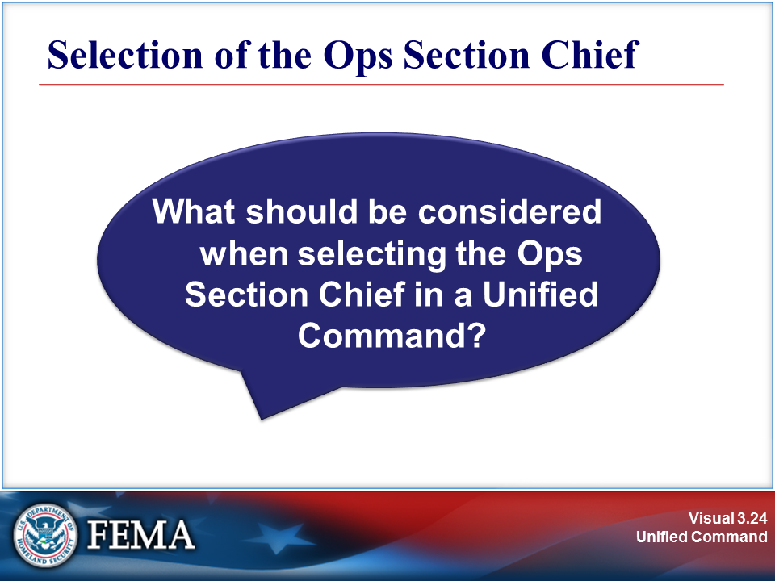 | 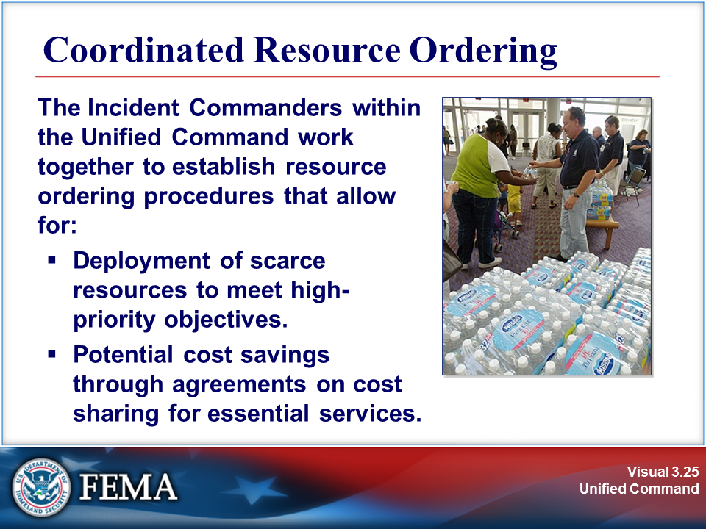
Your Notes

Visuals

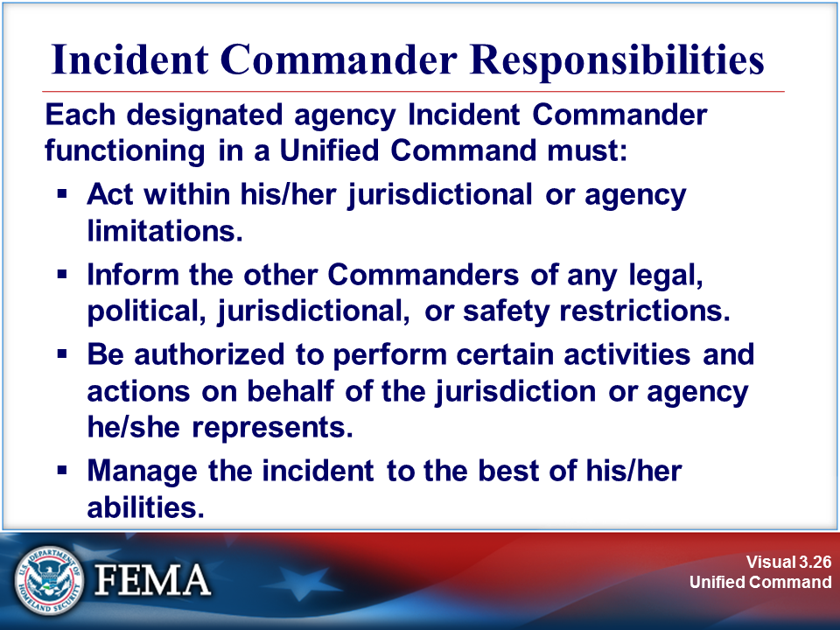 | 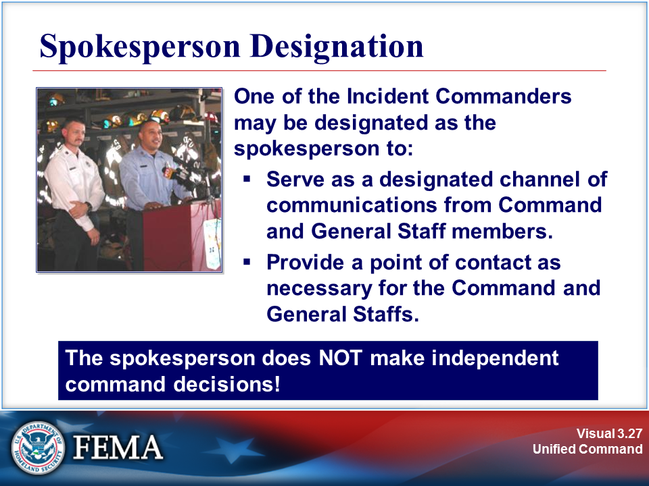
Your Notes

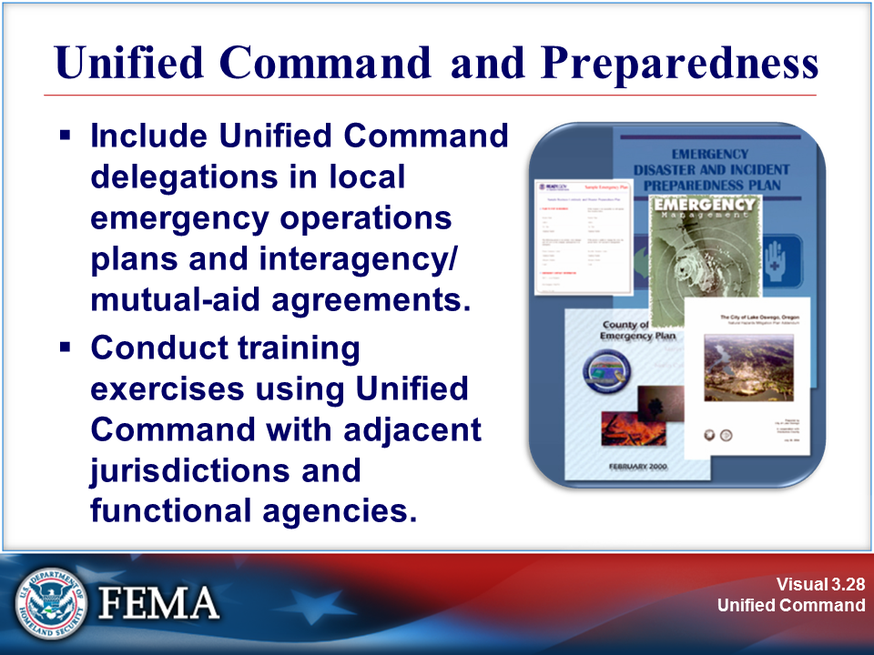 | 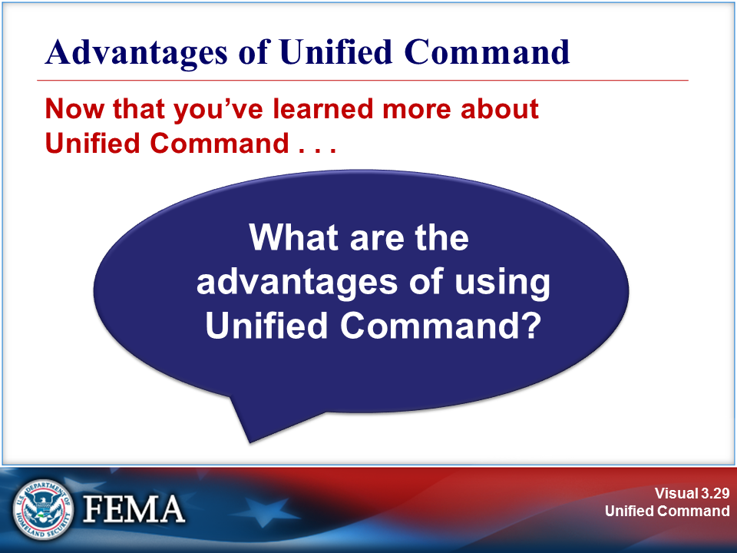
Your Notes

Visuals

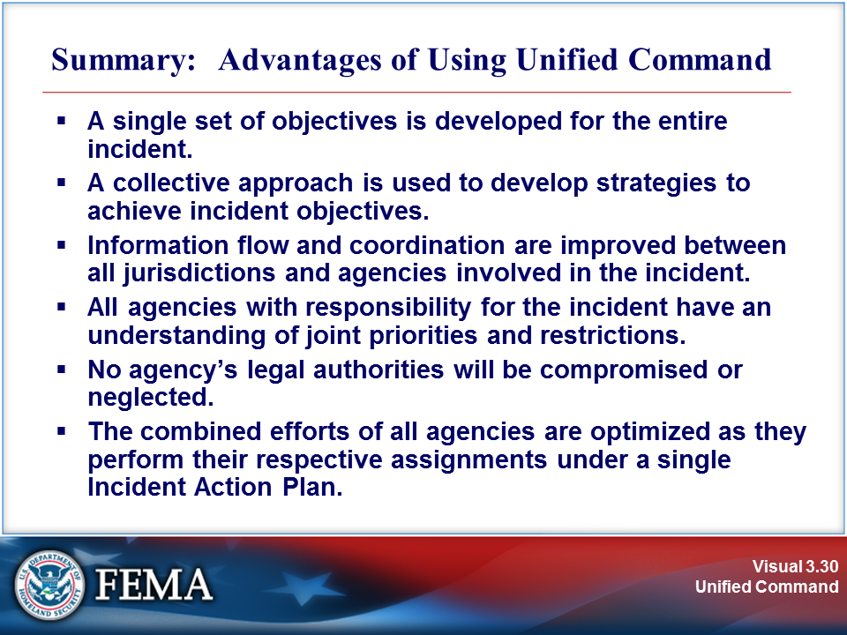 | 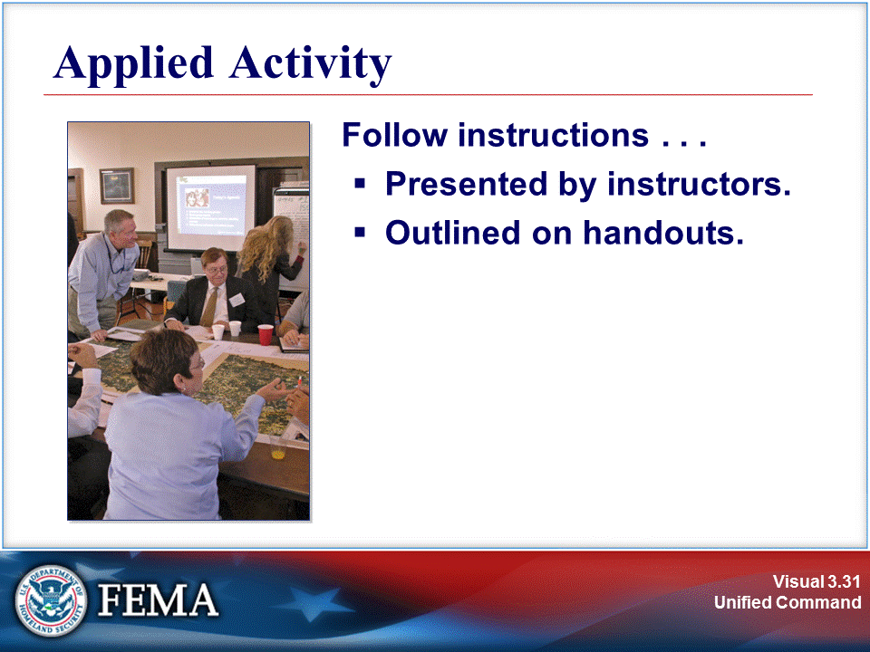
Your Notes

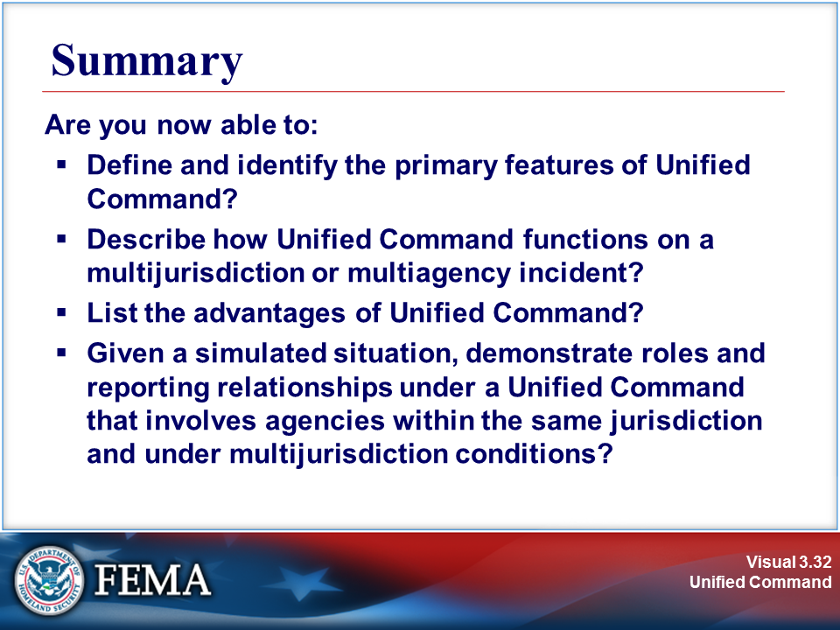
Your Notes

Your Notes

