Unit 4: Incident/Event Assessment & Agency Guidance in Establishing Incident Objectives

This page intentionally left blank.

Visuals

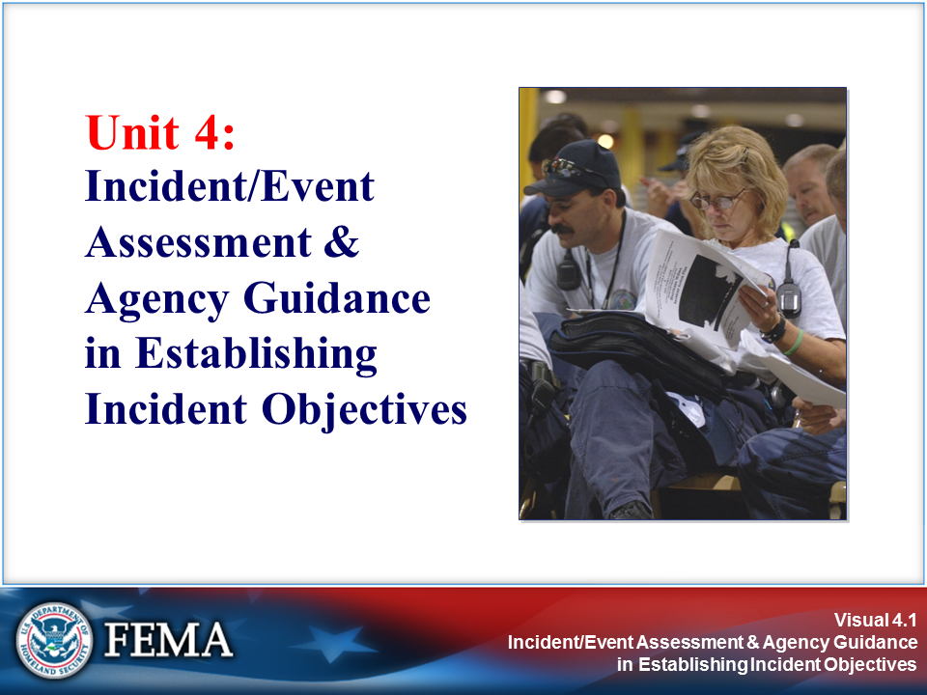 | 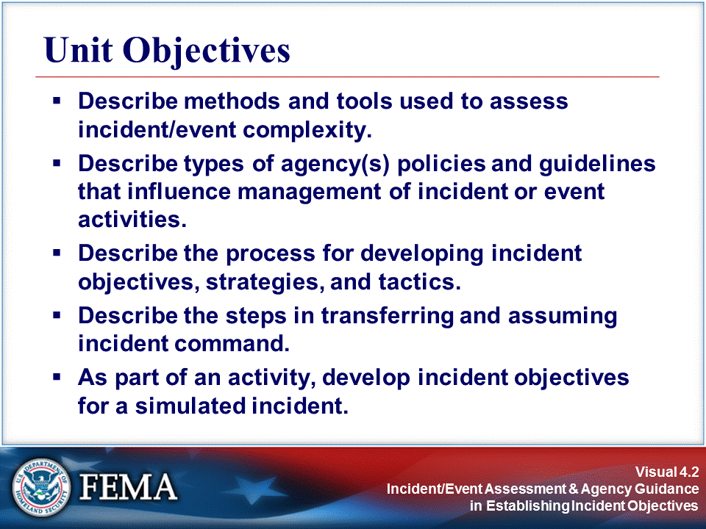
Your Notes

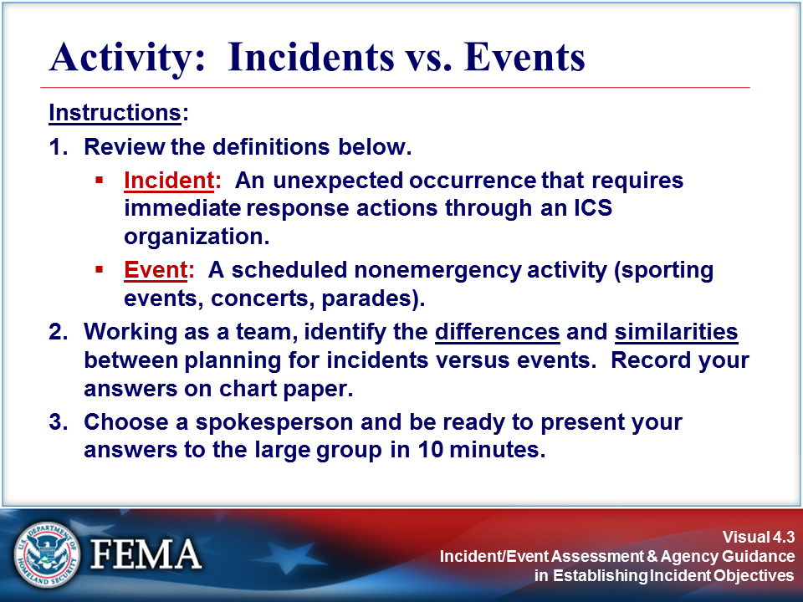 | 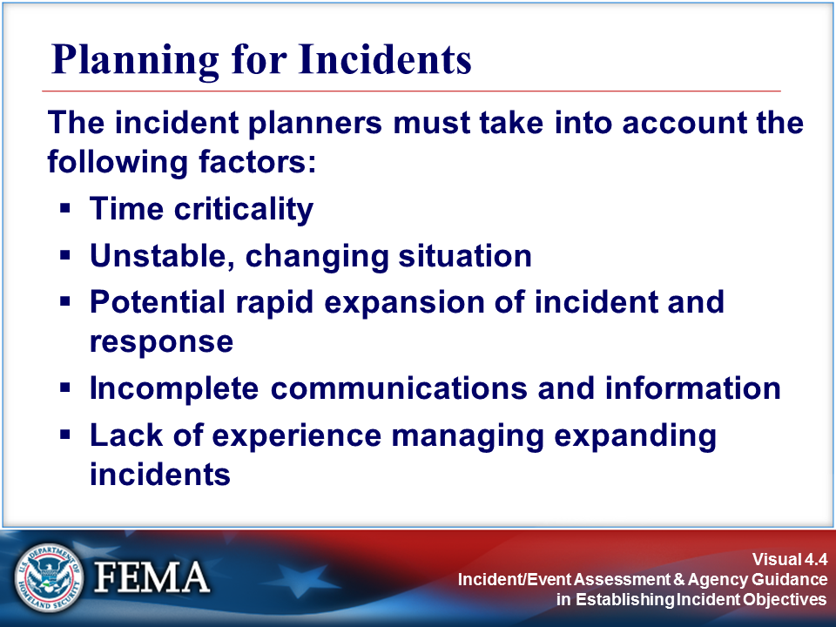
Your Notes

Visuals

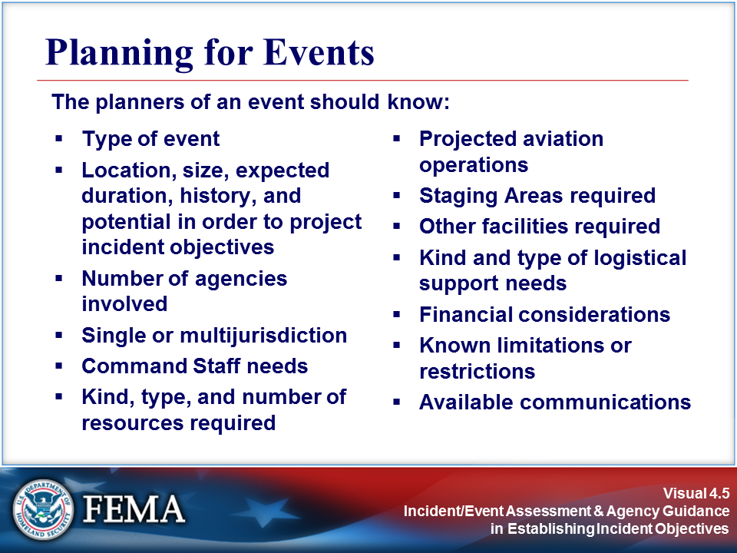 | 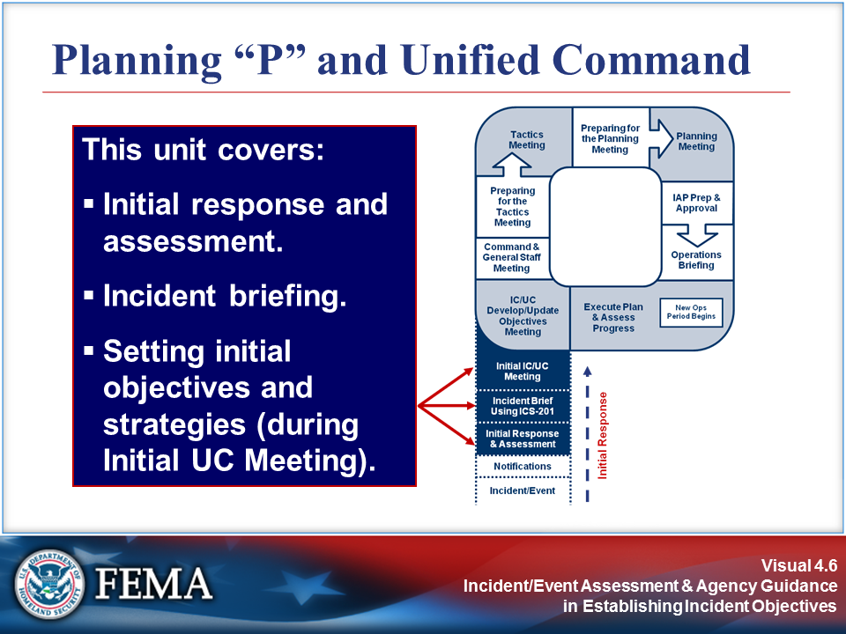
Your Notes

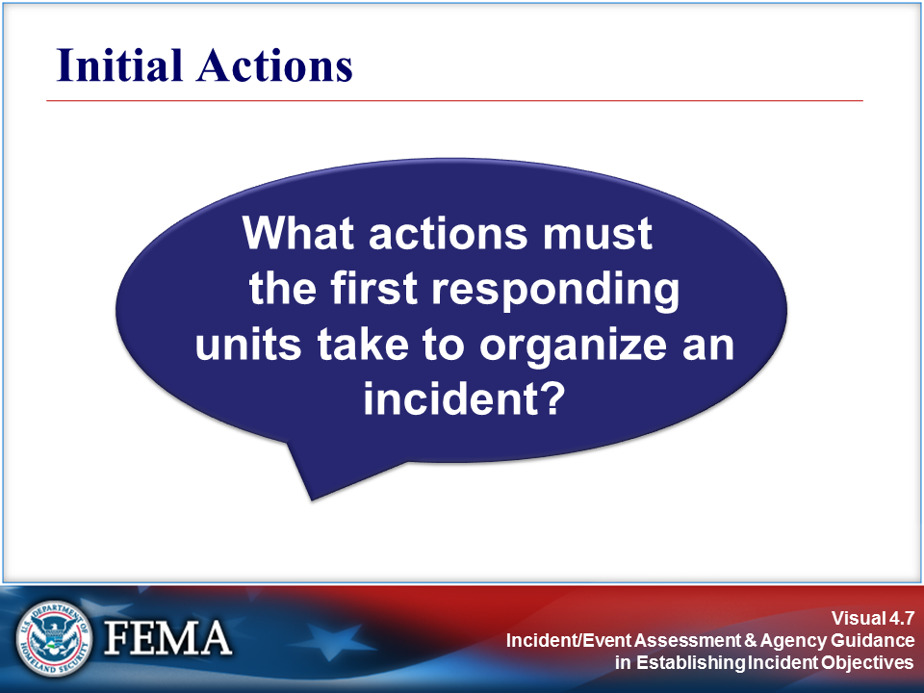 | 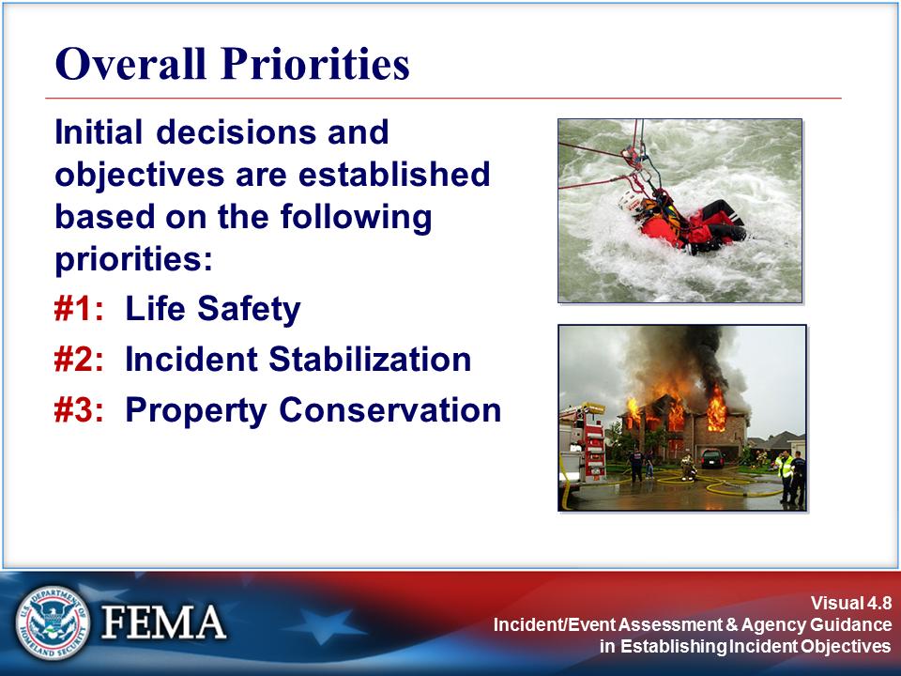
Your Notes

Visuals

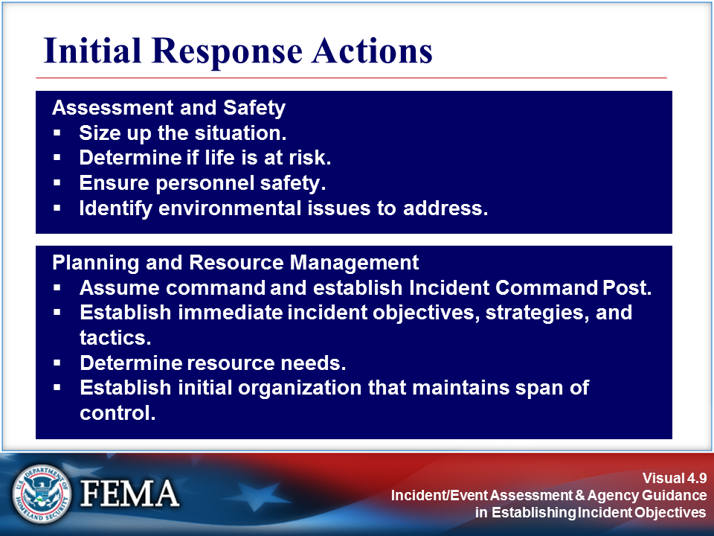 | Review the job aid on the following page.
Your Notes

Job Aid: Initial Response Actions

For any incident, the person currently in charge (Incident Commander) must do at least the following:

- Size up the situation. A thorough sizeup will provide the Incident Commander with the information needed to make initial management decisions.

- Determine if life is at immediate risk.

- Ensure that personnel safety factors are taken into account.

- Determine if there are any environmental issues that need to be addressed. For example, will a hazardous materials spill affect a nearby lake or stream? Is there a toxic plume that requires evacuation?

- Assume command and establish the Incident Command Post.

- Establish immediate incident objectives, strategies, and tactics. The sizeup should provide information about what needs to be done first to prevent loss of life or injury and to stabilize the situation. For small incidents, the initial Incident Action Plan (IAP) may be verbal and may cover the entire incident. For larger, more complex incidents, the initial IAP may cover the initial operating period. A written IAP will then be developed.

- Determine if there are enough resources of the right kind and type on scene or ordered. The incident objectives will drive resource requirements. What resources are required to accomplish the immediate incident objectives? If the right kind and type of resources are not on scene, the Incident Commander must order them immediately.

- Establish the initial organization that maintains span of control. At this point, the Incident Commander should ask: What organization will be required to execute the IAP and achieve the objectives? He or she should establish that organization, always keeping in mind safety and span-of-control concerns. Consider if span of control is or will soon approach practical limits. The span of control range of three to seven is to ensure safe and efficient utilization of resources.

Ordering an Incident Management Team (IMT) may be necessary depending on the size or complexity of the incident, or existing policies and laws. Many local organizations are not equipped to manage a type 3 incident, so when a sizeup reveals that additional IMT support may be required, it should be requested as soon as possible.

Visuals

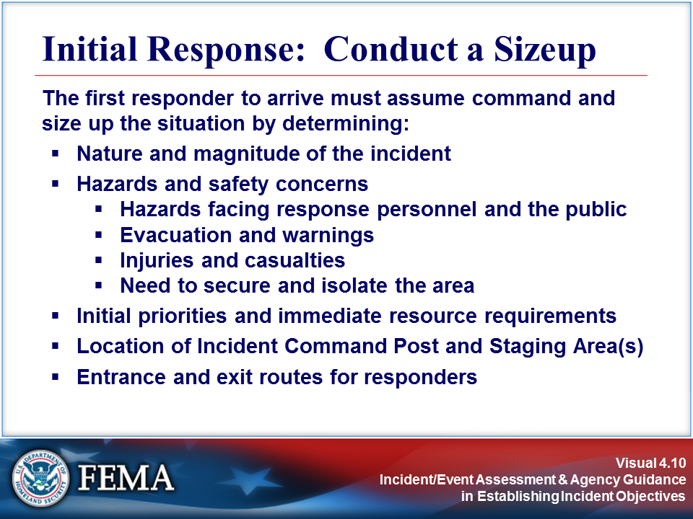 | 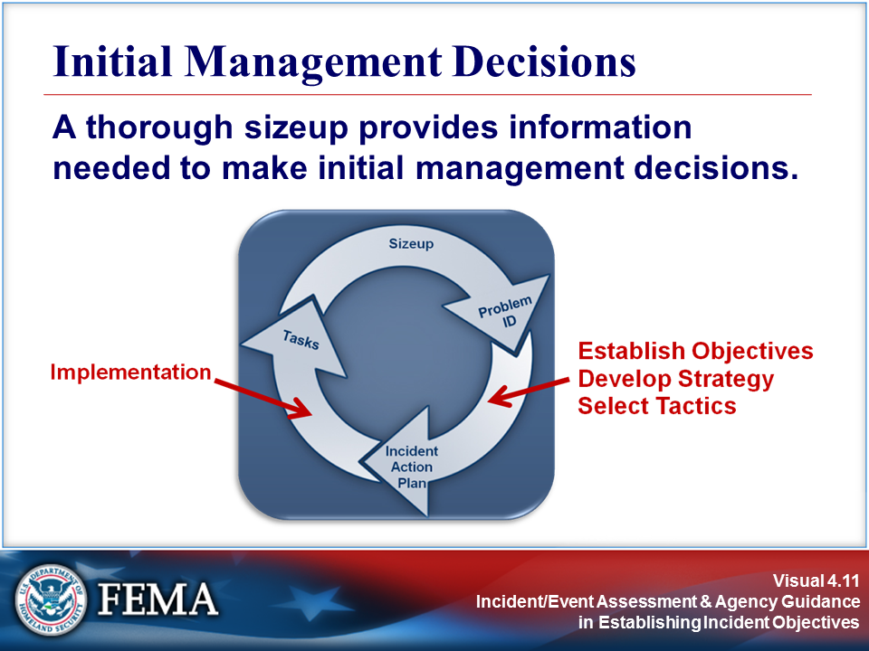
Your Notes

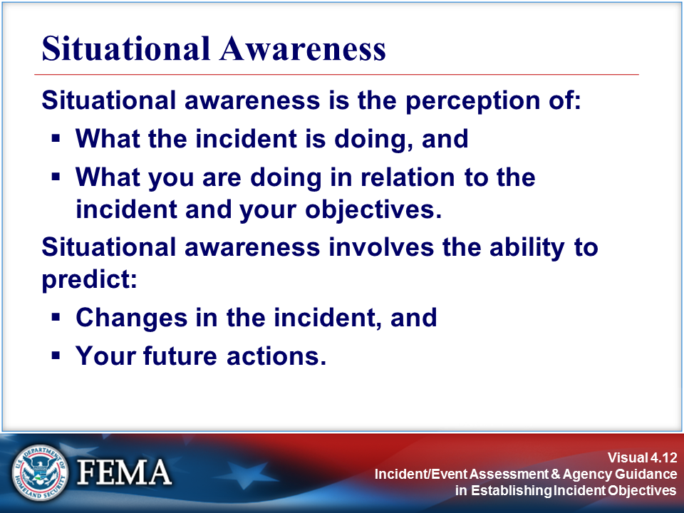 | 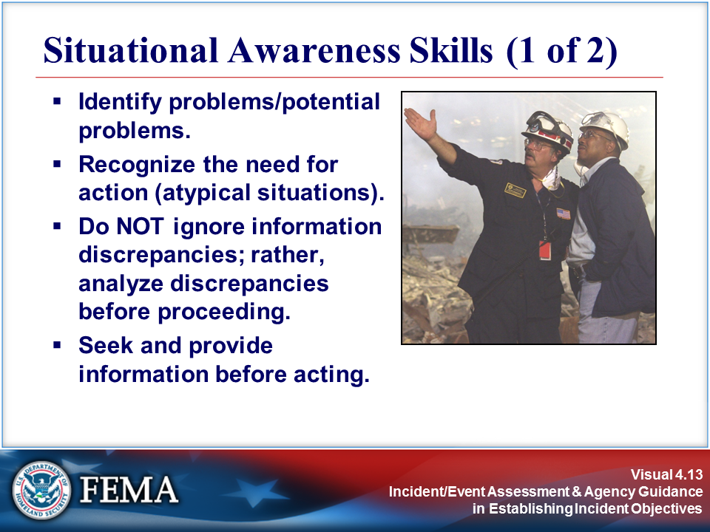
Your Notes

Visuals

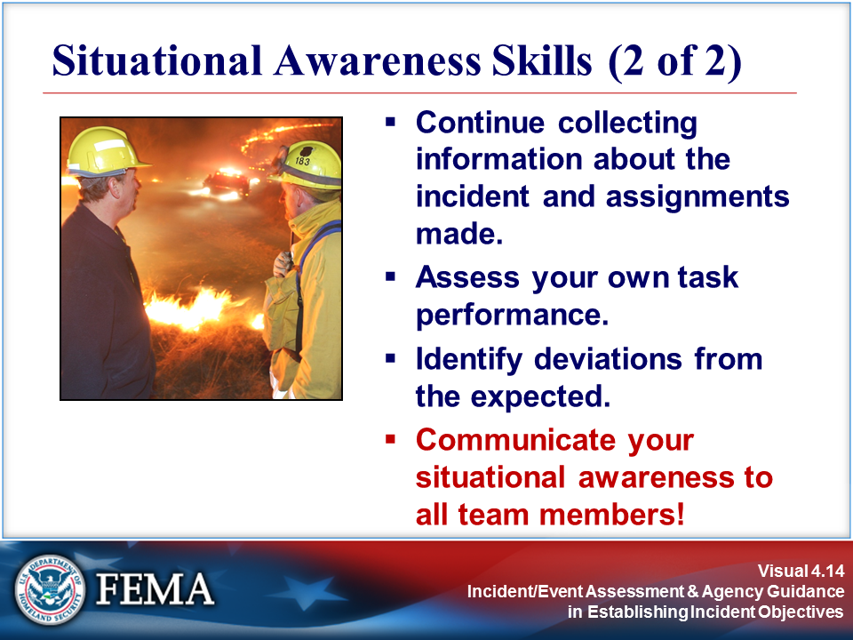 | 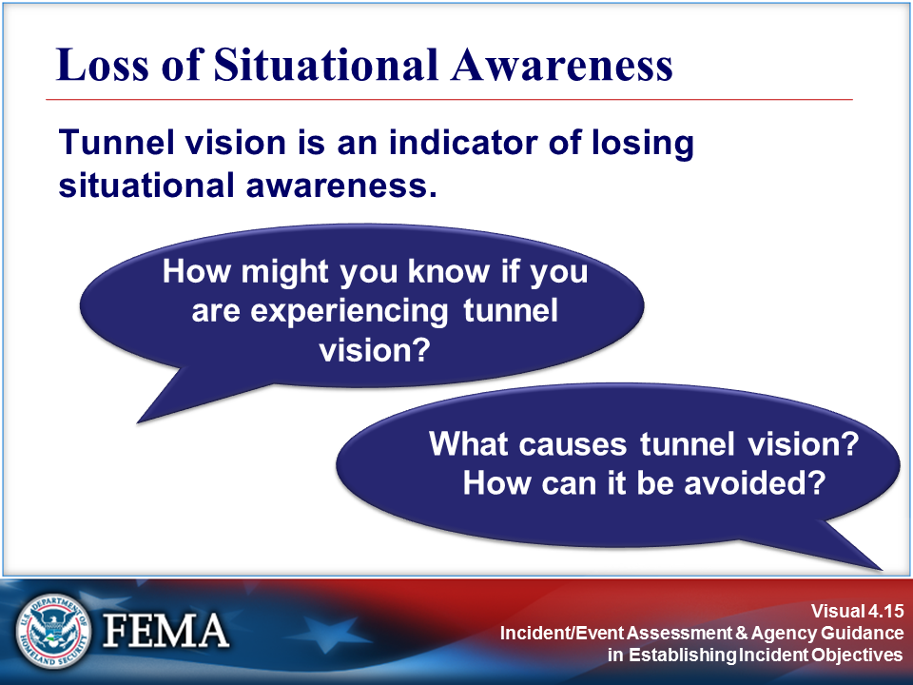
Your Notes

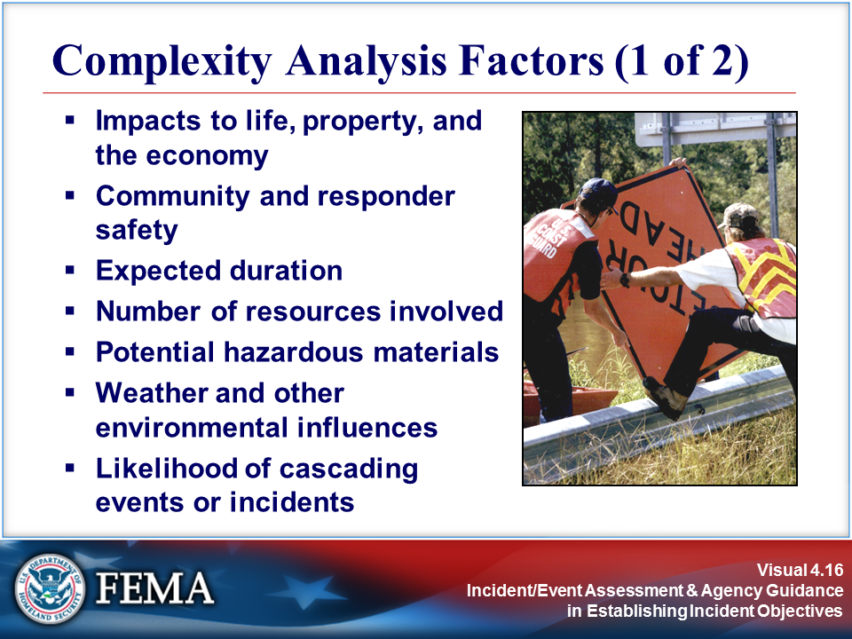 | 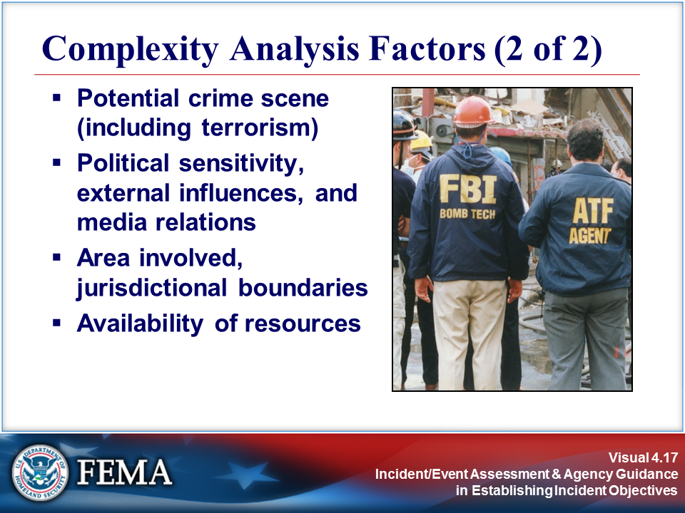
Your Notes

Visuals

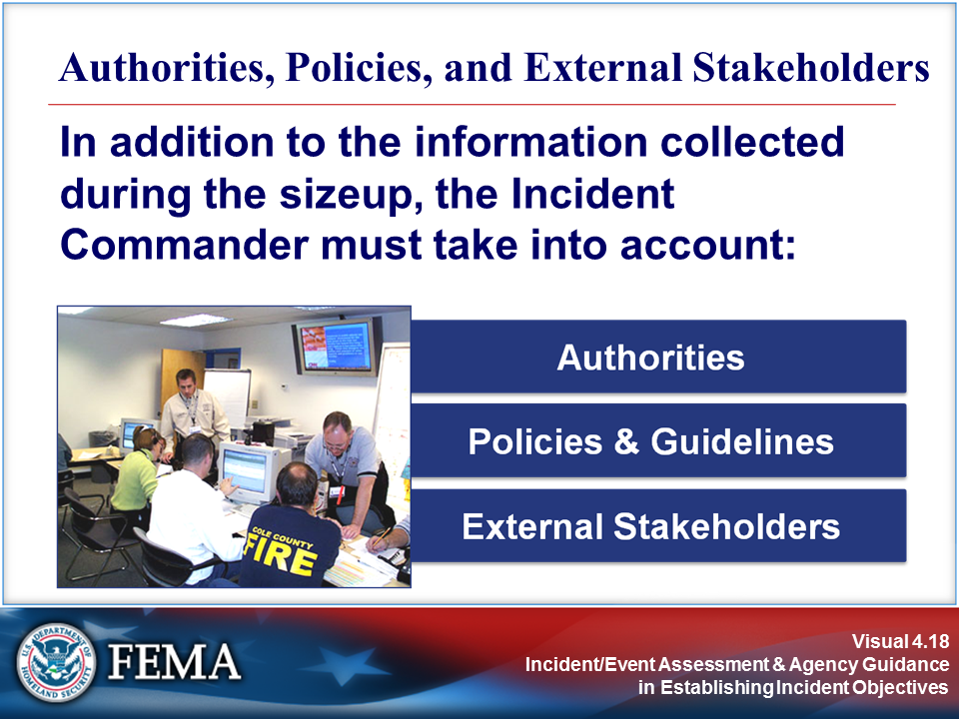 | 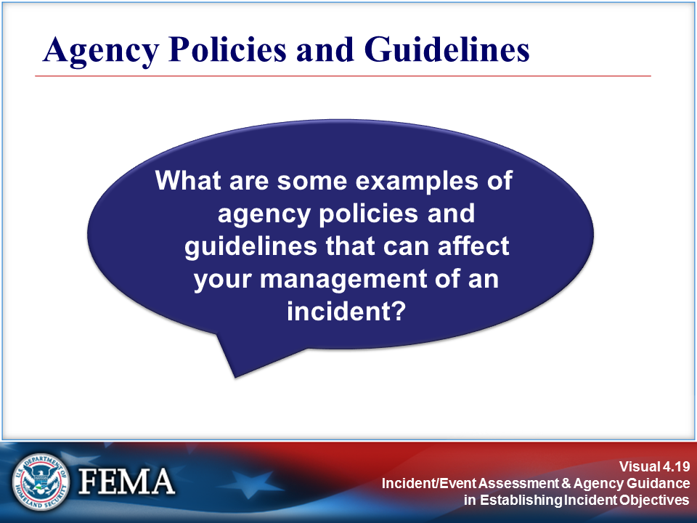
Your Notes

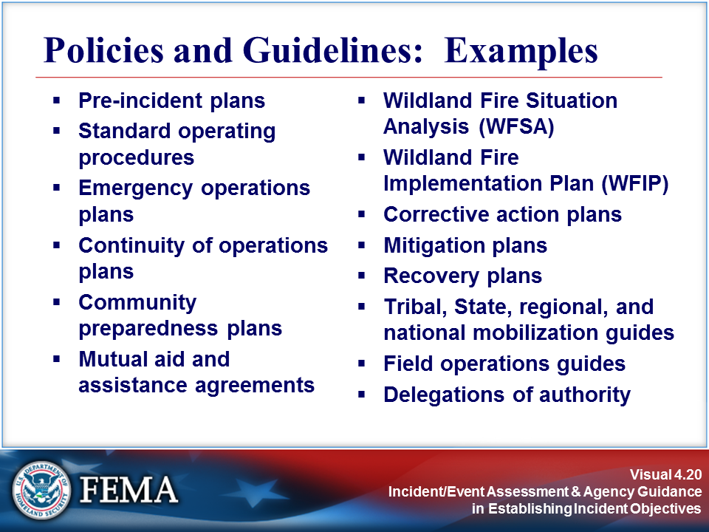 | 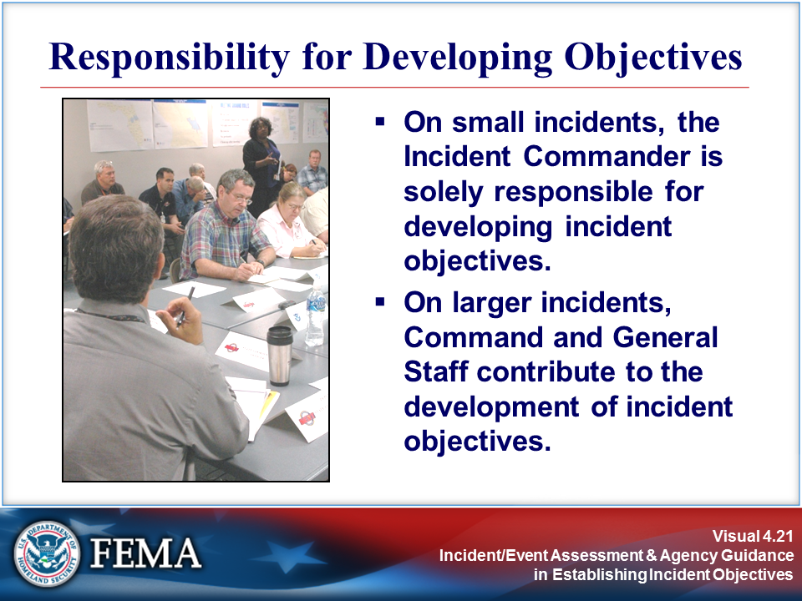
Your Notes

Visuals

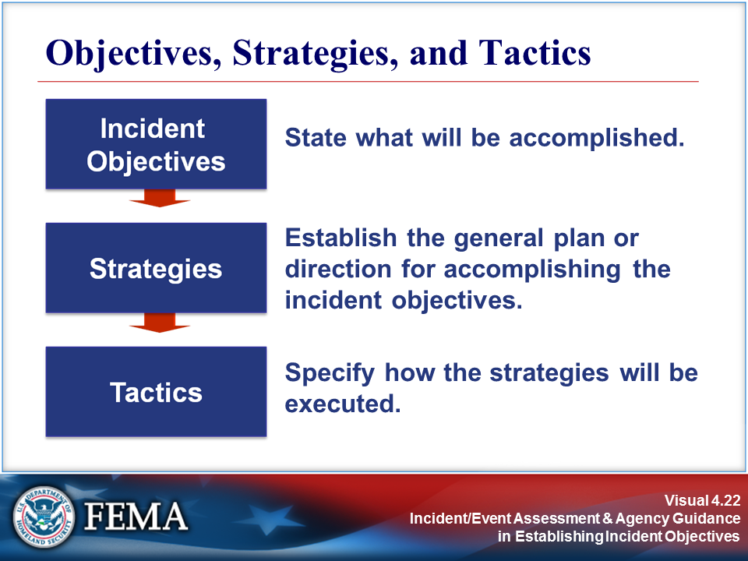 | 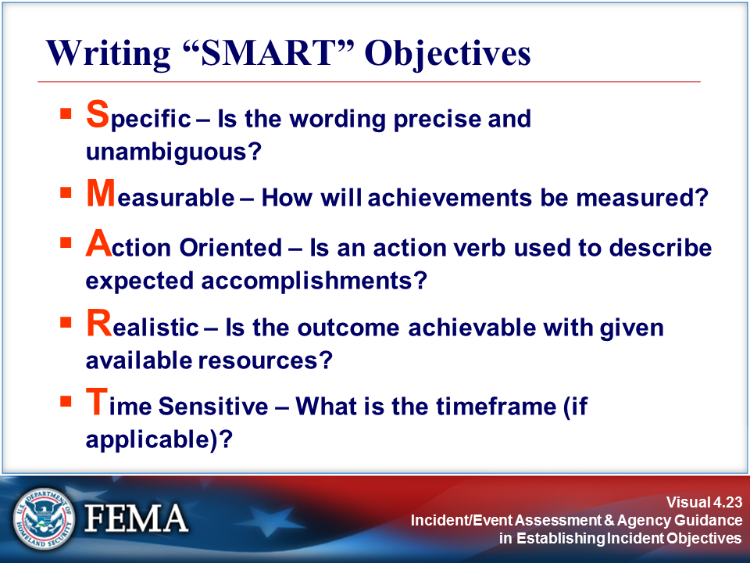
Your Notes

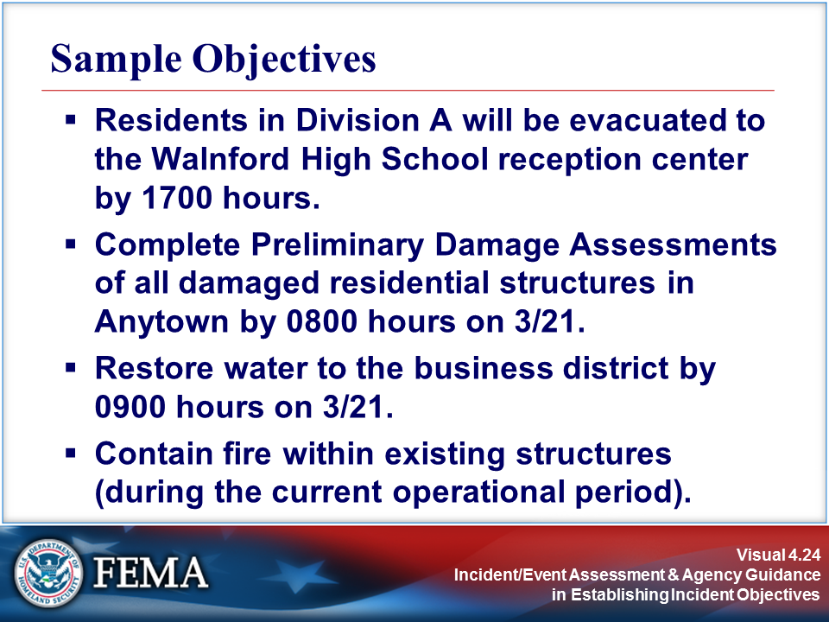 | 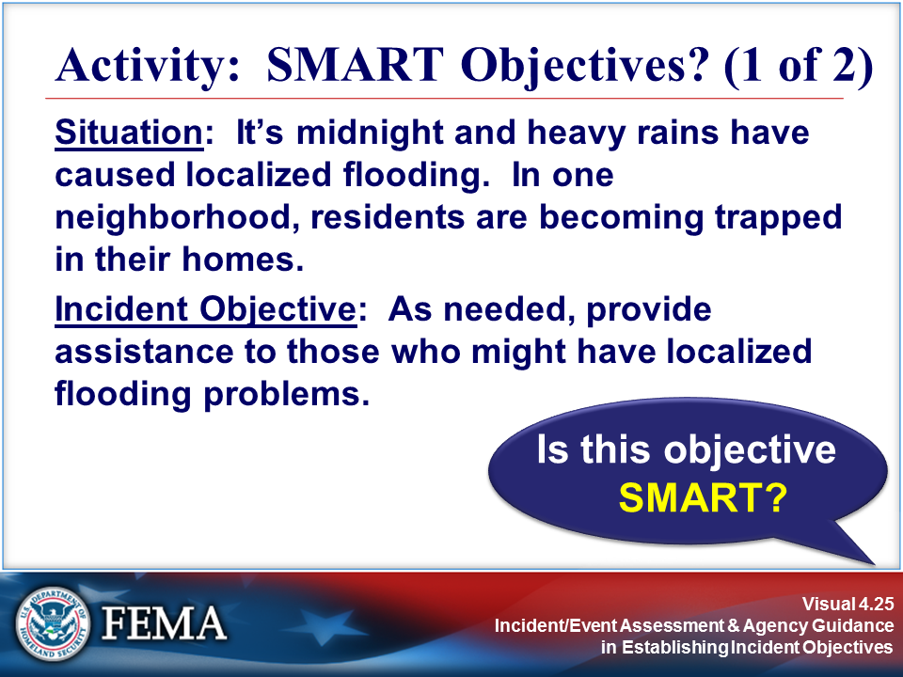
Your Notes

Visuals

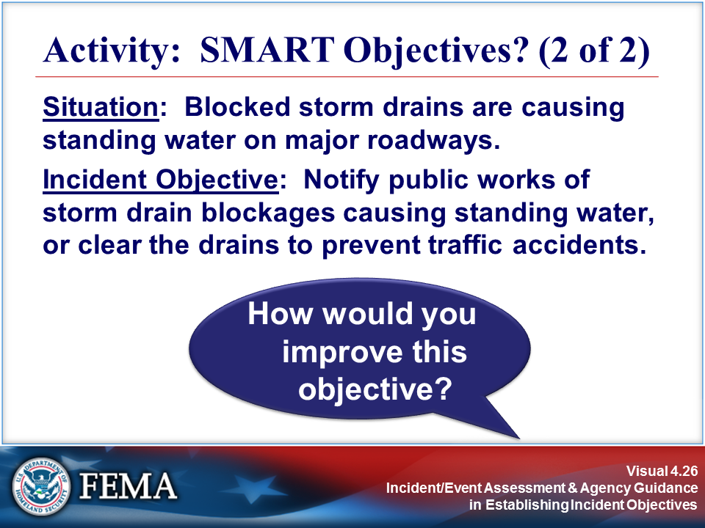 | 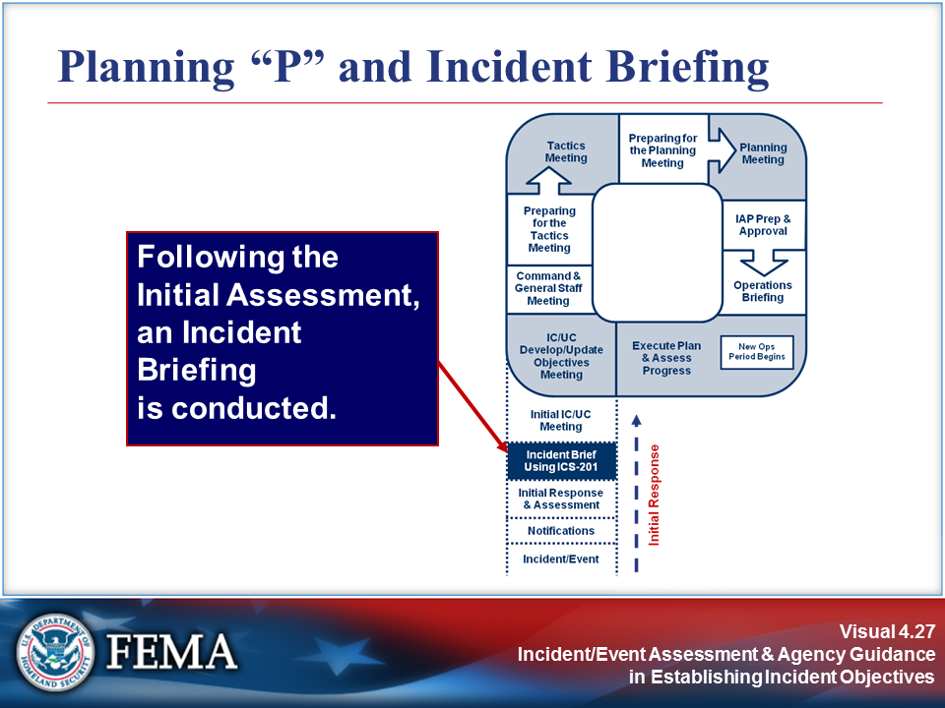
Your Notes

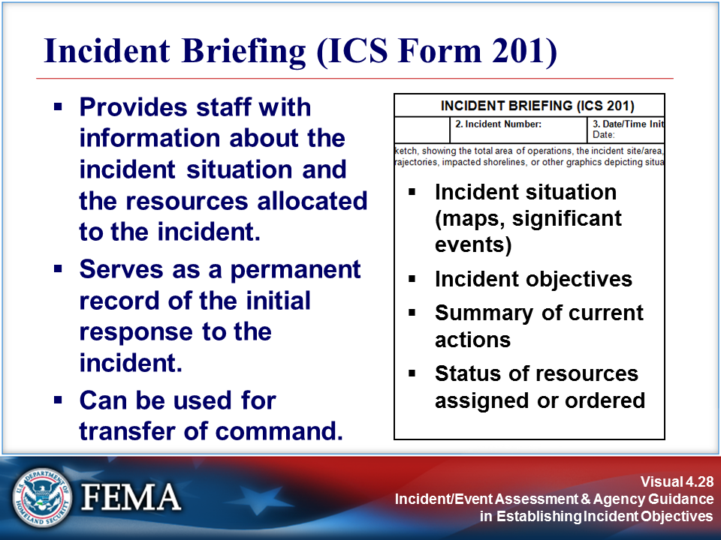 | 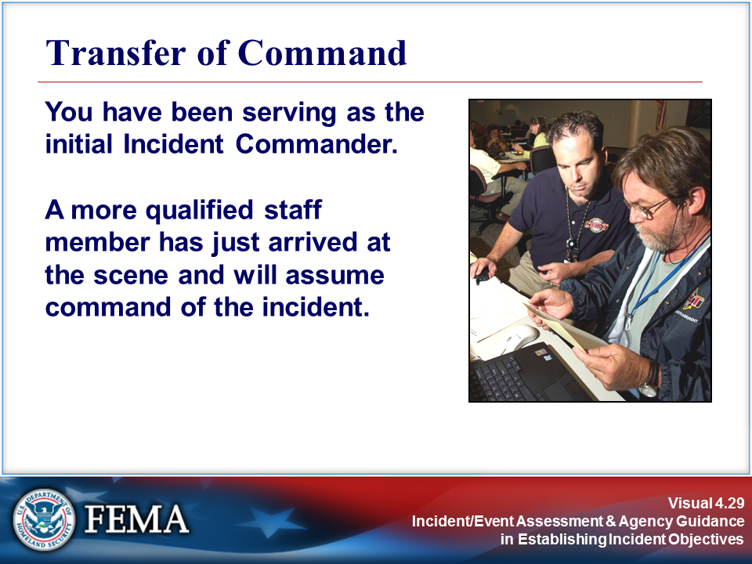
Your Notes

Visuals

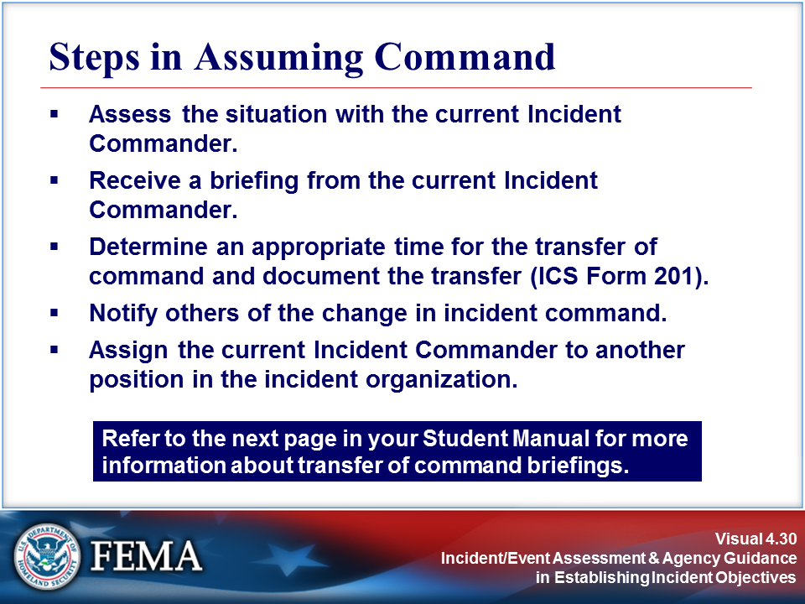 | View the job aid on the next page.
Your Notes

Job Aid: Steps in Assuming Command

Transfer of Command Briefings
A transfer of command briefing must be held by the current Incident Commander, and take place face to face if possible. The briefing must cover the following:
- Incident history (what has happened)
- Priorities and objectives
- Current plan
- Resource assignments
- Incident organization
- Resources ordered/needed
- Facilities established
- Status of communications
- Any constraints or limitations as directed by policies and guidelines
- Incident potential
- Status of Delegation of Authority, inherent or specific
The incoming Incident Commander must ensure that he or she understands the responsible agencies’ policies and Agency Administrator’s direction as discussed earlier in this unit. This may be inherent based on the person’s employment or rank, or may be provided by the Agency Administrator.

Changing Incident Objectives

Explain that the incoming Incident Commander, because of depth of experience or a change in incident-related conditions, may desire to modify incident objectives upon transition of command. Changes could be required for the following reasons:

- Change in Agency Administrator goals
- Change in available resources – kinds or types
- Failure or unexpected success of tactical efforts
- Improved intelligence
- Cost factors
- Political considerations
- Environmental considerations

(Continued on the next page.)

Job Aid: Steps in Assuming Command (Continued)

Critical changes should be made immediately, rather than allowing the existing plan to proceed. Delayed changes may result in additional control problems, greater loss, and increased expense and risk. However, changes can cause disruptions. When possible, less time-sensitive changes should be implemented at the start of the next operational period.

Making a change does not imply that previous decisions and actions were wrong. Many things can influence the need for change. The Incident Commander must be assertive but also aware of potential risk and safety considerations involved in changes. Four guidelines to changes are:

- Implement appropriate safety procedures for all changes. Before implementing changes, the Incident Commander must consider the impact on the safety of responders. If a change in the IAP places responders at greater risk, safety procedures must be changed as well.
- Make changes only if you must. Do not make unnecessary changes to incident objectives or the IAP.
- Make changes sooner rather than later. Evaluate the impact of any changes on overall operations. Do not wait beyond the beginning of the next operational period to make changes. If changes are critical, make them immediately.
- Ensure that the changes are communicated clearly throughout the organization. Poor communication of changed objectives will reduce the efficiency of the response. It could also increase costs and put responders at greater risk.

Visuals

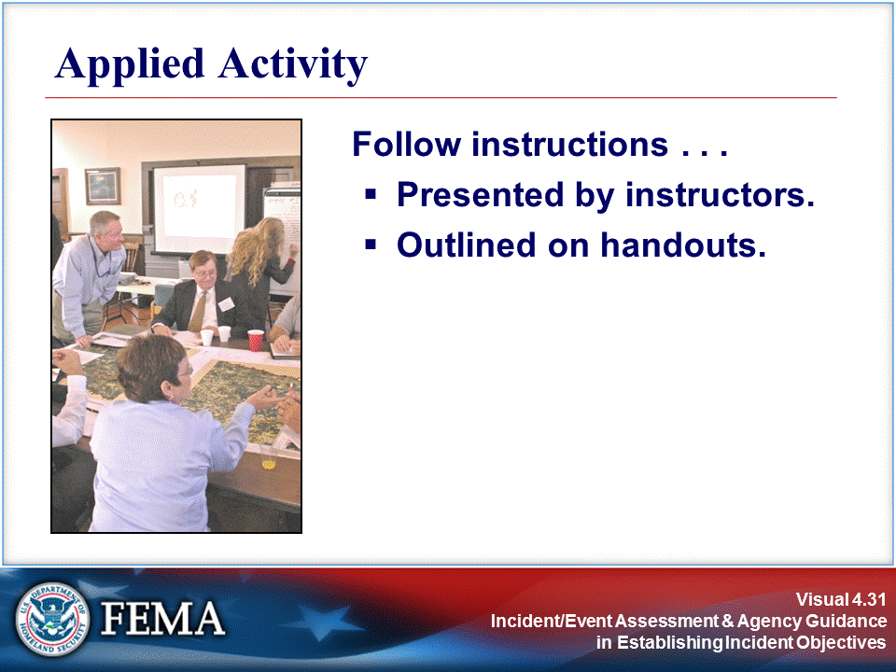 | 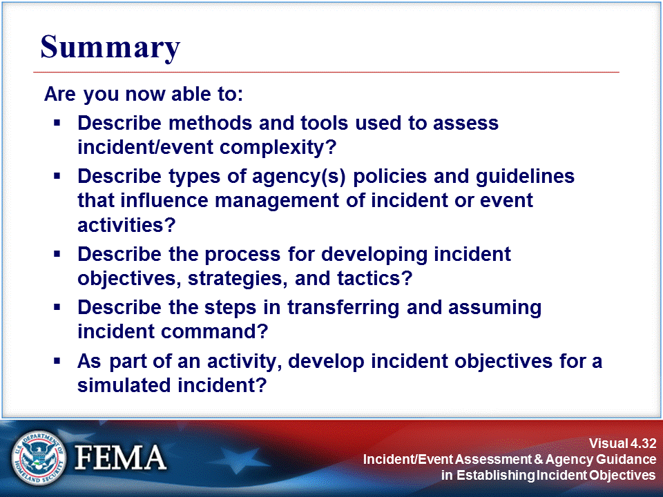
Your Notes

Your Notes

