Unit 5: Planning Process

This page intentionally left blank.

Visuals

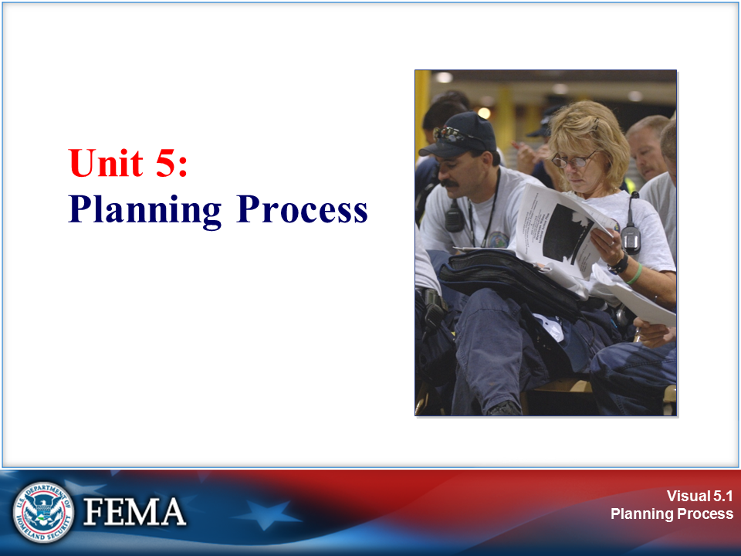 | 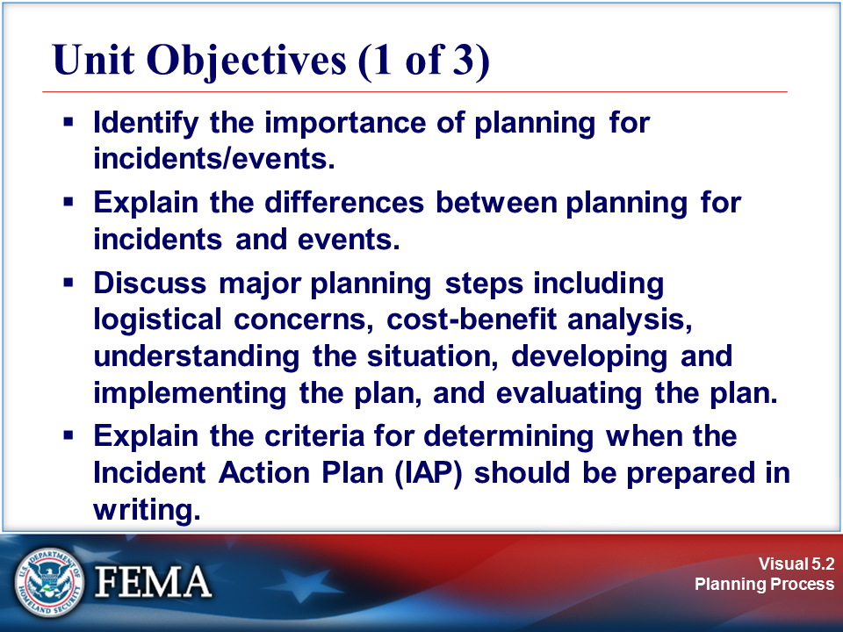
Your Notes

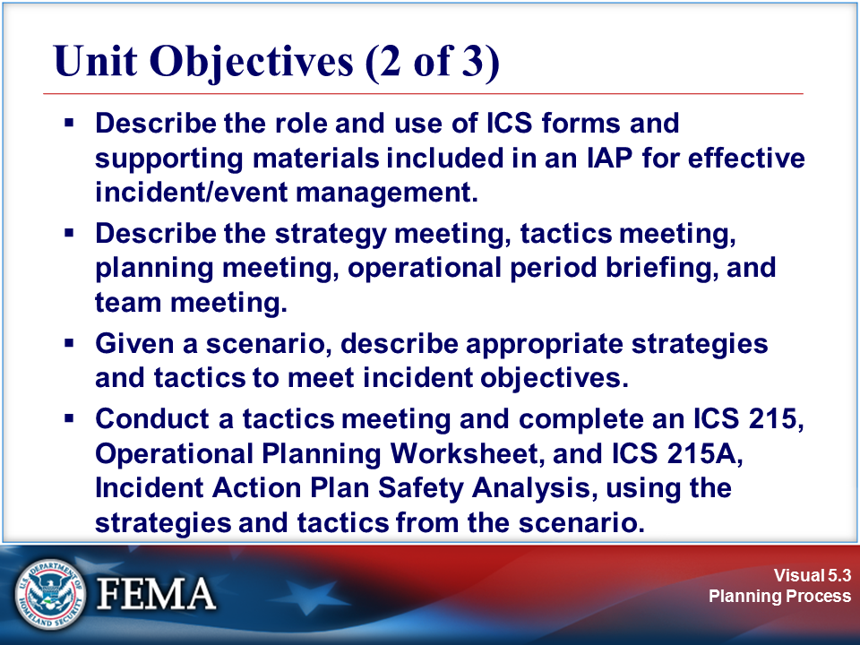 | 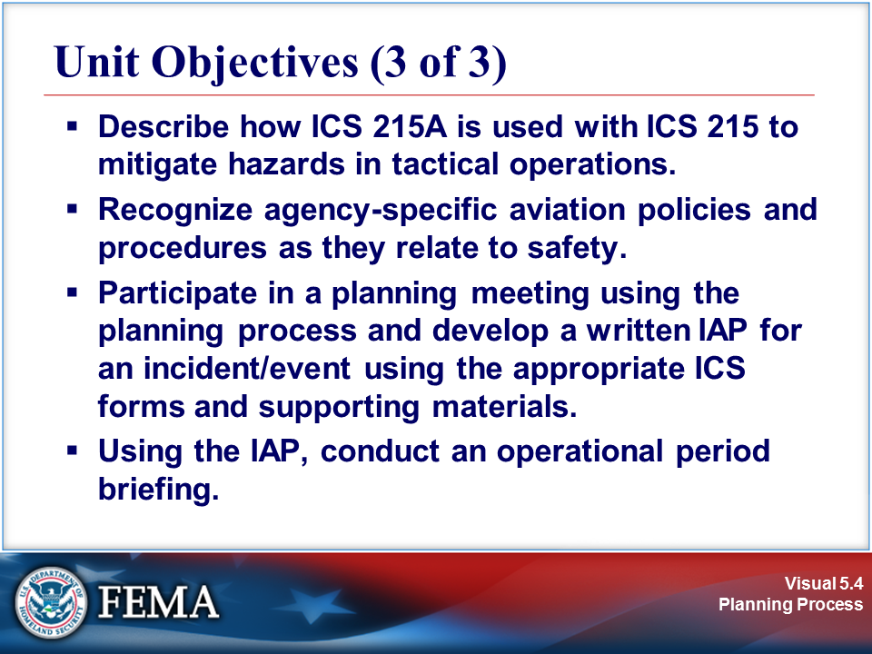
Your Notes

Visuals

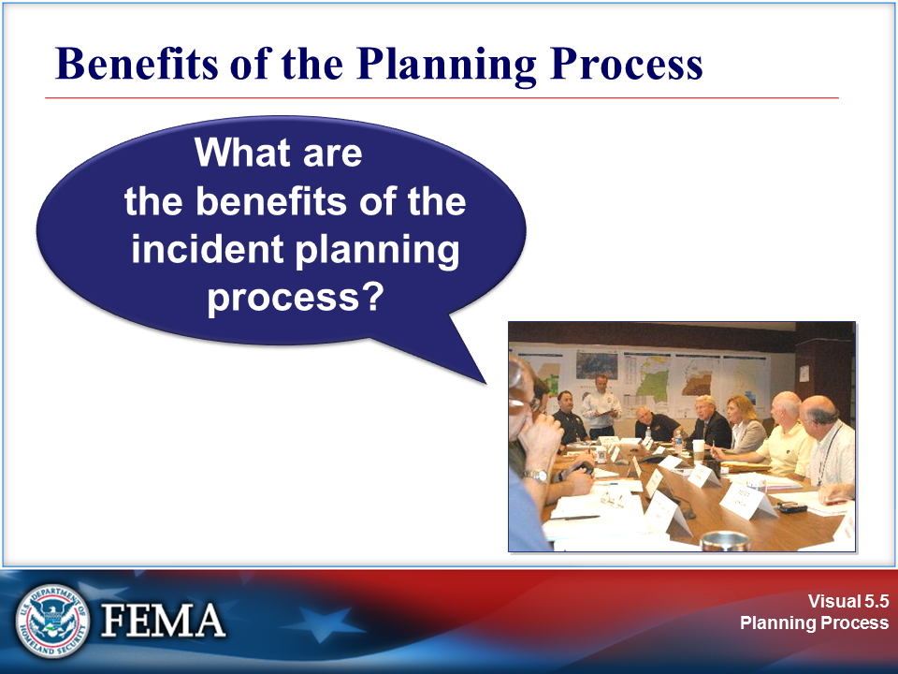 | 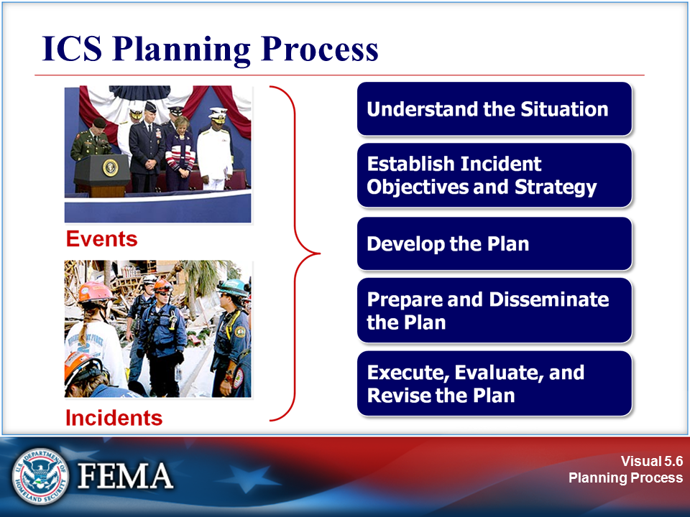
Your Notes

View the job aid on the next page.

Job Aid: ICS Planning Process

- Understand the Situation: The first phase includes gathering, recording, analyzing, and displaying situation, resource, and incident potential information in a manner that will facilitate:
- Increased situational awareness of the magnitude, complexity, and potential impact of the incident; and
- The ability to determine the resources required to develop and implement an effective IAP.

- Establish Incident Objectives and Strategy: The second phase includes formulating and prioritizing measurable incident objectives and identifying an appropriate strategy. The incident objectives and strategy must conform to the legal obligations and management objectives of all affected agencies. These may also need to include specific issues relevant to critical infrastructure.

Reasonable alternative strategies that will accomplish overall incident objectives are identified, analyzed, and evaluated to determine the most appropriate strategy for the situation at hand. Evaluation criteria include public health and safety factors, estimated costs, and various environmental, legal, and political considerations.

- Develop the Plan: The third phase involves determining the tactical direction and the specific resource, reserves, and support requirements for implementing the selected strategies and tactics for the operational period.

Before the formal planning meetings, each member of the Command and General Staffs is responsible for gathering certain information to support the proposed plan.

- Prepare and Disseminate the Plan: The fourth phase involves preparing the plan in a format that is appropriate for the level of complexity of the incident. For the initial response, the format is a well-prepared outline for an oral briefing. For most incidents that will span multiple operational periods, the plan will be developed in writing according to ICS procedures.

- Execute, Evaluate, and Revise the Plan: The planning process includes the requirement to execute and evaluate planned activities and check the accuracy of information to be used in planning for subsequent operational periods. The General Staff should regularly compare planned progress with actual progress. When deviations occur and when new information emerges, that information should be included in the first step of the process used for modifying the current plan or developing the plan for the subsequent operational period.

Source: NIMS Document Tab 8 – The Planning Process

Visuals

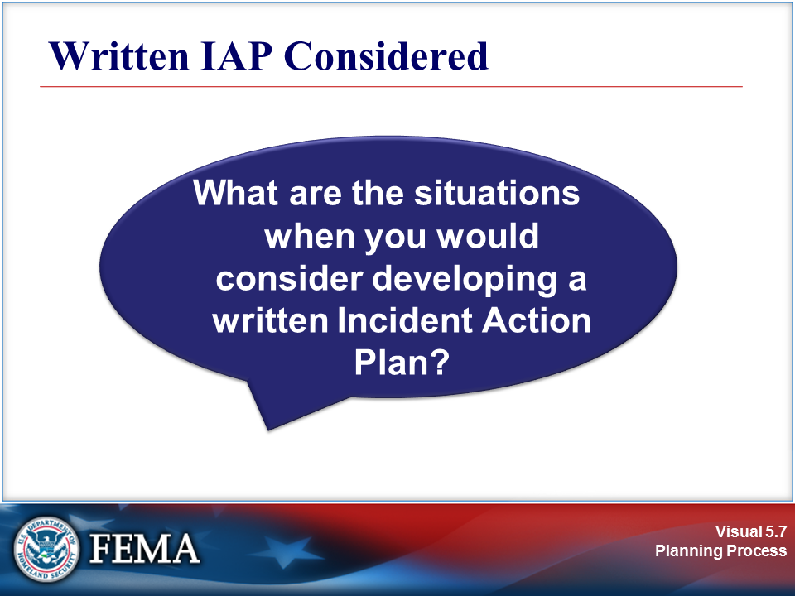 | 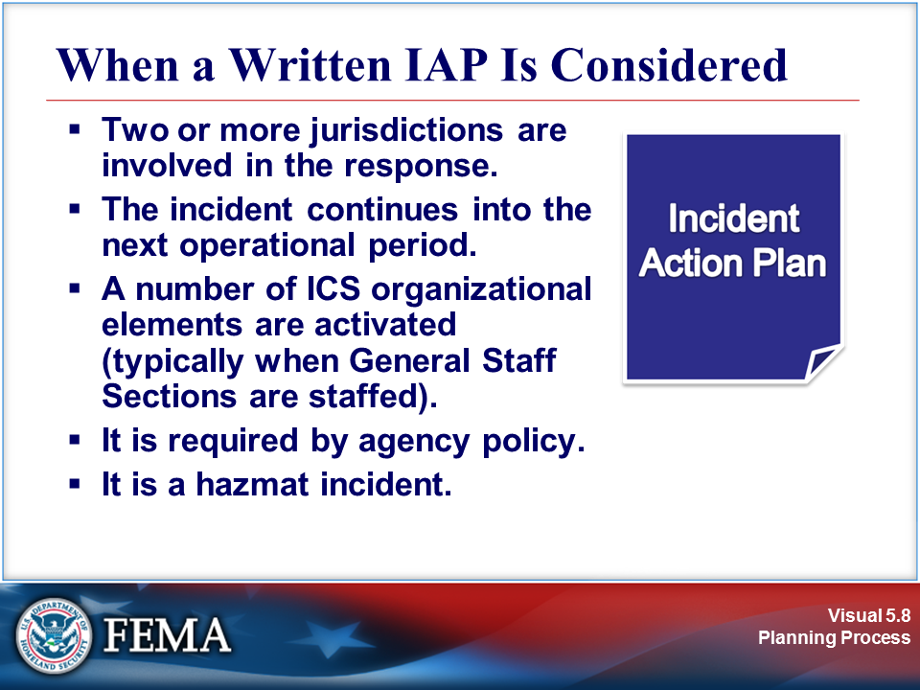
Your Notes

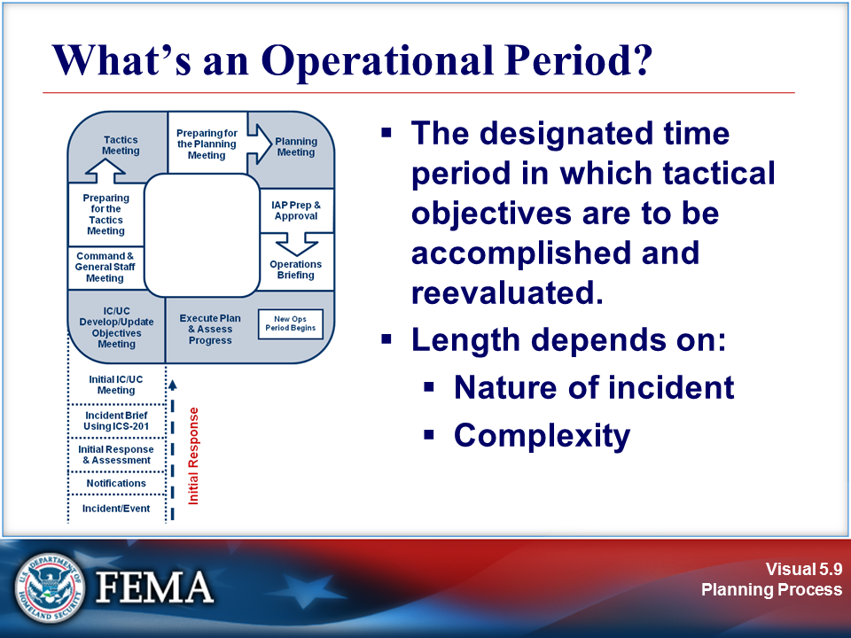
Your Notes

Visuals

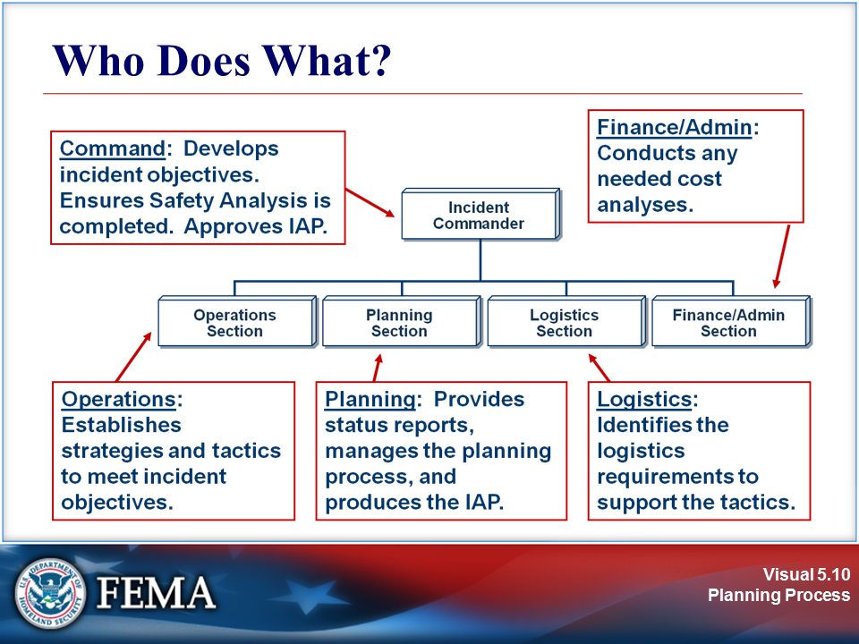 | View the job aid on the next page.
Your Notes

Job Aid: Responsibilities for Planning

All Command and General Staff members have responsibilities for planning.

Incident Commander | - Provides overall incident objectives and strategy.  - Establishes procedures for incident resource ordering.  - Establishes procedures for resource activation, mobilization, and employment.  - Approves completed IAP by signature.  With Safety Officer:  - Reviews hazards associated with the incident and proposed tactical assignments. Assists in developing safe tactics.  - Develops safety message(s).
Operations Section Chief | - Assists in identifying strategies.  - Determines tactics to achieve incident objectives.  - Determines work assignments and resource requirements.  With Safety Officer:  - Reviews hazards associated with the incident and proposed tactical assignments.  - Assists in developing safe tactics.
Planning Section Chief | - Conducts the planning meeting.  - Coordinates preparation and documentation of the IAP.
Logistics Section Chief | - Ensures that resource ordering procedures are communicated to appropriate agency ordering points.  - Develops a transportation system to support operational needs.  - Ensures that the Logistics Section can support the IAP.  - Completes assigned portions of the written IAP.  - Places order(s) for resources.
Finance/Admin. Section Chief | - Provides cost implications of incident objectives, as required.  - Ensures that the IAP is within the financial limits established by the Incident Commander.  - Evaluates facilities, transportation assets, and other contracted services to determine if any special contract arrangements are needed.

Visuals

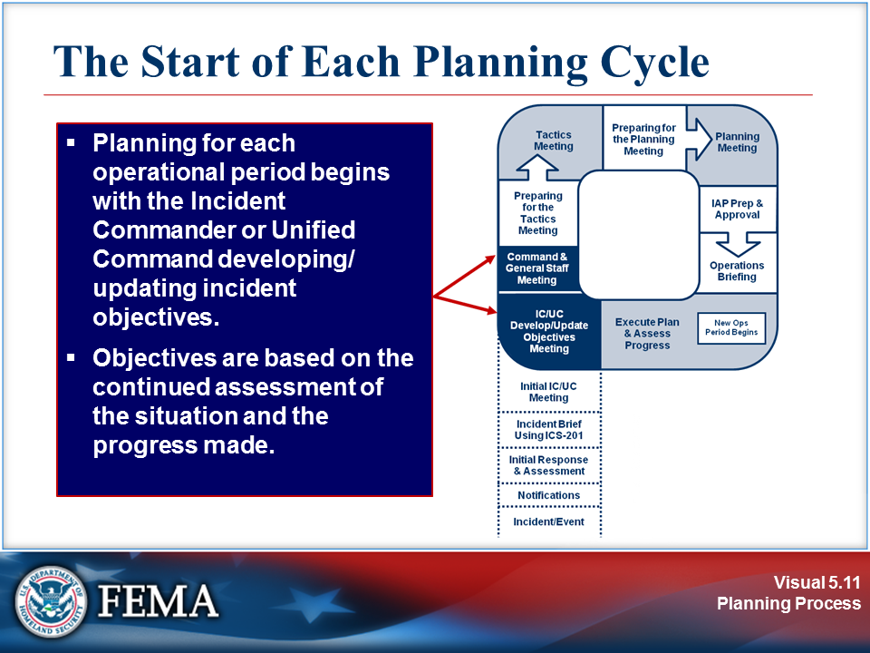 | View the job aid on the next page.
Your Notes

Job Aid: The Start of Each Planning Cycle

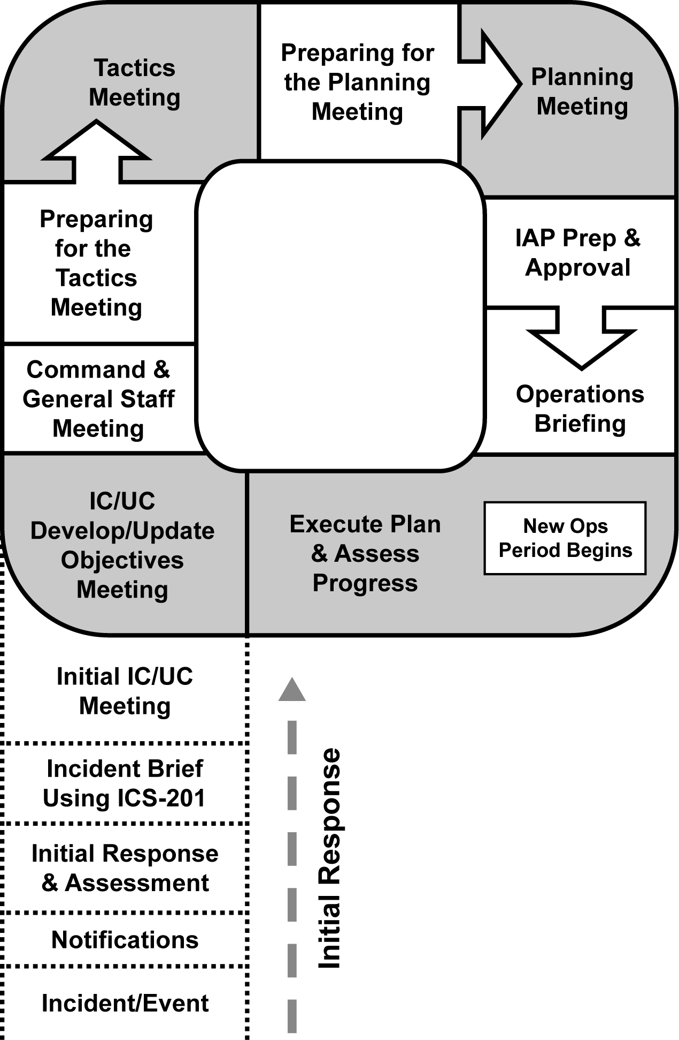

- The leg of the “P” describes the initial response period: Once the incident/event begins, the steps are Notifications, Initial Response & Assessment, Incident Briefing Using ICS 201, and Initial Incident Command (IC)/Unified Command (UC) Meeting.
- At the top of the leg of the “P” is the beginning of the first operational planning period cycle. In this circular sequence, the steps are IC/UC Develop/Update Objectives Meeting, Command and General Staff Meeting, Preparing for the Tactics Meeting, Tactics Meeting, Preparing for the Planning Meeting, Planning Meeting, IAP Prep & Approval, and Operations Briefing.
- At this point a new operational period begins. The next step is Execute Plan & Assess Progress, after which the cycle begins again.

Visuals

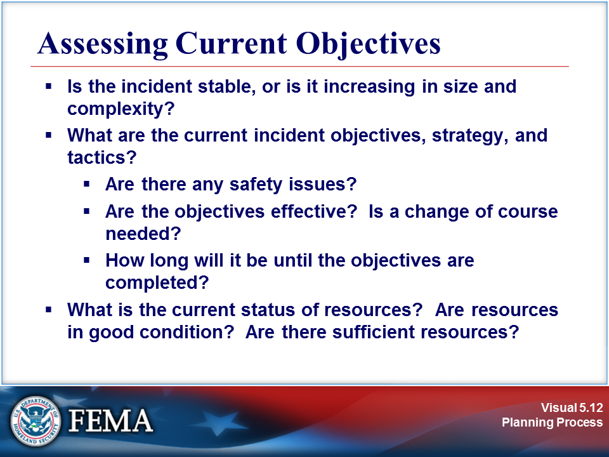 | 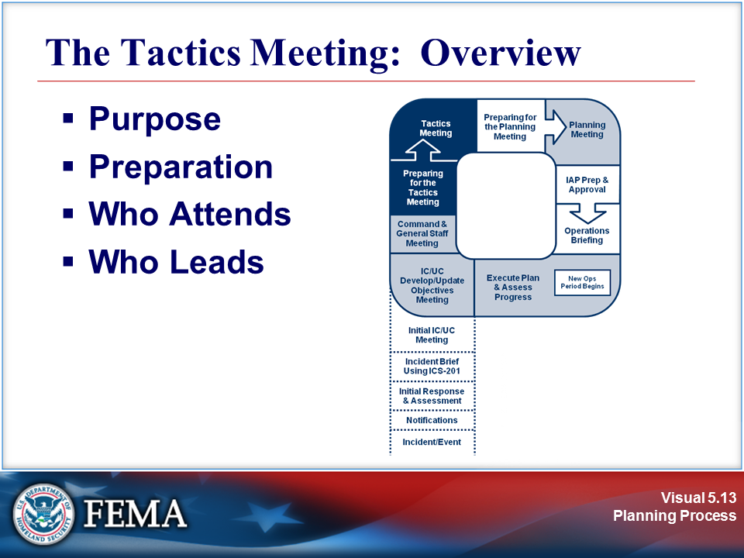
Your Notes

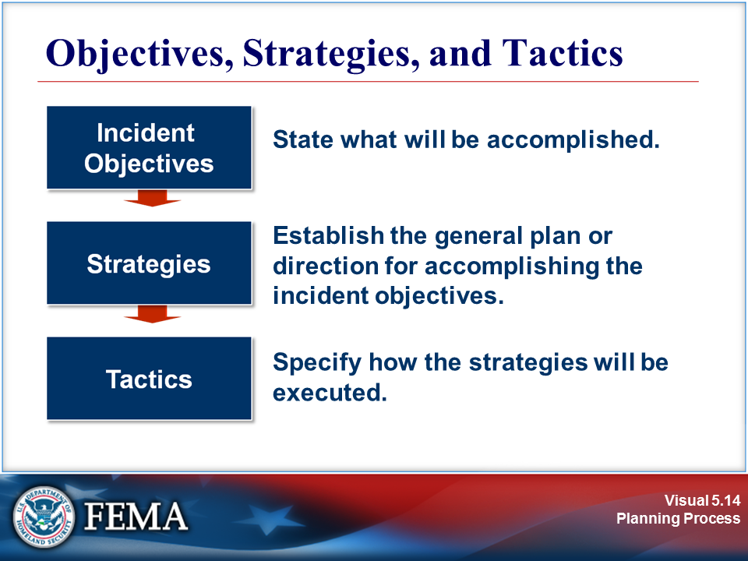 | 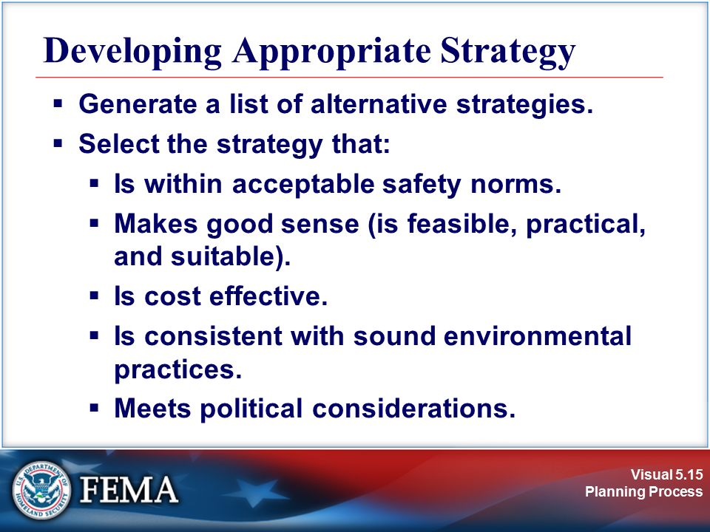
Your Notes

Visuals

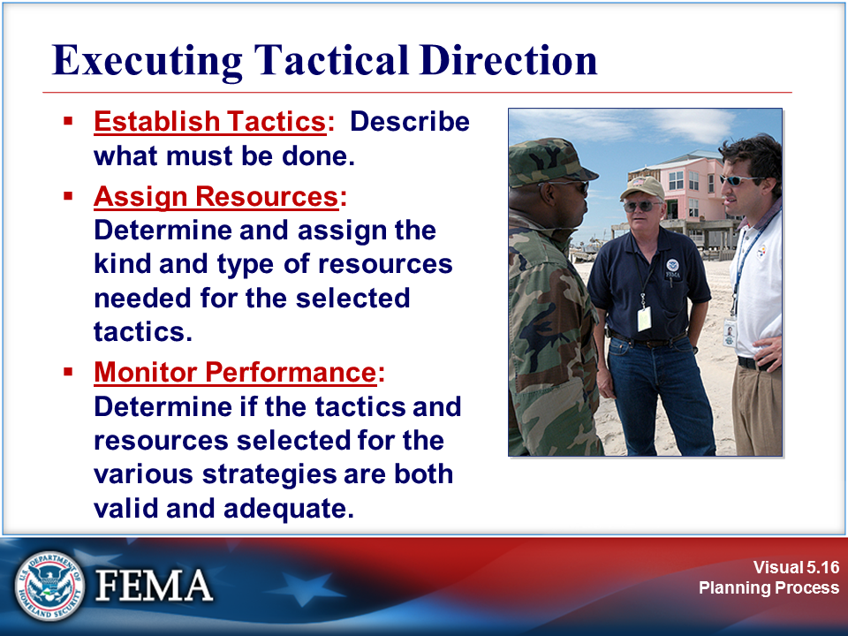 | 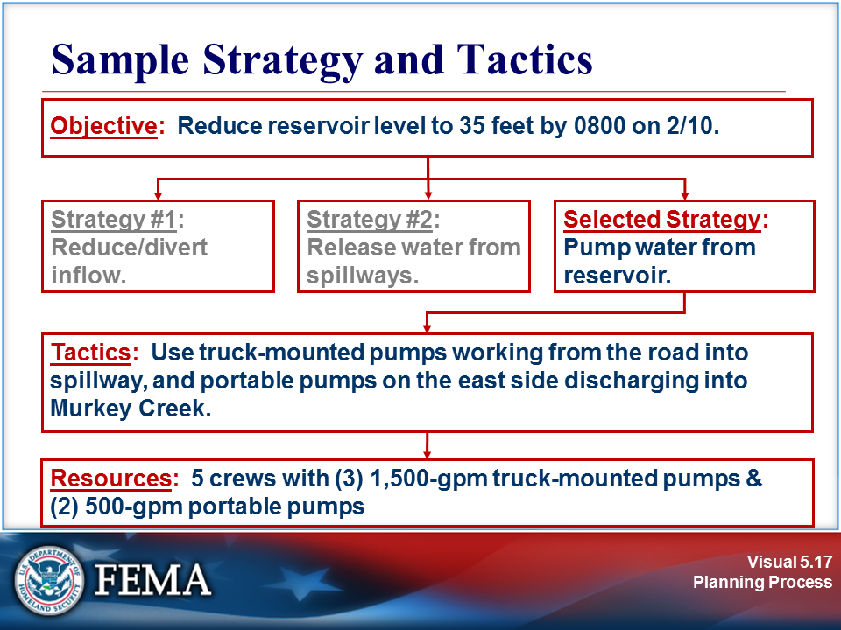
Your Notes

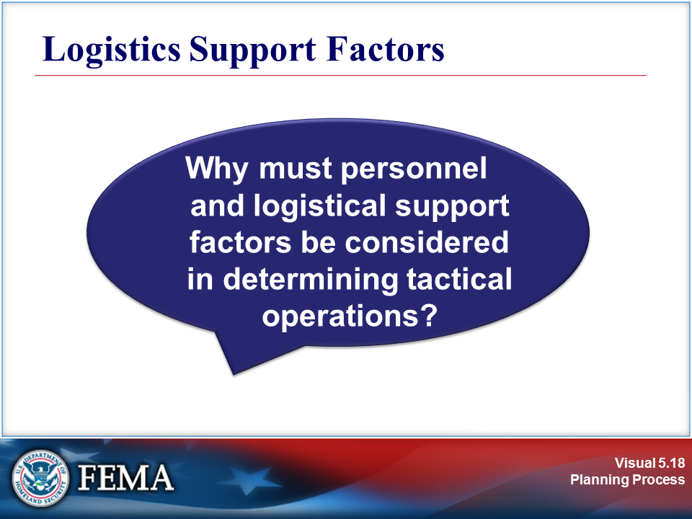 | 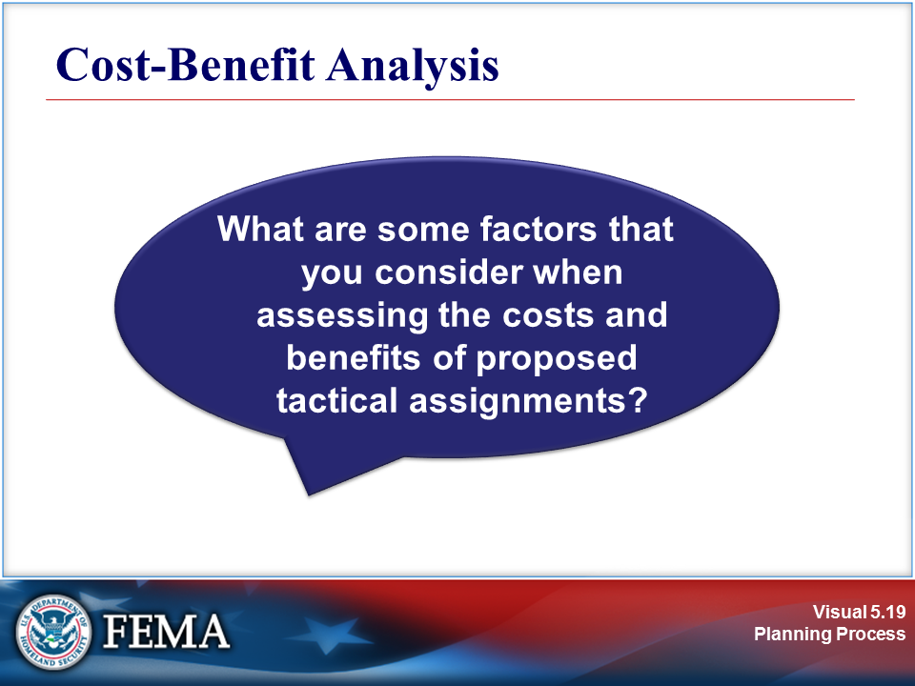
Your Notes

Visuals

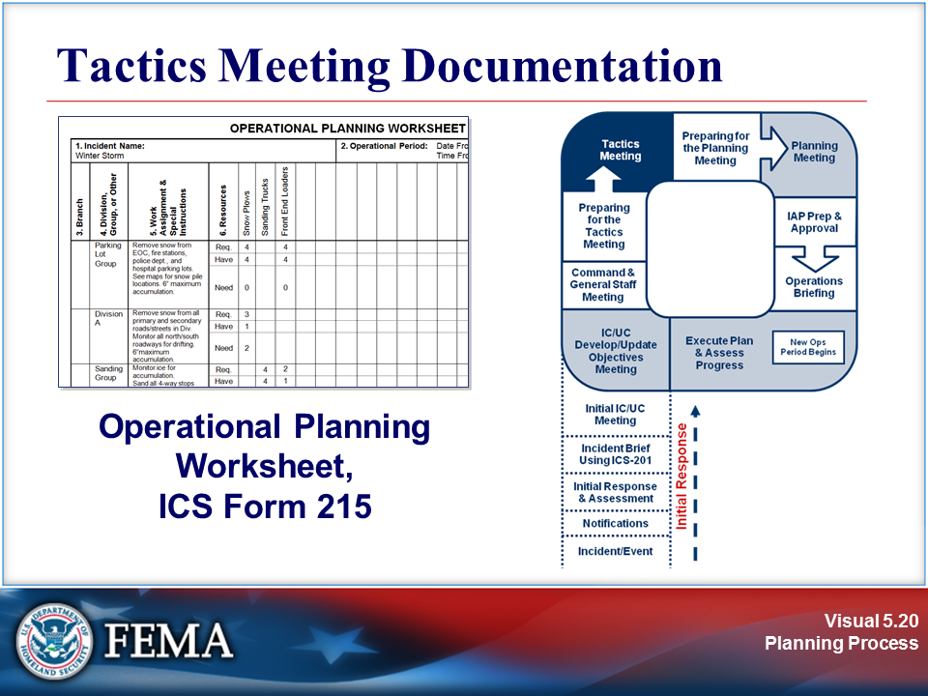 | View the sample on the next page.
Your Notes

Sample Operational Planning Worksheet, ICS Form 215

1. Incident Name: Winter Storm |  |  |  |  |  |  |  |  | 2. Operational Period: Date From: 2/10 Date To: 2/11  Time From: 1800 Time To: 0600
3. Branch | 4. Division, Group, or Other | 5. Work Assignment & Special Instructions | 6. Resources | Snow Plows | Sanding Trucks | Front End Loaders |  |  |  |  |  |  |  |  |  | 7. Overhead Position(s) | 8. Special Equipment & Supplies | 9. Reporting Location | 10. Requested Arrival Time
 | Parking Lot  Group | Remove snow from EOC, fire stations, police dept., and hospital parking lots. See maps for snow pile locations. 6” maximum accumulation. | Req. | 4 |  | 4 |  |  |  |  |  |  |  |  |  |  |  | Public Works Shop | 1700
 |  |  | Have | 4 |  | 4
 |  |  | Need | 0 |  | 0
 | Division A | Remove snow from all primary and secondary roads/streets in Div. Monitor all north/south roadways for drifting. 6”maximum accumulation. | Req. | 3 |  |  |  |  |  |  |  |  |  |  |  |  |  | Public Works  Shop | 1700
 |  |  | Have | 1
 |  |  | Need | 2
 | Sanding Group | Monitor ice for accumulation.  Sand all 4-way stops and lighted intersections. Sand available at County Sand and Gravel storage. | Req. |  | 4 | 2 |  |  |  |  |  |  |  |  |  |  |  | Public Works Shop | 1700
 |  |  | Have |  | 4 | 1
 |  |  | Need |  | 0 | 1
 |  |  | Have
 |  |  | Need
ICS 215 |  | 11. Total Resources Required |  | 7 | 4 | 6 |  |  |  |  |  |  |  |  |  |  | 14. Prepared by:  Name: Sandy Miller  Position/Title: Resources UL  Signature:  Date/Time: Feb. 10/1100
 |  | 12. Total Resources Have on Hand |  | 5 | 4 | 5
 |  | 13. Total Resources Need To Order |  | 2 | 0 | 1

Visuals

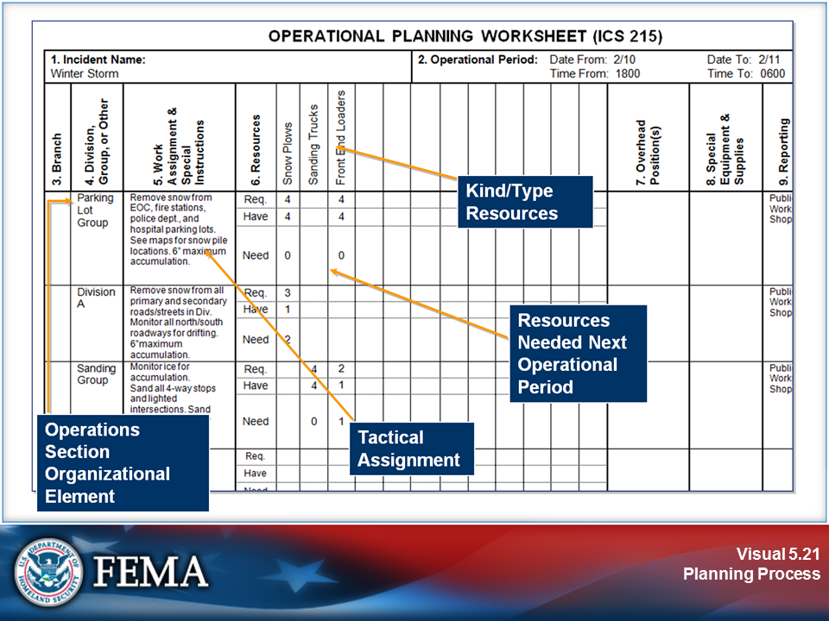 | 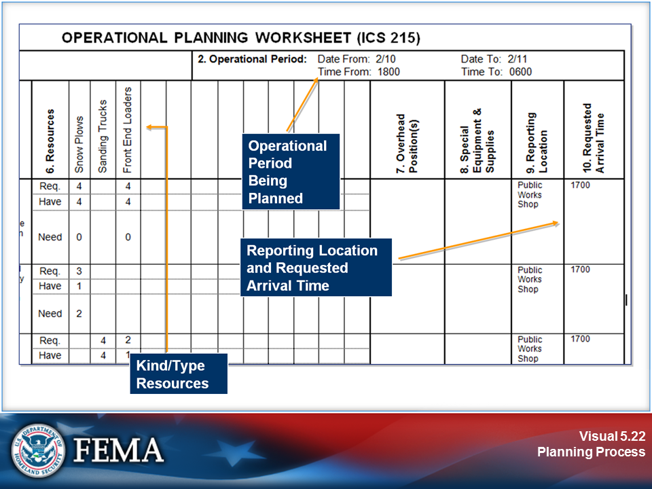
Your Notes

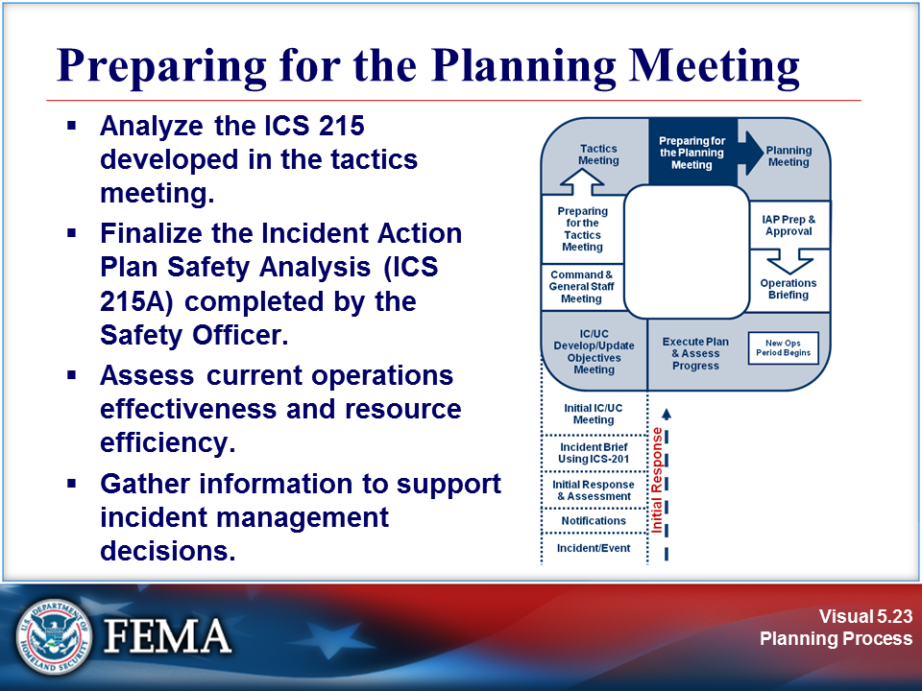 | View the job aid on the next page.
Your Notes

Job Aid: Preparing for the Planning Meeting

Preparing for the Planning Meeting: Responsibilities
Incident Commander | - Gives direction.  - Communicates.  - Manages.  - Does not get involved in details
Safety Officer | - Identifies incident risks and hazards.  - Completes ICS Form 215A developed at the tactics meeting.  - Works with the Operations Section Chief on tactical safety issues.  - Identifies safety issues associated with incident facilities and nontactical activities, such as transportation and food service.
Liaison Officer | - Identifies cooperating and assisting agencies.  - Identifies special agency needs.  - Determines capabilities of cooperating and assisting agencies.  - Determines restrictions on participation of cooperating and assisting agencies.  - Confirms name and contact location of agency representatives.
Public Information Officer | - Assesses general media coverage to date.  - Identifies incident-related information issues that need to be explained or corrected with the media.  - Determines what Joint Information System (JIS) elements and procedures are in place.  - Determines process for development and approval of media releases and visits.
Operations Section Chief | - Continues to obtain good incident resource and status information.  - Communicates current information.  - Considers alternate strategies and determines probable tactics.  - Calculates resource requirements.  - Works with the Safety Officer and Planning Section staff to complete ICS Forms 215 and 215A developed at the tactics meeting.
Planning Section Chief | - Prepares incident maps and displays, as necessary.  - Develops information for the lAP.  - Develops situation status and predictions.  - Acquires information and ICS forms for the IAP.
Logistics Section Chief | - Determines service and support needs for the incident.  - Determines responder medical and rehabilitation needs.  - Determines incident communications needs.  - Confirms resource ordering process.
Finance/  Administration Section Chief | - Collects information on rental agreements and contracts.  - Determines potential and actual claims.  - Calculates incident costs to date.  - Develops cost-benefit analyses as requested.

Visuals

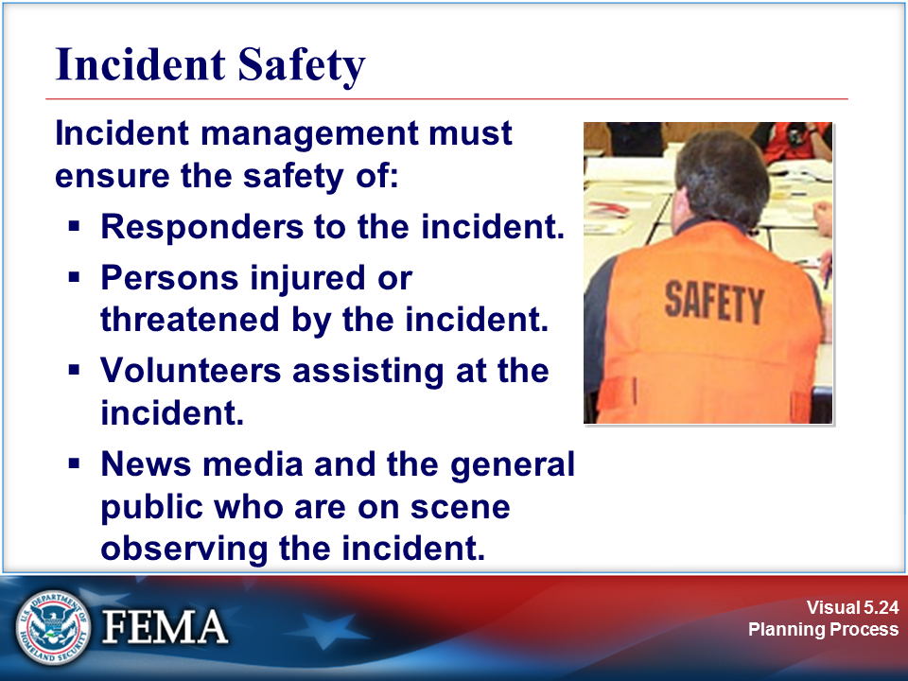 | 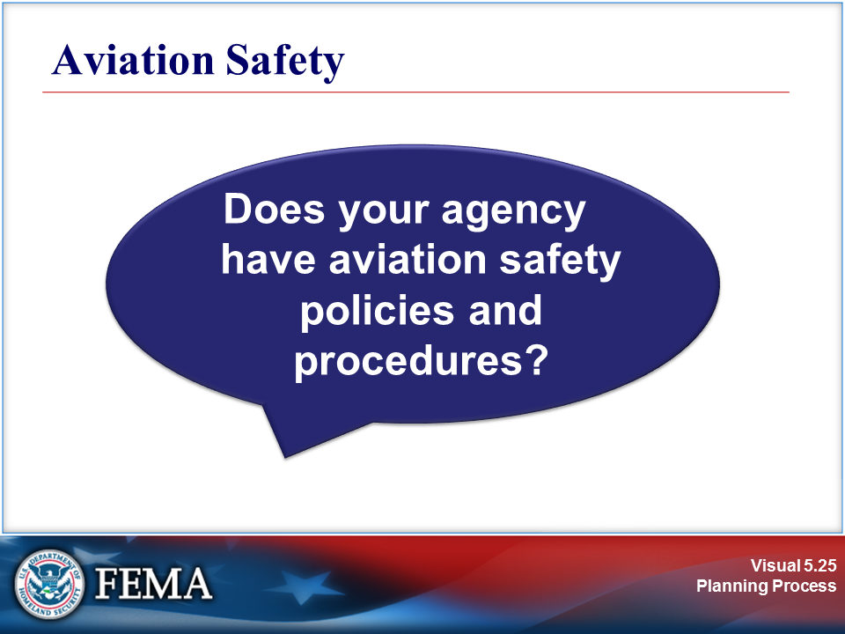
Your Notes

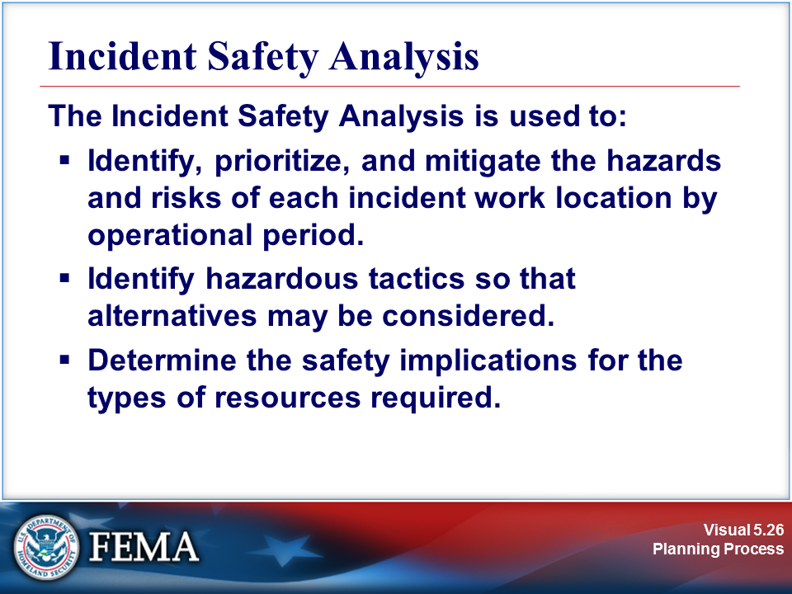 | 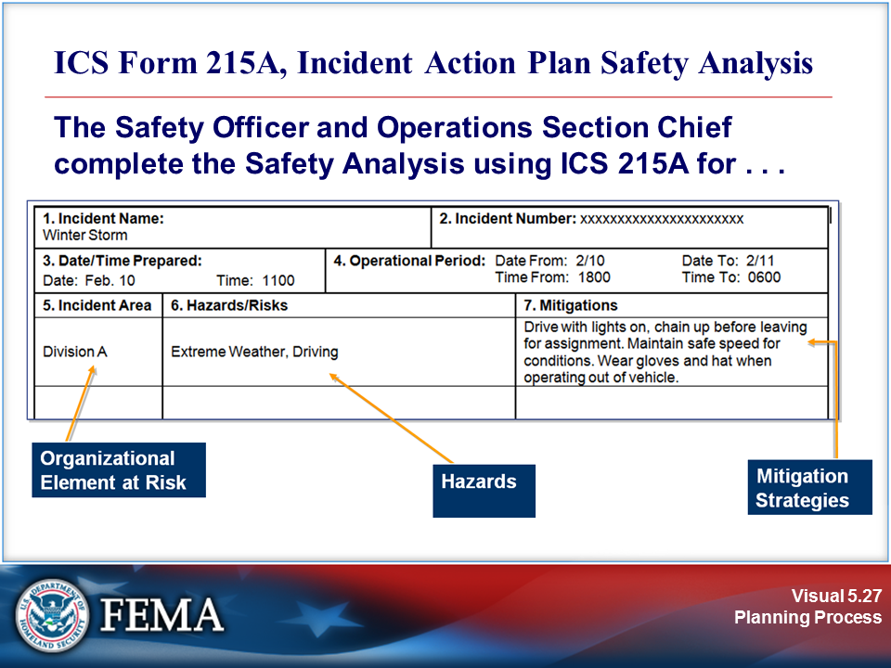
Your Notes

Sample: Incident Action Plan Safety Analysis, ICS Form 215A

1. Incident Name:  Winter Storm |  |  |  | 2. Incident Number: xxxxxxxxxxxxxxxxxxxxxx
3. Date/Time Prepared:  Date: Feb. 10 Time: 1100 |  | 4. Operational Period: Date From: 2/10 Date To: 2/11  Time From: 1800 Time To: 0600
5. Incident Area | 6. Hazards/Risks |  |  |  | 7. Mitigations
Division A | Extreme Weather, Driving |  |  |  | Drive with lights on, chain up before leaving for assignment. Maintain safe speed for conditions. Wear gloves and hat when working outside.
8. Prepared by (Safety Officer): Name: Pam Alice Signature:
Prepared by (Operations Section Chief): Name: Dan Campbell Signature:
ICS 215A |  |  | Date/Time: Feb. 10/1100

Sample: Preparing for the Planning Meeting

ICS Form 215A, Incident Action Plan Safety Analysis
The Safety Officer or the Incident Commander should coordinate, develop, and approve an ICS Form 215A, Incident Action Plan Safety Analysis, for each operational period with the Operations Section Chief.

ICS Form 215A is a tool used by the Safety Officer as a concise way of identifying hazards and risks present in different areas of the incident and specific ways of mitigating those issues during an operational period.

The objective of the Incident Action Plan Safety Analysis is to identify and mitigate the hazards and risks of each incident work location by operational period. The mitigation methods selected may affect the resources required for the incident work location. The Safety Analysis may also reveal that the proposed tactic is too hazardous to attempt and another tactic must be developed.

ICS Form 215A, Incident Action Plan Safety Analysis, is used as a display during the Planning Meeting. It provides information on:
- Incident work location(s)
- Risk mitigations
- Date (daily) prepared by Operation Section Chief/Safety Officer and approved by Safety Officer
Techniques for Identifying Hazards | Types of Risks
- Personal observation and/or experience  - Checklist  - Communication with incident personnel  - Personnel | - Traffic  - Confined space  - Downhill fireline construction  - Air operations  - Hazardous materials  - Slip, trip, and fall  - Weather
Locations | Mitigation of Hazards
- Divisions  - Groups  - Helibase  - Staging Area  - Emergency Operations Center  - Others | - Use of personal protective equipment (PPE)  - Proper clothing for inclement weather  - Reflective clothing and lights for nighttime or low-light operations  - Maintain awareness of landing zones

Visuals

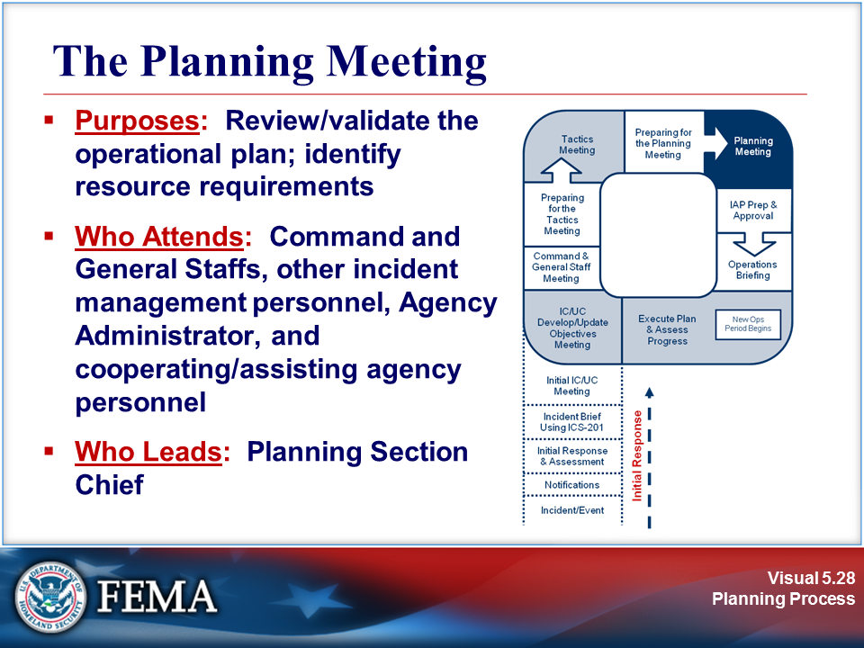 | 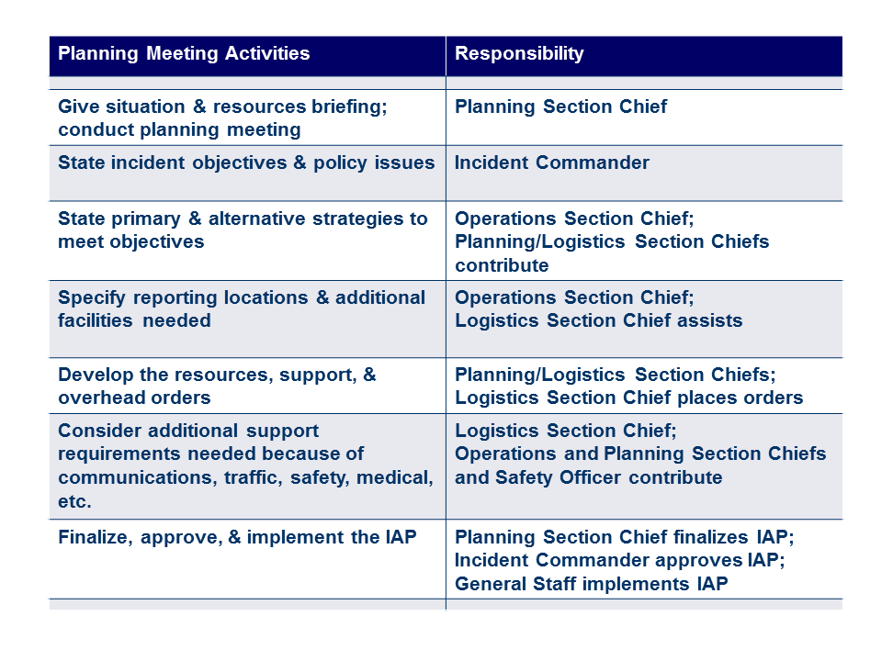
Your Notes

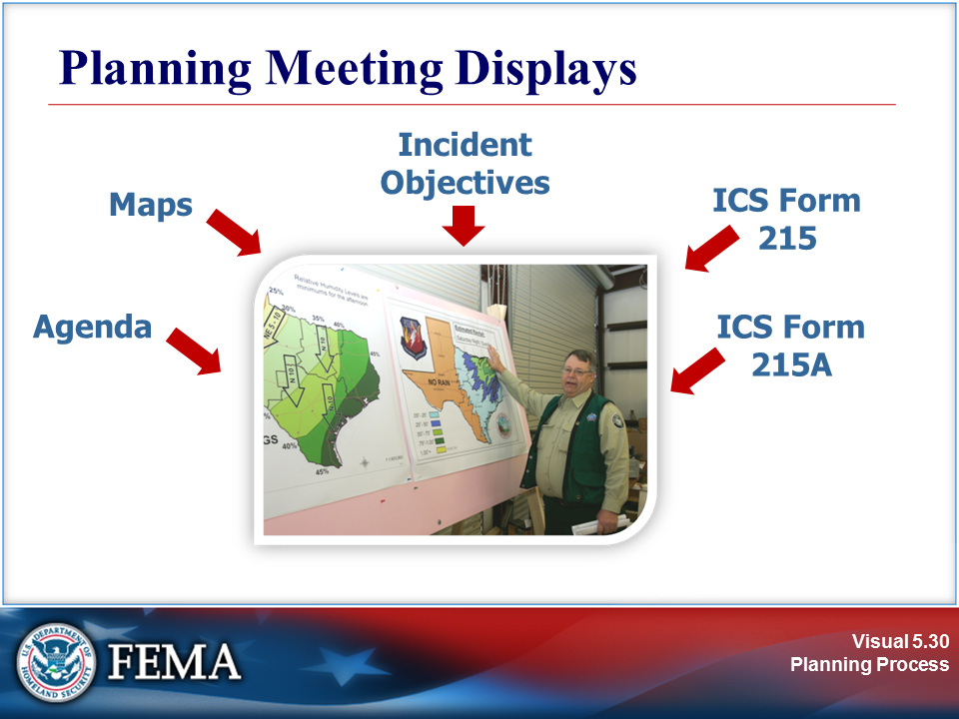 | 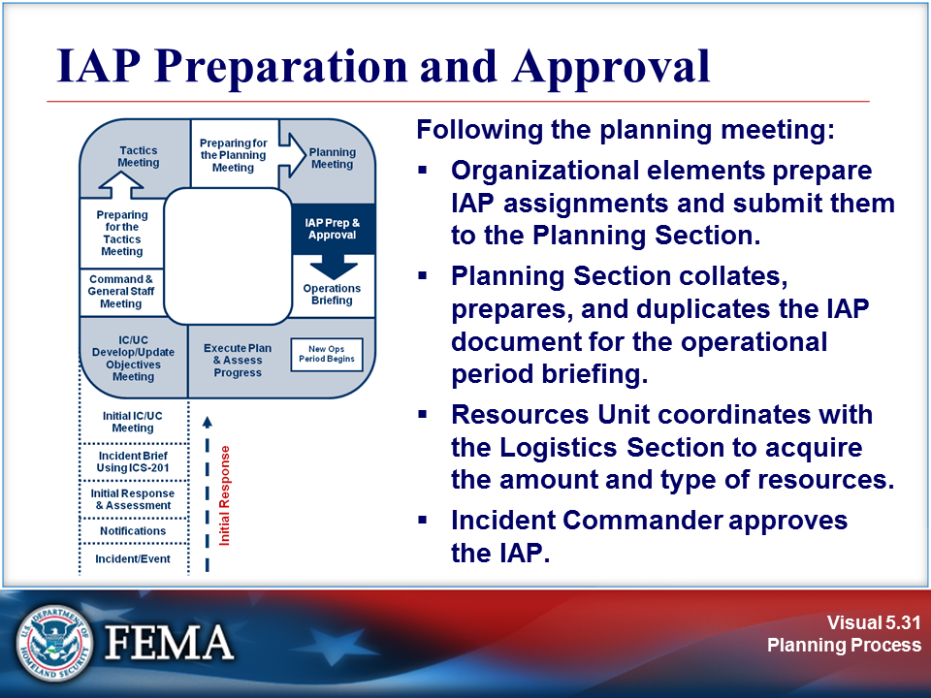
Your Notes

Visuals

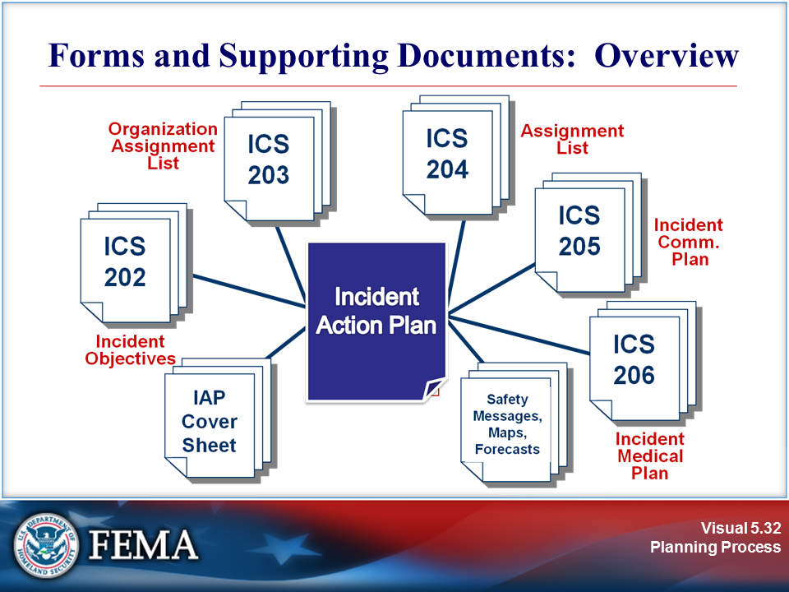 | View the job aid on the next page.
Your Notes

Job Aid: Forms and Supporting Documents: Overview

ICS Forms

ICS uses a series of standard forms and supporting documents that convey directions for the accomplishment of the objectives and distributing information. Listed below are the standard ICS form titles and descriptions of each form:

Standard Form Title | Description
Incident Briefing  ICS 201 | Provides the Incident Command/Unified Command and General Staffs with basic information regarding the incident situation and the resources allocated to the incident. This form also serves as a permanent record of the initial response to the incident.
Incident Objectives ICS 202 | Describes the basic strategy and objectives for use during each operational period.
Organization Assignment List  ICS 203 | Provides information on the response organization and personnel staffing.
Assignment List  ICS 204 | Used to inform personnel of assignments. After Incident Command/Unified Command approves the objectives, staff members receive the assignment information contained in this form.
Incident Radio Communications Plan  ICS 205 | Provides, in one location, information on the assignments for all radio communications equipment for each operational period. The plan is a summary of information. Information from the Incident Communications Plan on frequency assignments can be placed on the appropriate Assignment form (ICS Form 204).
Communications List  ICS 205A | Records methods of contact for incident personnel. While the Incident Radio Communications Plan (ICS 205) is used to provide information on all radio frequencies down to the Division/Group level, the ICS 205A indicates all methods of contact for personnel assigned to the incident (radio frequencies, phone numbers, pager numbers, etc.), and functions as an incident directory.
Medical Plan  ICS 206 | Provides information on incident medical aid stations, transportation services, hospitals, and medical emergency procedures.
Incident Organization Chart  ICS 207 | Provides a visual wall chart depicting the ICS organization position assignments for the incident.
Incident Status Summary  ICS 209 | Summarizes incident information for staff members and external parties, and provides information to the Public Information Officer for preparation of media releases.
Incident Status Change  ICS 210 | Used by the Incident Communications Center Manager to record status change information received on resources assigned to the incident. This information could be transmitted with a General Message (ICS 213). The form could also be used by Operations as a worksheet to track entry, etc.

Job Aid: Forms and Supporting Documents: Overview (Continued)

ICS Forms

Standard Form Title | Description
Check-In List  ICS 211 | Used to check in personnel and equipment arriving at the incident. Check-in consists of reporting specific information that is recorded on the form.
General Message  ICS 213 | Used by:  - Incident dispatchers to record incoming messages that cannot be orally transmitted to the intended recipients.  - EOC and other incident personnel to transmit messages via radio or telephone to the addressee.  - Incident personnel to send any message or notification that requires hard-copy delivery to other incident personnel.
Unit Log  ICS 214 | Provides a record of unit activities. Unit Logs can provide a basic reference from which to extract information for inclusion in any after-action report.
Operational Planning Worksheet  ICS 215 | Documents decisions made concerning resource needs for the next operational period. The Planning Section uses this worksheet to complete Assignment Lists, and the Logistics Section uses it for ordering resources for the incident. This form may be used as a source document for updating resource information on other ICS forms such as the ICS 209.
Incident Action Plan Safety Analysis  ICS 215A | Communicates to the Operations and Planning Section Chiefs safety and health issues identified by the Safety Officer.
Support Vehicle/Equipment Inventory  ICS 218 | Provides an inventory of all transportation and support vehicles and equipment assigned to the incident.
Air Operations Summary  ICS 220 | Provides information on air operations including the number, type, location, and specific assignments of helicopters and fixed-wing aircraft.
Demobilization Check-Out  ICS 221 | Ensures that resources checking out of the incident have completed all appropriate incident business, and provides the Planning Section information on resources released from the incident.

Visuals

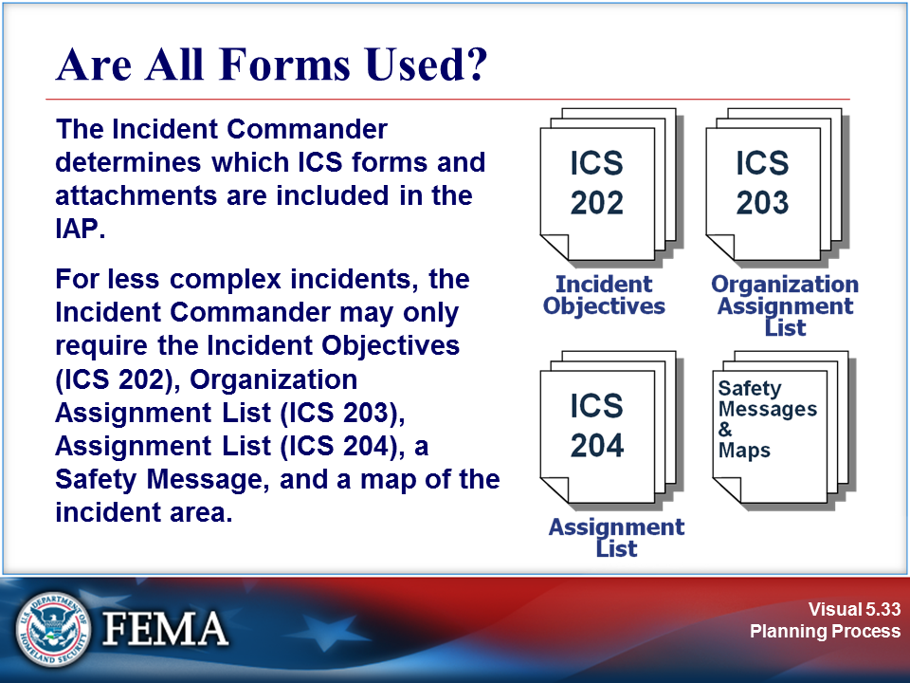 | 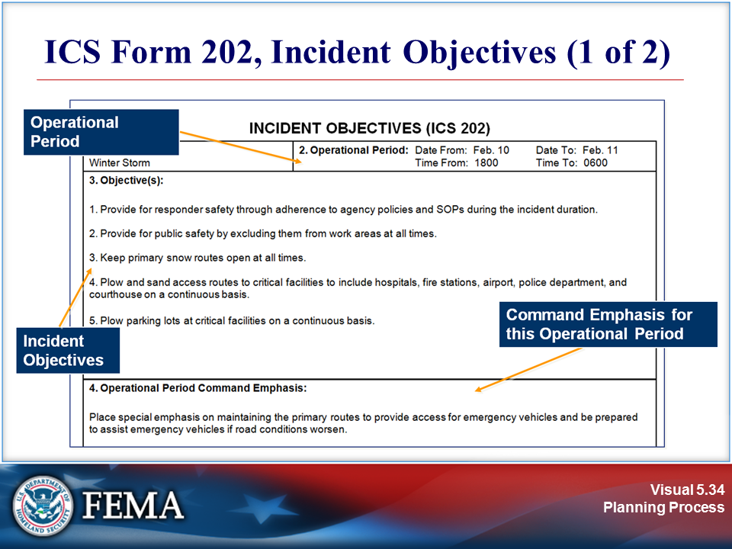
Your Notes

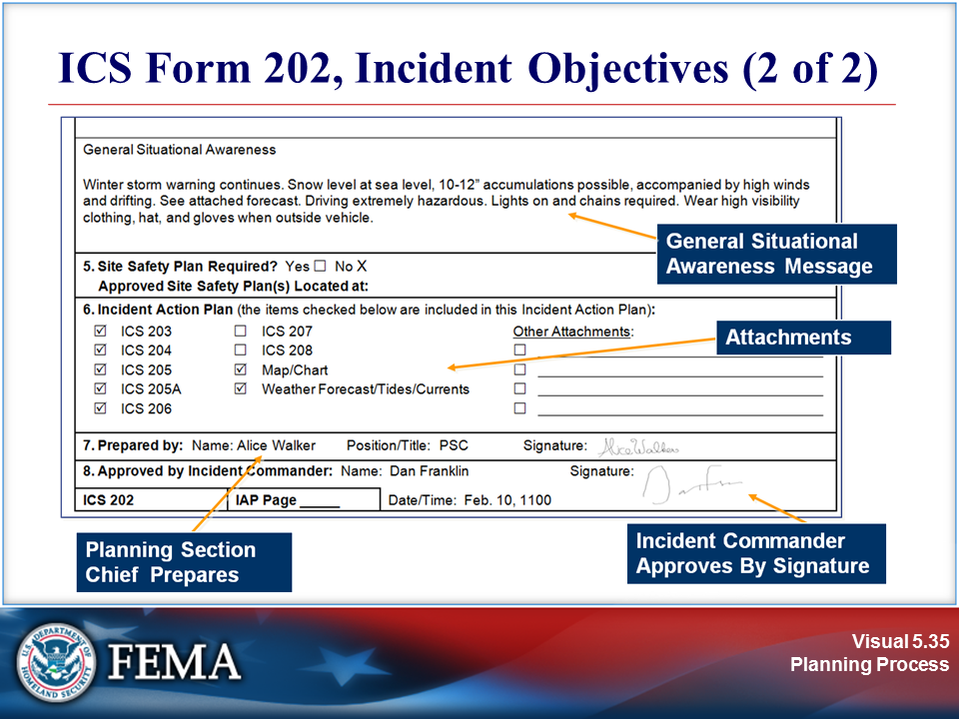 | View the sample on the next page.
Your Notes

Sample: Sample Incident Objectives, ICS Form 202

1. Incident Name: Winter Storm |  | 2. Operational Period: Date From: Feb. 10 Date To: Feb. 11  Time From: 1800 Time To: 0600
3. Objective(s):

1. Provide for responder safety through adherence to agency policies and SOPs during the incident duration.

2. Provide for public safety by excluding the public from work areas at all times.

3. Keep primary snow routes open at all times.

4. Plow and sand access routes to critical facilities to include hospitals, fire stations, airport, police department, and courthouse on a continuous basis.

5. Plow parking lots at critical facilities on a continuous basis.
4. Operational Period Command Emphasis:

Place special emphasis on maintaining the primary routes to provide access for emergency vehicles and be prepared to assist emergency vehicles if road conditions worsen.

General Situational Awareness

Winter storm warning continues. Snow level at sea level, 10-12” accumulations possible, accompanied by high winds and drifting. See attached forecast. Driving extremely hazardous. Lights on and chains required. Wear high-visibility clothing, hat, and gloves when outside vehicle.
5. Site Safety Plan Required? Yes No
Approved Site Safety Plan(s) Located at:
6. Incident Action Plan (the items checked below are included in this Incident Action Plan):
ICS 203 ICS 207 Other Attachments:
ICS 204 ICS 208
ICS 205 Map/Chart
ICS 205A Weather Forecast/Tides/Currents
ICS 206
7. Prepared by: Name: Walker Wetzel Position/Title: PSC Signature:

8. Approved by Incident Commander: Name: Jerry Franklin Signature:
ICS 202 | IAP Page _____ |  | Date/Time: Feb. 10, 1100

Visuals

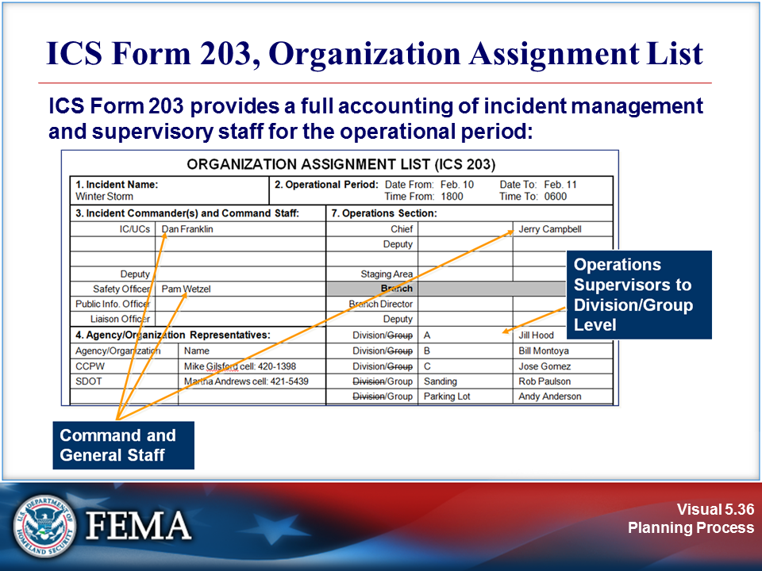 | View the sample on the next page.
Your Notes

Sample: Sample Organization Assignment List, ICS Form 203

1. Incident Name: Winter Storm |  |  | 2. Operational Period: Date From: Feb. 10 Date To: Feb. 11  Time From: 1800 Time To: 0600
3. Incident Commander(s) and Command Staff: |  |  |  |  | 7. Operations Section:
IC/UCs | Jerry Franklin |  |  |  | Chief |  | Dan Campbell
 |  |  |  |  | Deputy
Deputy |  |  |  |  | Staging Area
Safety Officer | Pam Alice |  |  |  | Branch
Public Info. Officer |  |  |  |  | Branch Director
Liaison Officer |  |  |  |  | Deputy
4. Agency/Organization Representatives: |  |  |  |  | Division/Group | A | Bill Hood
Agency/Organization |  | Name |  |  | Division/Group | B | Andy Montoya
CCPW |  | Martha Gilsford cell: xxx-xxxx |  |  | Division/Group | C | Jose Gomez
SDOT |  | Mike Andrews cell: xxx-xxxx |  |  | Division/Group | Sanding | Rob Paul
 |  |  |  |  | Division/Group | Parking Lot | Jill Anderson
 |  |  |  |  | Branch
 |  |  |  |  | Branch Director
 |  |  |  |  | Deputy
5. Planning Section: |  |  |  |  | Division/Group
Chief |  | Walker Wetzel |  |  | Division/Group
Deputy |  |  |  |  | Division/Group
Resources Unit |  | Karen Fry |  |  | Division/Group
Situation Unit |  | Linda Tom |  |  | Division/Group
Documentation Unit |  | Wilson Parks |  |  | Branch
Demobilization Unit |  |  |  |  | Branch Director
Technical Specialists |  |  |  |  | Deputy
NOAA Weather |  | -378- |  |  | Division/Group
 |  |  |  |  | Division/Group
 |  |  |  |  | Division/Group
6. Logistics Section: |  |  |  |  | Division/Group
Chief |  | Sherrie Hillman |  |  | Division/Group
Deputy |  |  |  |  | Air Operations Branch
Support Branch |  |  |  |  | Air Ops Branch Dir.
Director
Supply Unit |  | Jon Carter
Facilities Unit |  |  |  |  | 8. Finance/Administration Section:
Ground Support Unit |  | Jessica Martinez |  |  | Chief | Carol Thomas
Service Branch |  |  |  |  | Deputy
Director |  |  |  |  | Time Unit
Communications Unit |  | Mike Walters |  |  | Procurement Unit | Sara White
Medical Unit |  |  |  |  | Comp/Claims Unit
Food Unit |  |  |  |  | Cost Unit
9. Prepared by: Name: Karen Fry Position/Title: Resources Unit Signature:
ICS 203 |  | IAP Page _____ |  | Date/Time: Feb. 10/1300

Visuals

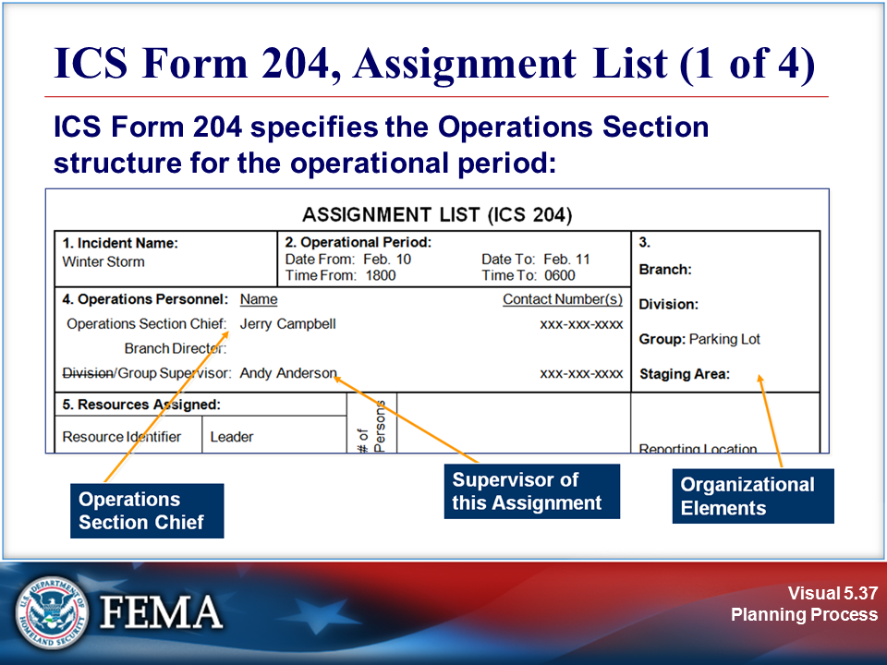 | 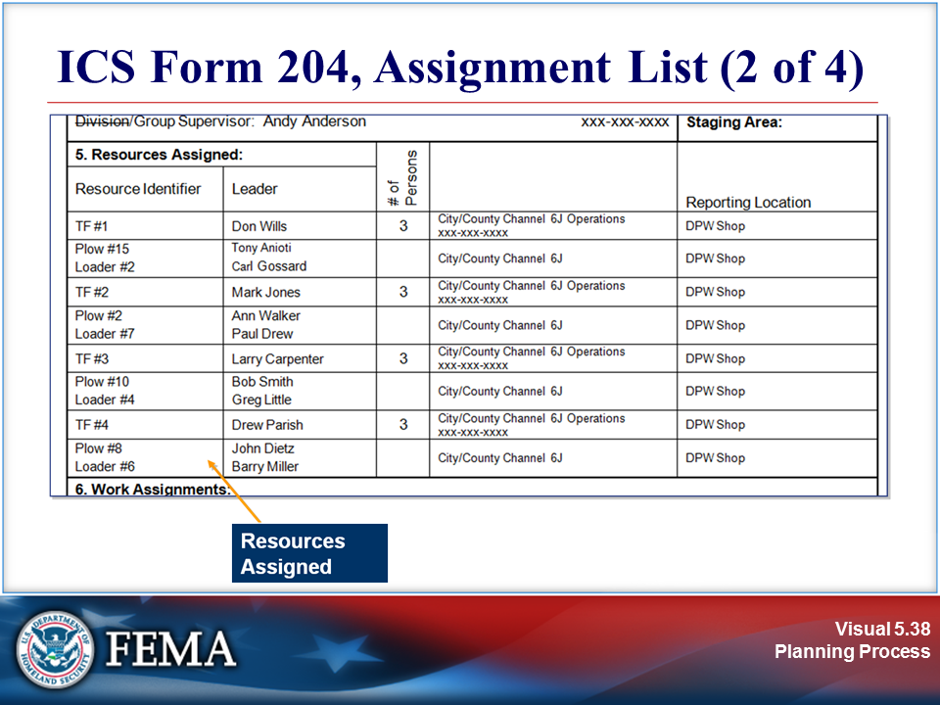
Your Notes

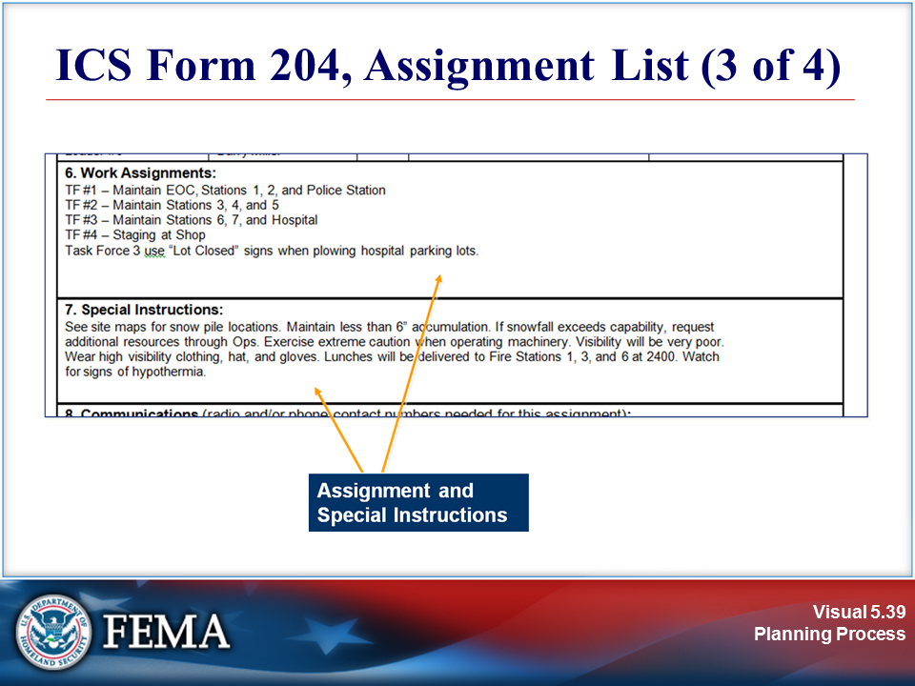 | 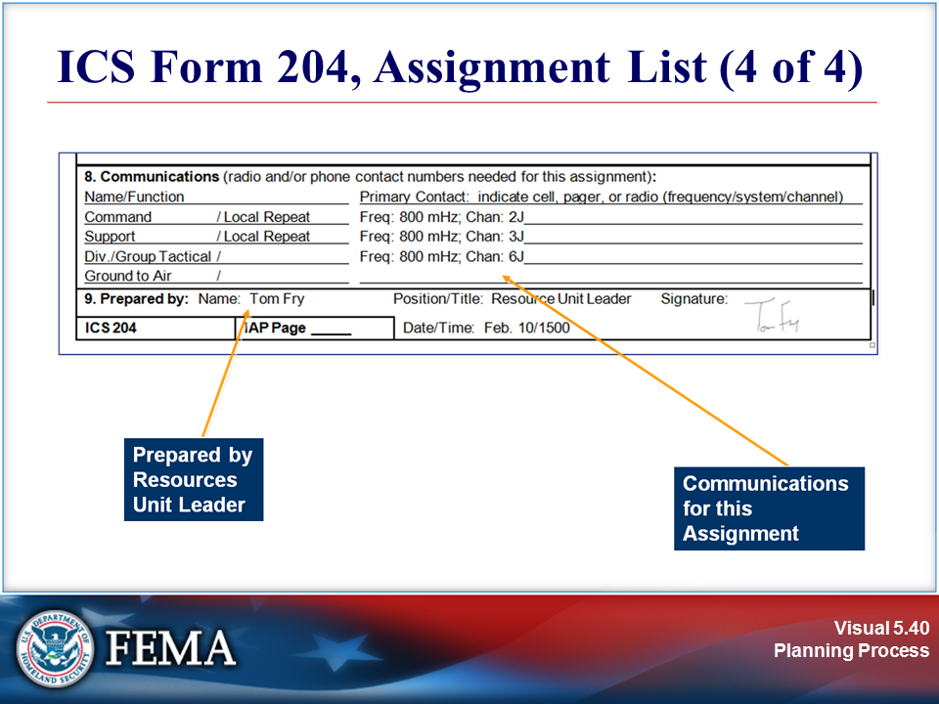
Your Notes |  | View the sample on the next page.

Sample: Sample Assignment List, ICS Form 204

1. Incident Name:  Winter Storm |  |  | 2. Operational Period:  Date From: Feb. 10 Date To: Feb. 11  Time From: 1800 Time To: 0600 |  |  |  | 3.  Branch: 1  Division: 1  Group: Parking Lot 1  Staging Area: 1
4. Operations Personnel: Name Contact Number(s)
Operations Section Chief: Dan Campbell xxx-xxx-xxxx
Branch Director:
Division/Group Supervisor: Andy Anderson xxx-xxx-xxxx
5. Resources Assigned: |  |  |  | # of  Persons |  |  | Reporting Location
Resource Identifier | Leader
TF #1 | Carl Wills |  |  | 3 |  | City/County Channel 6J Operations  xxx-xxx-xxxx | DPW Shop
Plow #15  Loader #2 | Don Anioti  Tony Gossard |  |  |  |  | City/County Channel 6J | DPW Shop
TF #2 | Paul Jones |  |  | 3 |  | City/County Channel 6J Operations  xxx-xxx-xxxx | DPW Shop
Plow #2  Loader #7 | Walker Wetzel  Mark Drew |  |  |  |  | City/County Channel 6J | DPW Shop
TF #3 | Greg Carpenter |  |  | 3 |  | City/County Channel 6J Operations  xxx-xxx-xxxx | DPW Shop
Plow #10  Loader #4 | Bob Smith  Larry Little |  |  |  |  | City/County Channel 6J | DPW Shop
TF #4 | Barry Parish |  |  | 3 |  | City/County Channel 6J Operations  xxx-xxx-xxxx | DPW Shop
Plow #8  Loader #6 | Drew Dietz  John Miller |  |  |  |  | City/County Channel 6J | DPW Shop
6. Work Assignments:
TF #1 – Maintain EOC, Stations 1, 2, and Police Station
TF #2 – Maintain Stations 3, 4, and 5
TF #3 – Maintain Stations 6, 7, and Hospital
TF #4 – Staging at Shop
Task Force 3 uses “Lot Closed” signs when plowing hospital parking lots.
7. Special Instructions:
See site maps for snow pile locations. Maintain less than 6” accumulation. If snowfall exceeds capability, request
additional resources through Ops. Exercise extreme caution when operating machinery. Visibility will be very poor.
Wear high visibility clothing, hat, and gloves. Lunches will be delivered to Fire Stations 1, 3, and 6 at 2400. Watch
for signs of hypothermia.
8. Communications (radio and/or phone contact numbers needed for this assignment):
Name/Function Primary Contact: indicate cell, pager, or radio (frequency/system/channel)
Command / Local Repeat Freq: 800 mHz; Chan: 2J
Support / Local Repeat Freq: 800 mHz; Chan: 3J
Div./Group Tactical / Freq: 800 mHz; Chan: 6J
Ground to Air /
9. Prepared by: Name: Karen Fry Position/Title: Resource Unit Leader Signature:
ICS 204 |  | IAP Page _____ |  |  | Date/Time: Feb. 10/1500

Visuals

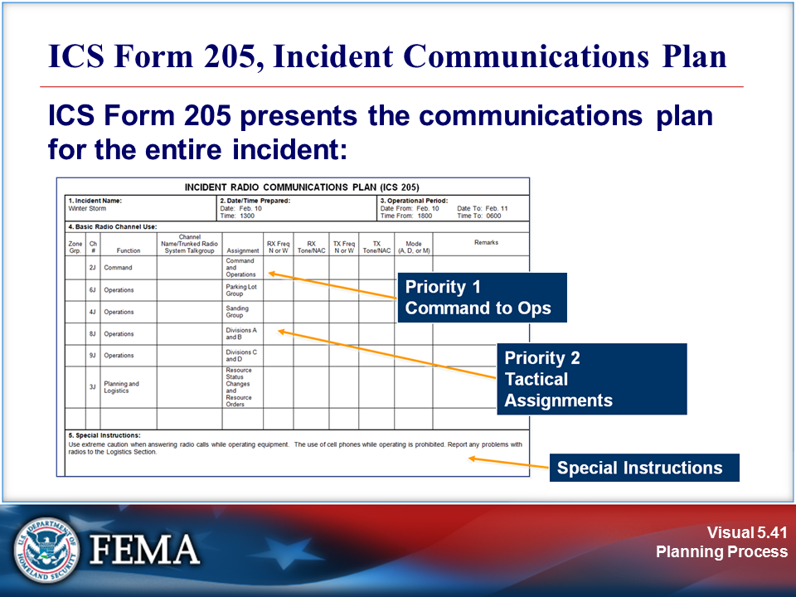 | View the sample on the next page.
Your Notes

Sample: Sample Incident Communications Plan, ICS Form 205

1. Incident Name:  Winter Storm |  |  |  |  |  | 2. Date/Time Prepared:  Date: Feb. 10  Time: 1300 |  |  |  |  |  |  |  |  |  |  | 3. Operational Period:  Date From: Feb. 10 Date To: Feb. 11  Time From: 1800 Time To: 0600
4. Basic Radio Channel Use:
Zone Grp. | Ch # | Function |  | Channel Name/Trunked Radio System Talkgroup |  |  |  | Assignment |  |  | RX Freq N or W |  | RX Tone/NAC |  | TX Freq N or W | TX Tone/NAC |  | Mode  (A, D, or M) | Remarks
 | 2J | Command |  |  |  |  | Command and Operations
 | 6J | Operations |  |  |  |  | Parking Lot Group
 | 4J | Operations |  |  |  |  | Sanding Group
 | 8J | Operations |  |  |  |  | Divisions A and B
 | 9J | Operations |  |  |  |  | Divisions C and D
 | 3J | Planning and Logistics |  |  |  |  | Resource Status Changes and Resource Orders
5. Special Instructions:
Use extreme caution when answering radio calls while operating equipment. The use of cell phones while operating is prohibited. Report any problems with radios to the Logistics Section.
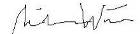6. Prepared by (Communications Unit Leader): Name: Mike Walters Signature:
ICS 205 |  |  |  |  | IAP Page _____ |  |  |  | Date/Time: Feb. 10/1300

Visuals

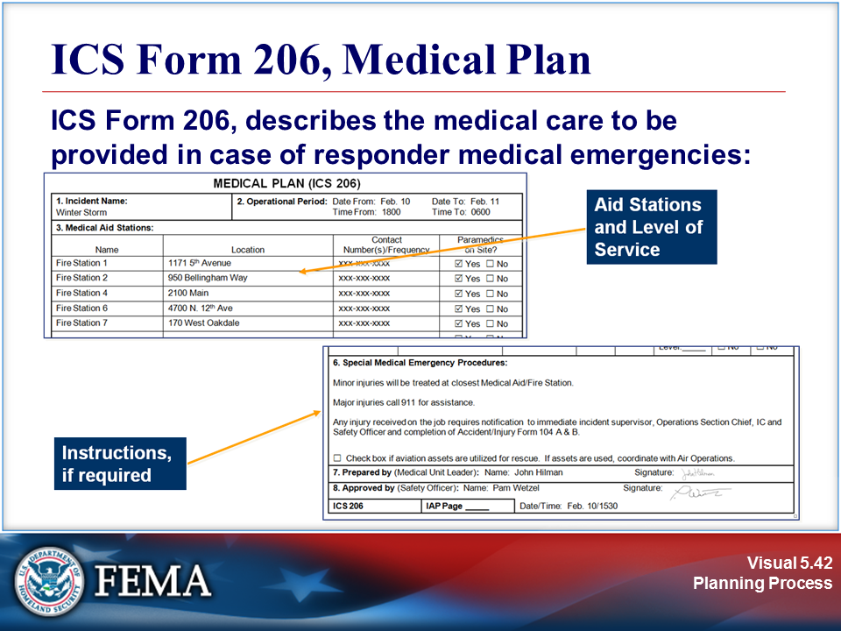 | View the sample on the next page.
Your Notes

Sample: Sample Medical Plan, ICS Form 206

1. Incident Name:  Winter Storm |  |  |  |  | 2. Operational Period: Date From: Feb. 10 Date To: Feb. 11  Time From: 1800 Time To: 0600
3. Medical Aid Stations:
Name |  |  | Location |  |  |  |  | Contact Number(s)/Frequency |  |  | Paramedics  on Site?
Fire Station 1 |  |  | 1171 5th Avenue |  |  |  |  | xxx-xxx-xxxx |  |  | Yes No
Fire Station 2 |  |  | 950 Bellingham Way |  |  |  |  | xxx-xxx-xxxx |  |  | Yes No
Fire Station 4 |  |  | 2100 Main |  |  |  |  | xxx-xxx-xxxx |  |  | Yes No
Fire Station 6 |  |  | 4700 N. 12th Ave |  |  |  |  | xxx-xxx-xxxx |  |  | Yes No
Fire Station 7 |  |  | 170 West Oakdale |  |  |  |  | xxx-xxx-xxxx |  |  | Yes No
 |  |  |  |  |  |  |  |  |  |  | Yes No
4. Transportation (indicate air or ground):
Ambulance Service |  |  | Location |  |  |  |  | Contact Number(s)/Frequency |  |  | Level of Service
 |  |  |  |  |  |  |  |  |  |  | ALS BLS
 |  |  |  |  |  |  |  |  |  |  | ALS BLS
 |  |  |  |  |  |  |  |  |  |  | ALS BLS
 |  |  |  |  |  |  |  |  |  |  | ALS BLS
5. Hospitals:
Hospital Name | Address,  Latitude & Longitude  if Helipad |  |  | Contact Number(s)/ Frequency |  |  | Travel Time |  |  | Trauma Center | Burn Center | Helipad
 |  |  |  |  |  |  | Air |  | Ground
Meridian | 500 W. Oakdale |  |  | xxx-xxx-xxxx |  |  | 15 |  | 45 | Yes  Level:_____ | Yes No | Yes No
 |  |  |  |  |  |  |  |  |  | Yes  Level:_____ | Yes No | Yes No
 |  |  |  |  |  |  |  |  |  | Yes  Level:_____ | Yes No | Yes No
6. Special Medical Emergency Procedures:

Minor injuries will be treated at closest Medical Aid/Fire Station.

Major injuries call 911 for assistance.

Any injury received on the job requires notification to immediate incident supervisor, Operations Section Chief, IC and Safety Officer and completion of Accident/Injury Form 104 A & B.
Check box if aviation assets are utilized for rescue. If assets are used, coordinate with Air Operations.
7. Prepared by (Medical Unit Leader): Name: Sherrie Hillman Signature:
8. Approved by (Safety Officer): Name: Pam Alice Signature:
ICS 206 |  | IAP Page _____ |  |  |  | Date/Time: Feb. 10/1530

Visuals

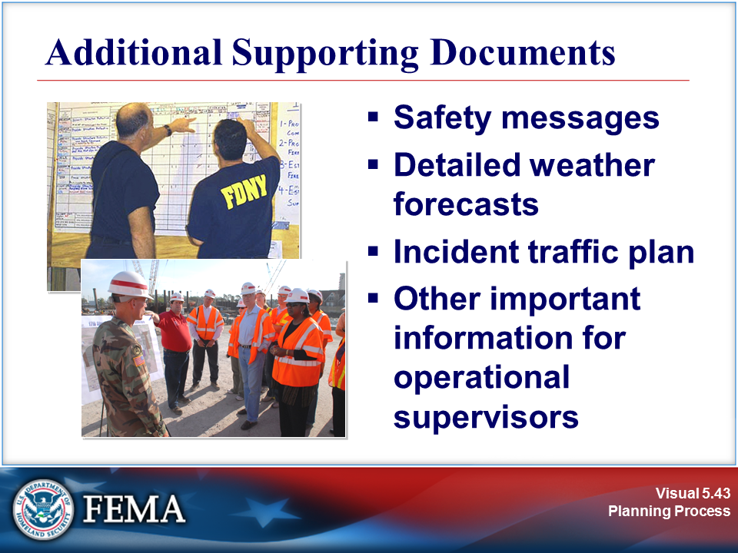 | 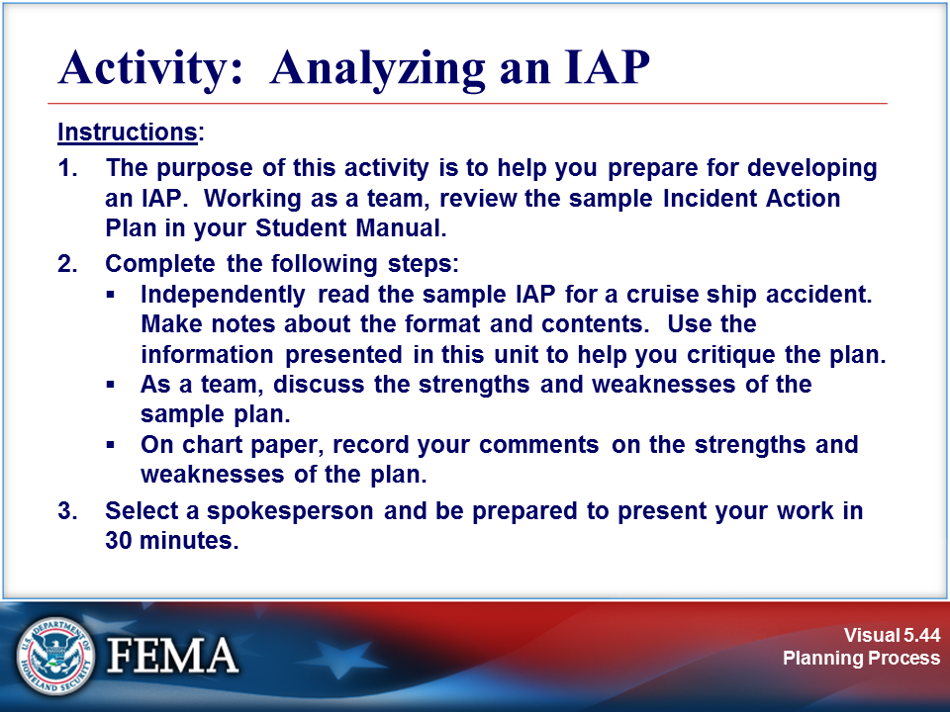
Your Notes

Complete the activity before proceeding.

Sample: Sample IAP (Page 1 of 9)

Incident Objectives (ICS 202)
1. Incident Name: Cruise Ship HazMat Spill |  | 2. Operational Period: Date From: Aug 19 Date To: Aug 19  Time From: 0600 Time To: 1800
3. Objective(s):

- Assist the cruise line and the USCG in ensuring that there are no injuries to the ship’s crew, nor to any of the incident responders.
- Assist the USCG in preventing the discharge of any further hazardous materials into the water and contain any spilled materials; plan for contingencies.
- Assess and document the potential for environmental damage should there be a further discharge of hazardous materials from the cruise ship. Plan for contingencies.
- Prevent damage to natural and cultural resources.
- Assist the USCG and cruise line in arranging and carrying out the safe passage of the ship out of the bay and out of the Park.

4. Operational Period Command Emphasis:

Maintain vigilance to avoid injuries or further environmental damage.

General Situational Awareness

(See attached Safety Message)
A moderate low pressure system is moving southerly from the Anchorage area and is expected to be in the Glacier Bay area by noon today.
Temperature: 60 to 65 degrees
Relative Humidity: 60 to 75%
Winds: west @ 10 to 18 knots
Seas: 3-foot swells with moderate to heavy chop
Sunrise: 0534 AKDT; Sunset: 2040 AKDT
Tides: Highs at 0256 (+18.7) and 1526 (+18.8); Lows at 0921 (-3.3) and 2143 (-1.8)

5. Site Safety Plan Required? Yes No
Approved Site Safety Plan(s) Located at:

6. Incident Action Plan (the items checked below are included in this Incident Action Plan):
ICS 203 ICS 207 Other Attachments:
ICS 204 ICS 208 Safety Message
ICS 205 Map/Chart
ICS 205A Weather Forecast/Tides/Currents
ICS 206
7. Prepared by: Name: Walker Wetzel Position/Title: PSC Signature:

8. Approved by Incident Commander: Name: Jerry Franklin Signature:
ICS 202 | IAP Page __1___ |  | Date/Time: 08-19-XX/0200

Sample: Sample IAP (Page 2 of 9)

ORGANIZATION ASSIGNMENT LIST (ICS 203)
1. Incident Name: Cruise Ship HazMat Spill |  |  | 2. Operational Period: Date From: Aug 19 Date To: Aug 19  Time From: 0600 Time To: 1800
3. Incident Commander(s) and Command Staff: |  |  |  |  | 7. Operations Section:
IC/UCs | Jerry Franklin |  |  |  | Chief | Dan Campbell
 | Xxxx Unified Command |  |  |  | Deputy
Deputy |  |  |  |  | Staging Area
Safety Officer | Pam Alice |  |  |  | Branch
Public Info. Officer | IOF2 |  |  |  | Branch Director
Liaison Officer |  |  |  |  | Deputy
4. Agency/Organization Representatives: |  |  |  |  | Division/Group | Vessel Stabilization | Aaron Brandon (USCG)
Agency/Organization |  | Name |  |  | Division/Group | Nat. Resc. Assessment | Carol Cartright (NPS)
NTSB |  | Shirley Prop |  |  | Division/Group | Salvage/Removal | Tyrone Pickerell (USCG)
AK DEC |  | Nick Hanson |  |  | Division/Group
 |  |  |  |  | Division/Group
 |  |  |  |  | Branch
 |  |  |  |  | Branch Director
 |  |  |  |  | Deputy
5. Planning Section: |  |  |  |  | Division/Group
Chief |  | Walker Wetzel |  |  | Division/Group
Deputy |  |  |  |  | Division/Group
Resources Unit |  |  |  |  | Division/Group
Situation Unit |  |  |  |  | Division/Group
Documentation Unit |  |  |  |  | Branch
Demobilization Unit |  |  |  |  | Branch Director
Technical Specialists |  |  |  |  | Deputy
-Oil Spill |  | Cordell Royball |  |  | Division/Group
-Investigator |  | Russ Williams |  |  | Division/Group
-Investigator |  | John Collingsworth |  |  | Division/Group
6. Logistics Section: |  |  |  |  | Division/Group
Chief |  | Sherrie Hillman |  |  | Division/Group
Deputy |  |  |  |  | Air Operations Branch
Support Branch |  |  |  |  | Air Ops Branch Dir.
Director |  |  |  |  | Helicopter Coordinator | Will Range (USCG)
Supply Unit
Facilities Unit |  |  |  |  | 8. Finance/Administration Section:
Ground Support Unit |  |  |  |  | Chief | FSC2
Service Branch |  |  |  |  | Deputy
Director |  |  |  |  | Time Unit | John Wayne
Communications Unit |  | Rick Lewin |  |  | Procurement Unit
Medical Unit |  | LaVell Patton |  |  | Comp/Claims Unit
Food Unit |  |  |  |  | Cost Unit | Mike Bannister
9. Prepared by: Name: Walker Wetzel Position/Title: PSC Signature:
ICS 203 |  | IAP Page __2___ |  | Date/Time: 08-19-XX/0200

Sample: Sample IAP (Page 3 of 9)

ASSIGNMENT LIST (ICS 204)
1. Incident Name:  Cruise Ship HazMat Spill |  |  | 2. Operational Period:  Date From: 08/19/XX Date To: 08/19/XX  Time From: 0600 Time To: 1800 |  |  |  | 3.  Branch: 1  Division: 1  Group: Vessel Stabilization 1  Staging Area: 1
4. Operations Personnel: Name Contact Number(s)
Operations Section Chief: Dan Campbell Channel 1
Branch Director:
Division/Group Supervisor: Aaron Brandon (USCG) Channel 5
5. Resources Assigned: |  |  |  | # of  Persons |  | Contact (e.g., phone, pager, radio frequency, etc.) | Reporting Location, Special Equipment and Supplies, Remarks, Notes, Information
Resource Identifier | Leader
Boom operations | Joe Watson |  |  | 3 |  | xxx-xxx-xxxx | Shag Cove/0730  BC Docks/0600
Pump operations | Ward Pecard |  |  | 3 |  | xxx-xxx-xxxx | Shag Cove/0730  BC Docks/0600
Radio crew | Jason Shep |  |  | 2 |  | xxx-xxx-xxxx | Shag Cove/0730  BC Docks/0600
6. Work Assignments:
--Assist the Coast Guard and the ship’s crew in insuring the safety of the crew by assuring that everyone wears prescribed safety equipment and crew is not directly exposed to hazardous or toxic materials.
--Assist the Communications Unit Leader with the installation of a radio repeated.
--Maintain boom material currently in place. Assure that it continues to contain hazardous materials.
--Operate pumps on board the YC to continue to reduce flooded compartments.
--Prevent, if possible, the discharge of any additional hazardous materials into the bay waters.
7. Special Instructions:

Complete a Unit Log. Debrief at the end of the operational period.
8. Communications (radio and/or phone contact numbers needed for this assignment):
Name/Function Primary Contact: indicate cell, pager, or radio (frequency/system/channel)
Command / Local Freq: 166.200; System: NIFC; Chan: 1
Command / Repeat Freq: 166.500; System: NIFC; Chan: 5
Status/Logistics / Local Freq: 157.10; System: GLBA; Chan: 3
Status/Logistics / Repeat Freq: 166.500; System: NIFC; Chan: 5
Group Tactical / On YC Freq: 168.825; System: GLBA; Chan: 2
Group Tactical / W/ USCG Freq: 157.100; System: GLBA; Chan: 6
Ground to Air / Freq: 168.575; System: GLBA; Chan: 8

9. Prepared by: Name: Walker Wetzel Position/Title: PSC Signature:
ICS 204 |  | IAP Page __3___ |  |  | Date/Time: 08/09/XX,/0200

Sample: Sample IAP (Page 4 of 9)

ASSIGNMENT LIST (ICS 204)
1. Incident Name:  Cruise Ship HazMat Spill |  |  | 2. Operational Period:  Date From: 08/19/XX Date To: 08/19/XX  Time From: 0600 Time To: 1800 |  |  |  | 3.  Branch: 1  Division: 1  Group: Natural Resources Assessment 1  Staging Area: 1
4. Operations Personnel: Name Contact Number(s)
Operations Section Chief: Dan Campbell Channel 11 & Channel 1
Branch Director:
Division/Group Supervisor: Carol Cartright Channel 11 & Channel 1
5. Resources Assigned: |  |  |  | # of  Persons |  | Contact (e.g., phone, pager, radio frequency, etc.) | Reporting Location, Special Equipment and Supplies, Remarks, Notes, Information
Resource Identifier | Leader
Biotech Team 1 | Bud Ricer |  |  | 2 |  | Channel 11 | Shag Cove/0730  BC Docks/0600
NR Planning | Gail Irvington |  |  | 3 |  | Channel 11
Biotech Team 2 | Steve Taggert |  |  | 2 |  | Channel 11 | Gustavis Airport/ 1100  Gustavis Airport/ 0700
6. Work Assignments:

Develop contingency plans for the following:
--Fuel spill while the vessel remains in Shag Cove.
--Fuel spill during the movement of the vessel from Shag Cove out of the park.
--Fuel spill in Bartlett Cove if the vessel is stored there.
--Catastrophic structural failure of the vessel resulting in it sinking.
Conduct ground survey of Shag Cove shore to determine extent, if any, that hazardous materials are reaching shore.
Conduct aerial survey of the bay; map bird concentrations.
7. Special Instructions:

Complete a Unit Log. Debrief at the end of operational period.
8. Communications (radio and/or phone contact numbers needed for this assignment):
Name/Function Primary Contact: indicate cell, pager, or radio (frequency/system/channel)
Command / Local Freq: 166.200; System: NIFC; Chan: 1
Command / Repeat Freq: 166.500; System: NIFC; Chan: 5
Status/Logistics / Local Freq: 157.10; System: GLBA; Chan: 3
Status/Logistics / Repeat Freq: 166.500; System: NIFC; Chan: 5
Group Tactical / Freq: 167.200; System: NIFC; Chan: 11
Ground to Air / Freq: 168.575; System: GLBA; Chan: 8
9. Prepared by: Name: Walker Wetzel Position/Title: PSC Signature:
ICS 204 |  | IAP Page __4___ |  |  | Date/Time: 08/09/XX / 0200

Sample: Sample IAP (Page 5 of 9)

ASSIGNMENT LIST (ICS 204)
1. Incident Name:  Cruise Ship HazMat Spill |  |  | 2. Operational Period:  Date From: 08/19/XX Date To: 08/19/XX  Time From: 0600 Time To: 1800 |  |  |  | 3.  Branch: 1  Division: 1  Group: Vessel Salvage/Removal 1  Staging Area: 1
4. Operations Personnel: Name Contact Number(s)
Operations Section Chief: Dan Campbell xxx-xxx-xxxx
Branch Director:
Division/Group Supervisor: Duane Jefferson (USCG) xxx-xxx-xxxx
5. Resources Assigned: |  |  |  | # of  Persons |  | Contact (e.g., phone, pager, radio frequency, etc.) | Reporting Location, Special Equipment and Supplies, Remarks, Notes, Information
Resource Identifier | Leader
Dive operations | Tyrone Pickerell (USCG) |  |  | 8 |  | xxx-xxx-xxxx
6. Work Assignments:

--Conduct repairs on the hull of the YC sufficient to allow the vessel to be moved safety out of the Park and to a designated repair facility.
--Prevent, if possible, the discharge of any hazardous materials into the bay waters.
7. Special Instructions:

Complete a Unit Log. Debrief at the end of the operational period.
8. Communications (radio and/or phone contact numbers needed for this assignment):
Name/Function Primary Contact: indicate cell, pager, or radio (frequency/system/channel)
Command / Local Freq: 166.200; System: NIFC; Chan: 1
Command / Repeat Freq: 166.500; System: NIFC; Chan: 5
Status/Logistics / Local Freq: 157.10; System: GLBA; Chan: 3
Status/Logistics / Repeat Freq: 166.500; System: NIFC; Chan: 5
Group Tactical / On YC Freq: 168.825; System: GLBA; Chan: 2
Group Tactical / W/ USCG Freq: 157.100; System: GLBA; Chan: 6
Ground to Air / Freq: 168.575; System: GLBA; Chan: 8
9. Prepared by: Name: Walker Wetzel Position/Title: PSC Signature:
ICS 204 |  | IAP Page __5___ |  |  | Date/Time: 08/09/XX/0200

Sample: Sample IAP (Page 6 of 9)

Incident Radio Communications Plan (ICS 205)
 | 1. Incident Name:  Cruise Ship HazMat Spill |  |  |  |  | 2. Date/Time Prepared:  Date:  Time: |  |  |  |  |  |  | 3. Operational Period:  Date From: Date To:  Time From: Time To:
 | 4. Basic Radio Channel Use:
 | Zone Grp. | Ch # | Function | Channel Name/Trunked Radio System Talkgroup |  |  | Assignment |  | RX Freq N or W | RX Tone/NAC | TX Freq N or W | TX Tone/NAC |  | Mode  (A, D, or M) | Remarks
 |  | 1 | Command | NIFC |  |  | Command and General Staff and Group Supervisors |  | 166.200
 |  | 2 | Local on YC | GLBA |  |  | Local on YC |  | 168.825 |  |  |  |  |  | Internal communications on YC
 |  | 3 | Logistics | GLBA |  |  | Logistics |  | 166.300
 |  | 5 | Tactical (through Repeater) | NIFC |  |  | Group Supervisors on YC |  | 166.500 |  |  |  |  |  | Communications between YC and ICP
 |  | 6 | Tactical w/ USCG | GLBA |  |  | Command and USCG |  | 157.100 |  |  |  |  |  | Group Supervisors scan this frequency
 |  | 7 | Tactical | GLBA |  |  | Investigation |  | 166.600
 |  | 8 | Air-Ground | GLBA |  |  | Aircraft Observation Dispatch |  | 168.575 |  |  |  |  |  | Flight Following
 |  | 11 | Tactical (through Repeater) | NIFC |  |  | NR Assessment Group |  | 167.200
 | 5. Special Instructions:
6. Prepared by (Communications Unit Leader): Name: Sherrie Hillman Signature:
ICS 205 |  |  |  |  | IAP Page __6___ |  |  | Date/Time: 08-19-XX, 0200

Sample: Sample IAP (Page 7 of 9)

Medical Plan (ICS 206)
1. Incident Name: Cruise Ship HazMat Spill |  |  |  |  | 2. Operational Period: Date From: Date To:  Time From: Time To:
3. Medical Aid Stations:
Name |  |  | Location |  |  |  |  | Contact Number(s)/Frequency |  |  | Paramedics  on Site?
NPS EMT’s |  |  | Cruise ship |  |  |  |  | xxx-xxx-xxxx |  |  | Yes No
NPS – GLBA HQ |  |  | Bartlett Cove |  |  |  |  | xxx-xxx-xxxx |  |  | Yes No
Gustavus Emergency Response |  |  | Gustavus |  |  |  |  | xxx-xxx-xxxx |  |  | Yes No
 |  |  |  |  |  |  |  |  |  |  | Yes No
 |  |  |  |  |  |  |  |  |  |  | Yes No
 |  |  |  |  |  |  |  |  |  |  | Yes No
4. Transportation (indicate air or ground):
Ambulance Service |  |  | Location |  |  |  |  | Contact Number(s)/Frequency |  |  | Level of Service
Gustavus Emergency Response |  |  | Gustavus |  |  |  |  | xxx-xxx-xxxx |  |  | ALS BLS
 |  |  |  |  |  |  |  |  |  |  | ALS BLS
 |  |  |  |  |  |  |  |  |  |  | ALS BLS
5. Hospitals:
Hospital Name | Address,  Latitude & Longitude  if Helipad |  |  | Contact Number(s)/ Frequency |  |  | Travel Time |  |  | Trauma Center | Burn Center | Helipad
 |  |  |  |  |  |  | Air |  | Ground
Bartlett Memorial | 3260 Hospital Drive, Juneau |  |  | xxx-xxx-xxxx |  |  | 1 hr |  | n/a | Yes  Level:_____ | Yes No | Yes No
 |  |  |  |  |  |  |  |  |  | Yes  Level:_____ | Yes No | Yes No
 |  |  |  |  |  |  |  |  |  | Yes  Level:_____ | Yes No | Yes No
 |  |  |  |  |  |  |  |  |  | Yes  Level:_____ | Yes No | Yes No
 |  |  |  |  |  |  |  |  |  | Yes  Level:_____ | Yes No | Yes No
6. Special Medical Emergency Procedures:

If necessary, a float plane will be dispatched from Glacier Bay Airways (697-2249 or 789-9009) and the victim will be flown to Juneau.
Conduct GLBA Dispatch in the event of ANY injury.
Check box if aviation assets are utilized for rescue. If assets are used, coordinate with Air Operations.
7. Prepared by (Medical Unit Leader): Name: Sherrie Hillman Signature:

8. Approved by (Safety Officer): Name: Pam Alice Signature:
ICS 206 |  | IAP Page __7___ |  |  |  | Date/Time: 08-19-XX/0200

Sample: Sample IAP (Page 8 of 9)

Safety Message/Plan (ICS 208)
1. Incident Name: Cruise Ship HazMat Spill |  |  | 2. Operational Period: Date From: 08/19/XX Date To: 08/19/XX  Time From: 0600 Time To: 1800
3. Safety Message/Expanded Safety Message, Safety Plan, Site Safety Plan:

All personnel working on the incident must be aware of the following hazards and take appropriate mitigation measures:

Individuals working aboard the cruise ship must be aware of:
- Significant amounts of diesel fuel and other petroleum products are mixed with water below decks. There is both a health hazard and a fire hazard associate with these materials.

HEALTH:

Inhalation: Inhalation of high concentrations of diesel fuel vapors causes dizziness, headaches, and stupor.
Ingestion: Ingestion of diesel fuel causes irritation of stomach and intestines with nausea and vomiting.
Skin Exposure: The liquid is irritating to the skin, especially where long term contact is involved. May burn skin or eyes.

FIRST AID:

- Remove victim to fresh air. Apply appropriate actions if breathing is labored or stops.
- If ingested, do NOT induce vomiting. Give water to dilute.
- For skin exposure, remove contaminated clothing and gently flush affected areas with fresh water for 15 minutes.
- In all cases, get medical advice and medical attention as soon as possible.

FIRE: If small, use dry chemical, CO₂, foam or water spray. If large, evacuate immediately.

- Decks and passageways are likely to be very slippery. Where possible, use sand or absorbent materials to improve footing and traction.
- Rubber gloves and protective clothing must be worn at all time by those entering the damaged areas of the vessel. Respiratory equipment is also required.

For ground personnel in the backcountry and along shore in the vicinity of the YC, maintain vigilance for bears and take evasive or avoidance actions.

All personnel on boats must wear PFD’s at all time, and be aware that water temperatures are sufficiently low to cause hypothermia with short exposure times.

THINK, AND ACT, SAFELY
4. Site Safety Plan Required? Yes No
Approved Site Safety Plan(s) Located At:
5. Prepared by: Name: Pam Alice Position/Title: Safety Officer Signature:
ICS 208 |  | IAP Page __8___ |  | Date/Time: 08/19/XX/0200

Sample: Sample IAP (Page 9 of 9)

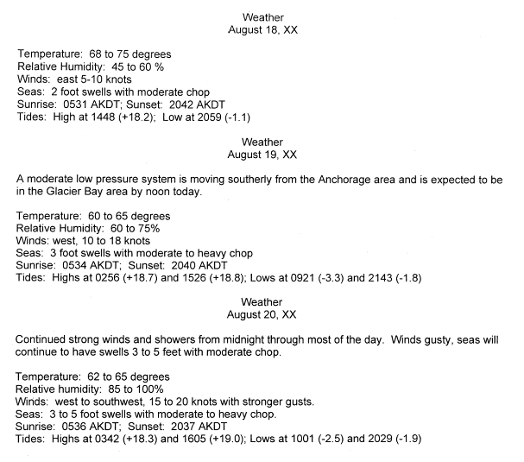

Visuals

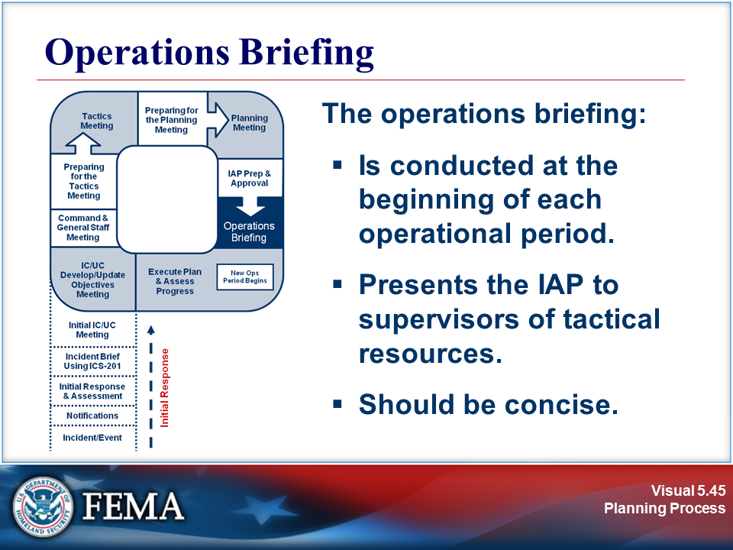 | 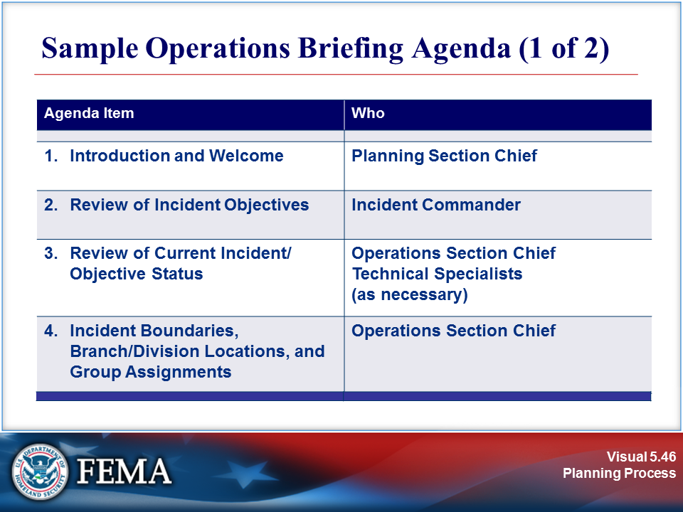
Your Notes

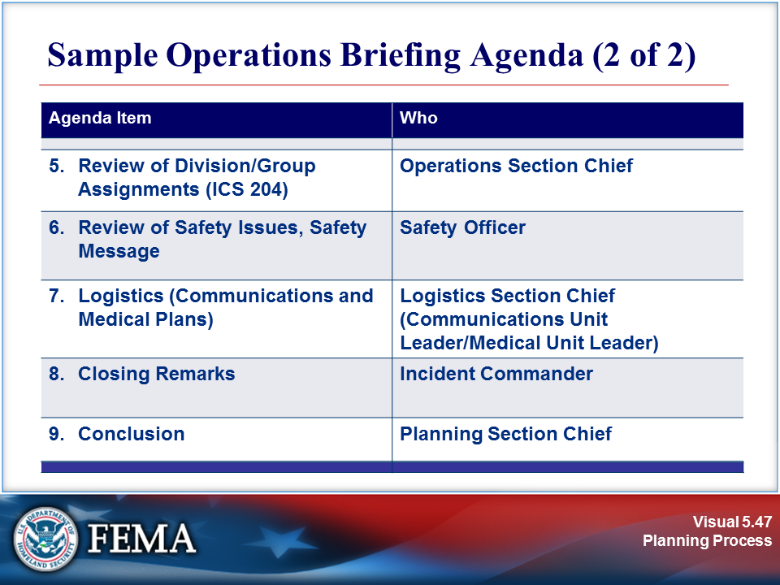 | View the sample on the next page.
Your Notes

Sample: Sample Operations Briefing Agenda

A sample operations briefing agenda is included below. Use this sample agenda as a guide for the operations briefing (also known as the shift briefing).

1. Situation Update
The Planning Section Chief provides an update of the incident, including the:
- Status of current tactical assignments.
- Response issues.
- New tactical assignments.
- Projections that may impact the next operational period.
2. Plan Review
The plan review may include last-minute “pencil” changes to the IAP and will include a discussion of each Division/Group Assignment Sheet and potential contingency plans. Each Division or Group Supervisor will have an opportunity to ask questions to clarify his or her assignment.
3. Discussion of Logistical Support Details
This item should include a review of Transportation, Communications, and Medical Plans, as well as plans for feeding and resting personnel.
4. Review of Safety Message
This item should cover the safety message and remind the Supervisors of the safety precautions that must be taken at the site.

Visuals

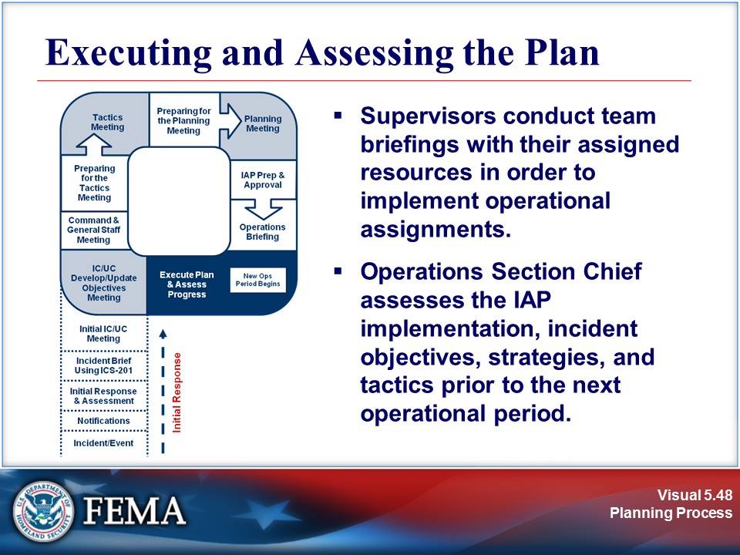 | 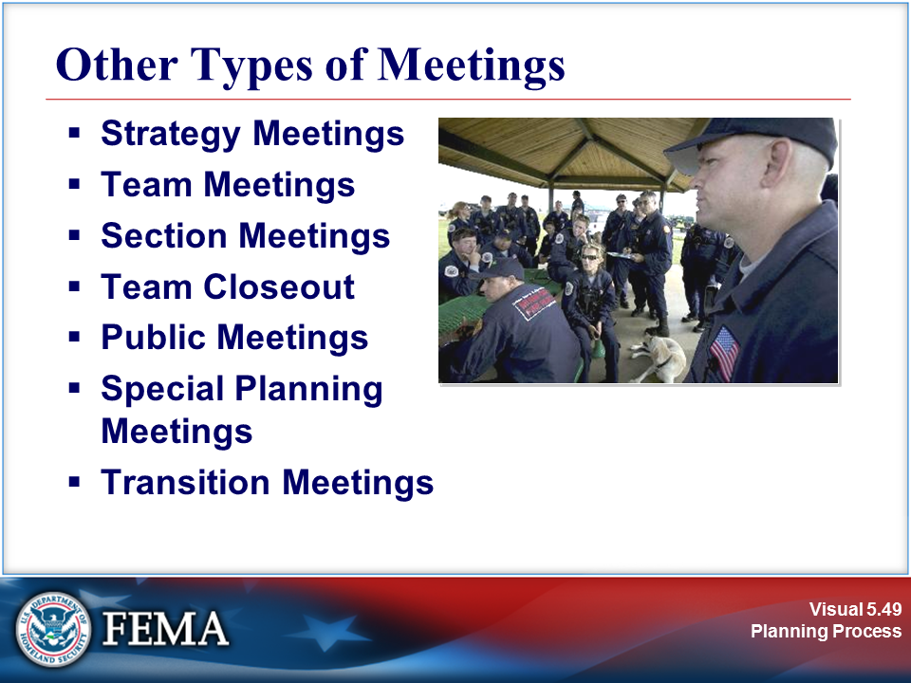
Your Notes

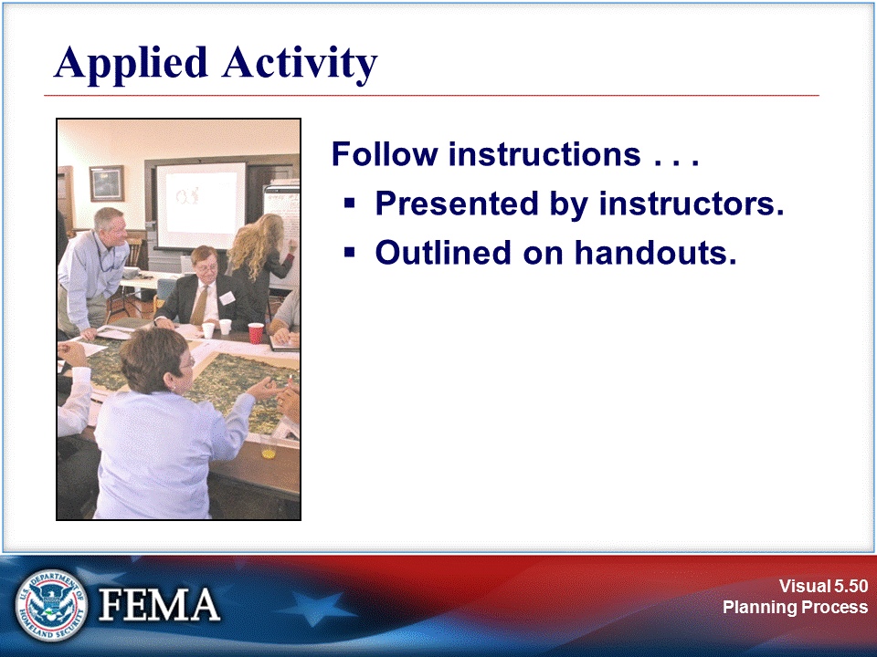 | 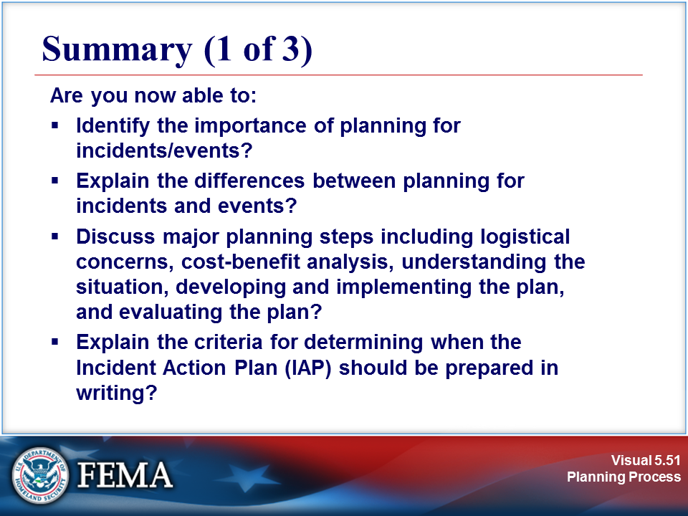
Your Notes

Visuals

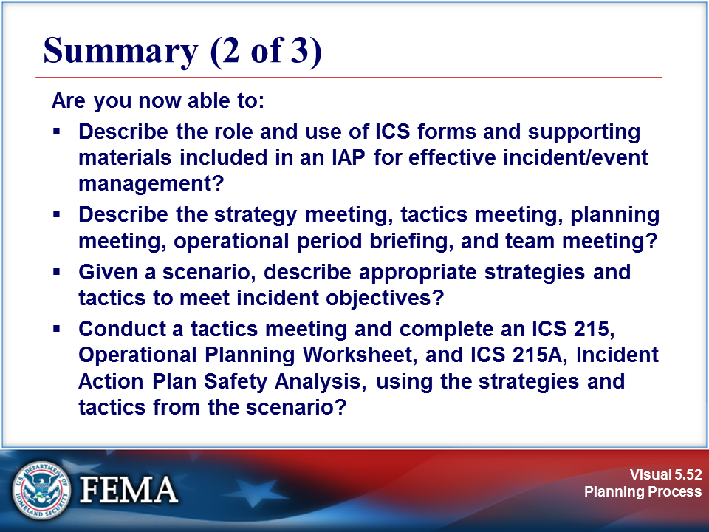 | 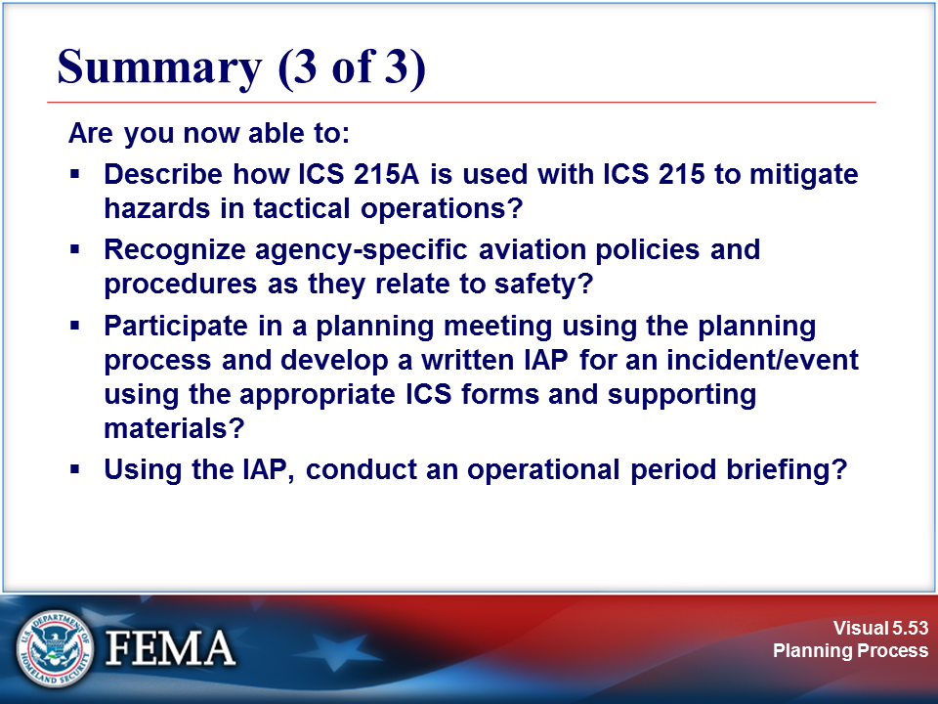
Your Notes

