Unit 6: Incident Resource Management

This page intentionally left blank.

Visuals

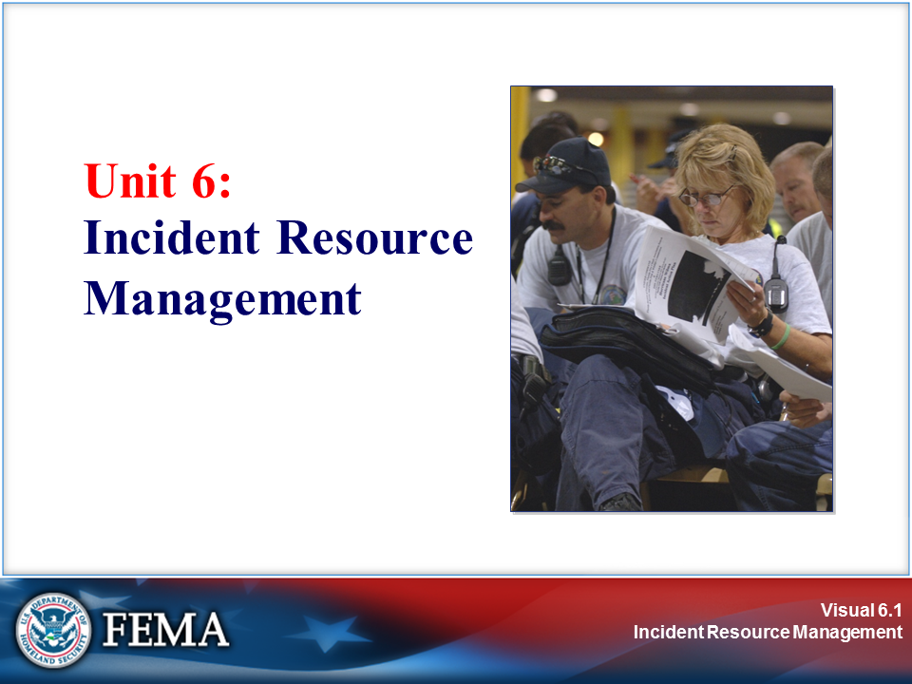 | 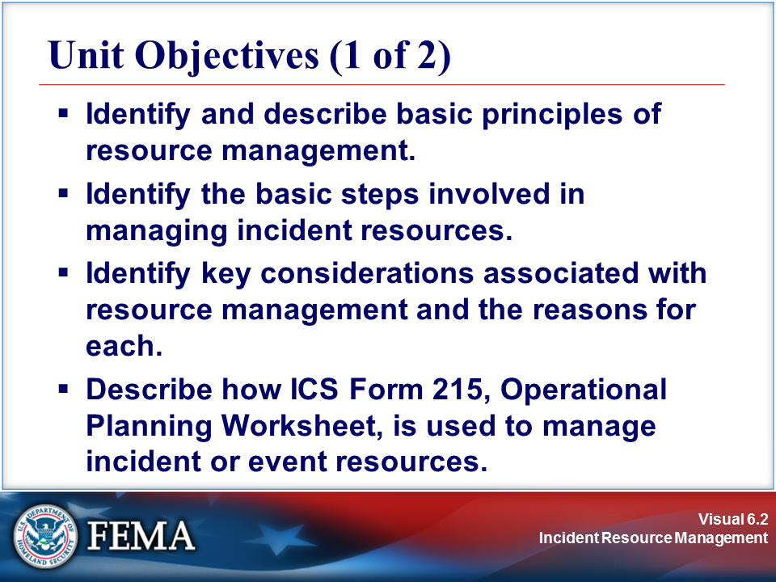
Your Notes

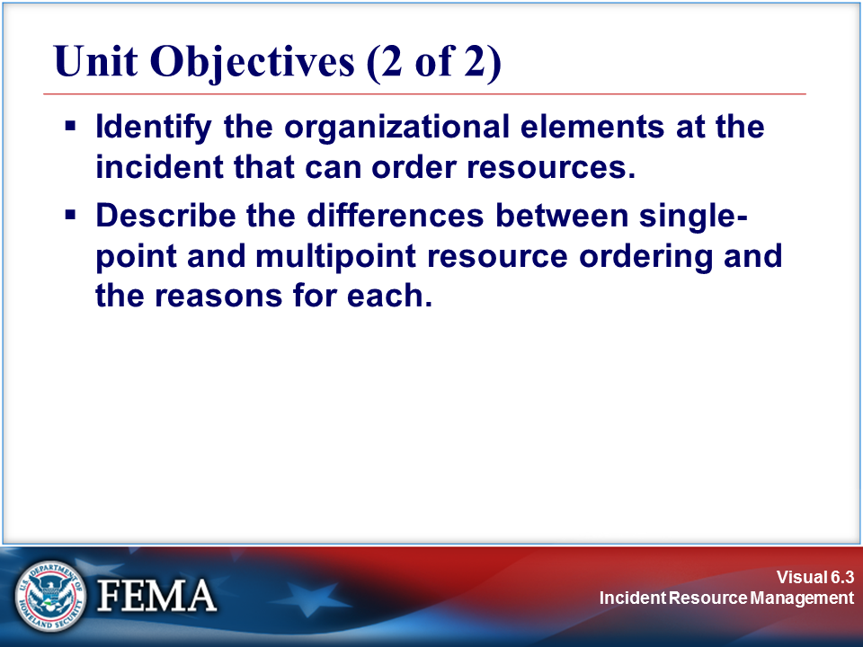 | 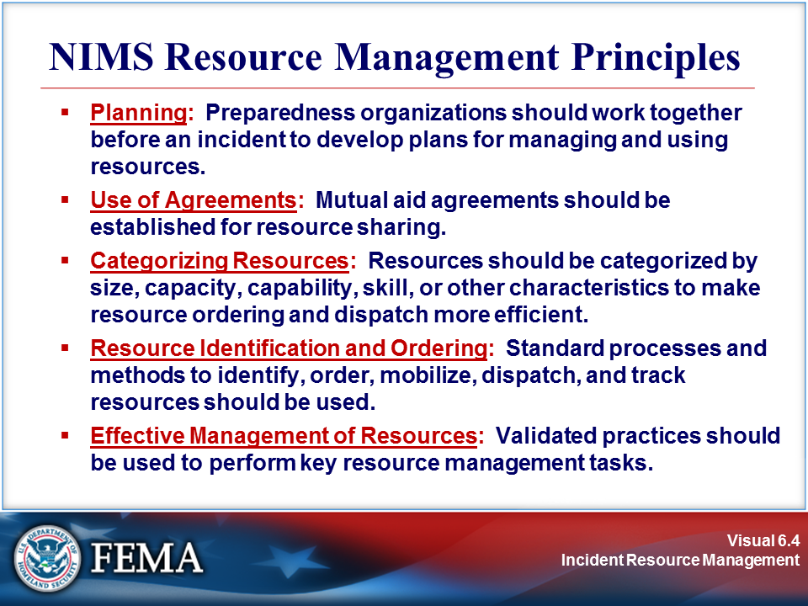
Your Notes

Visuals

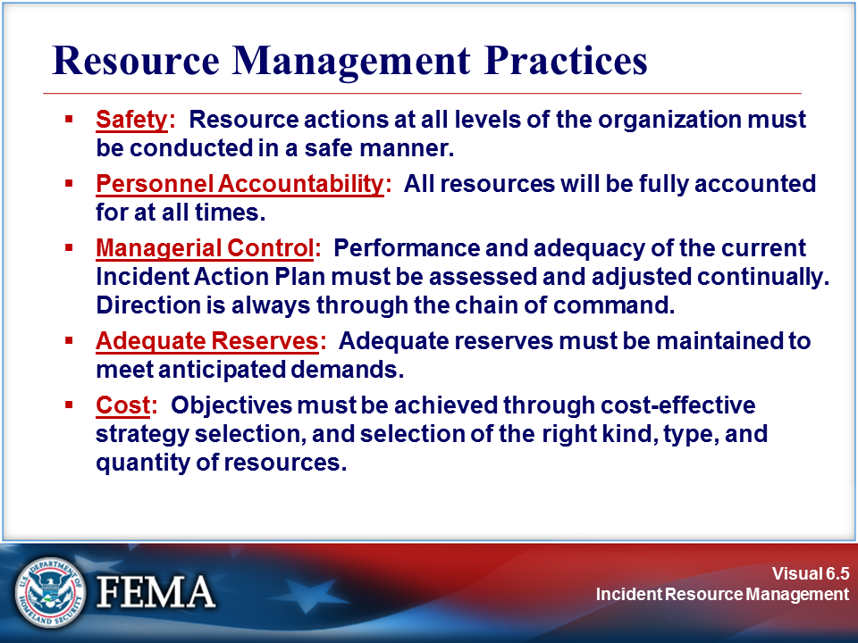 | View the job aid on the following page.
Your Notes

Job Aid: NIMS Resource Management Principles

The National Incident Management System (NIMS) includes the following principles related to resource management:

- Planning: Coordinated planning, training to common standards, and inclusive exercises provide a foundation for the interoperability and compatibility of resources throughout an incident. Jurisdictions should work together in advance of an incident to develop plans for ordering, managing, and employing resources. The planning process should include identifying resource needs based on the threats and vulnerabilities of the jurisdiction and developing alternative strategies to obtain the needed resources.

Planning may include the creation of new policies to encourage pre-positioned resources. Pre-positioned resources are those that are moved to an area near the expected incident site in response to anticipated resource needs. Plans should anticipate conditions or circumstances that may trigger a specific reaction, such as the restocking of supplies when inventories reach a predetermined minimum. Organizations and/or jurisdictions should continually assess the status of their resources in order to have an accurate list of resources available at any given time. Additionally, emergency management/response personnel should be familiar with the National Response Framework (NRF) and should be prepared to integrate and/or coordinate with Federal resources, including those that might be pre-positioned.

- Use of Agreements: Agreements among all parties providing or requesting resources are necessary to enable effective and efficient resource management during incident operations. This includes developing and maintaining standing agreements and contracts for services and/or supplies that may be needed during an incident.

- Categorizing Resources: Resources are organized by category, kind, and type, including size, capacity, capability, skill, and other characteristics. This makes the resource ordering and dispatch process within and across jurisdictions and between all levels of government, the private sector, and nongovernmental organizations (NGOs) more efficient, and is intended to ensure that needed resources are received.

- Resource Identification and Ordering: The resource management process uses standardized processes and methodologies to identify, order, mobilize, and track the resources required to support incident management activities. Those with resource management responsibilities perform these tasks either at the Incident Commander’s request or in accordance with planning requirements. Identification and ordering of resources are intertwined. In some cases, the identification and ordering process is compressed, where an Incident Commander may know the resources necessary for the task and specify a resource order directly. However, in larger, more complex incidents, the Incident Commander may not be fully aware of resources available to meet the incident demands. At this point, the Incident Commander may identify needs based on incident objectives and use the resource management process to fill these needs.

- Effective Management of Resources: Resource management involves acquisition procedures, management information, and redundant systems and protocols for ordering, mobilizing, dispatching, and demobilizing resources.

Job Aid: NIMS Resource Management Principles (Continued)

- Safety: Resource actions at all levels of the organization must be conducted in a safe manner. This basic principle of resource management includes ensuring the safety of:
- Responders to the incident.
- Persons injured or threatened by the incident.
- Volunteers assisting at the incident.
- News media and the general public who are on scene observing the incident.

- Personnel Accountability: All resources will be fully accounted for at all times. ICS provides a unity of command structure that allows supervisors at every level to know exactly who is assigned and where they are assigned. If the management process is followed, and the principles of ICS maintained, personnel accountability can be maintained at all times.

- Managerial Control: Performance and adequacy of the current Incident Action Plan (IAP) must be assessed and adjusted continually. ICS has a built-in process that allows resource managers at all levels to constantly assess performance and the adequacy of current action plans. If necessary, strategies and actions used to achieve objectives can and must be modified at any time. Information exchange is encouraged across the organization. Direction is always through the chain of command.

- Adequate Reserves: Adequate reserves must be maintained to meet anticipated demands. Assignment of resources to the Incident Base, Camps, and Staging Areas provides the means to maintain adequate reserves. Reserves can always be increased or decreased in Staging Areas to meet anticipated demands.

- Cost: Objectives must be achieved through cost-effective strategy selection, and selection of the right kind, type, and quantity of resources. Incident-related costs must always be a major consideration.

The Incident Commander must ensure that objectives are being achieved through cost-effective strategy selection, and selection of the right kind and right number of resources.

The Finance/Administration Section’s Cost Unit has the responsibility to:
- Obtain and record all cost information.
- Prepare incident cost summaries.
- Prepare resource use cost estimates for planning.
- Make recommendations for cost savings.

The Cost Unit can assist the Incident Commander in ensuring a cost-effective approach to incident resource management, and should be activated on any large or prolonged incident.

Visuals

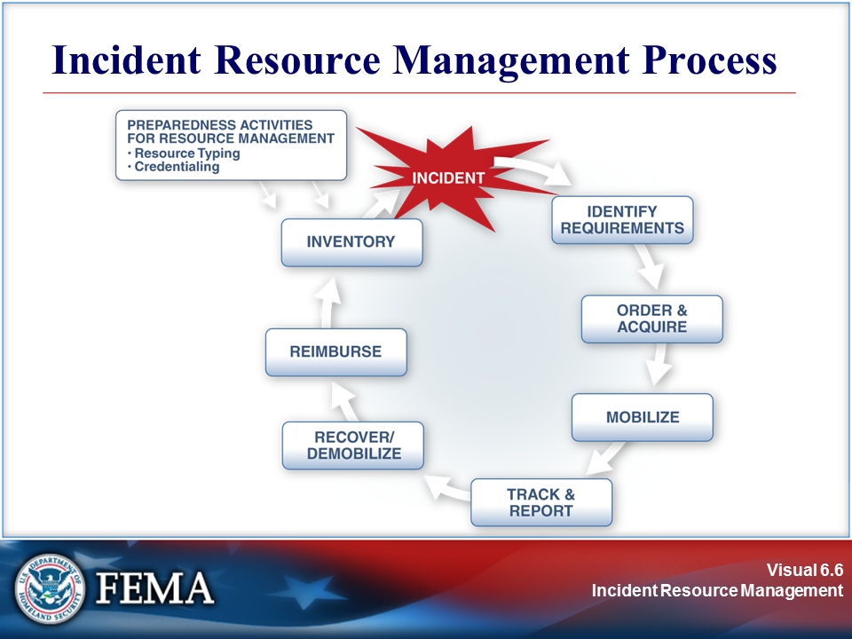 | 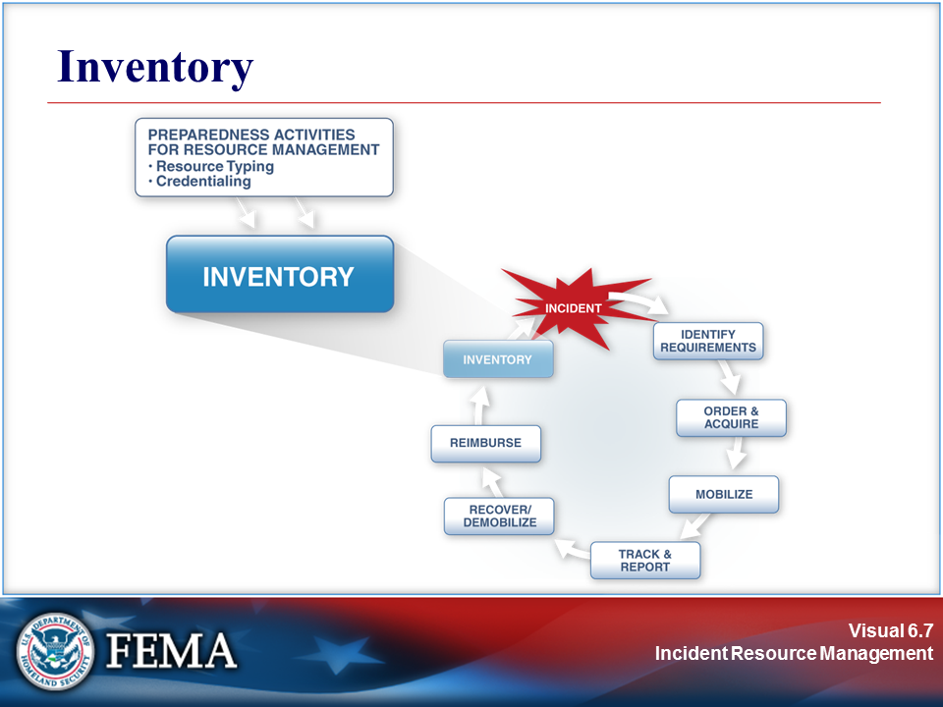
Your Notes

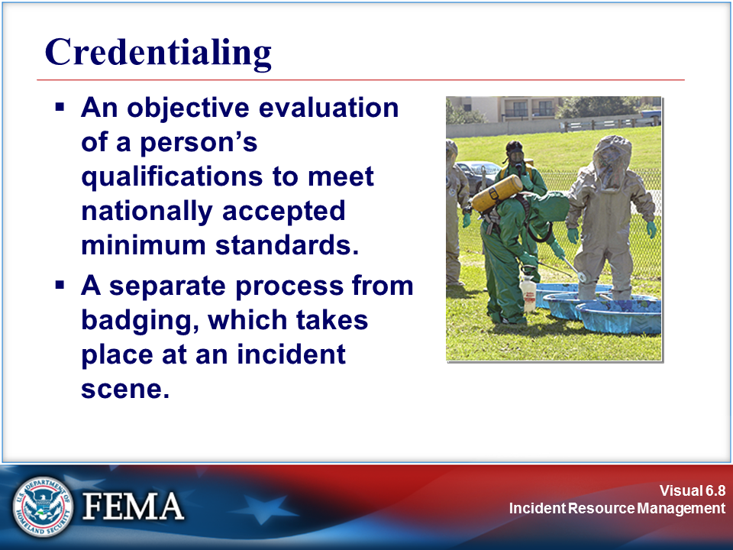 | View the job aid on the following page.
Your Notes

Job Aid: Credentialing

The following figure summarizes the NIMS credentialing process.

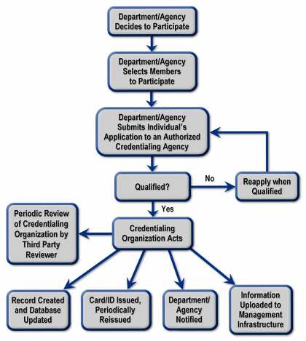

Source: NIMS document

Visuals

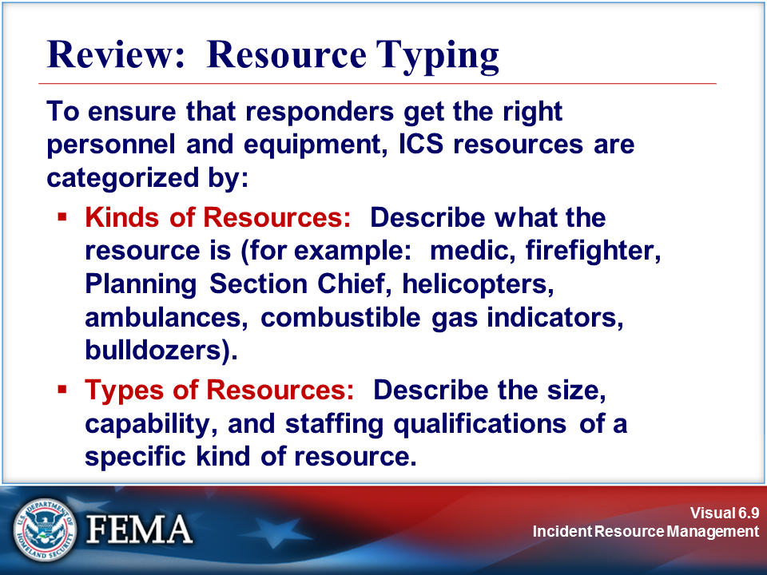 | 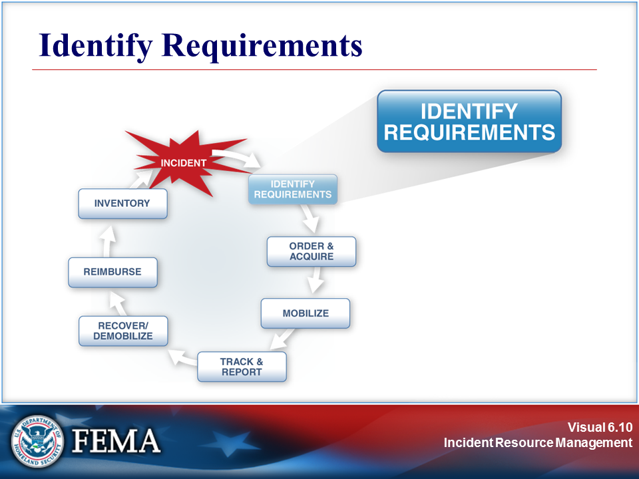
Your Notes

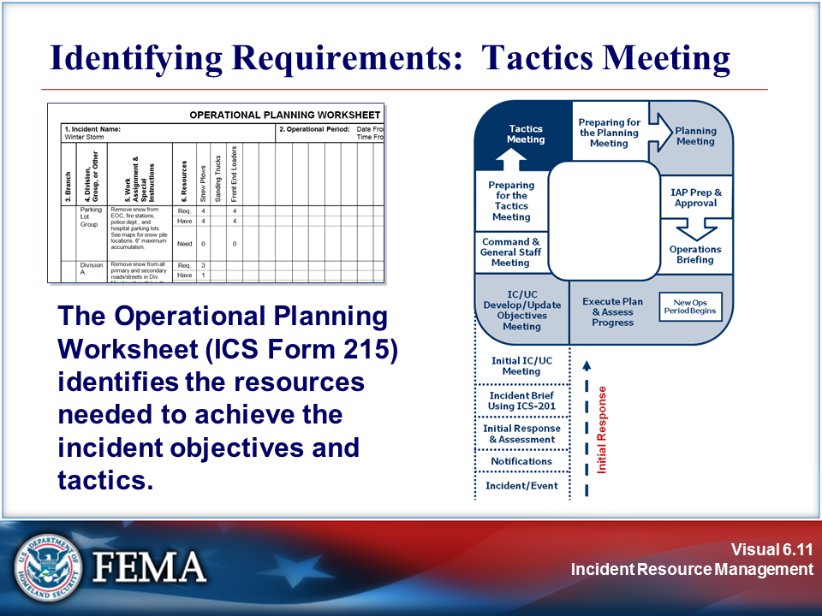 | 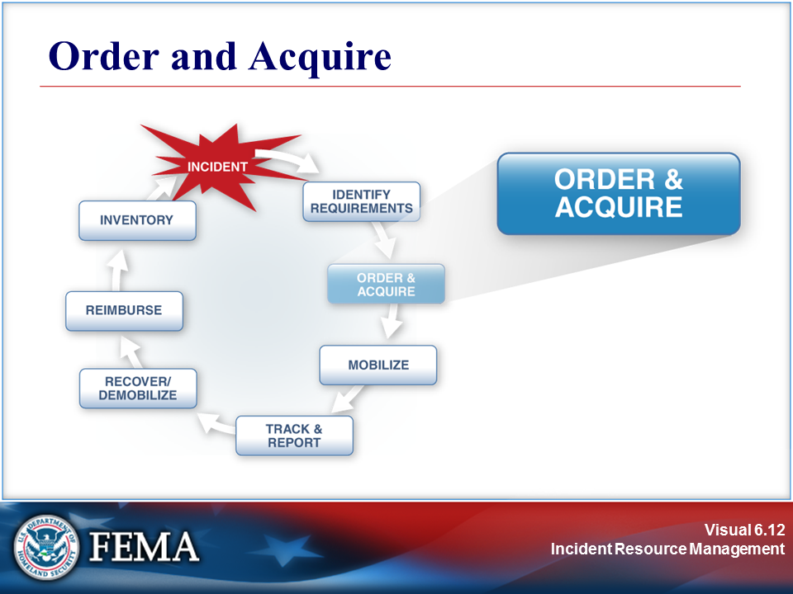
Your Notes

Visuals

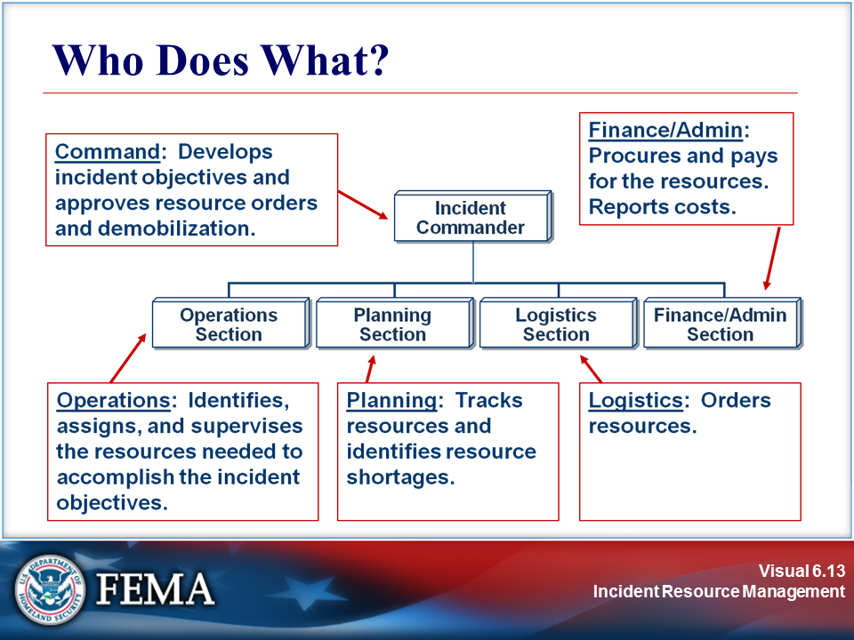 | 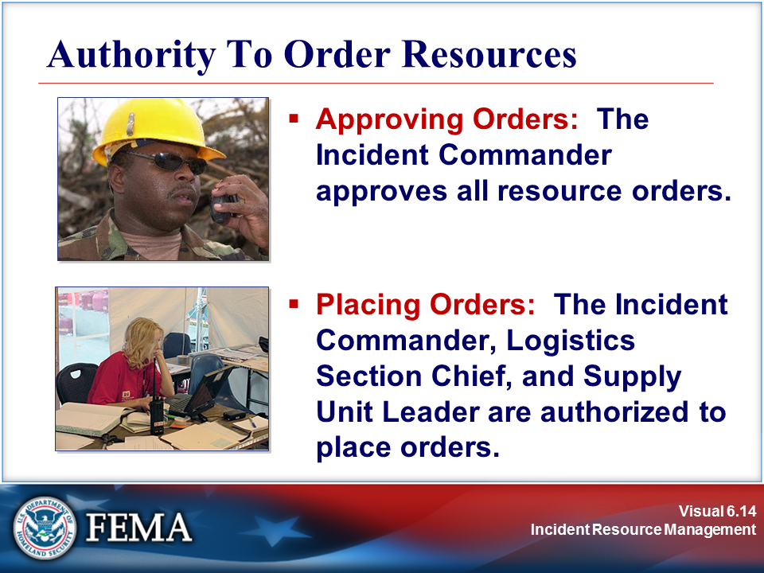
Your Notes

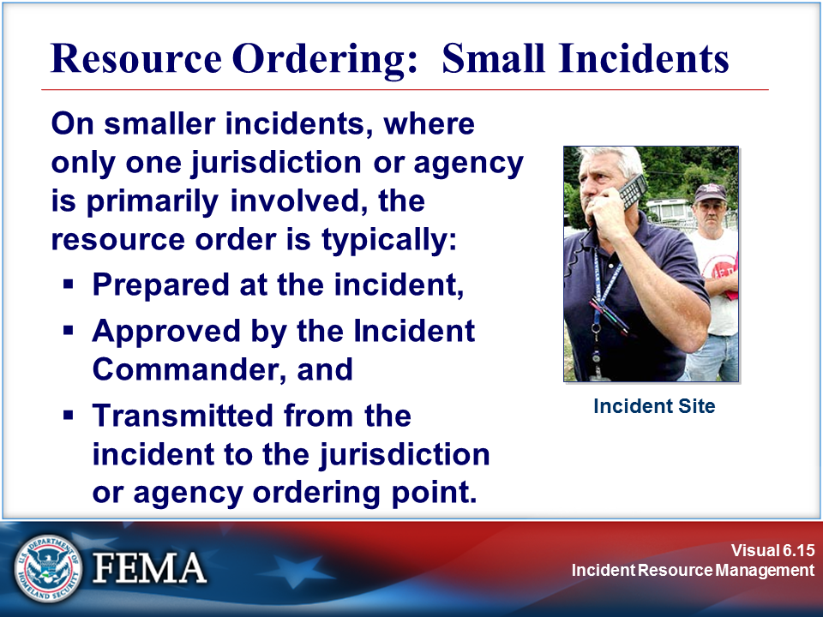 | 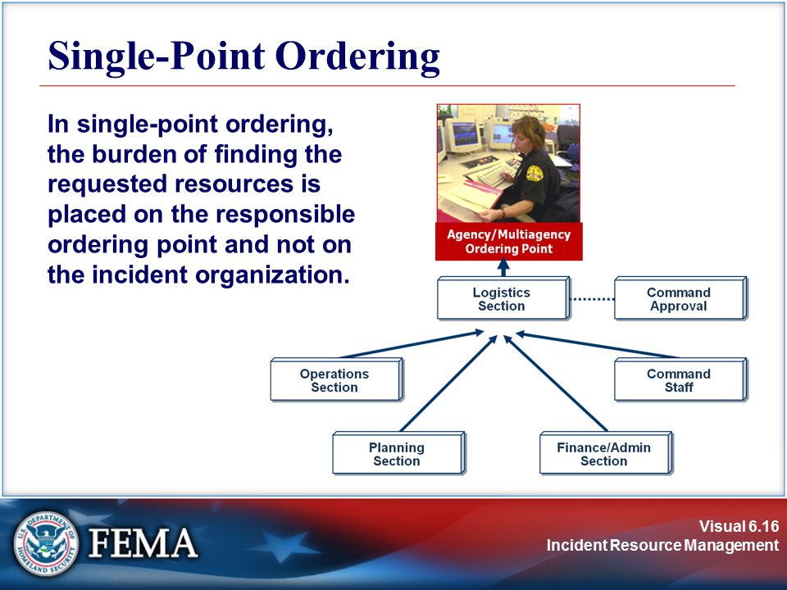
Your Notes

Visuals

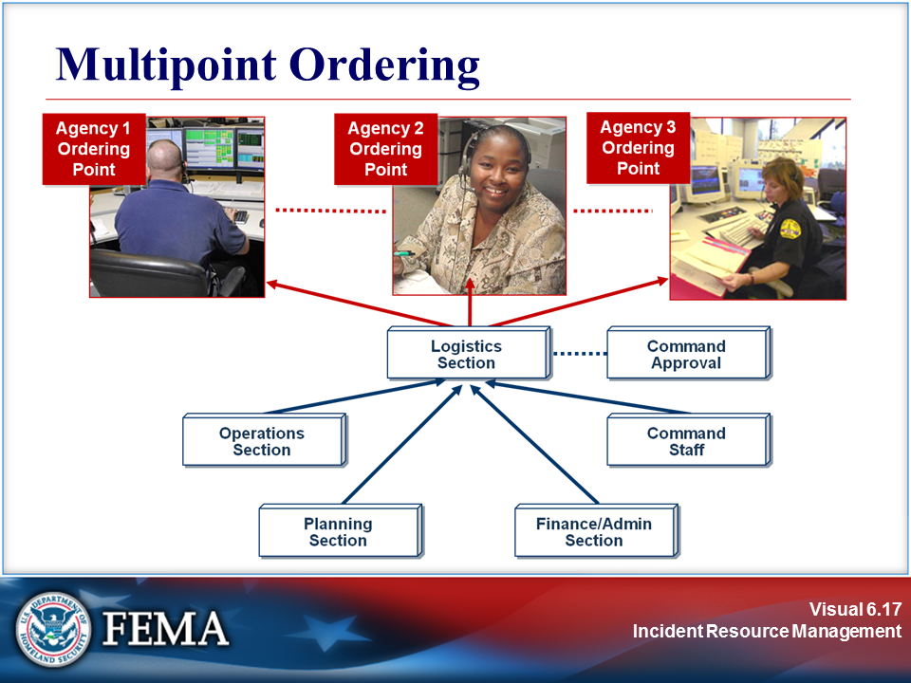 | 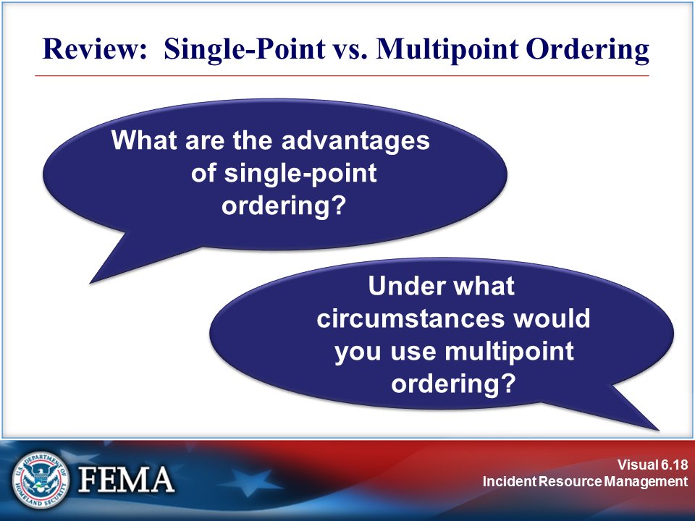
Your Notes

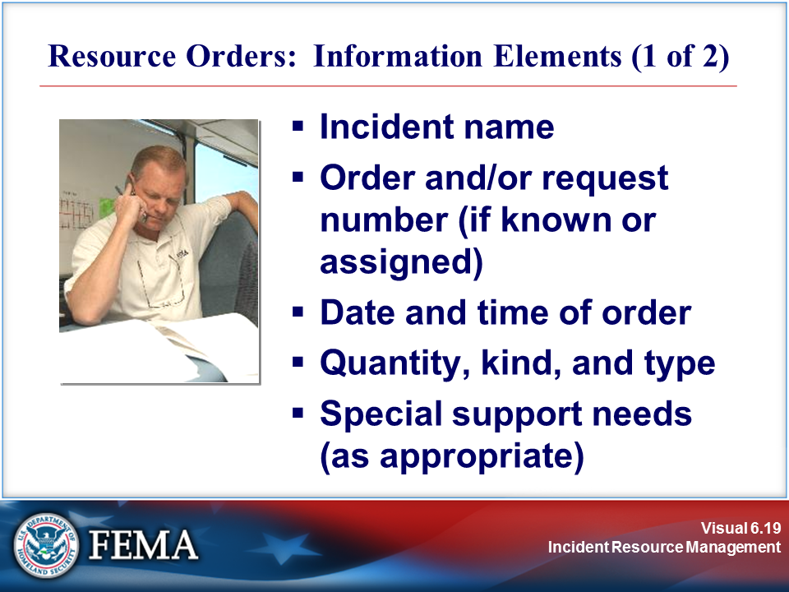 | 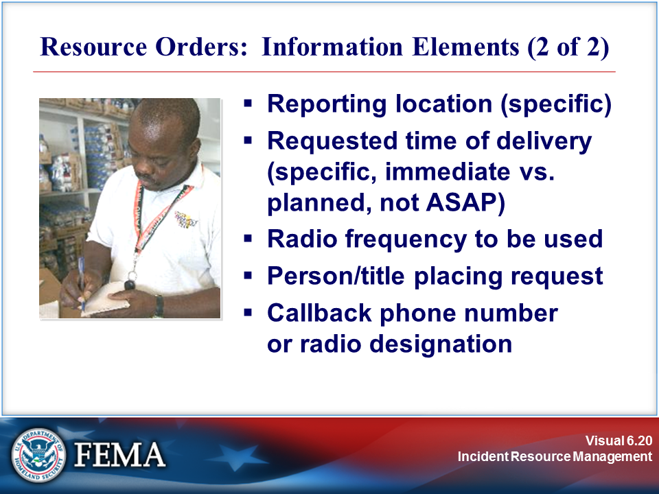
Your Notes

Visuals

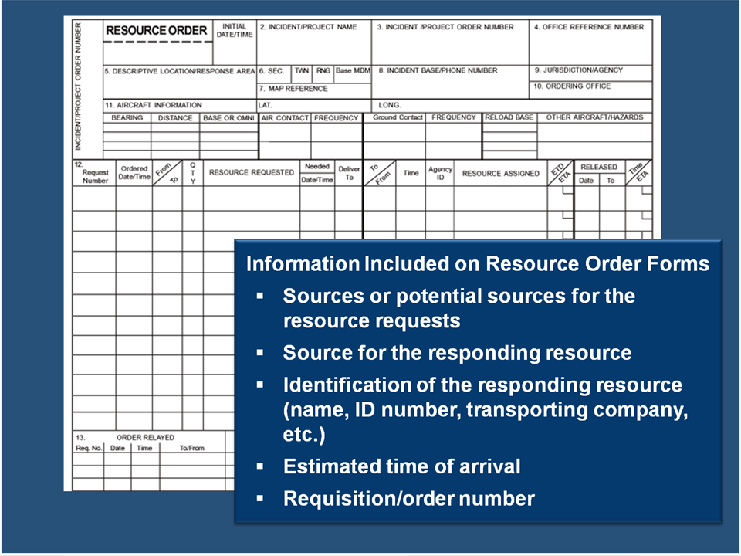 | 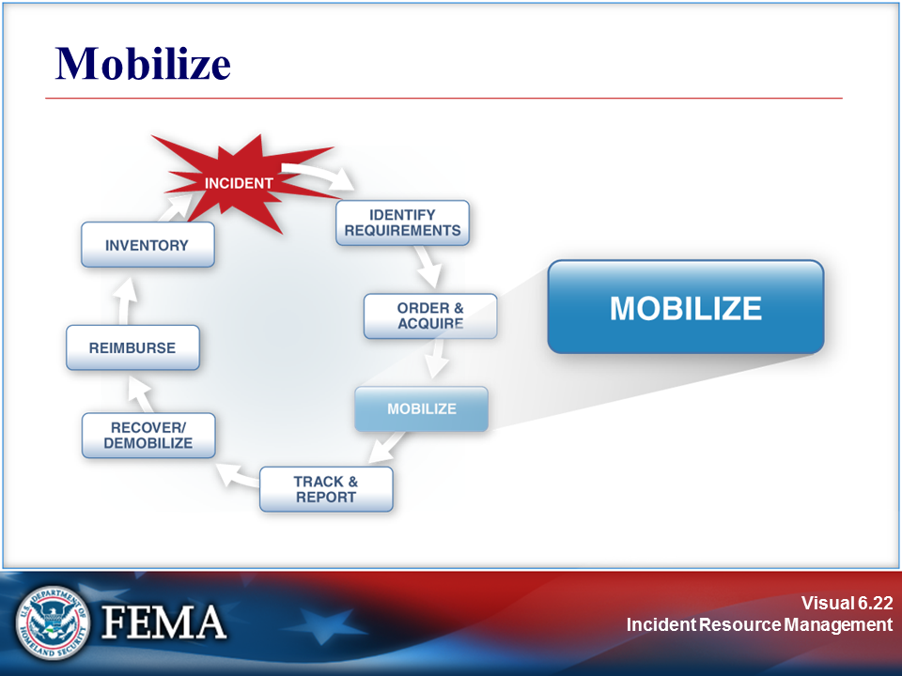
Your Notes

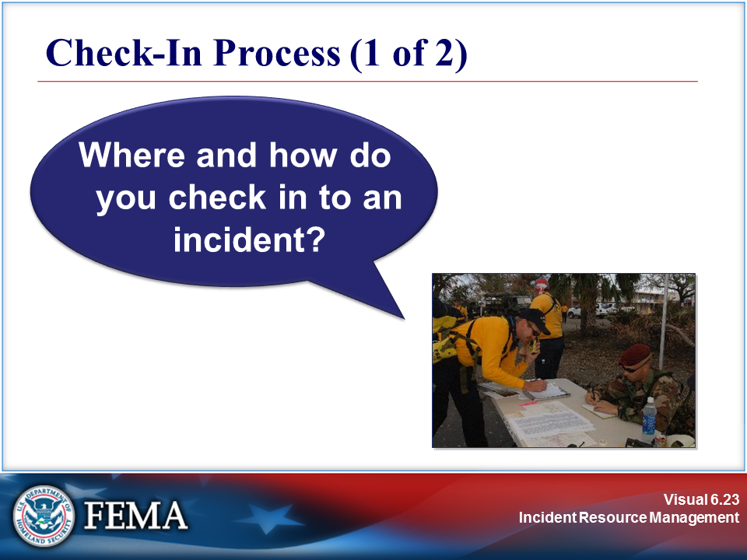 | 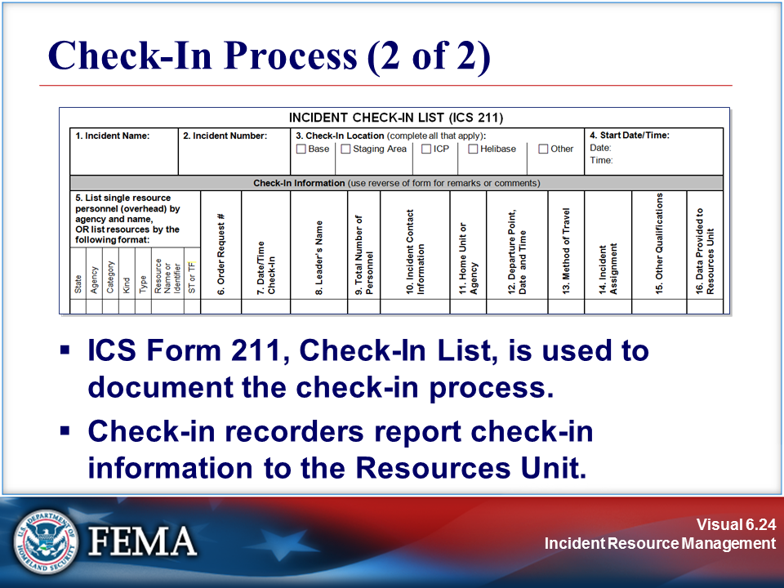
Your Notes

Sample: ICS Form 211

Incident Check-In List, ICS Form 211

1. Incident Name: |  |  |  |  |  | 2. Incident Number: |  |  |  | 3. Check-In Location (complete all that apply): |  |  |  |  |  |  |  |  |  | 4. Start Date/Time:  Date:  Time:
 |  |  |  |  |  |  |  |  |  | Base | Staging Area |  |  | ICP |  | Helibase |  | Other
Check-In Information (use reverse of form for remarks or comments)
5. List single resource personnel (overhead) by agency and name,  OR list resources by the following format: |  |  |  |  |  |  |  | 6. Order Request # | 7. Date/Time  Check-In | 8. Leader’s Name |  | 9. Total Number of Personnel | 10. Incident Contact Information |  | 11. Home Unit or Agency |  | 12. Departure Point, Date and Time |  | 13. Method of Travel | 14. Incident Assignment | 15. Other Qualifications | 16. Data Provided to Resources Unit
State | Agency | Category | Kind | Type | Resource Name or Identifier |  | ST or TF
ICS 211 |  |  | 17. Prepared by: Name: Position/Title: Signature: Date/Time:

Visuals

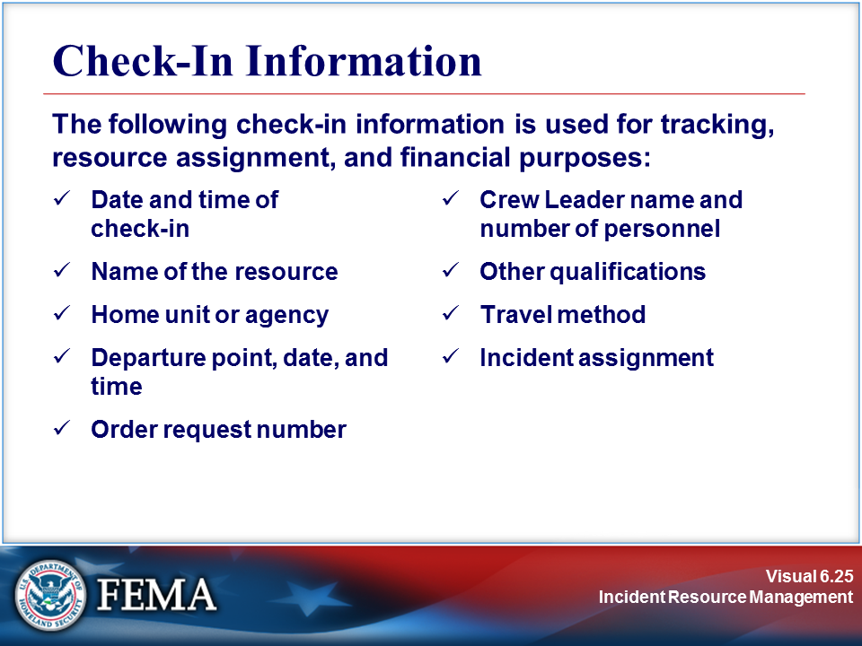 | 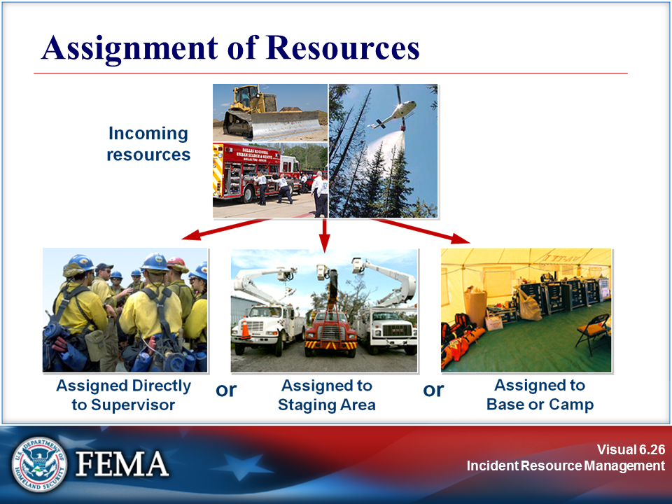
Your Notes

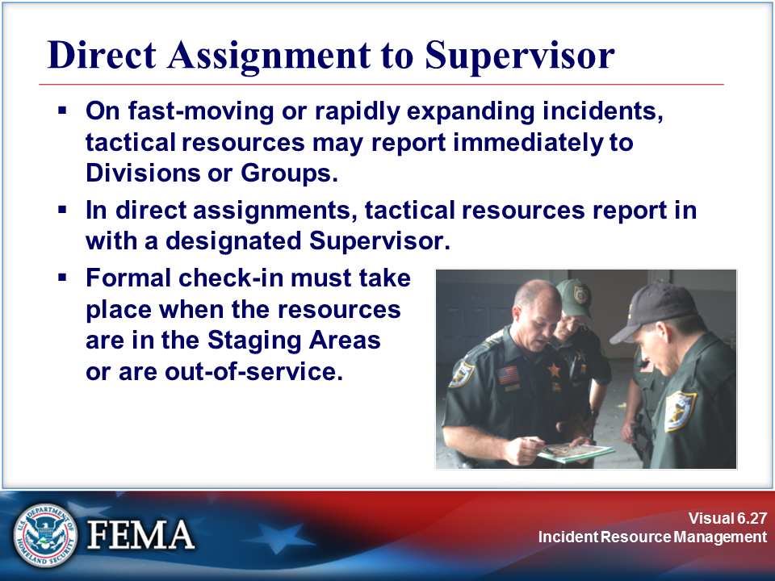 | 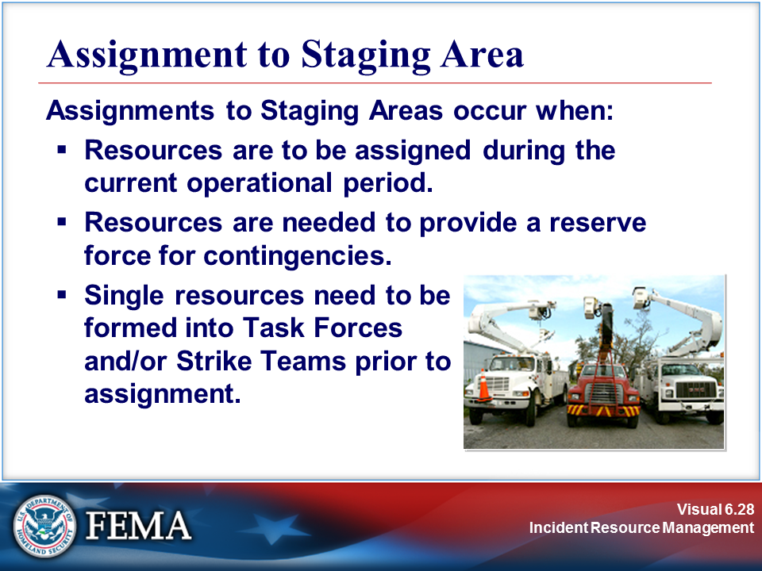
Your Notes

Visuals

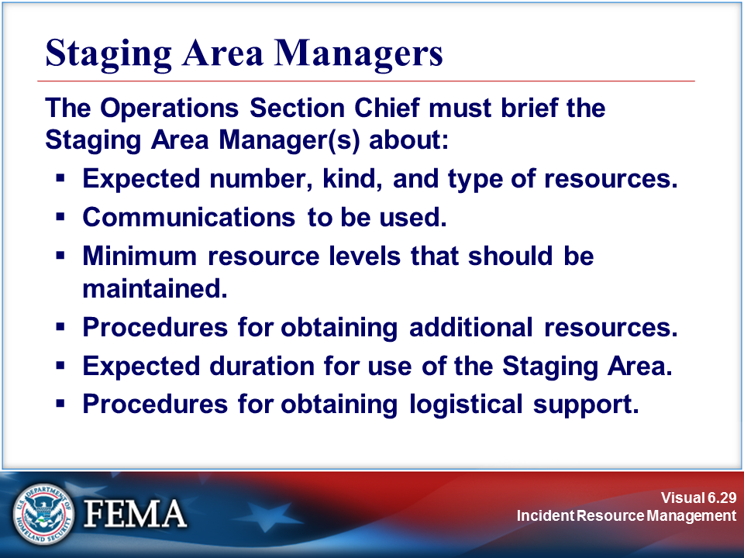 | 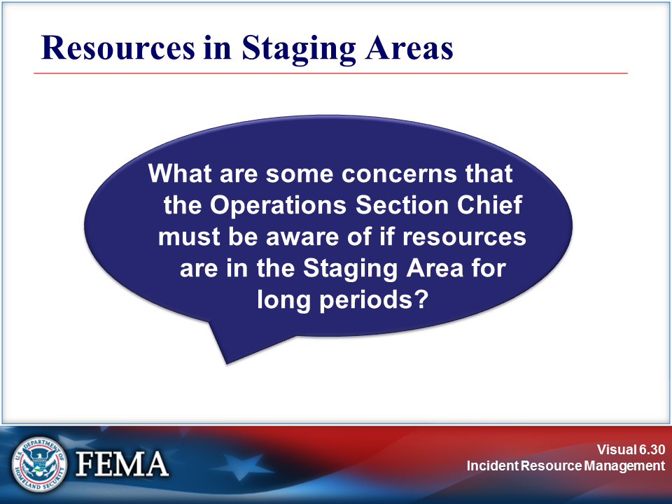
Your Notes

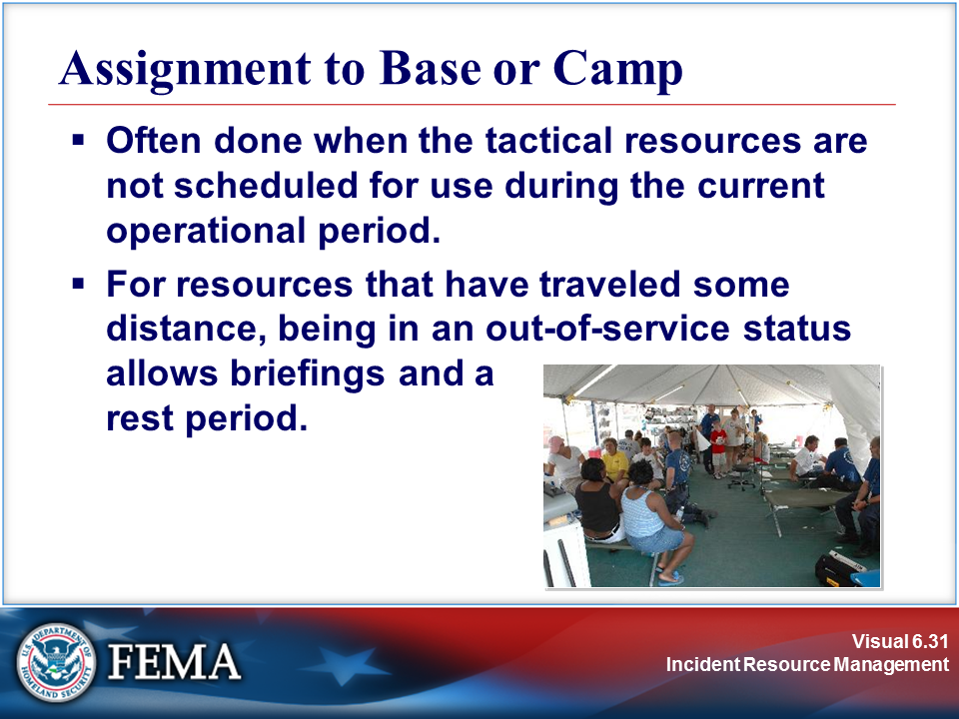 | 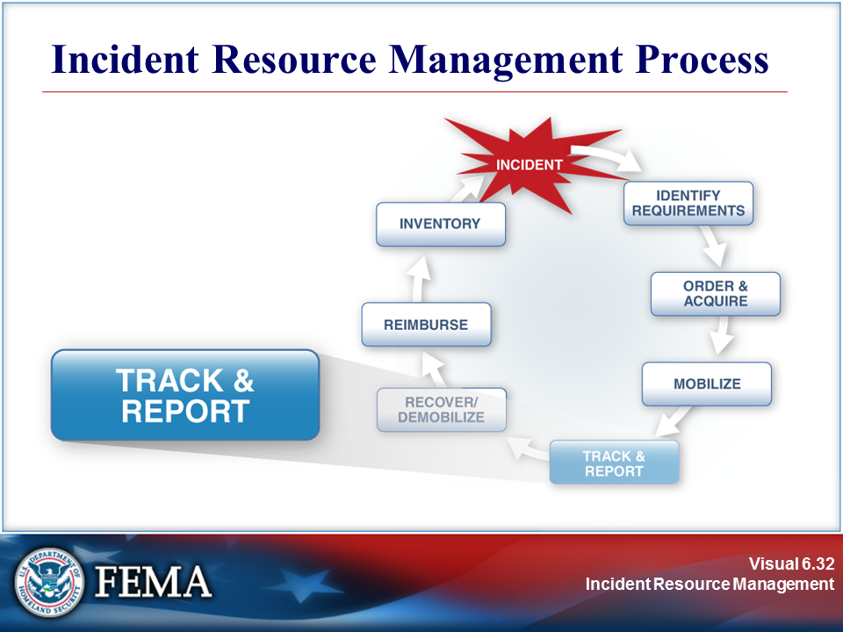
Your Notes

Visuals

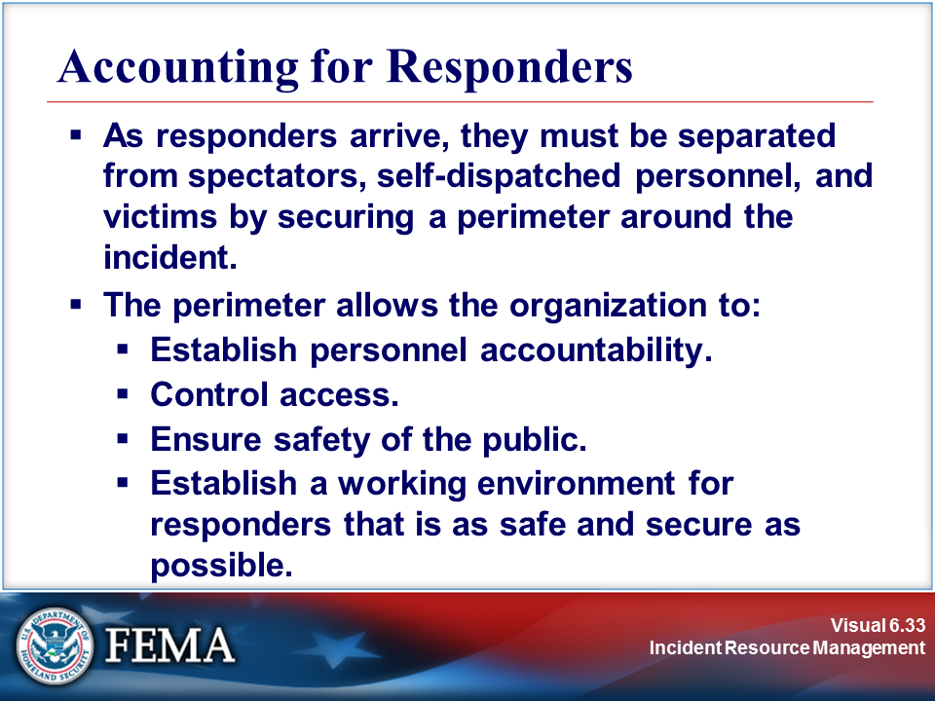 | 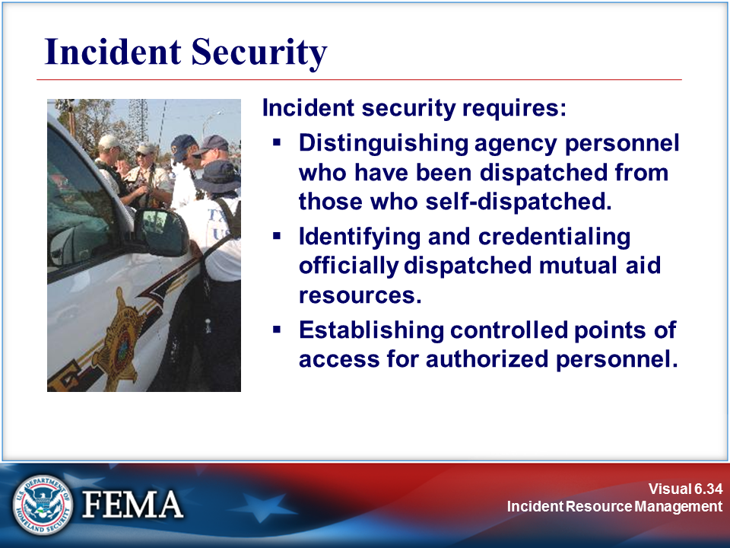
Your Notes

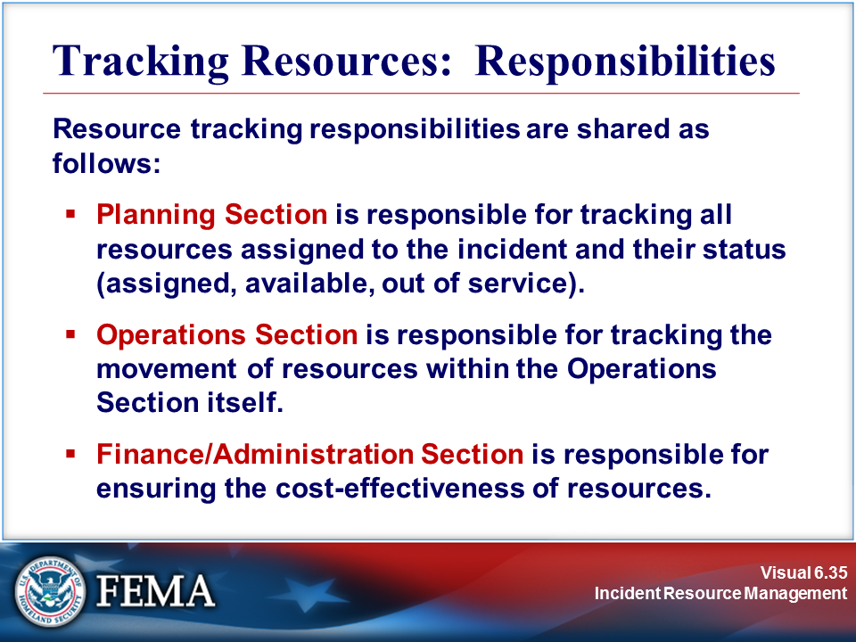 | 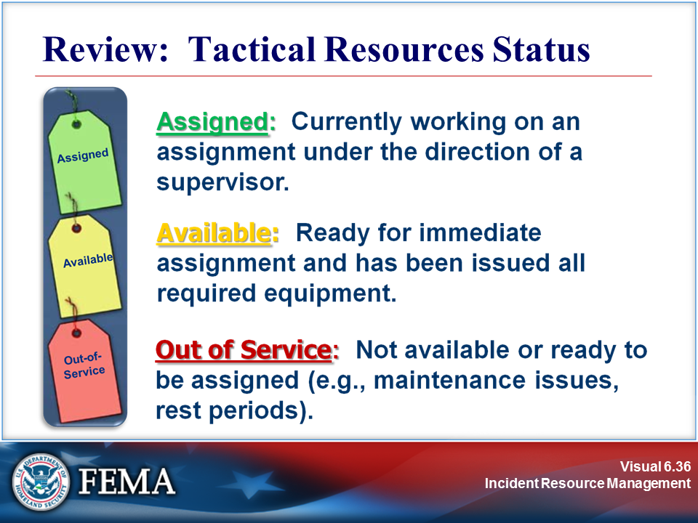
Your Notes

Visuals

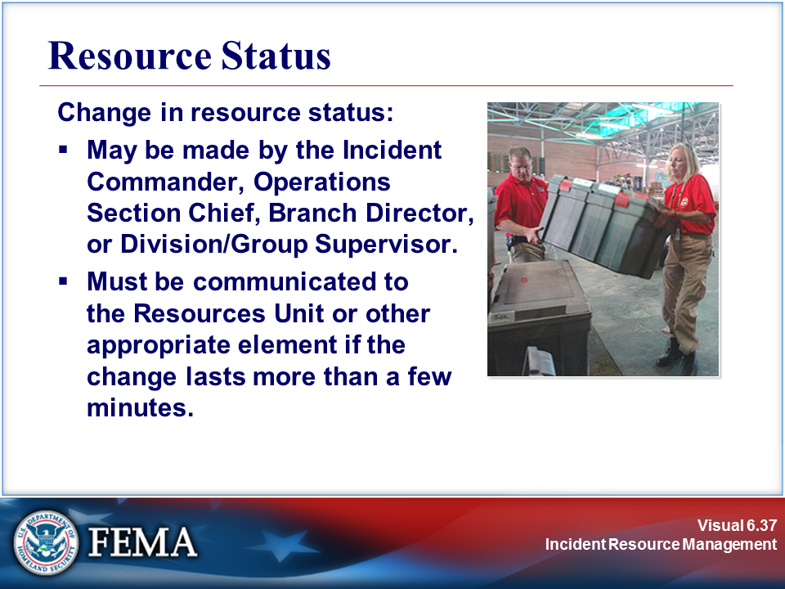 | 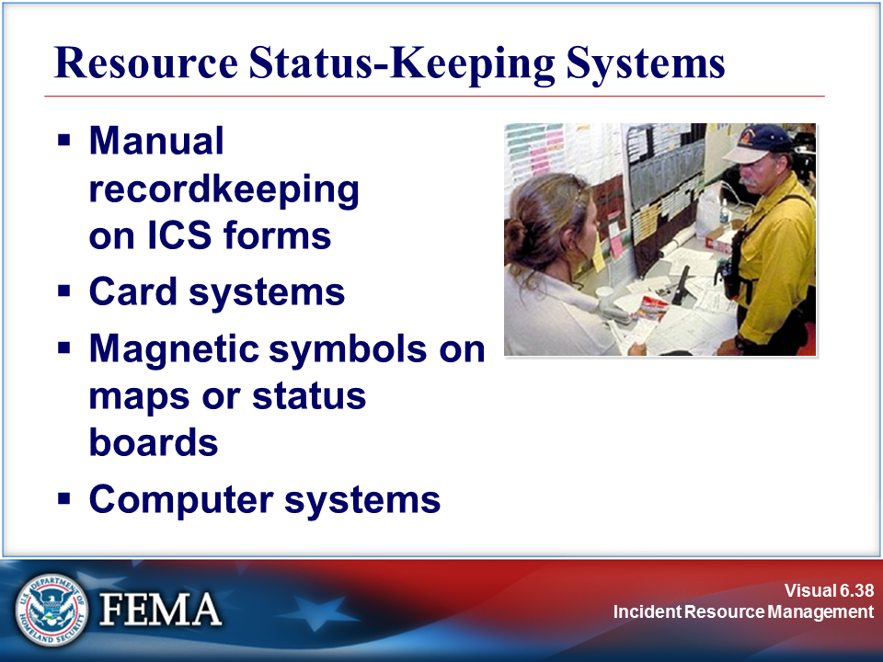
Your Notes

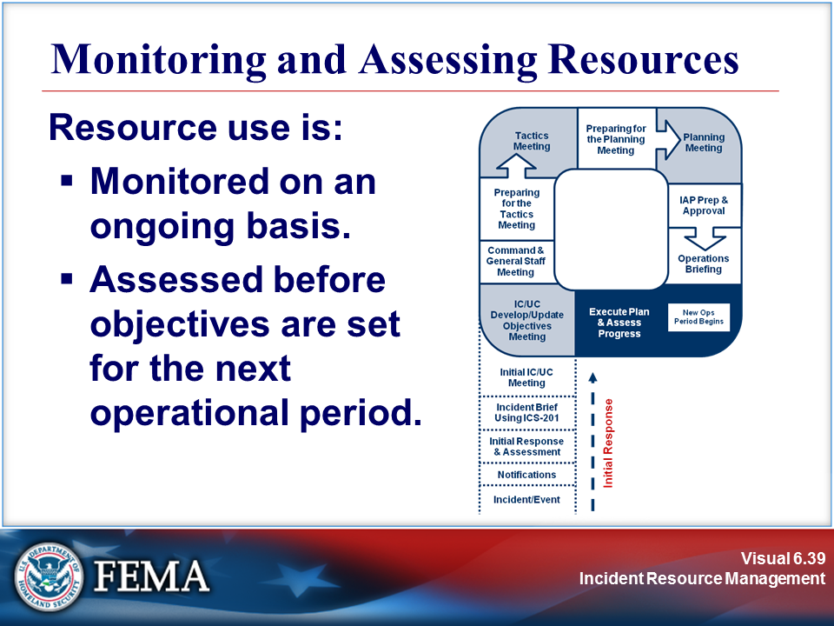 | 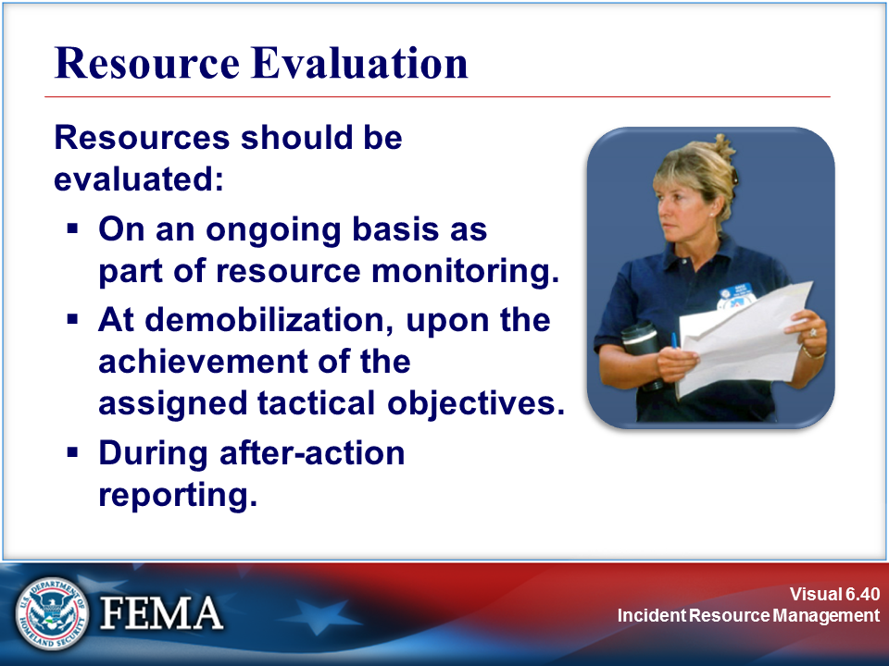
Your Notes

Visuals

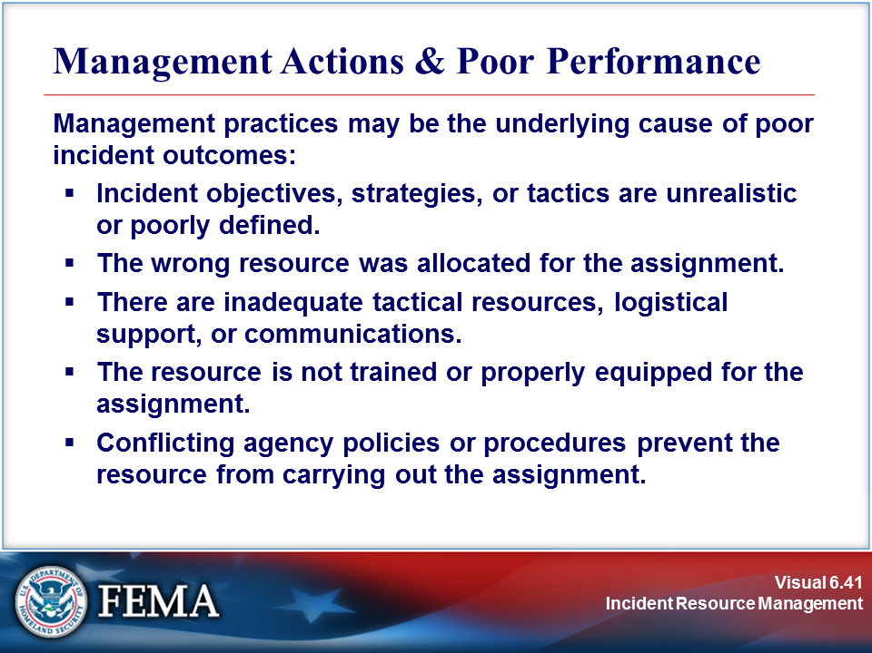 | 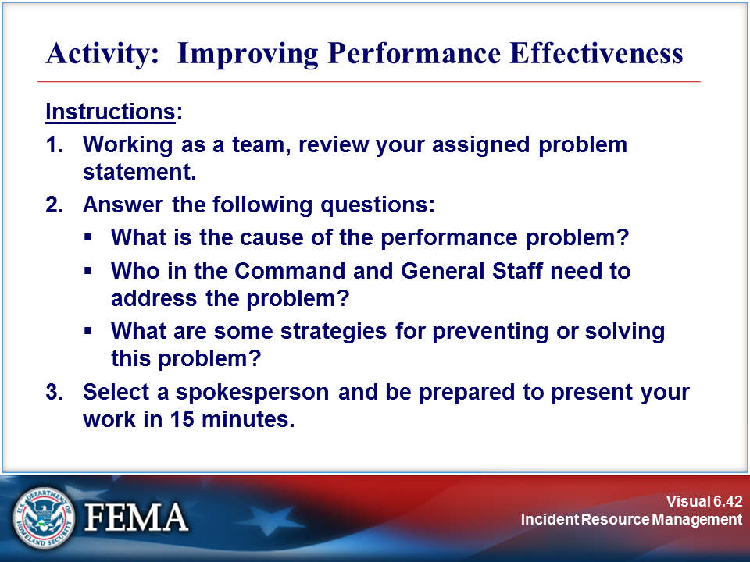
Your Notes

Complete the activity before proceeding.

Activity: Improving Performance Effectiveness

On a recent incident, the following performance issues have arisen.

Performance Issue #1: A local volunteer organization has personnel assigned to the Logistics Section to assist in providing meals to responders. One volunteer arrived for work visibly impaired, and informed his coworkers that he had “just a couple of drinks to relax” before coming to work.

Strategy:

Performance Issue #2: Resource tracking is poor. Check-In Recorders are providing incomplete or inaccurate information from responding resources. Some resources have evidently responded, worked, and gone home without ever having checked in. Additionally, resources obtained through a mutual aid agreement that are no longer needed remain at the incident site.

Strategy:

Performance Issue #3: Evacuation Division B is using non-uniformed personnel to deliver evacuation instructions door-to-door within the community. Compliance with the evacuation order is very poor, and 911 has been deluged with calls from the affected public asking if the evacuation order is official.

Strategy:

Activity: Improving Performance Effectiveness (Continued)

Performance Issue #4: A police officer at a traffic control point was struck by a motorist and received minor injuries. She was taken to the hospital by a witness to the accident, treated, and released. The first that incident management staff hear of the problem is when asked by the media at a press conference.

Strategy:

Performance Issue #5: Self-dispatched resources are arriving at the Staging Area. In the confusion, several of these resources who were assigned to Task Forces now appear to lack the skills needed to operate equipment or execute orders.

Strategy:

Performance Issue #6: The 5 o’clock news features a prominent interview with an incident responder at the Staging Area. The responder is not a member of the Public Information staff and has not been given an active assignment (or even seen the actual scene of the train wreck), but is waxing eloquently about how poorly the incident is being managed.

Strategy:

Visuals

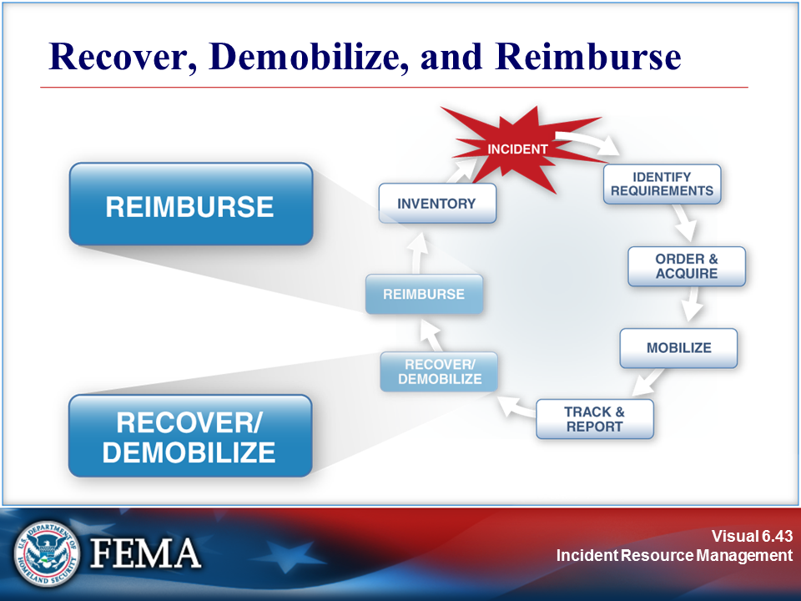 | 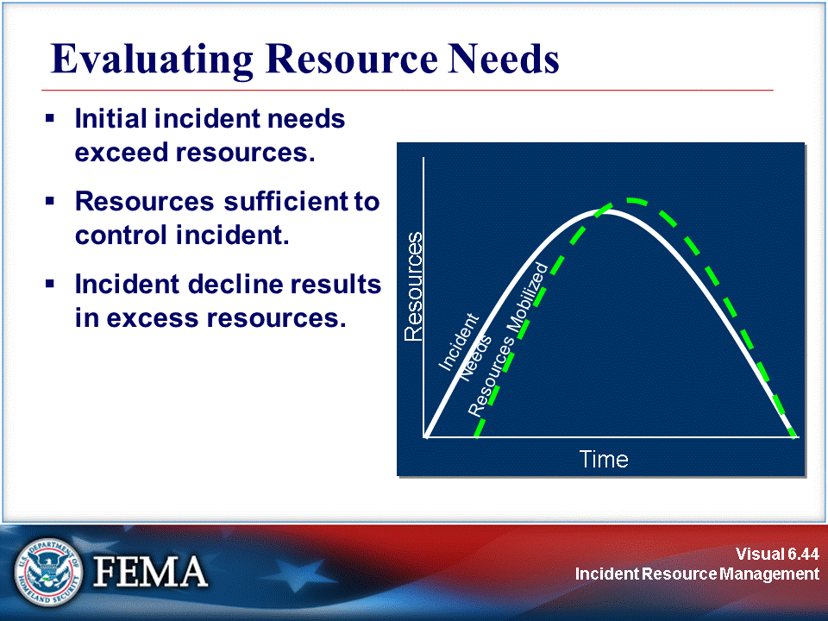
Your Notes

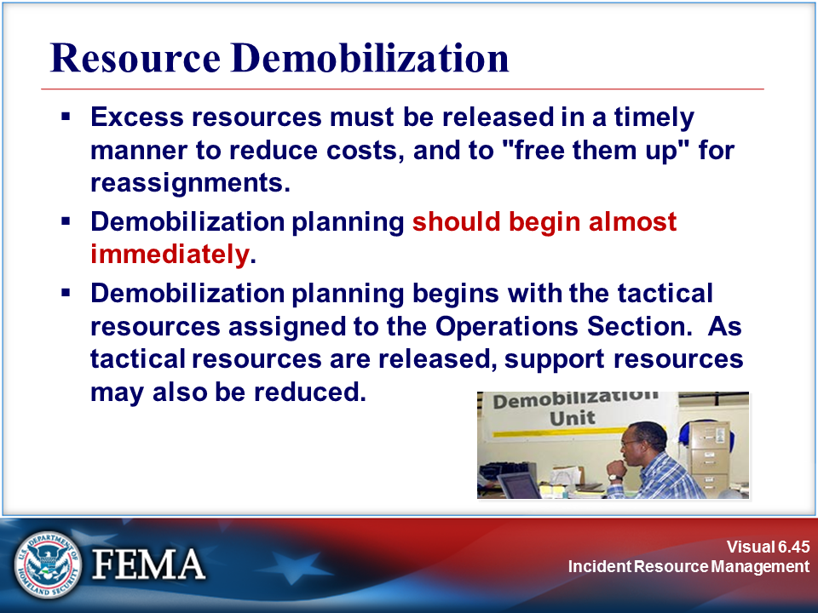 | 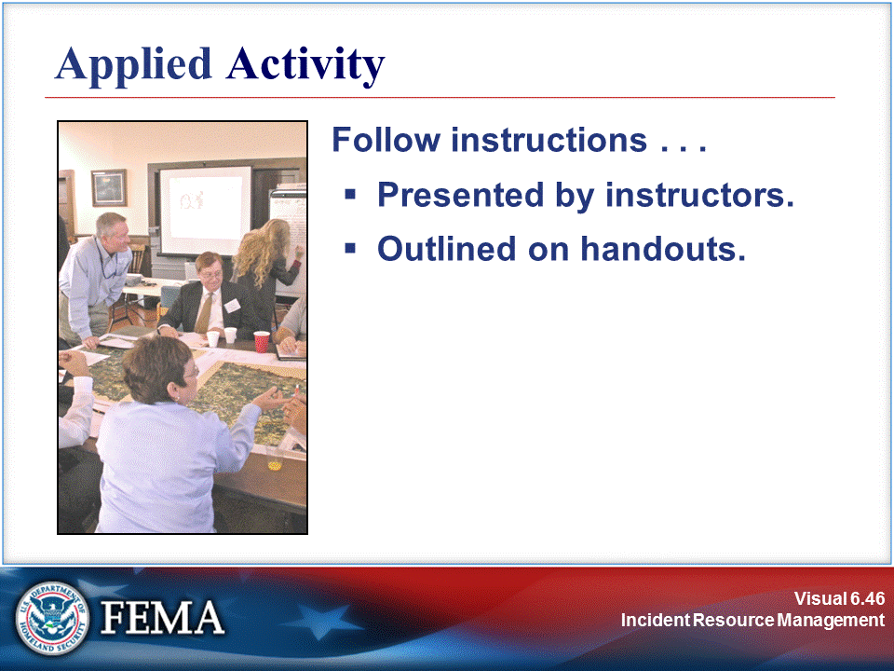
Your Notes

Visuals

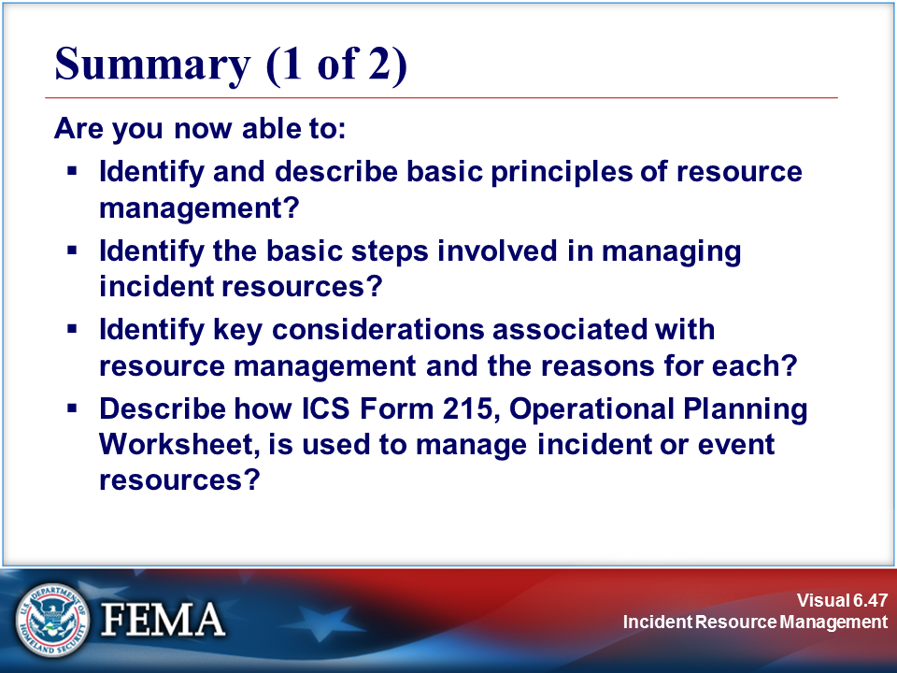 | 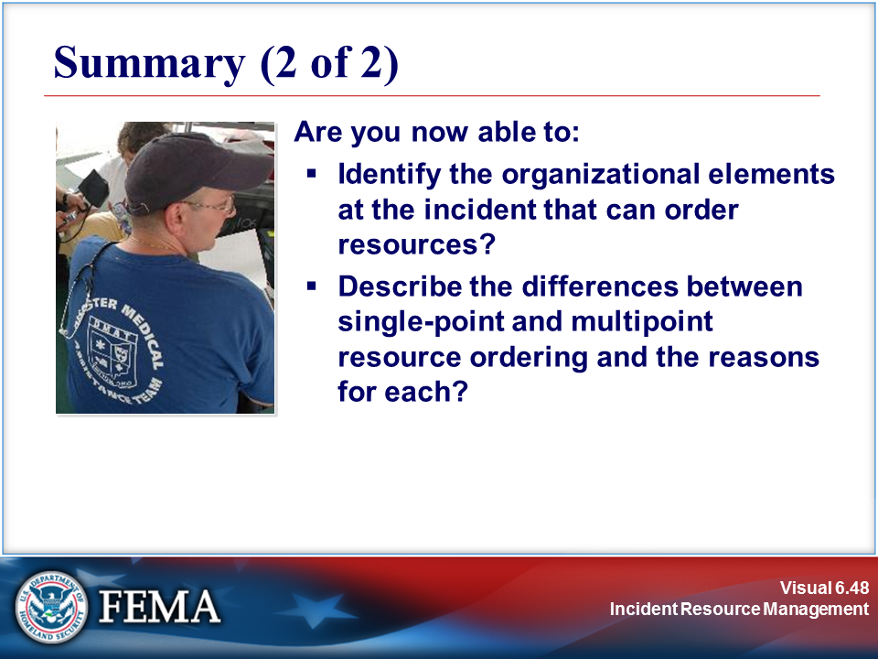
Your Notes

