Unit 7: Demobilization, Transfer of Command, and Closeout

This page intentionally left blank.

Visuals

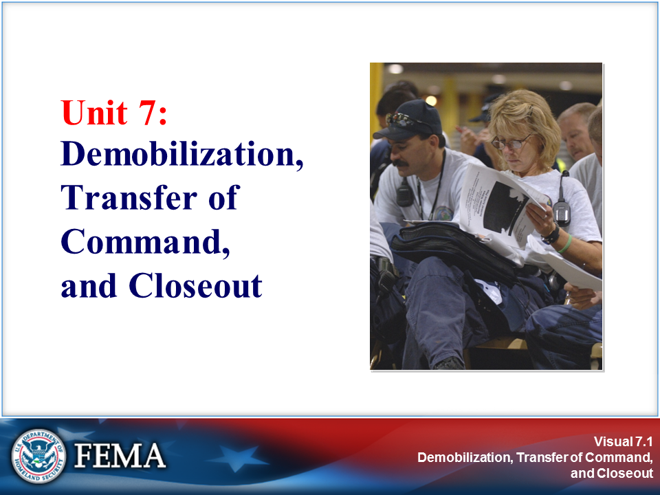 | 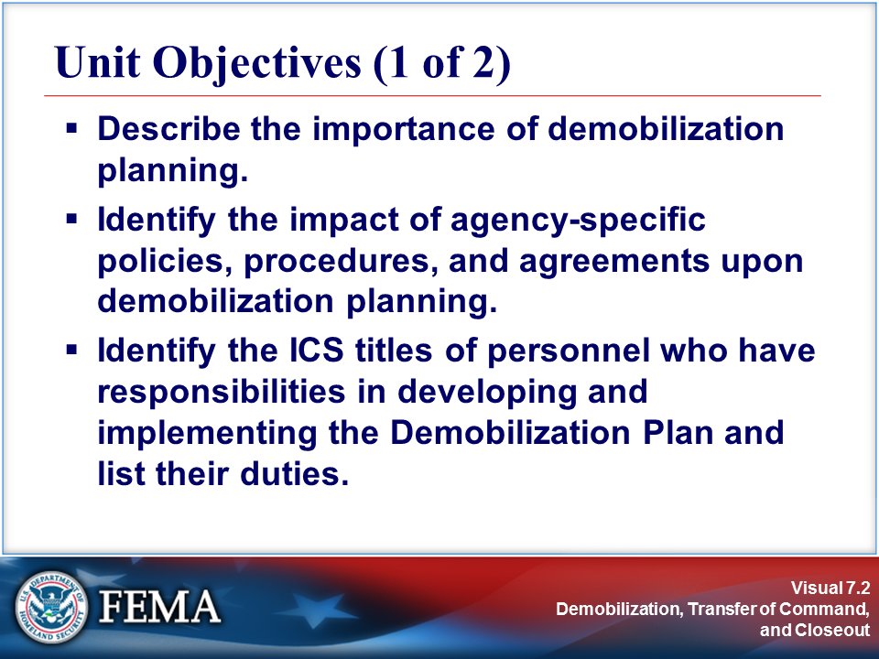
Your Notes

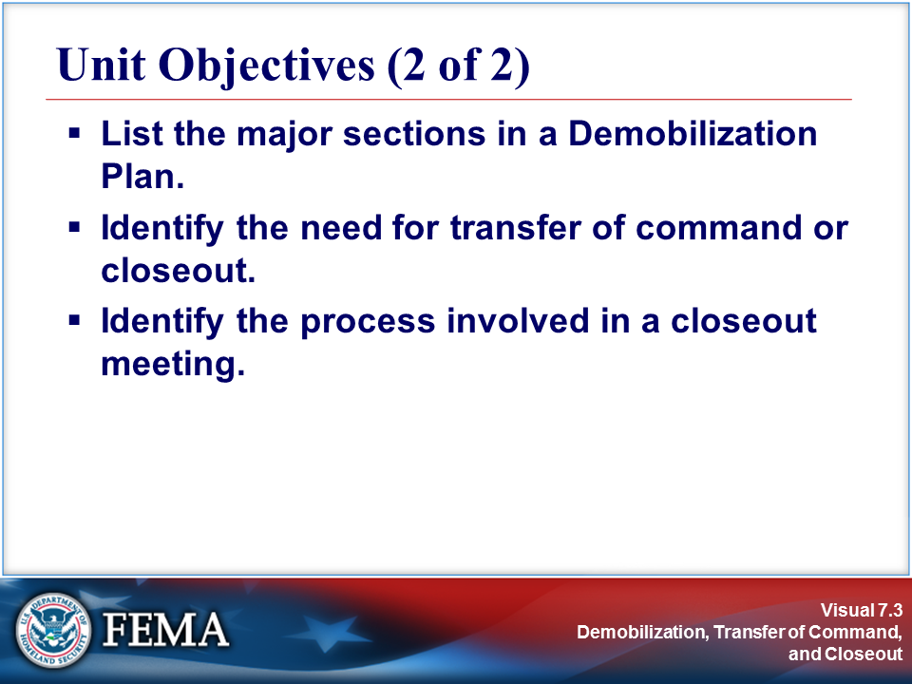 | 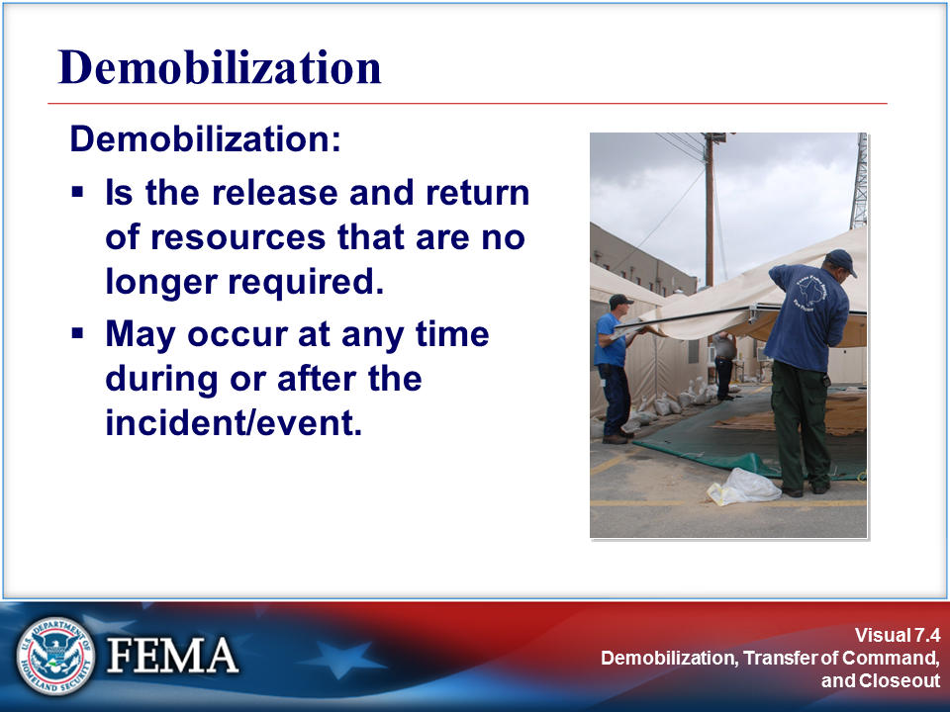
Your Notes |  | View the job aid on the next page.

Job Aid: Demobilization

After the incident is controlled and tactical resources are beginning to be released, the incident management organization should begin to monitor the number of support and management staff that are assigned. Below are some typical workload considerations to consider when planning for demobilization.

Position | Demobilization Considerations
Public Information Officer | Press interest may taper off toward the end of the incident, especially when tactics turn from life safety to cleanup. As the incident demobilizes, the need for interagency coordination of information may also decline. While it is important that the press continue to have a contact at the incident, it may be possible for the Public Information Officer to scale back operations.
Safety Officer | As the number of tactical operations at an incident decreases, the demand on the Safety Officer will also decline. However, some incidents require post-incident debriefings that will require the input of the Safety Officer. While the workload may level out, it may remain until the end of the incident.
Liaison Officer | As cooperating and assisting agency resources are demobilized, the Liaison Officer’s job will become less complex. The Liaison Officer is also likely to be involved in interagency post-incident review activities that may require continued presence at the incident and involvement after final demobilization.
Operations Section | The Operations Section Chief should be able to reduce support staff such as Deputies and Staging Area Managers as the Operations Section is demobilized.
Planning Section | In the Planning Section, the later workload falls on the Demobilization and Documentation Units. The Demobilization Unit will develop the Demobilization Plan and monitor its implementation. The Documentation Unit will package all incident documentation for archiving with the responsible agency or jurisdiction. Both of these processes are finished late in the incident.
Logistics Section | The Supply Unit and the Facilities Unit play major roles as the incident winds down. The Facilities Unit will need to demobilize the incident facilities, such as the Command Post and incident Base. The Supply Unit must collect, inventory, and arrange to refurbish, rehabilitate, or replace resources depleted, lost, or damaged at the incident.
Finance and Administration Section | Many of the activities of the Finance and Administration Section continue well after the rest of the organization has been demobilized. Much of the paperwork needed to document an incident is completed during or after demobilization.

Visuals

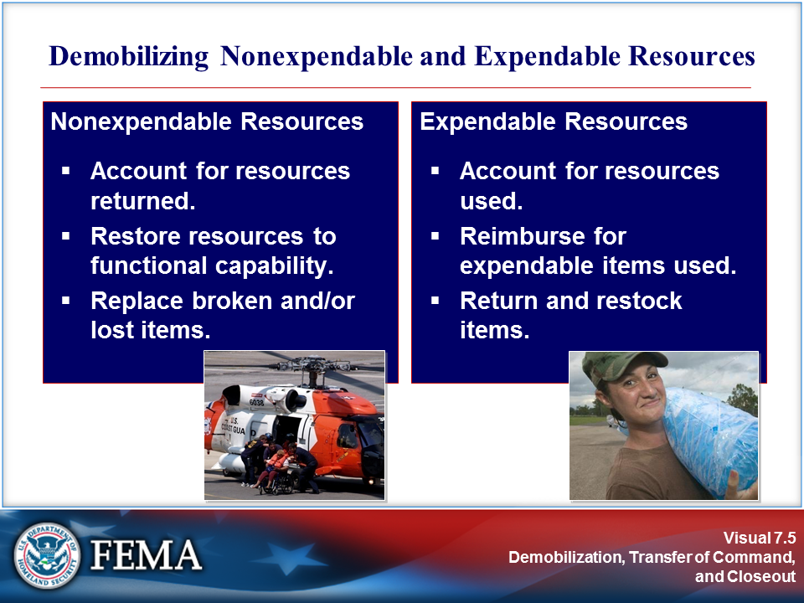 | 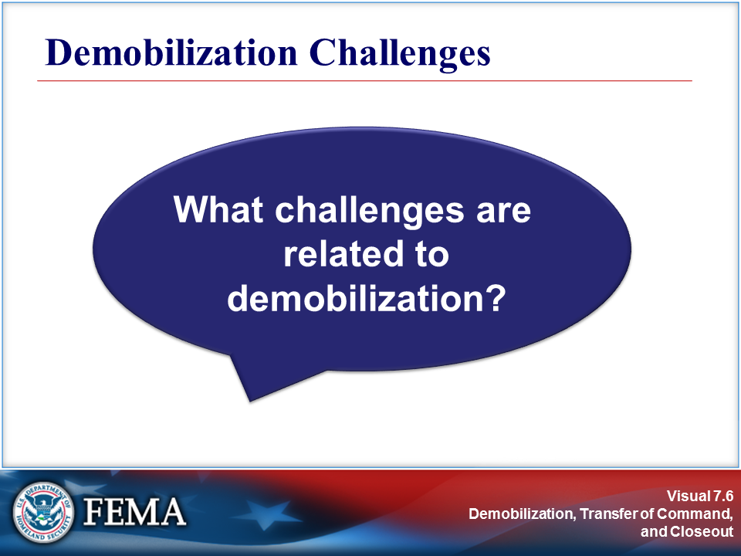
Your Notes

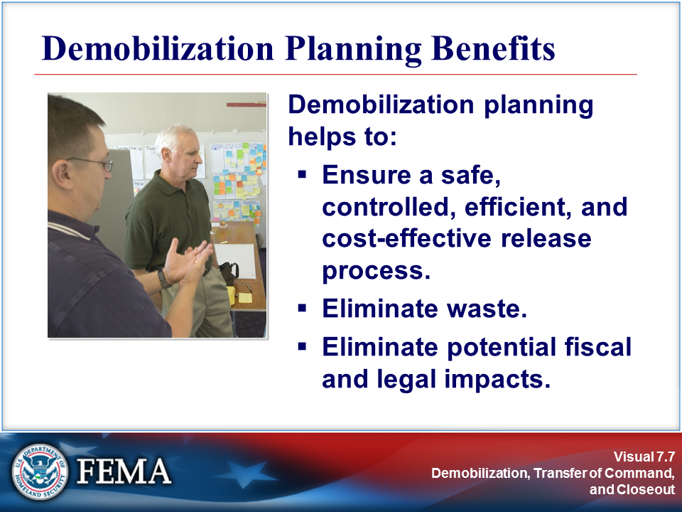 | 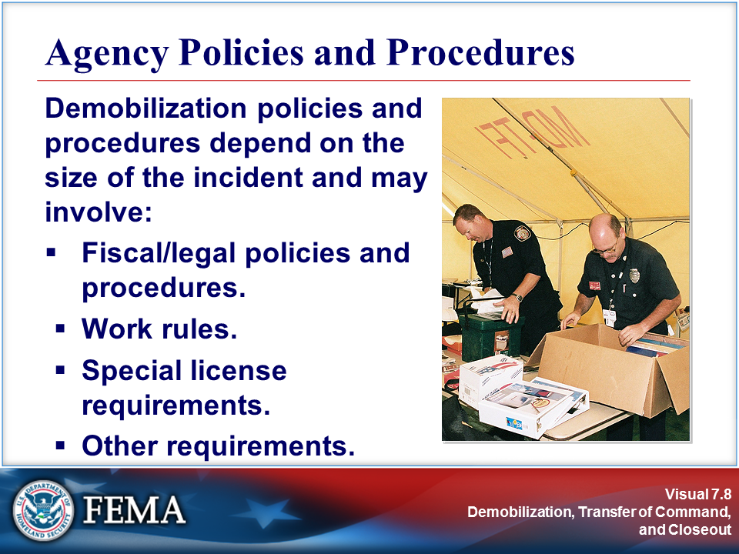
Your Notes

Visuals

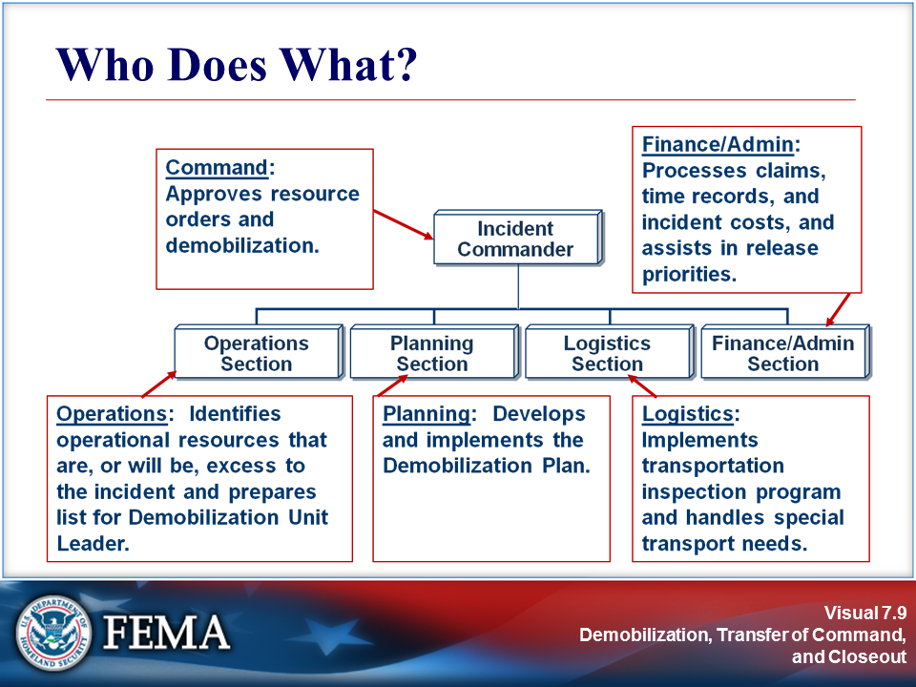 | 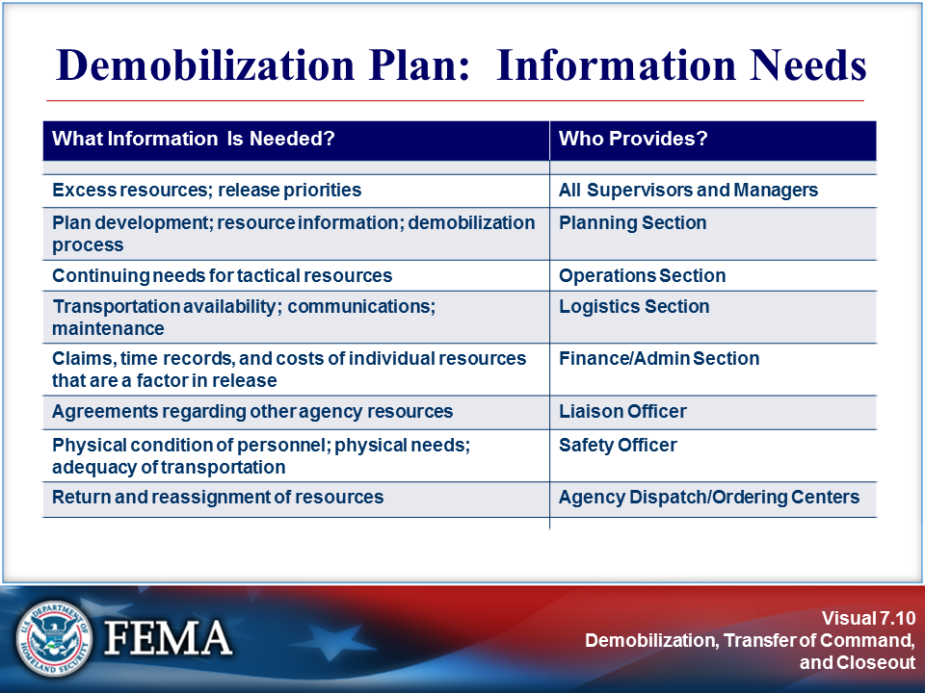
Your Notes

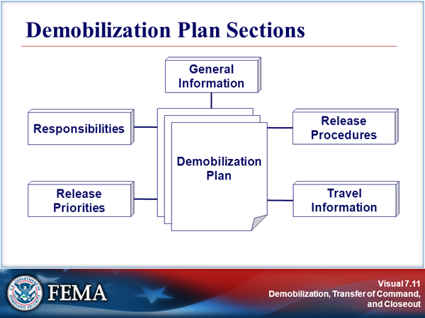 | View the sample plan on the next page.
Your Notes

Sample Demobilization Plan (Page 1 of 5)

NORTH SMITHMAN INCIDENT

Prepared by
 | Planning Section Chief |  | Date

Approved by
 | Logistics Section Chief |  | Date

Approved by
 | Operations Section Chief |  | Date

Approved by
 | Finance Section Chief |  | Date

Approved by
 | Supervisor-Expanded Dispatch |  | Date

Approved by
 | Incident Commander |  | Date

Sample Demobilization Plan (Page 2 of 5)

The Demobilization Plan contains five (5) sections:

1. General Information
2. Responsibilities
3. Release Priorities
4. Release Procedures
5. Travel Information

1. GENERAL INFORMATION

The demobilization process at the North Smithman Incident will require coordination with the Unified Command Team and the Expanded Dispatch function. All resources with their own transportation must meet rest/work guidelines prior to driving.

All releases from the Smithman Incident will be initiated in the Demob Unit after Incident Commander approval. The size and location of the Incident Base lends itself to the holding of surplus equipment and personnel during the time it takes to process all of the releases in a safe and efficient manner. No resources are to leave the Incident until authorized to do so. At this time, no off-Incident Demob Center will be activated. The Logistics Section will provide for all necessary transportation of released personnel and equipment. The Demob Unit will arrange for any needed flight arrangements through Expanded Dispatch.

The following are general guidelines to be followed for resources that are leaving the Incident.

A. No person will be released without having a minimum of eight (8) hours rest, unless specifically approved by the IC.

B. All Federal resources must be able to arrive at their home base prior to 2200 (10 PM). Other agencies and cooperators must meet individual agency regulations pertaining to rest and travel.

C. All Party Chiefs, Crew Supervisors, and Strike Team Leaders will be thoroughly briefed prior to leaving the Incident. Briefing to include: 1. method of travel, 2. passengers (if any), 3. destination, 4. ETD Camp/ETA home base, and 5. transportation arrangements.

All personnel returning home on commercial aircraft will be showered and wear clean clothing.

To prevent delays and work overloads, Logistics and Finance will be notified as soon as possible when surplus resources are to be Demobed. (Demob will try to advise the two Units 24 hours in advance.) Notification of Incident personnel will be by posting of "Tentative Releases" 12 hours in advance. Crew Supervisors may also be paged when the Demob process is to begin.

If applicable, all oversize vehicles (e.g., transports) MUST have appropriate permits to comply with State vehicle codes.

Sample Demobilization Plan (Page 3 of 5)

Performance Ratings are required for:
- Trainees
- Outstanding performance
- Deficient performance
- By personal request

All firefighting apparatus, rental equipment, and crew transport will have a vehicle inspection (Safety Check) at Ground Support prior to returning to their home unit or new assignment location. Pickups, sedans, and vans will also have a safety check by the Ground Support Unit before departing the Incident Base.

2. RESPONSIBILITIES

Functional heads (i.e., Section Chiefs and Unit Leaders) are responsible for determining resources surplus to their needs and submitting lists to the Demob Unit Leader.

The Demob Unit Leader is responsible for:

- Compiling “Tentative” and “Final” Release sheets. (Any Incident-formed Strike Teams and Task Forces must be disbanded before Incident Commander approval and release from the Incident.)
- Making all notifications to Incident and off-Incident personnel regarding tentative and final releases (includes Tanker and Helibases).
- Making sure that all signatures are obtained on the Demob Checkout form.
- Monitoring the Demob process and making any adjustments in the process.

The Incident Commander is responsible for:

- Establishing the release priorities through consultation with Unified Command.
- Reviewing and approving all tentative release lists.

The Logistics Section Chief is responsible for ensuring through:

- Facilities—that all sleeping and work areas are cleaned up before personnel are released.
- Supply—that all non-expendable property items are returned or accounted for prior to release.
- Ground Support—that there will be adequate ground transportation during the release process and that vehicles are inspected.
- Communications—that all radios have been returned or are accounted for.
- Food Unit—that there will be adequate meals for those being released and for those remaining in camp.

Sample Demobilization Plan (Page 4 of 5)

The Finance Section Chief is responsible for:

- Completion of all time and equipment reports for released personnel.
- Notification(s) for any ADO payoff(s).

The Planning Section Chief is responsible for managing duration of assignment policy for the Incident Commander.

Expanded Dispatch is responsible for:

- Reviewing tentative releases and notifying the Demob Unit Leader with release approvals, reassignments, and air travel information.
- Coordinating with the Rocky Mountain Coordination Center.

3. RELEASE PRIORITIES

The following release priorities have been established by the Unified Command Team:

- Initial attack or local cooperators
- Type 1 Crews
- Non-local engines, crews, and overhead
- Other local resources

Crews from other Regions will be grouped for demob when possible. Emergency situations will arise and will be handled expeditiously. Clearance for emergency demob is to be approved by the appropriate Section Chief, IC, or Agency Representative.

4. RELEASE PROCEDURES

Critical resources will be identified on the Daily Incident Commander conference calls. These resources will be listed in the Unified Command Action Plan and these resources cannot be released from the Incident without Unified Command approval.

All resources requiring airline travel must be submitted to Expanded Dispatch 36 hours in advance of planned travel. All other resource surpluses should be forwarded to Expanded Dispatch 24 hours in advance of planned release. Demob will also give Ground Support lead time to arrange for ground transportation for crews and individuals needing transportation.

Functional heads will identify surpluses within their units and submit a list (or lists) to the Demob Unit Leader in the Planning Section. The Demob Unit will combine lists and form a “Tentative Release” list to be submitted to the Incident Commander for review and approval. Demob will work with the Resources Unit so that the resource status board can be kept up to date.

Sample Demobilization Plan (Page 5 of 5)

After Incident Commander approval, Demob will notify Expanded Dispatch of the tentative releases for their concurrence. When concurrence is obtained from Expanded Dispatch, the Demob Unit Leader will:

- Prepare transportation manifests.
- Notify personnel to be released.
- Give crew leaders or individuals the final release form and briefing.

Crew leaders or individuals will take the ICS Form 221, Demobilization Check-Out form, to:

- Communications Unit Leader (if radio equipment has been issued)
- Facilities Unit Leader (to be sure sleeping area is clean)
- Supply Cache (to return all non-expendable property)
- Ground Support (for vehicle inspections)
- Finance (for time)
- Demob (last stop for final departure times and documentation)

The Demob Unit will:

- Notify the Resources Unit so that "T" card information is complete.
- Notify Expanded Dispatch of ETD, ETA, destination, and travel arrangements.
- Collect and send all Demob paperwork to the Documentation Unit.

5. TRAVEL INFORMATION

All resources will meet work/rest requirements prior to being released from the incident. Crews traveling on commercial aircraft will be given time to shower and dress in clean clothes. Any heavy or oversize equipment MUST have appropriate permits and follow any limitations on the movement of their equipment on public highways. All resources will meet any agency-specific requirements on hours of travel per day or other restrictions concerned with travel. Incident Demob will notify Expanded Dispatch when a resource is released, so the home Forest/Agency can be advised with an ETA. It will then be up to the sending Forest/Agency to keep track of released resources and report back if there are any problems or if more information is needed.

Incident Phone Numbers

North Smithman Demob: XXX-XXX-XXXX Expanded Dispatch: XXX-XXX-XXXX

Individual resources are to notify either the North Smithman Incident or Expanded Dispatch at the above numbers and their home unit dispatcher if significant delays occur en route to their next destination.

Visuals

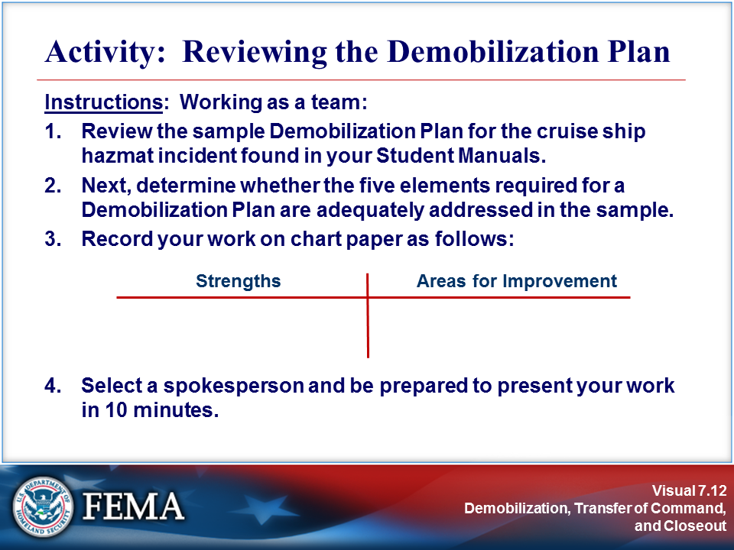 | Complete the activity before proceeding.
Your Notes

Activity: Reviewing the Demobilization Plan

Sample Demobilization Plan
Cruise Ship HazMat Incident (Page 1 of 2)

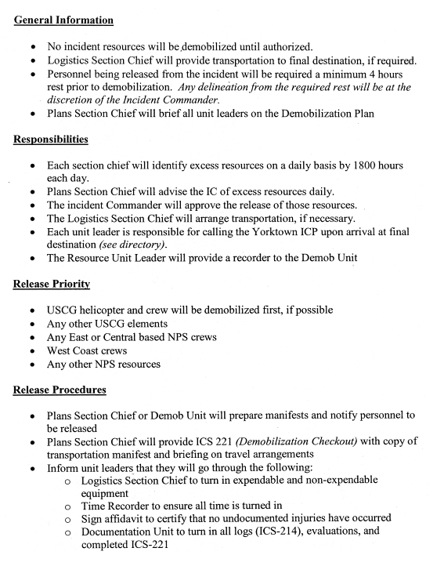

Activity: Reviewing the Demobilization Plan

Sample Demobilization Plan
Cruise Ship HazMat Incident (Page 2 of 2)

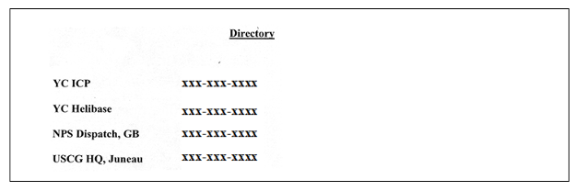

Visuals

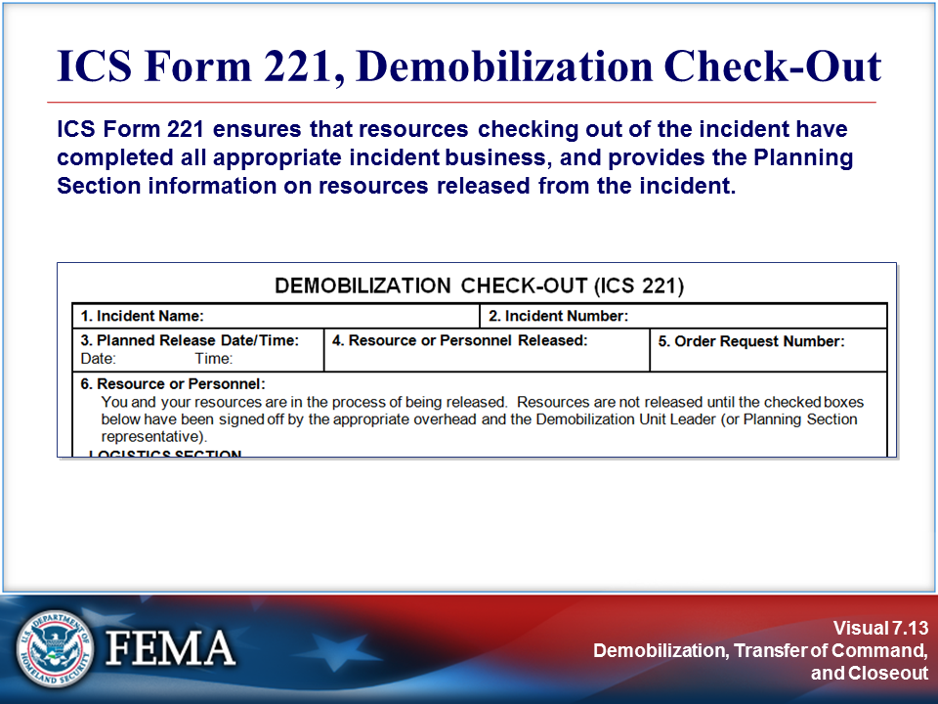 | 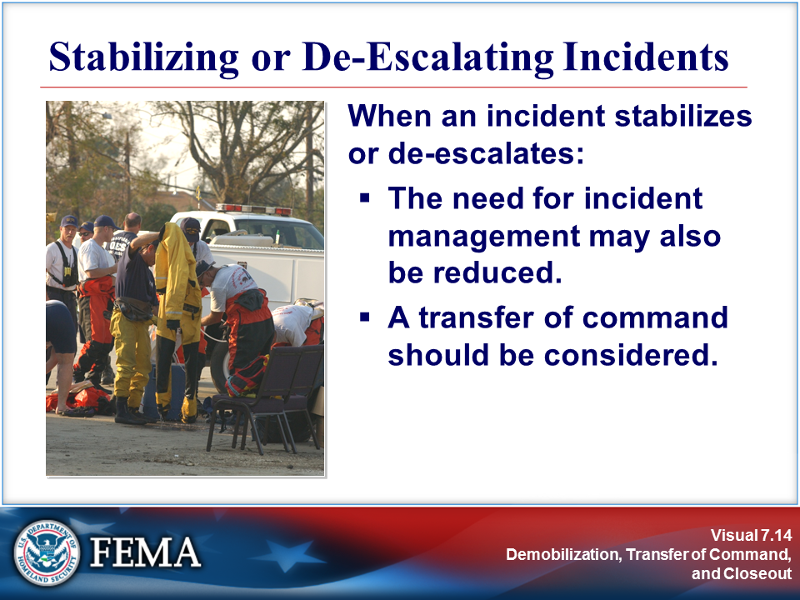
Your Notes

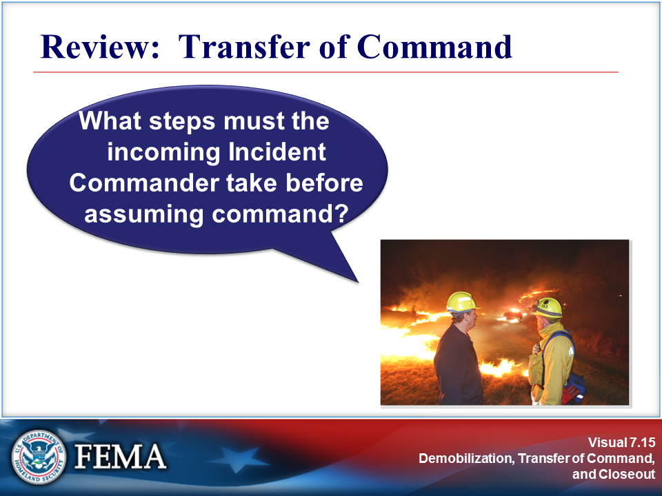 | 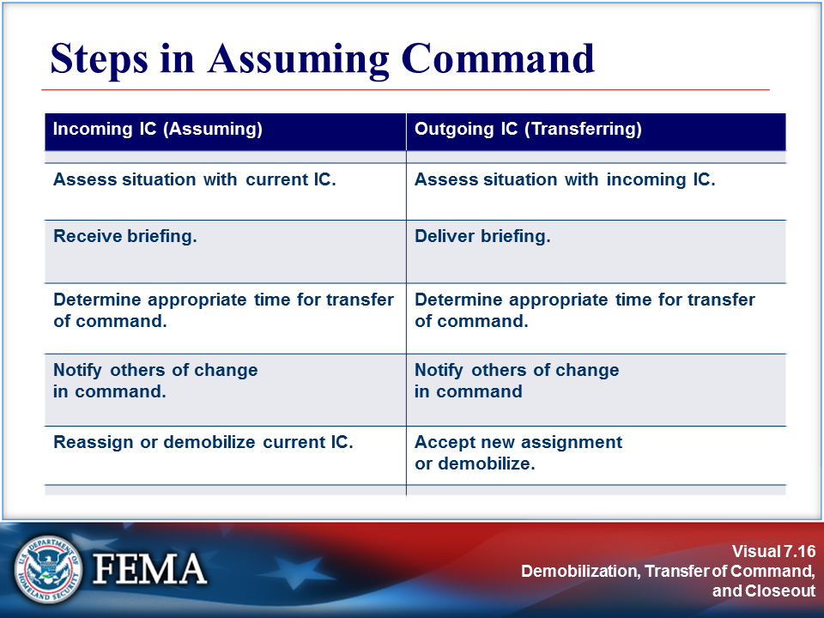
Your Notes

Visuals

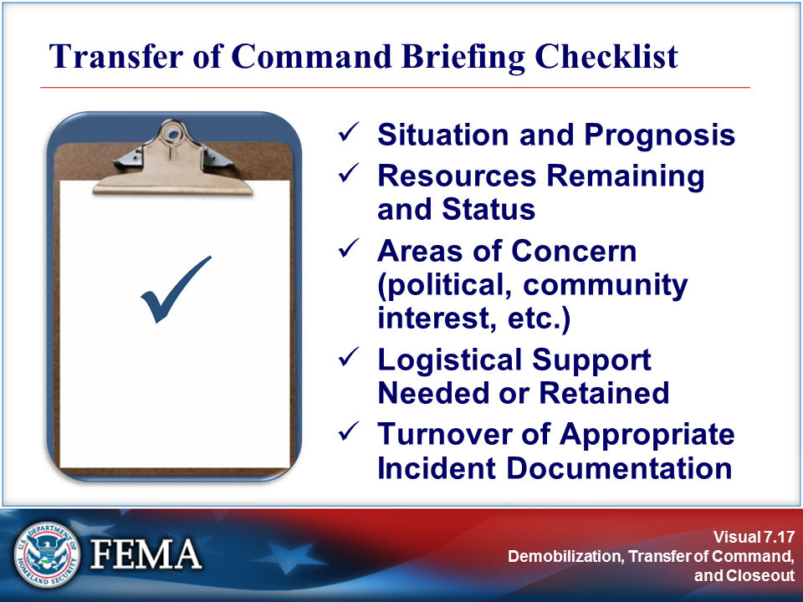 | 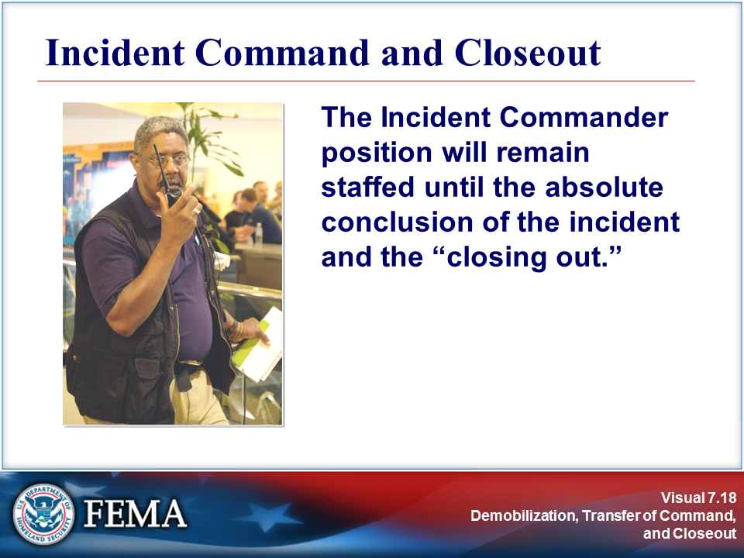
Your Notes

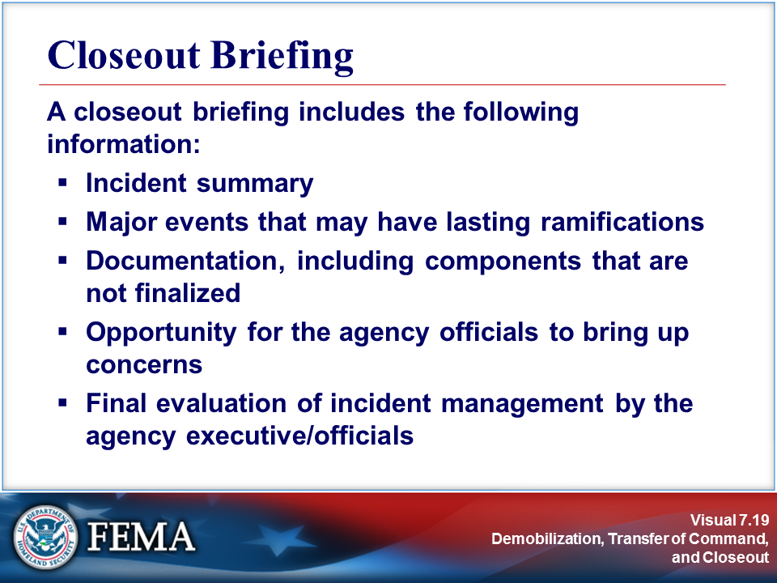 | 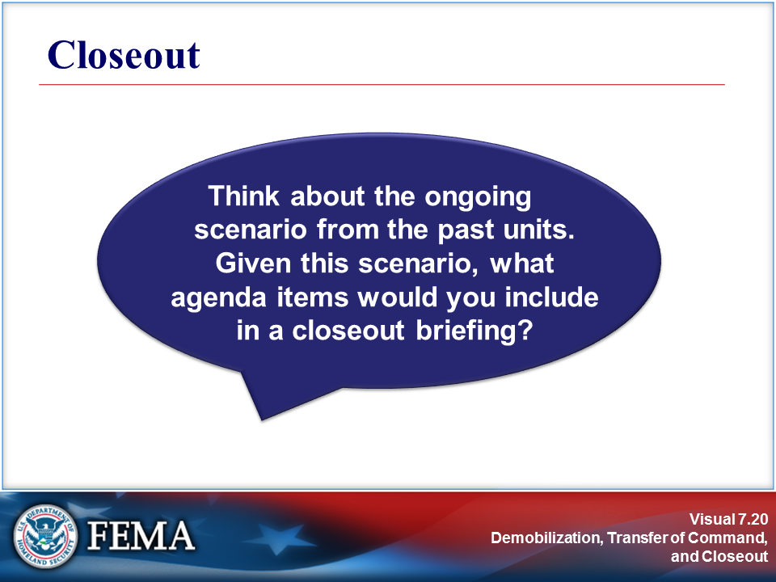
Your Notes

Visuals

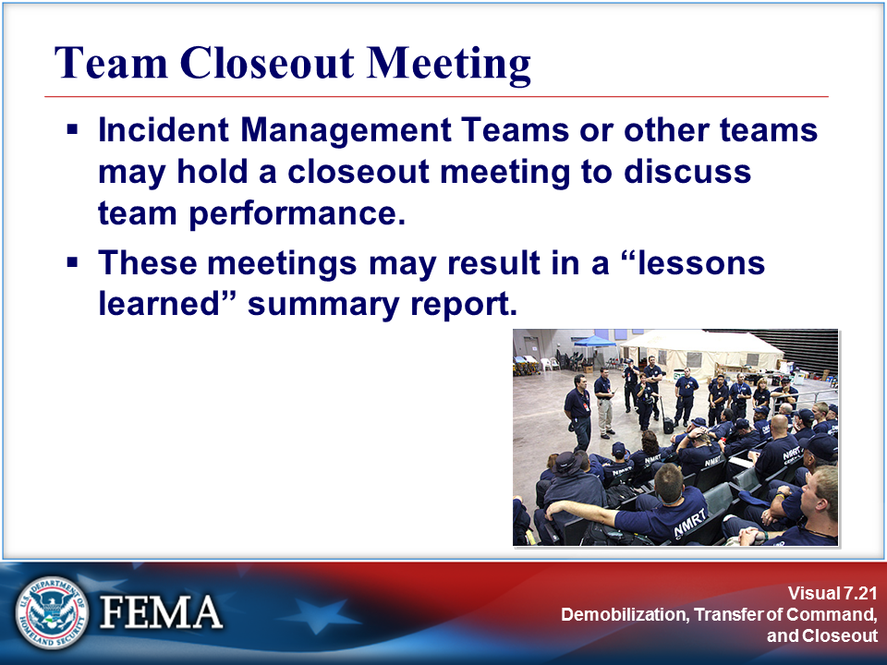 | 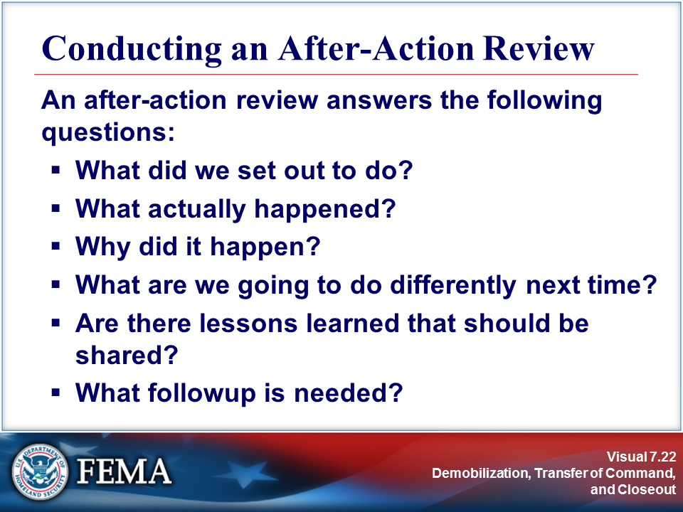
Your Notes

View the job aid on the next page.

Job Aid: Conducting an After-Action Review

After-Action Review (AAR) Tips

Overall Tips
- Schedule an After-Action Review (AAR) as soon after the incident as possible.
- Keep it short and focused.
- Focus on WHAT, not WHO.
- Establish clear ground rules: encourage candor and openness (this is dialog—not lecture or debate); focus on items that can be fixed; keep all discussions confidential.
- Use a skilled facilitator to conduct the AAR.

AAR Process Steps

Use the following questions to facilitate the AAR process:

- What did we set out to do?
- Establish the facts.
- Determine purpose of the mission and definition of success:
- Identify key tasks involved.
- Specify conditions under which each task may need to be performed (weather, topography, time restrictions, etc.).
- Define acceptable standards for success (explain what “Right” looks like).

- What actually happened?
- Continue to establish the facts.
- Participants should come to agreement on what actually happened.
- Pool multiple perspectives to build a shared picture of what happened.

- Why did it happen?
- Analyze cause and effect.
- Focus on WHAT, not WHO.
- Provide progressive refinement for drawing out explanations of what occurred. This will lead into developing possible solutions.

- What are we going to do differently next time?
- Solutions will arise naturally once problems are identified and understood.
- Focus on items you can fix, rather than external forces outside of your control.
- Identify areas where groups are performing well and that should be sustained. This will help repeat success and create a balanced approach to the AAR.

Areas To Sustain/Maintain Strengths:

Areas To Improve:

- Are there lessons learned that should be shared immediately?
- Identify the process for sharing lessons learned.
- Option 1: Document the Issue, Discussion, Recommendation
- Option 2: Document the Concept of the Operation, Results, Trends, Recommendation
- Determine and describe the most notable successes from the incident.
- Determine and describe the most difficult challenges faced and how they were overcome.

Job Aid: Conducting an After-Action Review (Continued)

- What followup is needed?
- Be specific about actions, timelines, and responsibilities.
- What changes, additions, or deletions are recommended to SOPs, plans, or training?
- What issues were not resolved to your satisfaction and need further review?

Visuals

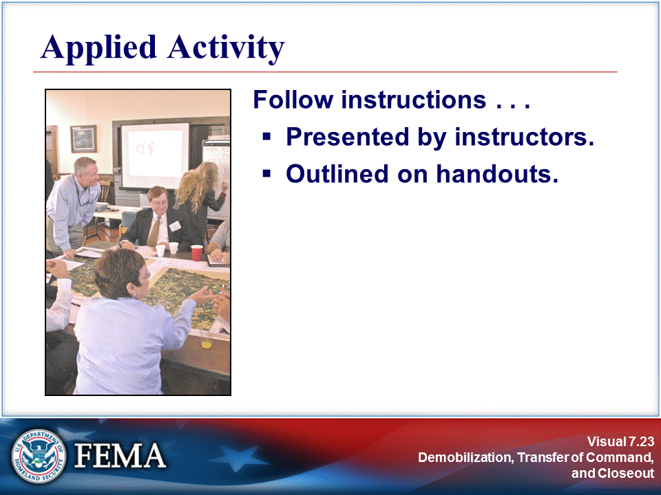 | 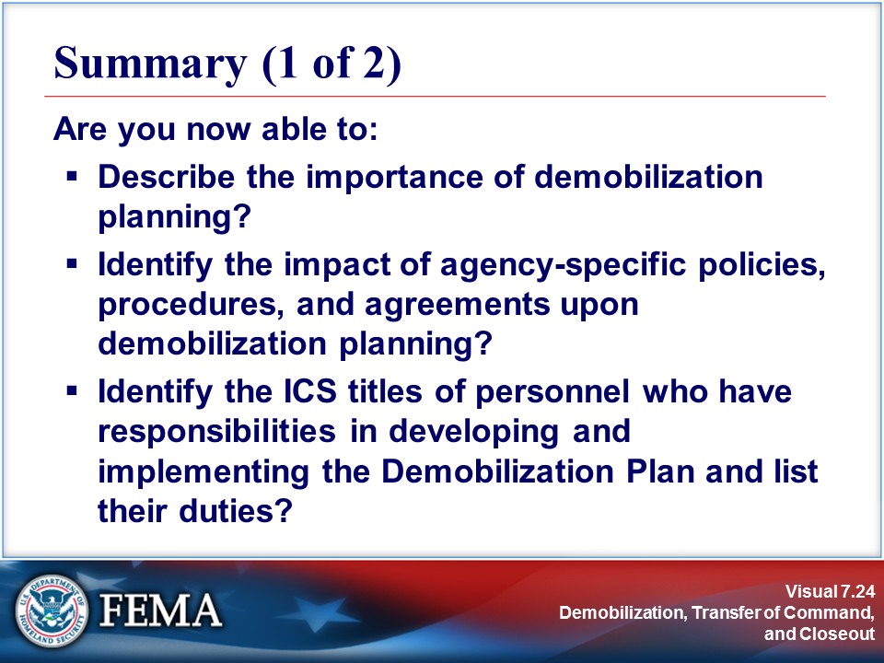
Your Notes

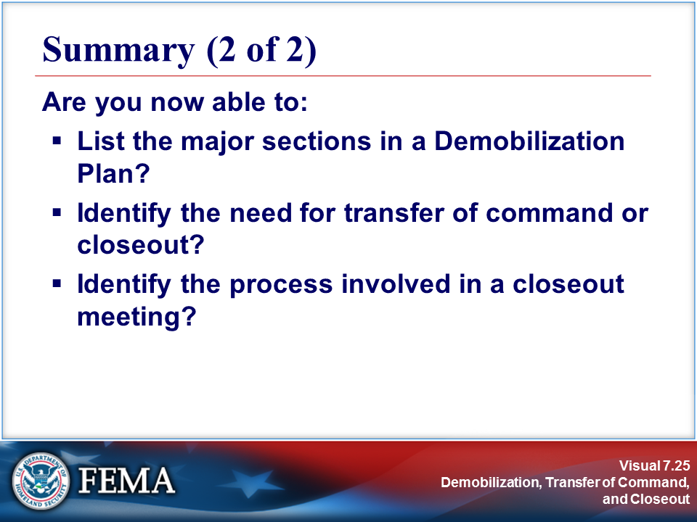
Your Notes

